|  |
| --- |
| Kaizen Primary School - Knowledge Organiser |

|  |  |  |  |
| --- | --- | --- | --- |
| **Sport focus:** | **Tag Rugby** | **Year 2** | **Cycle 1** |

**What? (Key Vocabulary)**

|  |  |
| --- | --- |
| **Spelling** | **Definition/Sentence** |
| **Warm up** | Preparing our bodies for exercise, pumping blood around our bodies faster, to prevent injuries |
| **Cool down** | An easy exercise, done after exercise, to allow the body to transition to a resting state |
| **Rugby ball** | An oval shaped ball used in tag rugby |
| **Tagging** | Making contact with the ball carrier or attacking player |
| **Dodging** | Changing direction quickly, avoiding contact with the opposition. |
| **Ball carrier** | The player in the game who is carrying the ball. |
| **Evasion** | Running into open space. |

|  |
| --- |
| **Diagrams and Symbols** |

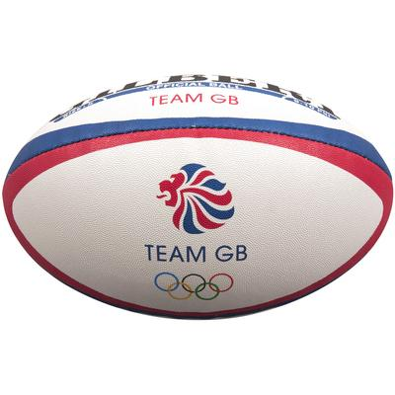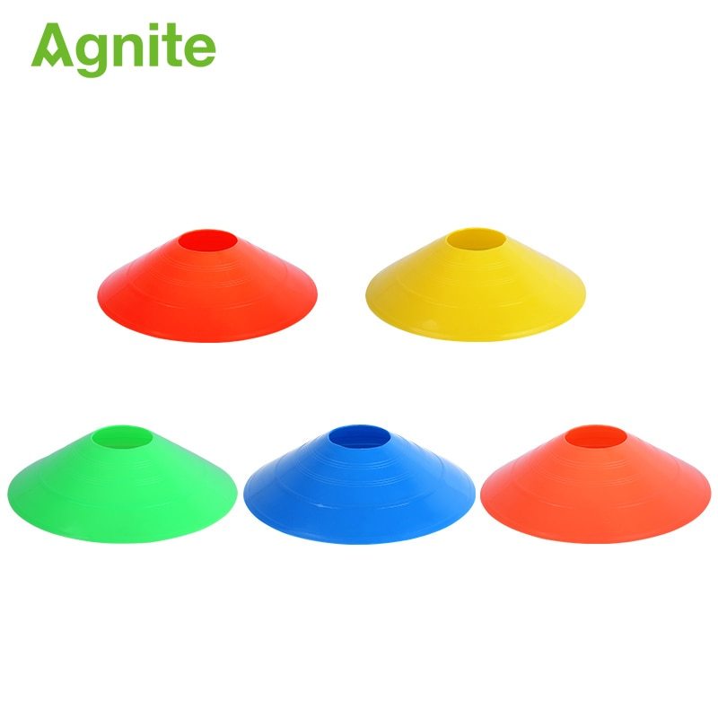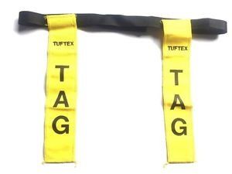

|  |
| --- |
| **Possible Experiences** |

Passing in 2s

Truck and trailer

Tag gate (with ball)

Team tag

**What? (Key Knowledge)**

|  |  |
| --- | --- |
| Teaching Points | |
| Catching a rugby ball with consistently in pairs. |  |
| Passing a ball to someone else in the correct direction. |  |
| How to control and catch a ball with movement, in any direction. |  |
| Opposed condition games that involve tagging. |  |
| How to influence opposed conditioned games involving tagging and passing a ball. |  |
| Rules | |
| Players can run with the ball until tagged | |
| Players must remain on their feet at all times | |
| The ball must be placed on the floor to score | |
| When tagging, players must shout ‘tag’ and stand still. | |
| Questions | |
| Q. What are the benefits of carrying the ball in two hands?  A. More control, more options to pass | |
| Q. What can we do to avoid being tagged?  A. Be aware of space and gaps in working area. | |
| Q. What do we need to say when tagging?  A. Tag | |
| Q. What can we do as a team to tag a player?  A .Work in a group to close down space. | |
| Q. Where is the best place for the defenders to get the ball carrier?  A. At the corners of the square, as this limits the direction they can run. | |