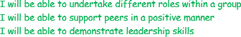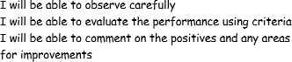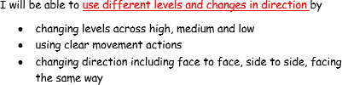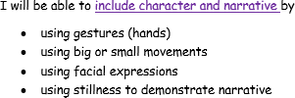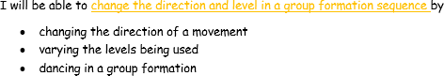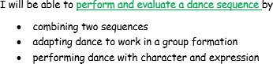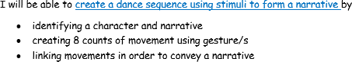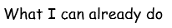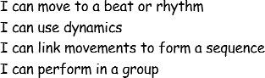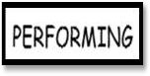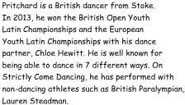
Year 4 Dance Knowledge Organiser

KEY QUESTIONS

What was the narrative? Was it clear?

What are levels?

How can you make a movement show character?

How can you change direction?

Why have you chosen that level for that movement?

KEY VOCABULARY
direction -the direction a dancer is facing

evaluate - discuss the strengths and areas for improvements
levels– the height the dancer moves at
narrrative– a dance or sequence that tells a story
stimuli– inspiration for the movement or

sequence– movements performed in an order or pattern

