The Flourish Federation—Knowledge Organiser

PE Focus: | Outdoor Adventurous Activities |  |  | KS2
 |  | Key Vocabulary
 |  | Verbal communication—use of sounds and words to express yourself.
Non-verbal communication— to
communicate without using language.
 |  | Teamwork—effective and efficient work within a group.
 |  | Cardinal directions—North, East, South and West
 |  | Ordinal directions—North East, South East, North West, South West
 |  | Tactical—thinking and planning strategically to achieve something.
 |  | Leadership—the act of leading a group.
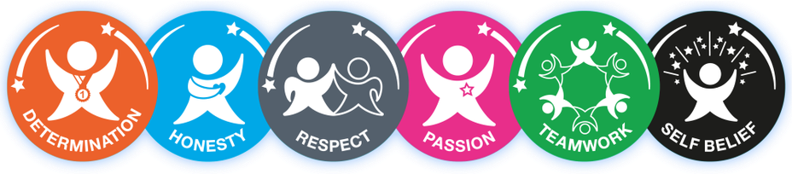
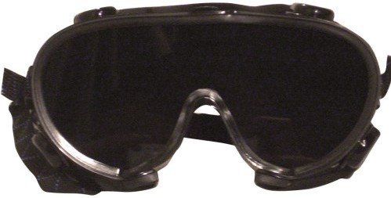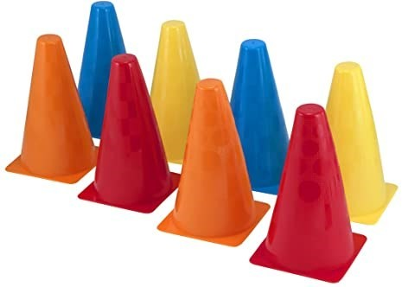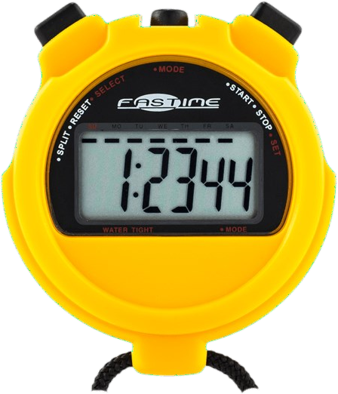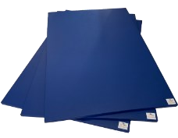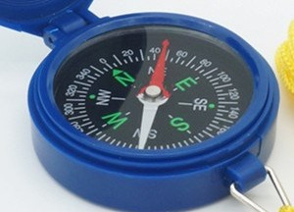
Key Knowledge
I can work with different partners to complete a teamwork task.
I can work with a group to complete a task.
I can use ordinal and cardinal compass directions.
I can plot and follow co-ordinates.
I can develop communication skills within a large team Paralympic game.
I can use communication and team work skills in a large group.

Equipment
Compasses
Stopwatches
Cones
Balls
Hoops
Blindfold goggles
Mats

OAA Games
All Aboard: Keep the class in 3 small groups. The aim is to get all of their team stood and Balanced on the tarpaulin sheet. After each successful attempt the team should step off the sheet and it folded in half.
The idea is to get the group on to the smallest sheet they can. Get children to fold without stepping off!
Ro-Sham-Bo : Set out a semi circle path using cones. Split the children into two lines at either end of the semi circle. Both children enter the bath jumping towards each other until they meet. When they meet they must play rock, paper, scissors against each other until one child wins. The winner continues
jumping down the path in the same direction, whilst the other side allow their next player to start
jumping.
Capture the flag: in teams children attempt to steal a flag from another team’s territory and then return it to their own. Children can guard their own flag by tagging the opposition if they enter their quarter of the territory. Children who are tagged must return to their base before attempting to capture again. If a
child captures the flag they can be tagged anywhere on the pitch (if tagged the flag is returned). To guard
their flag children must stand 5m away.
Lefty/righty: in their groups, children stand in a straight line. The child at the front passes the ball backwards to their left, then the next to the right. This is then repeated until the child at the back
received the ball. This child collects the ball and runs to the front and repeats. Once the child that started
at the front returned to the front of the line, that team can sit down.
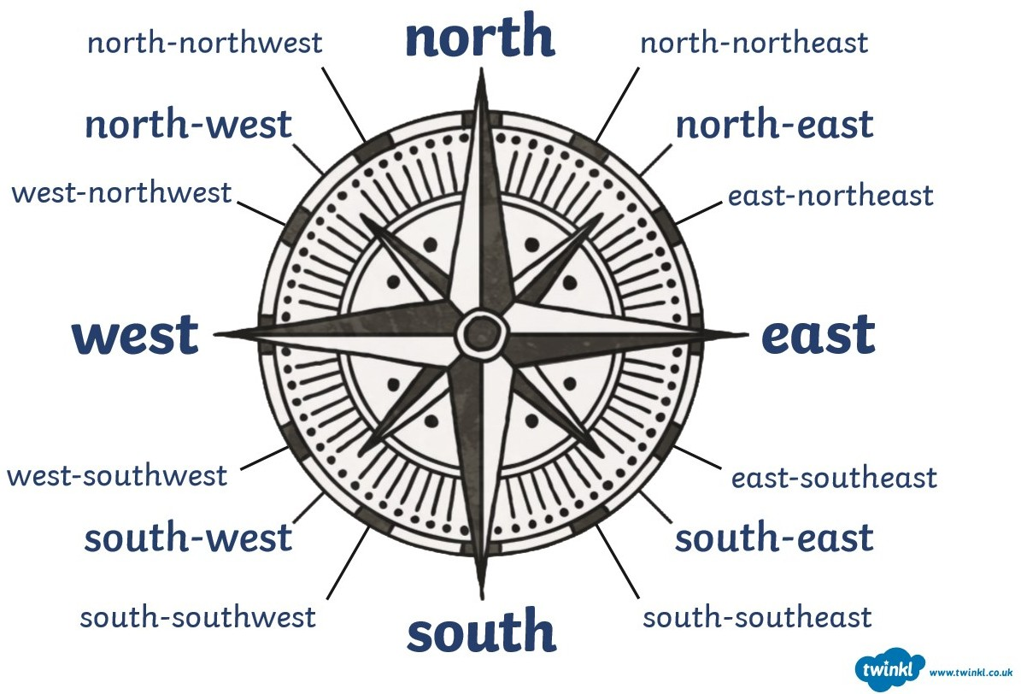
Visuals

