Year 3 Dance Knowledge Organiser

KEY QUESTIONS
What are dynamics in dance?

How can you show the beat using your body?

KEY VOCABULARY
beat – the underlying pulse for the movement to follow

dynamics - how the body moves using speed, energy and flow
energy– the force applied to a movement

flow – the continuity of the movement

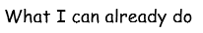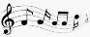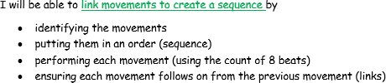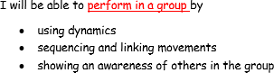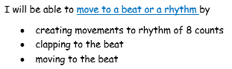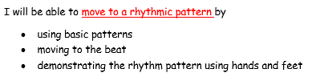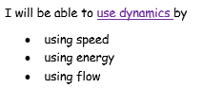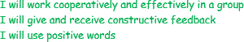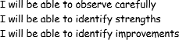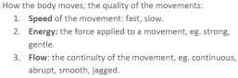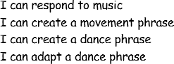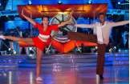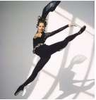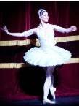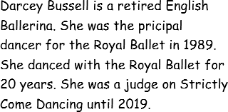
How are the dynamics different?

How are the movements linked and sequenced?

How can you make the dynamics clear?
rhythmic pattern – movements performed in a pattern speed - how fast or slow the movement is performed sequence – movements performed in an order or pattern
perform – remembering the sequence and dancing in front of others

