|  |
| --- |
| PE - Knowledge Organiser |

|  |  |  |  |
| --- | --- | --- | --- |
| **Sport focus:** | **Tag Rugby** | **Year 5** | **Autumn 2** |

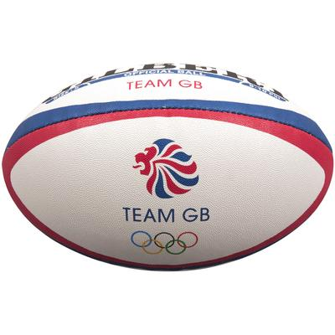



|  |
| --- |
| **Diagrams and Symbols** |



**What? (Key Vocabulary)**

|  |  |
| --- | --- |
| **Spelling** | **Definition/Sentence** |
| **Warm up** | Preparing our bodies for exercise, pumping blood around our bodies faster, to prevent injuries |
| **Cool down** | An easy exercise, done after exercise, to allow the body to transition to a resting |
| **Agility** | The ability to change direction quickly |
| **Footwork** | Skills of the ball carrier to evade being tagged e.g. Pace change, side step. |
| **Turn over ball** | The possession of the ball being lost |
| **Try** | The grounding of the ball on or over the try line. |
| **Support player** | Attacking team player without the ball. |
| Scanning for space | Ability of the player to look up and recognise the space caused by the defenders wearing tags. |

|  |
| --- |
| **Possible Experiences** |

End ball

Breakout tag

Bonus tag

Decision making

Action jack (Challenge)

**What? (Key Knowledge)**

|  |  |
| --- | --- |
| Teaching Points | |
| Know how to influence opposed conditioned rugby games |  |
| How to control and catch a ball with movement in an opposed situation. |  |
| How to effectively invade space and evade opponents during a rugby based game. |  |
| How to take part in conditioned games with understanding of tactics and rules |  |
| Lead an effective warm up. |  |
| How to manage teams and lead skill practices. |  |
| Rules | |
| Players can run with the ball until tagged | |
| Players must remain on their feet at all times | |
| The ball must be placed on the floor to score | |
| When tagging, players must shout ‘tag’ and stand still. | |
| Questions | |
| Q. What is the advantage of moving the ball quickly within the playing area?  A. Defenders have less time to prepare. | |
| Q. As a defender, what can you do to help stop the attackers?  A. Anticipate the direction of attack and pressurise ball carrier once they enter your area. | |
| Q. Why would you pass before being tagged?  A.Because there is a player in a better position to make ground or to score. | |
| Q. What do you need to shout when tagging?  A. Tag | |