Knowledge Organiser

Sport focus: | Gymnastics | Year 1 | Spring 1
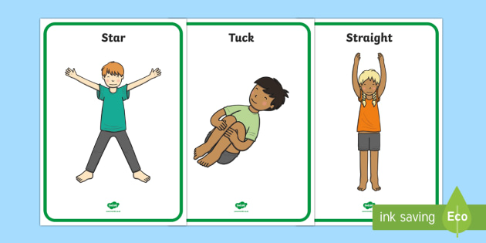
Possible Experiences

Travelling like an animal
Musical statues (lesson focused)
Going through the gears
Shapes

Diagrams and Symbols

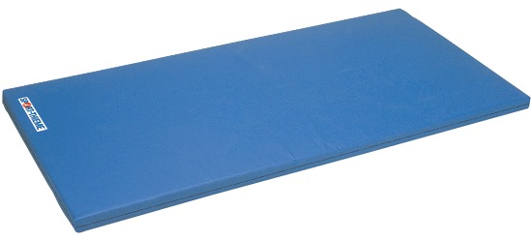
What? (Key Vocabulary)
Spelling | Definition/Sentence
Warm up | Preparing our bodies for exercise, pumping blood around our bodies faster, to prevent injuries
Cool down | An easy exercise, done after exercise, to allow the body to transition to a resting
Flexibility | The range of motion available at a joint. Being able to bend your body
Balance | An even distribution of weight enabling someone or something to remain steady. Not falling over.
Shapes | Using your body to create different shapes. The shapes include; straight, start, tuck, pike and straddle
Travelling | Performing a movement that moves the body, moving in different ways within an area

What? (Key Knowledge)

Teaching Points
Copy, remember, explore and repeat simple actions such as balances and shapes, and link various ideas with control and coordination.
How to use and explore equipment safely.
Rules
The lesson should always start with a warm up
The teacher should always be in a position to view all children working
The lesson set out should allow for differentiation
Children should be working in bare feet
The lesson should conclude with a cool down
Questions
Q. Can you name one or more of the five basic shapes
A. Star, straight, tuck, straddle and pike
Q. What can we do to help us balance?
A. Put out our hands, stare at a spot. Touch our nose
Q. Why do we need to warm up?
A. To not get injured
Q. Why do we need to have a quality start?
A. To make sure we are focused and we perform all of our moves correctly
Q. Why is it important that we are aware of space around us?
A. So we do not bump into anyone else and so we give everyone enough space to work.

