YEAR 6 PE Knowledge Organiser: DANCE

KEY QUESTIONS
How can you emphasise character to the audience?

What types of expression can be used?

KEY VOCABULARY
choreographic devices- a method to manipulate, change or repeat movements to develop a dance
canon – a choreographic device used to change the structure
dynamics – how the body moves

evaluate - discuss the strengths and areas for improvements
narrative – a dance or sequence that tells a story retrograde -performing movements backwards sequence– movements performed in an order or pattern unison– performing identical movements at the same time

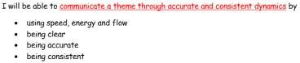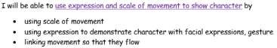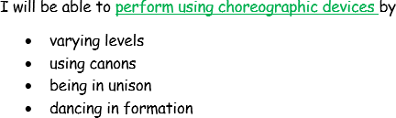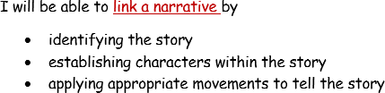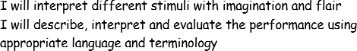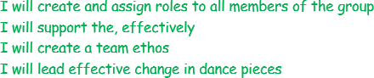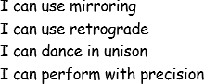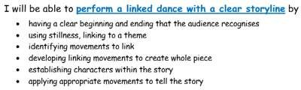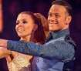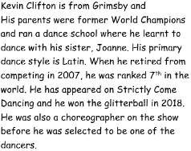
What choreographic devices work best for this dance?

Which dynamics are associated with this theme?
How can you link movements together to create a sense of flow to the sequence?

