|  |
| --- |
| Knowledge Organiser |

|  |  |  |  |
| --- | --- | --- | --- |
| **Sport focus:** | **Gymnastics** | **Year 4** | **Spring 1** |

|  |
| --- |
| **Possible Experiences** |

One to two and two to one

Jump to it

Working with a partner

Mirroring a partner



|  |
| --- |
| **Diagrams and Symbols** |

 

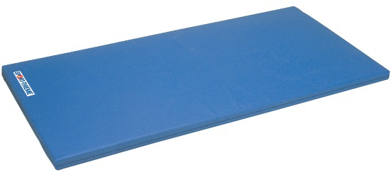

**What? (Key Vocabulary)**

|  |  |
| --- | --- |
| **Spelling** | **Definition/Sentence** |
| **Flexibility** | The range of motion through which a body part can move without feeling pain. |
| **Control** | When performing a sequence, balance or when pupils are stopping, pupils should be taught to hold still |
| **Routine** | A combination of stunts displaying a full range of skills on one apparatus. |
| **Sequence** | Two or more positions or skills which are performed together creating a different skill or activity. |
| **Apparatus** | The equipment used during gymnastic lessons |
| **Composition** | The structure of a routine and how each individual element, movement or skill is arranged into a routine is called the composition of the routine |

**What? (Key Knowledge)**

|  |  |
| --- | --- |
| Teaching Points | |
| How to link ideas, skills and techniques with control, precision and fluency when performing basic skills (balances and rolls) with a partner. |  |
| Understand composition by performing more complex sequences including rolls and partner balances. |  |
| Describe how to refine, improve and modify performances. |  |
| Perform safely on basic equipment. |  |
| Rules | |
| The lesson should always start with a warm up | |
| The teacher should always be in a position to view all children working | |
| The lesson set out should allow for differentiation | |
| Children should be working in bare feet | |
| The lesson should conclude with a cool down | |
| Questions | |
| Q. What elements are required to perform a sequence?  A. Travel, jump, turn, balance and roll | |
| Q. Where can sequences be performed  A. On the floor, on apparatus or both | |
| Q. How can you demonstrate partner work?  A. Mirroring, balancing, canon, synchronisation and to travel on, over or around | |
| Q. When giving feedback, why is it important to use positive language?  A. To encourage them to improve, to show what they have achieved is good, to boost confidence, etc | |