Q1. (a) Methylamine is a weak Brønsted-Lowry base and can be used in aqueous solution with one other substance to prepare a basic buffer.
(i) Explain the term Brønsted-Lowry base and write an equation for the reaction of methylamine with water to produce an alkaline solution.
Brønsted-Lowry base ..........................................................................
Equation ..............................................................................................

(ii) Suggest a substance that could be added to aqueous methylamine to produce a basic buffer.
.............................................................................................................

(iii) Explain how the buffer solution in part (a)(ii) is able to resist a change in pH when a small amount of sodium hydroxide is added.
.............................................................................................................
.............................................................................................................
.............................................................................................................
(5)

(b) Explain why methylamine is a stronger base than ammonia.
......................................................................................................................
......................................................................................................................
......................................................................................................................
(2)

(c) A cation is formed when methylamine reacts with a large excess of bromoethane. Name the mechanism involved in the reaction and draw the structure of the cation formed.
Name of mechanism ....................................................................................
Structure

(2)
(Total 9 marks)

Q2. (a) Outline a mechanism for the formation of ethylamine from bromoethane. State why the ethylamine formed is contaminated with other amines. Suggest how the reaction conditions could be modified to minimise this contamination.
(6)

(b) Suggest one reason why phenylamine cannot be prepared from bromobenzene in a similar way. Outline a synthesis of phenylamine from benzene. In your answer you should give reagents and conditions for each step, but equations and mechanisms are not required.
(5)
(Total 11 marks)

Q3. Compound Z can be formed via compounds X and Y in the three step synthesis shown below.
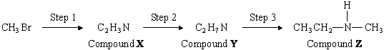
Identify compounds X and Y and give reagents and conditions for Steps 1 and 2.
State the type of compound of which Z is an example.
Compound Z reacts with a large excess of bromomethane to form a solid product. Draw the structure of this product and name the type of mechanism for this reaction.
(Total 9 marks)

Q4. (a) Name and outline a mechanism for the formation of butylamine, CH₃CH₂CH₂CH₂NH₂, by the reaction of ammonia with 1-bromobutane, CH₃CH₂CH₂CH₂Br.
Name of mechanism ....................................................................................
Mechanism

(5)

(b) Butylamine can also be prepared in a two-step synthesis starting from 1-bromopropane, CH₃CH₂CH₂Br. Write an equation for each of the two steps in this synthesis.
Step 1
......................................................................................................................
Step 2
......................................................................................................................
(3)

(c) (i) Explain why butylamine is a stronger base than ammonia.
.............................................................................................................
.............................................................................................................
.............................................................................................................

(ii) Identify a substance that could be added to aqueous butylamine to produce a basic buffer solution.
.............................................................................................................
(3)

(d) Draw the structure of a tertiary amine which is an isomer of butylamine.

(1)
(Total 12 marks)

Q5. The following reaction scheme shows the formation of two amines, K and L, from methylbenzene.
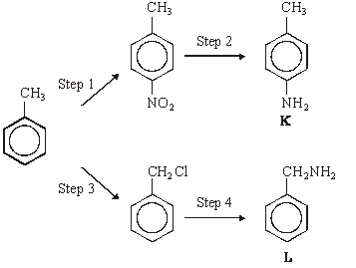
(a) (i) Give the reagents needed to carry out Step 1. Write an equation for the formation from these reagents of the inorganic species which reacts with methylbenzene.
Reagents ............................................................................................
Equation .........….................................................................................

(ii) Name and outline a mechanism for the reaction between this inorganic species and methylbenzene.
Name of mechanism ............................................................................
Mechanism

(7)

(b) Give a suitable reagent or combination of reagents for Step 2.
......................................................................................................................
(1)

(c) (i) Give the reagent for Step 4 and state a condition to ensure that the primary amine is the major product.
Reagent .............................................................................................
Condition ........................................................….................................

(ii) Name and outline a mechanism for Step 4.
Name of mechanism ...........................................................................
Mechanism

(7)

(d) Explain why amine K is a weaker base than ammonia.
......................................................................................................................
......................................................................................................................
......................................................................................................................
(2)

(e) Draw the structure of the organic compound formed when a large excess of bromomethane reacts with amine L.

(1)

(f) Draw the structure of the organic compound formed when ethanoyl chloride reacts with amine L in an addition–elimination reaction.

(1)
(Total 19 marks)

Q6. Consider the following reaction sequence.
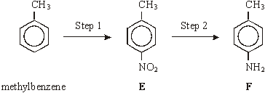
(a) For Step 1, name the mechanism and give the reagents involved.
Name of mechanism ....................................................................................
Reagents ......................................................................................................
(3)

(b) For Step 2, give a reagent or combination of reagents. Write an equation for this reaction using [H] to represent the reductant.
Reagent(s) ...................................................................................................

Equation .......................................................................................................
(2)

(c) Give the m/z value of a major peak which could appear in the mass spectrum of methylbenzene, but not in the spectrum of either E or F.
......................................................................................................................
(1)

(d) Draw the structure of the species formed by F in an excess of hydrochloric acid.

(1)

(e) Compounds G and H are both monosubstituted benzenes and both are isomers of F.
G is a primary amine and H is a secondary amine. Draw the structures of G and H below.
G

H

(2)
(Total 9 marks)

Q7. (a) Name the compound (CH₃)₂NH
......................................................................................................................
(1)

(b) (CH₃)₂NH can be formed by the reaction of an excess of CH₃NH₂ with CH₃Br. Name and outline a mechanism for this reaction.
Name of mechanism ....................................................................................
Mechanism

(5)

(c) Name the type of compound produced when a large excess of CH₃Br reacts with CH₃NH₂ Give a use for this type of compound.
Type of compound ......................................................................................
Use ..............................................................................................................
(2)

(d) Draw the structures of the two compounds formed in the reaction of CH₃NH₂ with ethanoic anhydride.

(2)
(Total 10 marks)

Q8. (a) The repeating units of two polymers, P and Q, are shown below.
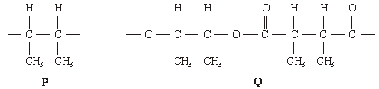
(i) Draw the structure of the monomer used to form polymer P. Name the type of polymerisation involved.
Structure of monomer

Type of polymerisation .......................................................................

(ii) Draw the structures of two compounds which react together to form polymer Q. Name these two compounds and name the type of polymerisation involved.
Structure of compound 1

Name of compound 1 .........................................................................
Structure of compound 2

Name of compound 2 ........................................................................
Type of polymerisation .......................................................................

(iii) Identify a compound which, in aqueous solution, will break down polymer Q but not polymer P.
.............................................................................................................
(8)

(b) Draw the structures of the two dipeptides which can form when one of the amino acids shown below reacts with the other.
Structure 1 Structure 2
(2)

(c) Propylamine, CH₃CH₂CH₂NH₂, can be formed either by nucleophilic substitution or by reduction.
(i) Draw the structure of a compound which can undergo nucleophilic substitution to form propylamine.

(ii) Draw the structure of the nitrile which can be reduced to form propylamine.

(iii) State and explain which of the two routes to propylamine, by nucleophilic substitution or by reduction, gives the less pure product. Draw the structure of a compound formed as an impurity.
Route giving the less pure product .....................................................
Explanation .........................................................................................
.............................................................................................................
Structure of an impurity

(5)
(Total 15 marks)

Q9. Haloalkanes are useful compounds in synthesis.
Consider the three reactions of the haloalkane A shown below.
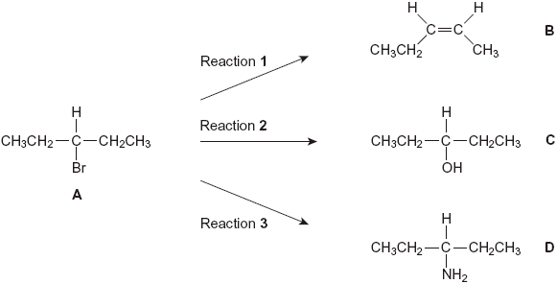
(a) (i) Draw a branched-chain isomer of A that exists as optical isomers.

(1)

(ii) Name the type of mechanism in Reaction 1.
.............................................................................................................
(1)

(iii) Give the full IUPAC name of compound B.
.............................................................................................................
(1)

(b) The infrared spectra shown below are those of the four compounds, A, B, C and D.
Using Table 1 on the Data Sheet, write the correct letter in the box next to each spectrum.
(i)
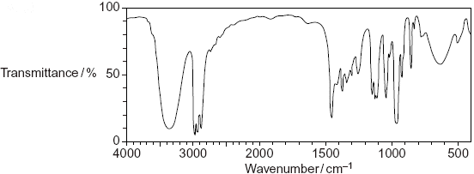

(ii)
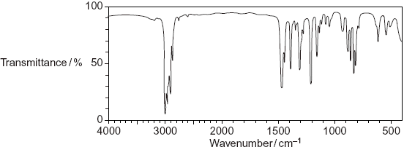

(iii)
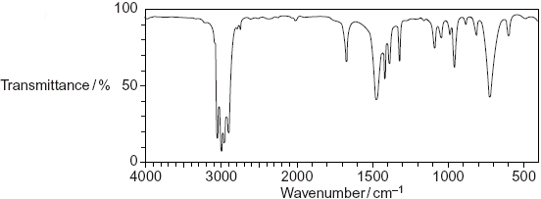

(iv)
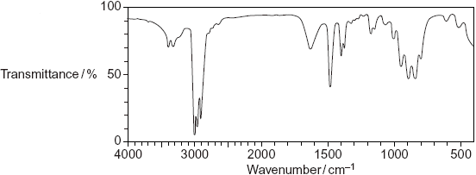

(4)

(c) Draw the repeating unit of the polymer formed by B and name the type of polymerisation involved.
Repeating unit

Type of polymerisation .................................................................................
(2)

(d) (i) Outline a mechanism for Reaction 3.

(4)

(ii) State the conditions used in Reaction 3 to form the maximum amount of the primary amine, D.
.............................................................................................................
(1)

(iii) Draw the structure of the secondary amine formed as a by-product in Reaction 3.

(1)

(e) D is a primary amine which has three peaks in its ¹³C n.m.r. spectrum.
(i) An isomer of D is also a primary amine and also has three peaks in its ¹³C n.m.r. spectrum. Draw the structure of this isomer of D.

(1)

(ii) Another isomer of D is a tertiary amine. Its ¹H n.m.r. spectrum has three peaks. One of the peaks is a doublet. Draw the structure of this isomer of D.

(1)
(Total 17 marks)

Q10. The compound (CH₃CH₂)₂NH can be made from ethene in a three-step synthesis as shown below.
(a) Name the compound (CH₃CH₂)₂NH
......................................................................................................................
(1)

(b) Identify compounds F and G.
Compound F ...............................................................................................
Compound G ...............................................................................................
(2)

(c) For the reactions in Steps 1, 2 and 3,
• give a reagent or reagents
• name the mechanism.
Balanced equations and mechanisms using curly arrows are not required.
......................................................................................................................
......................................................................................................................
......................................................................................................................
......................................................................................................................
......................................................................................................................
......................................................................................................................
......................................................................................................................
......................................................................................................................
(6)

(d) Identify one organic impurity in the product of Step 3 and give a reason for its formation.
......................................................................................................................
......................................................................................................................
......................................................................................................................
(2)
(Total 11 marks)

Q11. The hydrocarbons benzene and cyclohexene are both unsaturated compounds.
Benzene normally undergoes substitution reactions, but cyclohexene normally
undergoes addition reactions.
(a) The molecule cyclohexatriene does not exist and is described as hypothetical.
Use the following data to state and explain the stability of benzene compared with the hypothetical cyclohexatriene.
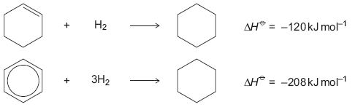
......................................................................................................................
......................................................................................................................
......................................................................................................................
......................................................................................................................
......................................................................................................................
......................................................................................................................
......................................................................................................................
......................................................................................................................
(Extra space) ...............................................................................................
......................................................................................................................
......................................................................................................................
......................................................................................................................
(4)

(b) Benzene can be converted into amine U by the two-step synthesis shown below.
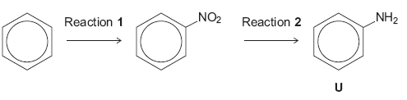
The mechanism of Reaction 1 involves attack by an electrophile.
Give the reagents used to produce the electrophile needed in Reaction 1.
Write an equation showing the formation of this electrophile.
Outline a mechanism for the reaction of this electrophile with benzene.
......................................................................................................................
......................................................................................................................
......................................................................................................................
......................................................................................................................
......................................................................................................................
......................................................................................................................
......................................................................................................................
......................................................................................................................
(Extra space) ................................................................................................
......................................................................................................................
......................................................................................................................
......................................................................................................................
......................................................................................................................
......................................................................................................................
......................................................................................................................
(6)

(c) Cyclohexene can be converted into amine W by the two-step synthesis shown below.
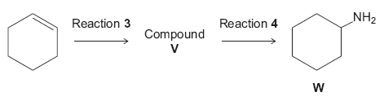
Suggest an identity for compound V.
For Reaction 3, give the reagent used and name the mechanism.
For Reaction 4, give the reagent and condition used and name the mechanism.

Equations and mechanisms with curly arrows are not required.
......................................................................................................................
......................................................................................................................
......................................................................................................................
......................................................................................................................
......................................................................................................................
......................................................................................................................
......................................................................................................................
(Extra space) ...............................................................................................
......................................................................................................................
......................................................................................................................
......................................................................................................................
......................................................................................................................
......................................................................................................................
(6)

(d) Explain why amine U is a weaker base than amine W.
......................................................................................................................
......................................................................................................................
......................................................................................................................
......................................................................................................................
......................................................................................................................
(Extra space) ................................................................................................
......................................................................................................................
......................................................................................................................
(3)
(Total 19 marks)

Q12. The amide or peptide link is found in synthetic polyamides and also in naturally
occurring proteins.
(a) (i) Draw the repeating unit of the polyamide formed by the reaction of propanedioic acid with hexane-1,6-diamine.

(2)

(ii) In terms of the intermolecular forces between the polymer chains, explain why polyamides can be made into fibres suitable for use in sewing and weaving, whereas polyalkenes usually produce fibres that are too weak for this purpose.
.............................................................................................................
.............................................................................................................
.............................................................................................................
.............................................................................................................
.............................................................................................................
.............................................................................................................
(Extra space) ......................................................................................
.............................................................................................................
.............................................................................................................
(3)

(b) (i) Name and outline a mechanism for the reaction of CH₃CH₂COCl with CH₃NH₂
Name of mechanism............................................................................
Mechanism

(5)

(ii) Give the name of the product containing an amide linkage that is formed in the reaction in part (b) (i).
.............................................................................................................
(1)

(c) The dipeptide shown below is formed from two different amino acids.
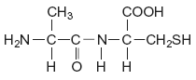
Draw the structure of the alternative dipeptide that could be formed by these two amino acids.

(1)

(d) The amino acids serine and aspartic acid are shown below.
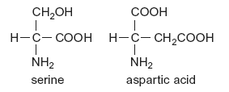
(i) Give the IUPAC name of serine.
.............................................................................................................
(1)

(ii) Draw the structure of the species formed when aspartic acid reacts with aqueous sodium hydroxide.

(1)

(iii) Draw the structure of the species formed when serine reacts with dilute hydrochloric acid.

(1)

(iv) Draw the structure of the species formed when serine reacts with an excess of bromomethane.

(1)
(Total 16 marks)

Q13.This question is about the primary amine CH₃CH₂CH₂NH₂
(a) The amine CH₃CH₂CH₂NH₂ reacts with CH₃COCl
Name and outline a mechanism for this reaction.
Give the IUPAC name of the organic product.

........................................................................................................................
........................................................................................................................
(6)

(b) Isomers of CH₃CH₂CH₂NH₂ include another primary amine, a secondary amine and a tertiary amine.
(i) Draw the structures of these three isomers.
Label each structure as primary, secondary or tertiary.

(3)

(ii) Use Table 1 on the Data Sheet to explain how you could use infrared spectra in the range outside the fingerprint region to distinguish between the secondary amine and the tertiary amine.
...............................................................................................................
...............................................................................................................
...............................................................................................................
...............................................................................................................
...............................................................................................................
(2)

(c) The amine CH₃CH₂CH₂NH₂ can be prepared by two different routes.
Route A is a two-stage process and starts from CH₃CH₂Br.
Route B is a one-stage process and starts from CH₃CH₂CH₂Br.
(i) Identify the intermediate compound in Route A.
Give the reagents and conditions for both stages in Route A and the single stage in Route B.
...............................................................................................................
...............................................................................................................
...............................................................................................................
...............................................................................................................
...............................................................................................................
...............................................................................................................
...............................................................................................................
...............................................................................................................
...............................................................................................................
...............................................................................................................
...............................................................................................................
...............................................................................................................
...............................................................................................................
...............................................................................................................
...............................................................................................................
(7)

(ii) Give one disadvantage of Route A and one disadvantage of Route B.
...............................................................................................................
...............................................................................................................
...............................................................................................................
...............................................................................................................
(2)
(Total 20 marks)

M1. (a) (i) H+ or proton acceptor (1)
CH₃NH₂ + H₂O () CH₃⁺NH₃ (+) OH– (1)

(ii) CH₃NH₃Cl or HCl (1)
Or any ammonium compound or strong acid
name or formula

(iii) extra OH– reacts with
or reaction / equilibrium moves to left
or ratio salt / base remains almost constant (1)
Any 2
5

(b) lone pair (on N accepts H⁺) (1)
CH₃ increases electron density (on N)
donates / pushes electrons
has positive inductive effect (1)
2

(c) nucleophilic substitution (1)
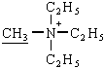 (1)
2
[9]

M2. (a)
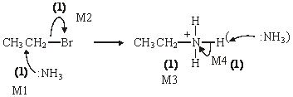
Further reaction / substitution / formation of 2° / 3° amines etc (1)
use an excess of NH₃ (1)
6

(b) 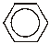 repels nucleophiles (such as NH₃) (1)
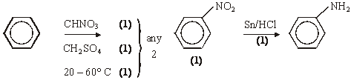
5

Notes
(a) allow S_{N}1
penalise: Br– intead of NH₃ removing H⁺ for M4
not contamination with other amines (this is in the question) not diamines
(b) allow because NH₃ is a nuclephile or benzene is (only) attacked by electrophiles
or C–Br bond (in bromobenzene) is stronger / less polar or Br lp delocalized
HNO₃ / H₂SO₄ without either conc scores (1) allow 20 – 60° for (1) (any 2 ex 3)
allow name or structure of nitrobenzene
other reducing agents: Fe or Sn with HCl (conc or dil or neither)
not conc H₂SO₄ or conc HNO₃
allow Ni/H₂
Not NaBH₄ or LiAlH₄
ignore wrong descriptions for reduction step e.g. hydrolysis or hydration
[11]

Organic points
(1) Curly arrows: must show movement of a pair of electrons,
i.e. from bond to atom or from lp to atom / space
e.g.

(2) Structures
penalise sticks (i.e. 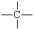) once per paper
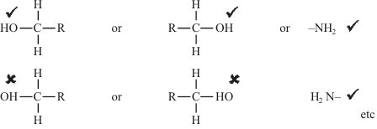
Penalise once per paper
allow CH₃– or –CH₃ or or CH₃
or H₃C–

M3. X is CH₃CN or ethanenitrile or ethanonitrile or methyl cyanide or
cyanomethane or ethyl nitrile or methanecarbonitrile
Not ethanitrile
but contradiciton of name and structure lose marks
1
Y is CH₃CH₂NH₂ or ethylamine or aminoethane or ethanamine
1
Step 1: reagent KCN not HCN/HCl
condition (aq)/alcohol - only allow condition if reagent
correct or incomplete
2
Step 2: reagent H₂ LiAlH₄ Na Zn/Fe/Sn Not NaBH₄
condition Ni/Pt/Pd ether ethanol HCl
2

Z is an amine or aminoalkane or named amine even if incorrect name for Z
secondary (only award if amine correct)
1
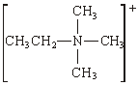 (Br–) + can be on N or outside brackets as shown
1
nucleophilic substitution
1
[9]

M4. (a) Nucleophilic substitution
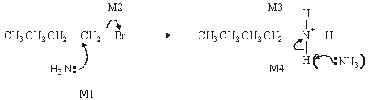
1
M1, M2 and M4 for arrows, M3 for structure of cation
(Allow M2 alone first, i.e. SN1 formation of carbocation)
(Penalise M4 if Br– used to remove H⁺)

4
(b) Step 1 CH₃CH₂CH₂CN 1
CH₃CH₂CH₂Br + KCN → CH₃CH₂CH₂CN + KBr balanced
1
(or CN–) (or Br–)
(not HCN)
1
Step 2 CH₃CH₂CH₂CN + 2H₂ → CH₃CH₂CH₂CH₂NH₂
(or 4[H])
1

(c) (i) Lone pair (on N) (in correct context)
1
R group increases electron density / donates electrons /pushes
electrons / has positive inductive effect
1
(ii) Any strong acid (but not concentrated)
or any amine salt or ammonium salt of a strong acid
1

(d) CH₃CH₂N(CH₃)₂
1
[12]

M5. (a) (i) conc HNO₃
1
conc H₂SO₄
allow 1 for both acids if either conc missing
1
HNO₃ + 2H₂SO₄ → NO₂⁺ + H₃O⁺ + 2HSO₄–
or HNO₃ + H₂SO₄ → NO₂⁺ + H₂O + HSO₄–
1

(iii) electrophilic substitution CH₃
1
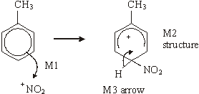
horseshoe must not extend beyond C2 to C6 but can be smaller
+ must not be too close to Cl
3

(b) Sn or Fe / HCl (conc or dil or neither)
or Ni / H₂ not NaBH₄ LiAlH₄
1

(c) (i) NH₃
1
Use an excess of ammonia
1
(ii) nucleophilic substitution
1
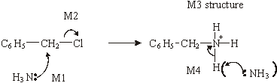
4

(d) lone pair on N less available (in correct context)
1
delocalised into the ring (Q of L)
1

(e)
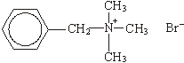

ignore Br
+ must be on N or outside a
square bracket
1

(f)
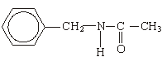
1
[19]

M6. (a) electrophilic substitution;
1
cone HNO₃;
1
cone H₂SO₄ either or both cone missing scores one for both acids;
1

(b) Sn or Fe/HCl (cone or dil or neither);
(ignore extra NaOH)
1
Sn or Fe/H₂SO₄ (dil or neither)
(not HNO₃ at all)
or H₂/Ni
(not NaBH₄/ LiAlH₄ or Na/C₂H₅OH)
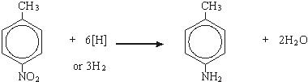
1

(c) 77 or 92;
1

(d)
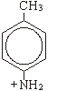
1
(allow -NH₃⁺)

(e) G
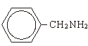
1
H
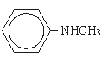
1
[9]

M7. (a) dimethylamine
1

(b) nucleophilic substitution
1
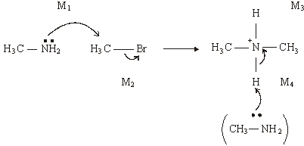
4

(c) quaternary ammonium salt
1
(cationic) surfactant / bactericide / detergent / fabric softener or
conditioner/hair conditioner
1

(d)
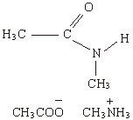

(allow CH₃COOH or CH₃COO– NH₄⁺)
2
[10]

M8. (a) (i) CH₃CH=CHCH₃
1
Addition or radical (QoL)
1

(ii) CH₃CH(OH)CH(OH)CH₃ or with no brackets
1
butan(e)–2,3–diol or 2,3–butan(e)diol
1
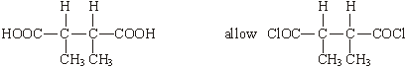
1
2,3–dimethylbutan(e)dioic acid 2,3–dimethylbutan(e)dioyl chloride
ignore –1,4–
1
condensation (QoL)
1

(iii) NaOH or HCl etc or Na₂CO₃
Allow conc sulphuric/nitric
NOT water nor acidified water nor weak acids
1

(b) Structure 1
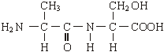

Allow –CONH– and –COHN–
Allow zwitterions
NOT polypeptides/repeating units
1
Structure 2 either of
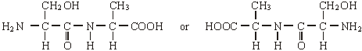
1

(c) (i) CH₃CH₂CH₂Br
allow –Cl, –I
1
(ii) CH₃CH₂CN
1

(iii) (nucleophilic) substitution or from CH₃CH₂CH₂Br
if reduction written here, no further marks
1
further substitution/reaction occurs or other products are formed
Allow reduction forms only one product
1
one of
(CH₃CH₂CH₂)₂NH
(CH₃CH₂CH₂)₃N
(CH₃CH₂CH₂)₄N⁺ Br–
Allow salts including NH₄Br
Allow HBr
1
[15]

M9. (a) (i)
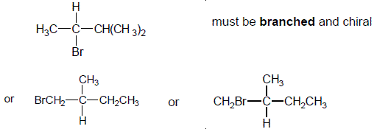
not allow C₃H₇
allow C₂H₅ bonded to C either way round
1

(ii) elimination
allow base – elimination
but penalise any other qualification
1

(iii) Z-pent-2-ene or cis-pent-2-ene either Z or cis is necessary
(allow Z-2-pentene or cis-2-pentene)
with or without brackets around Z
with or without hyphens
1

(b) (i) C
1
(ii) A
1
(iii) B
1
(iv) D
1

(c)
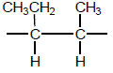
allow C₂H₅ bonded via C or H
must have both trailing bonds
ignore brackets or n
1
addition or radical or step or chain growth
QOL not additional
1

(d) (i)
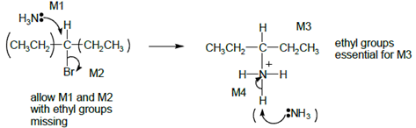
Allow SN1, i.e M2 first then attack of NH₃ on carbocation.
Allow C₂H₅ in M3 bonded either way
Allow with or without NH₃ to remove H⁺ in M4, but lose mark if Br– used.
ignore δ+ or δ– unless wrong
+ on central C instead of δ + loses M2
4

(ii) excess NH₃
ignore reflux
allow conc ammonia in sealed tube
1

(iii)
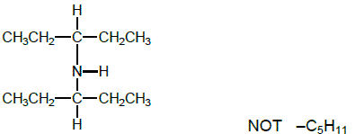
Allow C₂H₅ bonded either way
1

(e) (i)
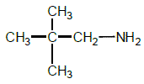
1

(ii)
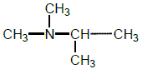
NOT (C₂H₅)₂NCH₃ which is tertiary with 3 peaks but its spectrum has no doublet.
1
[17]

M10. (a) diethylamine OR ethyl ethanamine OR ethyl aminoethane
ignore N–
1

(b) For (b) and (c)
There are three valid routes for this synthesis called
Routes A, B and C below
• Decide which route fits the answer best (this may not be the
best for part b) to give the candidate the best possible overall mark.
• Mark part (b)
• For this best route mark the mechanism and reagent independently
• Migration from one route to another is not allowed
• Either name or formula is allowed in every case.
• Ignore conditions unless they are incorrect.

 | Route A | Route B | Route C
F | CH₃CH₂Br or CH₃CH₂Cl | C₂H₆ | CH₃CH₂OH | 1
G | CH₃CH₂NH₂ ethylamine OR ethanamine OR aminoethane | CH₃CH₂Br OR  CH₃CH₂Cl | CH₃CH₂Br OR  CH₃CH₂Cl | 1

(c)
 |  | Route A | Route B | Route C
Step 1 | Reagent(s) | HBr OR HCl | H₂/Ni (Not NaBH₄) | H₂O & H₃PO₄ OR  H₂O & H₂SO₄ | 1
 | Mechanism | Electrophilic addition | addition (allow electrophilic OR catalytic but not nucleophilic) ignore hydrogenation | Electrophilic addition | 1

Step 2 | Reagent(s) | NH₃ | Cl₂ OR Br₂ | HBr OR KBr & H₂SO₄ OR PCl₃ OR PCl₅ OR SOCl₂ | 1
 | Mechanism | Nucleophilic substitution | (free) radical substitution | Nucleophilic substitution | 1

Step 3 | Reagent(s) | CH₃CH₂Br OR CH₃CH₂Cl | CH₃CH₂NH₂ OR NH₃ but penalise excess ammonia here | CH₃CH₂NH₂  OR NH₃ but penalise excess ammonia here | 1
 | Mechanism | Nucleophilic substitution | Nucleophilic substitution | Nucleophilic substitution | 1

(d) tertiary amine OR triethylamine OR (CH₃CH₂)₃N
Quaternary ammonium salt
OR tetraethylammonium bromide OR chloride OR ion
OR (CH₃CH₂)₄N⁺ (Br– OR Cl–)
1
further substitution will take place OR
diethylamine is a better nucleophile than ethylamine
1
[11]

M11. (a) M1 Benzene is more stable than cyclohexatriene
more stable than cyclohexatriene must be stated or implied
If benzene more stable than cyclohexene, then penalise M1 but mark on
If benzene less stable: can score M2 only
1
M2 Expected ΔH^{ο} hydrogenation of C₆H₆ is 3(–120)
= –360 kJ mol⁻¹
Allow in words e.g. expected ΔH^{ο} hydrog is three times the ΔH^{ο} hydrog of cyclohexene
1

M3 Actual ΔH^{ο} hydrogenation of benzene is
152 kJ mol⁻¹ (less exothermic)
or 152 kJ mol⁻¹ different from expected
Ignore energy needed
1
M4 Because of delocalisation or electrons spread out or resonance
1

(b) No mark for name of mechanism
Conc HNO₃
If either or both conc missing, allow one;
1
Conc H₂SO₄
this one mark can be gained in equation
1
2 H₂SO₄ + HNO₃ → 2 HSO₄– + NO₂⁺ + H₃O⁺
OR
H₂SO₄ + HNO₃ → HSO₄– + NO₂⁺ + H₂O
OR via two equations
H₂SO₄ + HNO₃ → HSO₄– + H₂NO₃⁺
H₂NO₃+ → NO₂⁺ + H₂O
Allow + anywhere on NO₂⁺
1

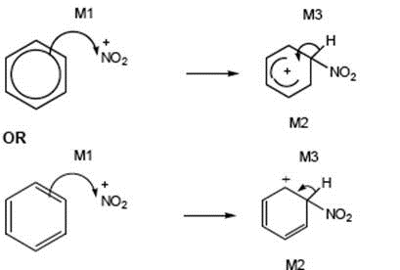
M1 arrow from within hexagon to N or + on N
Allow NO₂⁺ in mechanism
horseshoe must not extend beyond C2 to C6 but can be smaller
+ not too close to C1
M3 arrow into hexagon unless Kekule
allow M3 arrow independent of M2 structure
ignore base removing H in M3
+ on H in intermediate loses M2 not M3
3

(c) If intermediate compound V is wrong or not shown, max 4 for 8(c)
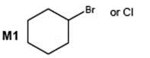
or chlorocyclohexane or bromocyclohexane
1

Reaction 3
M2 HBr
1
M3 Electrophilic addition
Allow M2 and M3 independent of each other
1

Reaction 4
M4 Ammonia if wrong do not gain M5
1
Allow M4 and M6 independent of each other
M5 Excess ammonia or sealed in a tube or under pressure
1
If CE e.g. acid conditions, lose M4 and M5
M6 Nucleophilic substitution
1

(d) Lone or electron pair on N
No marks if reference to “lone pair on N” missing
1
Delocalised or spread into ring in U
1
Less available (to accept protons) or less able to donate (to H⁺)
1
[19]

M12. (a) (i)
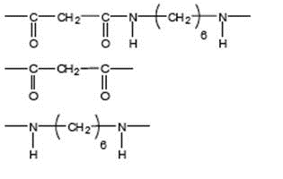
Allow –CONH- or - COHN -
Mark two halves separately
lose 1 each for missing trailing bonds at one or both ends or error in peptide link or either or both of H or OH on ends
1
Not allow –(C₆H₁₂)–
Ignore n
1

(ii) M1 in polyamides - H bonding
1
M2 in polyalkenes - van der Waals forces
Penalise forces between atoms or van der Waals bonds
1
M3 Stronger forces (of attraction) in polyamides
Or H bonding is stronger
(must be a comparison of correct forces to score M3)
Do not award if refer to stronger bonds
1

(b) (i) (nucleophilic) addition elimination
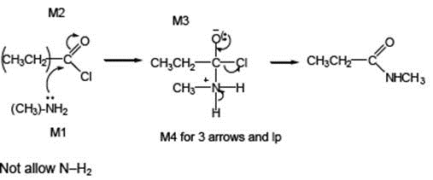

Minus sign on NH₂ loses M1
1
M2 not allowed independent of M1, but allow M1 for correct attack on C+
+ rather than + on C=O loses M2
If Cl lost with C=O breaking, max 1 for M1
M3 for correct structure with charges but
lp on O is part of M4
only allow M4 after correct/ very close M3
For M4, ignore NH₃ removing H⁺ but lose
M4 for Cl removing H⁺ in mechanism,
but ignore HCl as a product
4
(ii) N-methylpropanamide
Not N-methylpropaneamide
1

(c)
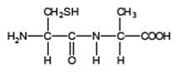
Allow –CONH– or –COHN–
1

(d) (i) 2-amino-3-hydroxypropanoic acid
1
(ii)
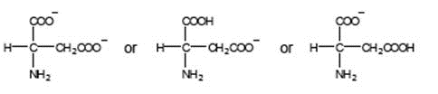
Must be salts of aspartic acid
allow –CO₂–
allow NH₂–
1

(iii) Penalise use of aspartic acid once in d(iii) and d(iv)
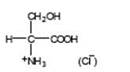
allow –CO₂H
allow ⁺NH₃–
don’t penalize position of + on NH₃
1

(iv) Penalise use of aspartic acid once in d(iii) and d(iv)
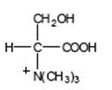(Br–)

allow –CO₂–
must show C-N bond
don’t penalize position of + on N(CH₃)₃
1
[16]

M13.(a) (nucleophilic) addition-elimination
1
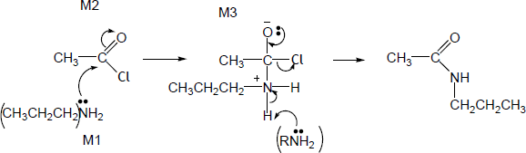
M4 for 3 arrows and lp
Allow wrong amine in M1 but penalise in M3
Allow C₃H₇ in M3
Minus sign on NH₃ loses M1 (but not M4 if NH₃ also shown here)
• Allow attack by: NH₂CH₂CH₂CH₃
• M2 not allowed independent of M1, but allow M1 for correct attack on C⁺
• + rather than δ+ on C=O loses M2
• If Cl lost with C=O breaking, max 1 for M1
• M3 for correct structure with charges but lone pair on O is part of M4
• 3 arrows in M4 can be shown in two separate steps.
• If M3 drawn twice, mark first answer eg ignore missing + if missed off second structure
• Only allow M4 after correct / very close M3
• For M4, ignore RNH₂ removing H⁺ but lose M4 for Cl– removing H⁺ in mechanism,
• but ignore HCl shown as a product.
4

N-propylethanamide must be this name even if wrong amine used
NOT N-propylethaneamide
1

(b) (i)
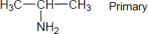
Not allow ambiguous C₃H₇NH₂
BEWARE No mark for the original amine CH₃CH₂CH₂NH₂
Label and structure must both be correct for each type to score the mark.
1

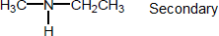
Allow C₂H₅
Penalize wrong number of carbons but otherwise correct, first time only.
1

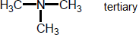
1

(ii) Absorption at 3300−3500 (cm⁻¹) in spectrum
Allow trough, peak, spike.
Ignore absorption at 750 − 1100 for C–C bond in secondary - this is within fingerprint region.
Allow any number in this range.
If range missing, no further marks.
If range linked to tertiary, no further marks.
1

N–H (bond) (only) present in secondary amine or not present in tertiary amine
OR
This peak or N–H absorption (only) present in spectrum of secondary amine or not present in spectrum of tertiary amine
1

(c) (i) M1 Route A: stage 1 KCN
Apply list principle for extra reagents or catalysts
NOT HCN NOT KCN / acid Not KCN / HCN
1

M2 Aqueous or ethanolic
M2 only scores after correct M1
ignore warm; acid here loses M1 & M2
1

M3 Route A Intermediate CH₃CH₂CN or propanenitrile
If M3 intermediate wrong, max 2 for M1 & M2 ie no mark for stage 2
Name alone must be exactly correct to gain M1 but mark on if name close
But if M3 intermediate close, eg “nitrile” or wrong nitrile, can award marks in stage 2
correct formula gains M1 (ignore name if close)
If stage 1 correct and intermediate is missing, can award marks in stage 2
contradiction of name and formula loses mark
stage 1 wrong & intermediate missing, no marks.
1
M4 Route A: stage 2 H₂
H loses M4 but mark on
LiAlH₄
Apply list principle for extra reagents or catalysts.
M5 only scores after correct M4
Not NaBH₄ not Sn or Fe / HCl
Allow (dil) acid after but not with LiAlH₄
Penalise conc acid.
1

M5 Ni or Pt or Pd
ether
1

M6 Route B NH₃
With acid loses M6 & M7
Apply list principle for extra reagents or catalysts.
1

M7 Excess NH₃
Ignore conc, ignore high P, ignore solvent.
1

(ii) Route A disadv Toxic / poisonous KCN or cyanide or CN⁻ or HCN
Expensive LiAlH₄
ignore acidified
OR lower yield because 2 steps
Allow H₂ flammable / explosive etc.
Not just dangerous.
Ignore time reasons.
1

Route B disadv Further reaction / substitution likely
Allow impure product.
1
[20]

