Questions
Q1.
For a given initial reactant pressure, the half-life for a first order gaseous reaction was found to be 30 minutes.
If the experiment were repeated at half the initial reactant pressure, the half-life would be
A 15 minutes.
B 30 minutes.
C 45 minutes.
D 60 minutes.
(Total for question = 1 mark)

Q2.
To determine the activation energy (E_{a}) for a reaction, the variation of reaction rate with temperature is investigated.
The rate constant, k, for the reaction is related to the absolute temperature, T, by the expression
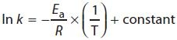
where R is the gas constant.
The activation energy for the reaction could be obtained by plotting a graph of
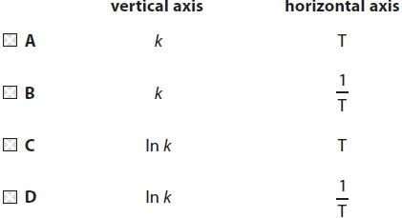
(Total for question = 1 mark)

Q3.
Four sketch graphs are shown below.
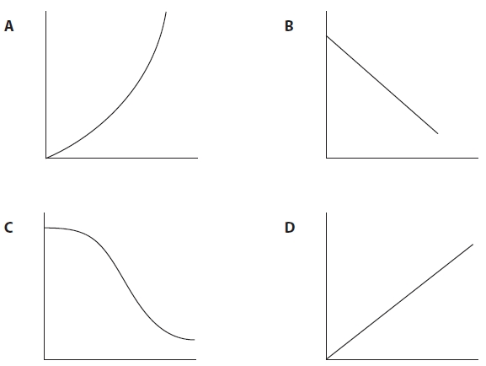
(a) Which could be a graph of the concentration of a reactant, on the vertical axis, against time for a zero order reaction?
(1)
A
B
C
D
(b) Which could be a graph of rate of reaction, on the vertical axis, against the concentration of a reactant for a first order reaction?
(1)
A
B
C
D
(c) Which could be a graph of rate of reaction, on the vertical axis, against the square of the concentration of a reactant for a second order reaction?
(1)
A
B
C
D
(d) Which could be a graph of the concentration of a reactant, on the vertical axis, against time for a reaction which is catalysed by a product?
(1)
A
B
C
D

(Total for question = 4 marks)

Q4.
Four sketch graphs are shown below.
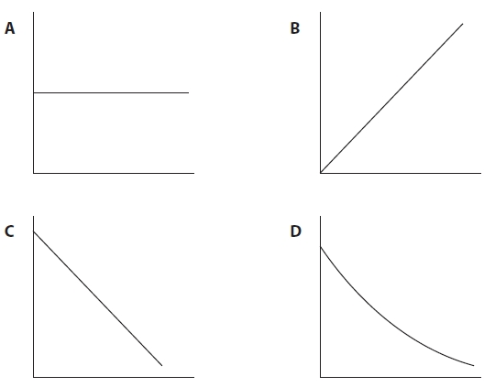
(a) Which could be a graph of rate of reaction, on the vertical axis, against the concentration of a reactant for a zero order reaction?
(1)
A
B
C
D
(b) Which could be a graph of rate of reaction, on the vertical axis, against the square of the concentration of a reactant for a second order reaction?
(1)
A
B
C
D
(c) Which could be a graph of the concentration of a reactant, on the vertical axis, against time for a first order reaction?
(1)
A
B
C
D
(d) Which could be a graph of ln(rate), on the vertical axis, against reciprocal of temperature, 1/T, for a reaction?
You may use the equation ln(rate) = 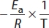 + constant
(1)
A
B
C
D

(Total for question = 4 marks)

Q5.
The first stage in the manufacture of nitric acid is the oxidation of ammonia:
4NH₃(g) + 5O₂(g) 4NO(g) + 6H₂O(g) ΔH = −906 kJ mol⁻¹
(a) In modern industrial plants this reaction is carried out at a pressure of around 3 atm. Which of the following statements is incorrect? The raised pressure
(1)

A helps push the reactants through the reactor.
B shifts the position of equilibrium to the right.
C increases the cost of the reactor.
D increases the energy cost of this part of the process.
(b) A platinum-rhodium alloy catalyst is used in this reaction. Which of the following statements is incorrect? The catalyst
(1)

A lowers the activation energy of the reaction.
B has no effect on the equilibrium constant for the reaction.
C alters the enthalpy change of the reaction.
D reduces the energy cost of this part of the process.
(c) The operating temperature of this reaction is about 900°C. The use of a high temperature
(1)

A increases the rate of the reaction and the equilibrium yield.
B increases the rate of the reaction and decreases the equilibrium yield.
C decreases the rate of the reaction and the equilibrium yield.
D decreases the rate of the reaction and increases the equilibrium yield.
(Total for Question = 3 marks)

Q6.
Which of the following changes will lead to the greatest increase in the rate of the
following endothermic reaction?
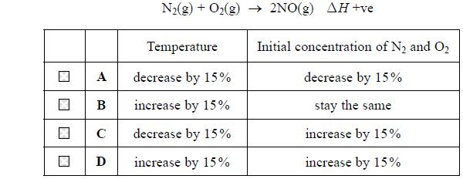
(Total for question = 1 mark)

Q7.
The equation below shows the hydrolysis of a bromoalkane.
RBr + OH⁻ ROH + Br⁻
For a particular bromoalkane, the rate equation is
rate = k[RBr]
The bromoalkane, RBr, is most likely to be
A CH₃Br
B CH₃CH₂Br
C (CH₃)₃CCH₂Br
D (CH₃)₃CBr
(Total for question = 1 marks)

Q8.
Propanone reacts with iodine in acidic solution as shown in the equation below.
The rate equation for the reaction is
(a) The most appropriate technique to investigate the rate of this reaction is
(1)
A titrating samples of reaction mixture with acid.
B measurement of optical activity.
C measurement of the volume of gas given off.
D colorimetry.
(b) Which statement about the reaction is not correct?
(1)
A The overall order of reaction is second order.
B The units of the rate constant are dm³ mol⁻¹ s⁻¹.
C The rate constant increases with temperature.
D The rate increases four times when the concentration of propanone and iodine
are both doubled.
(c) The reaction is carried out using a large excess of both propanone and acid.
Which of the graphs below shows the change of iodine concentration with time?
(1)
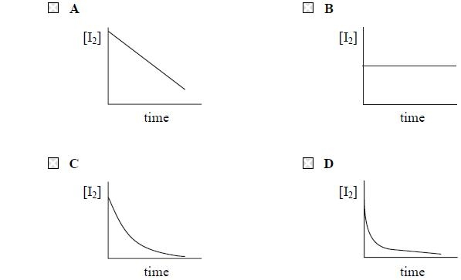
(Total for question = 3 marks)

Q9.
Which of the following methods would not be suitable for measuring the rate of the reaction between methanoic acid and bromine?
HCOOH(aq) + Br₂(aq) 2H⁺(aq) + 2Br⁻(aq) + CO₂(g)
A Colorimetry
B Measuring change in electrical conductivity
C Quenching samples and titrating with acid
D Measuring change in pressure
(Total for question = 1 marks)

Q10.
Methods for investigating reaction rates include
A colorimetry.
B measurement of change in volume.
C measurement of change of mass.
D quenching followed by titrating with acid.
Which method would be most suitable to investigate the rate of the following reactions?
(a) HCOOCH₃(aq) + NaOH(aq) → HCOONa(aq) + CH₃OH(aq)
(1)
A
B
C
D
(b) (CH₃)₂CCH₂(g) + HI(g) → (CH₃)₃CI(g)
(1)
A
B
C
D
(c) BrO₃⁻(aq) + 5Br⁻(aq) + 6H⁺(aq) → 3Br₂(aq) + 3H₂O(l)
(1)
A
B
C
D
(Total for question = 3 marks)

Q11.
2H₂(g) + 2NO(g) → 2H₂O(g) + N₂(g)
This reaction is first order with respect to hydrogen and second order with respect to nitrogen(II) oxide.
By what factor will the initial rate increase if the concentration of hydrogen and nitrogen(II) oxide are both tripled?
A 3
B 9
C 12
D 27
(Total for question = 1 mark)

Q12.
Which of the following graphs shows that a reaction is first order with respect to
reactant X?
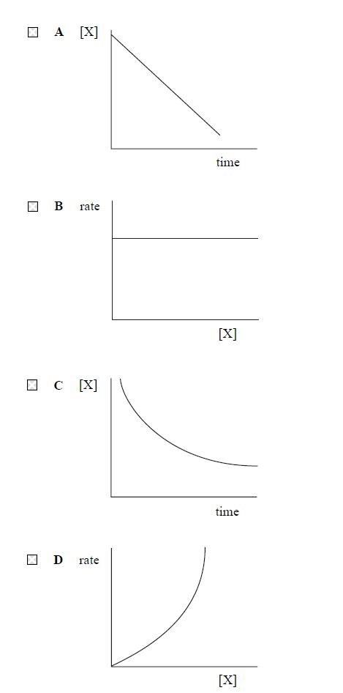
(Total for question = 1 mark)

Q13.
A reaction has the rate equation rate = k[X][Y]²[Z]. The concentrations of each reactant are shown in the table below.
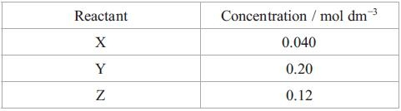
(a) If the rate of reaction under these conditions has a value of 0.24 mol dm ⁻³ s⁻¹, then the numerical value of k is
(1)
A 0.00080
B 0.533
C 1.875
D 1250
(b) The units for the rate constant, k, are
(1)
A mol⁻³ dm⁹ s⁻¹
B mol³ dm⁹ s⁻¹
C mol⁻³ dm⁻⁹ s⁻¹
D mol³ dm⁻⁹ s⁻¹
(Total for question = 2 marks)

Q14.
The rate equation for the reaction between hydrogen gas and nitrogen monoxide gas is
rate = k[NO]²[H₂]
If the concentration of both reactants is doubled, the rate will increase by a factor of
A 3
B 4
C 6
D 8
(Total for question = 1 mark)

Q15.
A halogenoalkane, RX, reacts with hydroxide ions, OH⁻, to form an alcohol.
RX + OH⁻ → ROH + X⁻
The rate equation for the reaction is rate = k[RX]. Which of these statements is incorrect?
A Rate [RX].
B RX is a a primary halogenoalkane.
C The reaction mechanism is S_{N}1.
D A carbocation intermediate forms in the reaction.
(Total for question = 1 mark)

Q16.
Methods for investigating reaction rates include
A colorimetry
B collecting and measuring the volume of a gas
C quenching, followed by titration with acid
D quenching, followed by titration with iodine solution.
Which method would be most suitable to investigate the rate of the following reactions?
(a) H₂O₂(aq) + 2I⁻(aq) + 2H⁺(aq) → 2H₂O(l) + I₂(aq)
(1)
A
B
C
D
(b) C₄H₉Br(l) + OH⁻(aq) → C₄H₉OH(l) + Br⁻(aq)
(1)
A
B
C
D
(Total for question = 2 marks)

Q17.
The overall equation for a reaction between two chemicals, M and N, is
M + 2N → P + Q
(a) This reaction occurs spontaneously at room temperature. Which of the following must be true?
(1)

A ΔH is positive.
B ΔH is negative.
C ΔS is positive.
D ΔS is negative.
(b) The reaction above occurs in two stages via an intermediate, T.
M + N → T slow
N + T → P + Q fast
From this it can be deduced that the rate equation for the reaction between M and N is
(1)

A rate = k[M][N]
B rate = k[M][N]²
C rate = k[M][T]
D rate = k[N][T]
(Total for Question = 2 marks)

Mark Scheme
Q1.

Q2.

Q3.
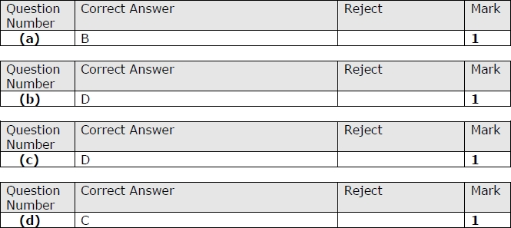

Q4.
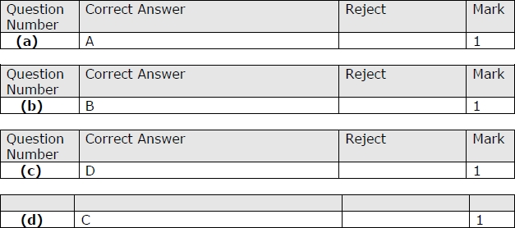

Q5.
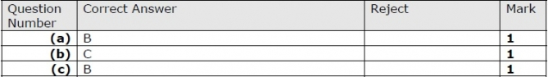

Q6.

Q7.

Q8.

Q9.

Q10.

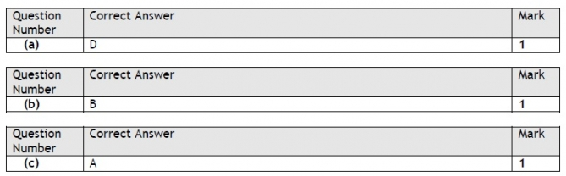

Q11.

Q12.

Q13.
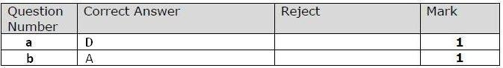

Q14.
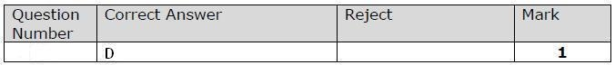

Q15.
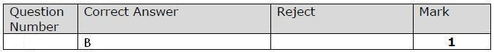

Q16.

Q17.

