Q1. (a) Synthetic polyamides are produced by the reaction of dicarboxylic acids with compounds such as H₂N(CH₂)₆NH₂
(i) Name the compound H₂N(CH₂)₆NH₂
.............................................................................................................

(ii) Give the repeating unit in the polyamide nylon 6,6.
.............................................................................................................
(2)

(b) Synthetic polyamides have structures similar to those found in proteins.
(i) Draw the structure of 2-aminopropanoic acid.

(ii) Draw the organic product formed by the condensation of two molecules of 2-aminopropanoic acid.

(2)

(c) Compounds like H₂N(CH₂)₆NH₂ are also used to make ionic compounds such as X, shown below.
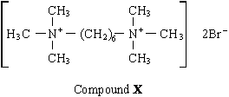
(i) X belongs to the same type of compound as (CH₃)₄N⁺Br–
Name this type of compound.
.............................................................................................................

(ii) State a reagent which could produce X from H₂N(CH₂)₆NH₂ and give a necessary condition to ensure that X is the major product.
Reagent .............................................................................................
Condition ............................................................................................

(iii) Name the mechanism involved in this reaction to form X.
.............................................................................................................
(4)
(Total 8 marks)

Q2.(a) Compound C, H₂N(CH₂)₄NH₂, can be synthesised from ethene in three steps as shown below.
Step 1 Step 2 Step 3
Ethene Compound Compound Compound
addition A substitution B C
reaction reaction C₄H₄N₂ H₂N(CH₂)₄NH₂
Name compound C and draw a structure for each of compounds A and B.
State the reagent(s) required for each step and name the type of reaction involved in the conversion of B into C.
(7)

(b) Draw the repeating unit of the polyamide formed when C reacts with hexanedioic acid. Discuss the interactions between the chains of the polyamide.
(4)

(c) Explain why polyamides are degraded by sodium hydroxide whereas polymers such as poly(ethene) are not.
(3)
(Total 14 marks)

Q3. (a) The hydrocarbon M has the structure shown below.
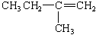
(i) Name hydrocarbon M.
.............................................................................................................

(ii) Draw the repeating unit of the polymer which can be formed from M. State the type of polymerisation occurring in this reaction.
Repeating unit

Type of polymerisation ........................................................................

(iii) The reaction between M and benzene in the presence of HCl and AlCl₃ is similar to the reaction between ethene and benzene under the same conditions. Name the type of mechanism involved and draw the structure of the major product formed in the reaction between M and benzene.
Name of mechanism ...........................................................................
Major product

(iv) Draw a structural isomer of M which shows geometrical isomerism.

(6)

(b) Draw the repeating unit of the polymer formed by the reaction between butanedioic acid and hexane-1,6-diamine. State the type of polymerisation occurring in this reaction and give a name for the linkage between the monomer units in this polymer.
Repeating unit

Type of polymerisation ................................................................................
Name of linkage ...........................................................................................
(4)
(Total 10 marks)

Q4. (a) Consider the following amino acid.
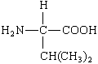
(i) Draw the structure of the amino acid species present in a solution at pH 12.

(ii) Draw the structure of the dipeptide formed from two molecules of this amino acid.

(iii) Protein chains are often arranged in the shape of a helix. Name the type of interaction that is responsible for holding the protein chain in this shape.
.............................................................................................................
(3)

(b) Consider the hydrocarbon G, (CH₃)₂C=CHCH₃, which can be polymerised.
(i) Name the type of polymerisation involved and draw the repeating unit of the polymer.
Type of polymerisation ........................................................................

Repeating unit

(ii) Draw the structure of an isomer of G which shows geometrical isomerism.

(iii) Draw the structure of an isomer of G which does not react with bromine water.

(4)
(Total 7 marks)

Q5. (a) The compound H₂C=CHCN is used in the formation of acrylic polymers.
(i) Draw the repeating unit of the polymer formed from this compound.

(ii) Name the type of polymerisation involved in the formation of this polymer.
.............................................................................................................
(2)

(b) When the dipeptide shown below is heated under acidic conditions, a single amino acid is produced.
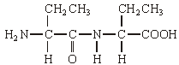
(i) Name this amino acid.
.............................................................................................................

(ii) Draw the structure of the amino acid species present in the acidic solution.

(2)

(c) The repeating unit of a polyester is shown below.
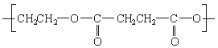
(i) Deduce the empirical formula of the repeating unit of this polyester.
.............................................................................................................

(ii) Draw the structure of the acid which could be used in the preparation of this polyester and give the name of this acid.

Structure ..............................................................................................
Name ...................................................................................................

(iii) Give one reason why the polyester is biodegradable.
.............................................................................................................
.............................................................................................................
(4)
(Total 8 marks)

Q6. Tetrafluoroethene, C₂F₄, is obtained from chlorodifluoromethane, CHClF₂, according to the equation:
2CHClF₂(g) C₂F₄(g) + 2HCl(g) ΔH^{ο} = +128kJ mol^{–1}
(a) A 1.0 mol sample of CHClF₂ is placed in a container of volume 18.5 dm³ and heated.
When equilibrium is reached, the mixture contains 0.20 mol of CHClF₂
(i) Calculate the number of moles of C₂F₄ and the number of moles of HCl present at equilibrium.
Number of moles of C₂F₄ ...................................................................
Number of moles of HCl .....................................................................

(ii) Write an expression for K_{c} for the equilibrium.

.............................................................................................................

(iii) Calculate a value for K_{c} and give its units.
Calculation ..........................................................................................
.............................................................................................................
.............................................................................................................
.............................................................................................................
Units ....................................................................................................
(6)

(b) (i) State how the temperature should be changed at constant pressure to increase the equilibrium yield of C₂F₄
.............................................................................................................
(ii) State how the total pressure should be changed at constant temperature to increase the equilibrium yield of C₂F₄
.............................................................................................................
(2)

(c) C₂F₄ is used to manufacture the polymer polytetrafluoroethene, PTFE. Name the type of polymerisation involved in the formation of PTFE.
......................................................................................................................
(1)
(Total 9 marks)

Q7. The amino acid alanine is shown below.
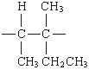
(a) A sample of alanine is dissolved in water.
(i) Draw the structure of the main alanine species present in this aqueous solution and give the name of this type of species.
Structure

Type of species .................................................................................

(ii) Draw the structure of the alanine species formed when an excess of hydrochloric acid is added to the solution.

(3)

(b) Alanine molecules may be reacted together to form a polypeptide. Give the repeating unit of this polypeptide and name the type of polymerisation involved in its formation.
Repeating unit

Type of polymerisation .......................................................................
(2)

(c) The repeating unit of a polyalkene is shown below.
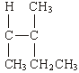
Give the name of the alkene which is used to form this polymer.
......................................................................................................................
(1)
(Total 6 marks)

Q8. (a) The structure below shows the repeating unit of a polymer.
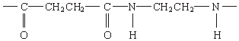
By considering the functional group formed during polymerisation, name this type of polymer and the type of polymerisation involved in its formation.
Type of polymer ...........................................................................................
Type of polymerisation .................................................................................
(2)

(b) Draw the structure of the species present in solid aminoethanoic acid, H₂NCH₂COOH

(1)

(c) Explain why the melting point of aminoethanoic acid is much higher than that of hydroxyethanoic acid, HOCH₂COOH
......................................................................................................................
......................................................................................................................
......................................................................................................................
(2)
(Total 5 marks)

Q9. (a) The repeating units of two polymers, P and Q, are shown below.
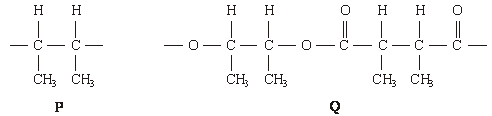
(i) Draw the structure of the monomer used to form polymer P. Name the type of polymerisation involved.
Structure of monomer

Type of polymerisation .......................................................................

(ii) Draw the structures of two compounds which react together to form polymer Q. Name these two compounds and name the type of polymerisation involved.
Structure of compound 1

Name of compound 1 .........................................................................
Structure of compound 2

Name of compound 2 ........................................................................
Type of polymerisation .......................................................................

(iii) Identify a compound which, in aqueous solution, will break down polymer Q but not polymer P.
.............................................................................................................
(8)

(b) Draw the structures of the two dipeptides which can form when one of the amino acids shown below reacts with the other.
Structure 1 Structure 2
(2)

(c) Propylamine, CH₃CH₂CH₂NH₂, can be formed either by nucleophilic substitution or by reduction.
(i) Draw the structure of a compound which can undergo nucleophilic substitution to form propylamine.

(ii) Draw the structure of the nitrile which can be reduced to form propylamine.

(iii) State and explain which of the two routes to propylamine, by nucleophilic substitution or by reduction, gives the less pure product. Draw the structure of a compound formed as an impurity.
Route giving the less pure product .....................................................
Explanation .........................................................................................
.............................................................................................................
Structure of an impurity

(5)
(Total 15 marks)

Q10. Fibres are made from natural and from synthetic polymers. Both types of polymer have advantages and disadvantages.
(a) Amino acids are the building blocks of naturally-occurring polymers called proteins.
Consider the following amino acid.
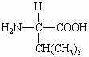
(i) Draw the structure of the amino acid species present in a solution at pH 12.

(ii) Use your understanding of amino acid chemistry to deduce the structure of the dipeptide formed from two molecules of this amino acid and illustrate your answer with a sketch showing the structure of the dipeptide.

(iii) Protein chains are often arranged in the shape of a helix. Name the type of interaction that is responsible for holding the protein chain in this shape.
.............................................................................................................
(3)

(b) Alkenes are the building blocks of synthetic addition polymers.
Consider the hydrocarbon G, (CH₃)₂C=CHCH₃, which can be polymerised.
(i) Draw the repeating unit of the polymer.

(ii) Draw the structure of an isomer of G which shows E-Z isomerism.

(iii) Draw the structure of an isomer of G which does not react with bromine water.

(3)

(c) Draw the repeating unit of the polymer formed by the reaction between butanedioic acid and hexane-1,6-diamine.

(2)

(d) Two plastic objects were manufactured, one from the polyalkene represented by the repeating unit in part (b)(i) and the other from the polyamide represented by the repeating unit in part (c).
After use it was suggested that both objects be disposed of as landfill.
(i) Describe an experiment in which you could compare the biodegradability of these two objects.
.............................................................................................................
.............................................................................................................
.............................................................................................................
.............................................................................................................
.............................................................................................................
.............................................................................................................
.............................................................................................................
(3)

(ii) Describe an advantage or a disadvantage of a different method of disposal of such objects compared with landfill.
.............................................................................................................
.............................................................................................................
.............................................................................................................
.............................................................................................................
.............................................................................................................
.............................................................................................................
(3)
(Total 14 marks)

Q11. Haloalkanes are useful compounds in synthesis.
Consider the three reactions of the haloalkane A shown below.
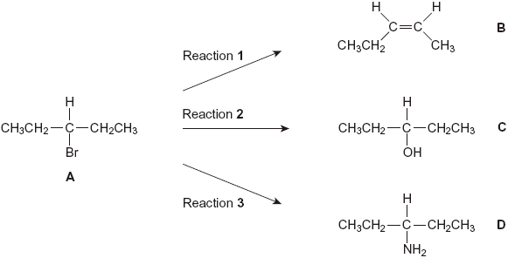
(a) (i) Draw a branched-chain isomer of A that exists as optical isomers.

(1)

(ii) Name the type of mechanism in Reaction 1.
.............................................................................................................
(1)

(iii) Give the full IUPAC name of compound B.
.............................................................................................................
(1)

(b) The infrared spectra shown below are those of the four compounds, A, B, C and D.
Using Table 1 on the Data Sheet, write the correct letter in the box next to each spectrum.
(i)
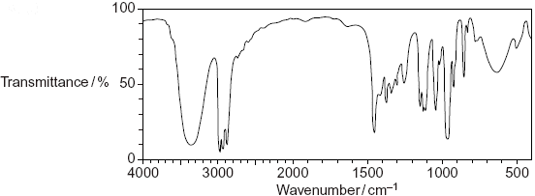

(ii)
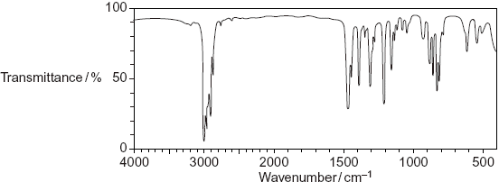

(iii)
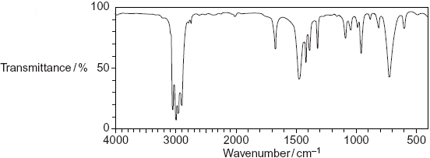

(iv)
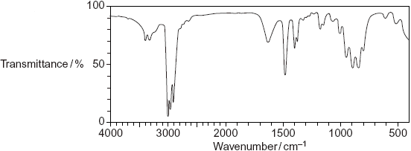

(4)

(c) Draw the repeating unit of the polymer formed by B and name the type of polymerisation involved.
Repeating unit

Type of polymerisation .................................................................................
(2)

(d) (i) Outline a mechanism for Reaction 3.

(4)

(ii) State the conditions used in Reaction 3 to form the maximum amount of the primary amine, D.
.............................................................................................................
(1)

(iii) Draw the structure of the secondary amine formed as a by-product in Reaction 3.

(1)

(e) D is a primary amine which has three peaks in its ¹³C n.m.r. spectrum.
(i) An isomer of D is also a primary amine and also has three peaks in its ¹³C n.m.r. spectrum. Draw the structure of this isomer of D.

(1)

(ii) Another isomer of D is a tertiary amine. Its ¹H n.m.r. spectrum has three peaks. One of the peaks is a doublet. Draw the structure of this isomer of D.

(1)
(Total 17 marks)

Q12. (a) Name compound Y, HOCH₂CH₂COOH
......................................................................................................................
(1)

(b) Under suitable conditions, molecules of Y can react with each other to form a polymer.
(i) Draw a section of the polymer showing two repeating units.

(1)

(ii) Name the type of polymerisation involved.
.............................................................................................................
(1)

(c) When Y is heated, an elimination reaction occurs in which one molecule of Y loses one molecule of water. The organic product formed by this reaction has an absorption at 1637 cm^{–1} in its infrared spectrum.
(i) Identify the bond that causes the absorption at 1637 cm^{–1} in its infrared spectrum.
.............................................................................................................
(1)

(ii) Write the displayed formula for the organic product of this elimination reaction.

(1)

(iii) The organic product from part (ii) can also be polymerised.
Draw the repeating unit of the polymer formed from this organic product.

(1)

(d) At room temperature, 2-aminobutanoic acid exists as a solid.
Draw the structure of the species present in the solid form.

(1)

(e) The amino acid, glutamic acid, is shown below.
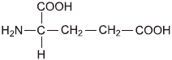
Draw the structure of the organic species formed when glutamic acid reacts with each of the following.
(i) an excess of sodium hydroxide

(1)

(ii) an excess of methanol in the presence of concentrated sulfuric acid

(1)

(iii) ethanoyl chloride

(1)

(f) A tripeptide was heated with hydrochloric acid and a mixture of amino acids was formed. This mixture was separated by column chromatography.
Outline briefly why chromatography is able to separate a mixture of compounds.
Practical details are not required.
......................................................................................................................
......................................................................................................................
......................................................................................................................
......................................................................................................................
......................................................................................................................
......................................................................................................................
(3)
(Total 13 marks)

Q13. Items softened with plasticisers have become an essential part of our modern society.
Compound S, shown below, is commonly known as phthalic acid.
Esters of phthalic acid are called phthalates and are used as plasticisers to soften polymers such as PVC, poly(chloroethene).
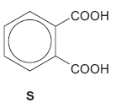
(a) Give the IUPAC name for phthalic acid.
......................................................................................................................
(1)

(b) Draw the displayed formula of the repeating unit of poly(chloroethene).

(1)

(c) The ester diethyl phthalate (DEP) is used in food packaging and in cosmetics.
(i) Complete the following equation showing the formation of DEP from phthalic anhydride.
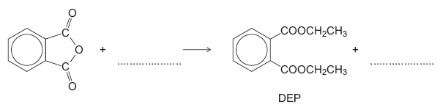
(2)
(ii) Deduce the number of peaks in the ¹³C n.m.r. spectrum of DEP.
.............................................................................................................
(1)

(iii) One of the peaks in the ¹³C n.m.r. spectrum of DEP is at δ = 62 ppm.
Table 3 on the Data Sheet can be used to identify a type of carbon atom responsible for this peak.
Draw a circle around one carbon atom of this type in the structure below.
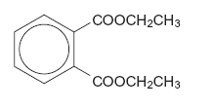
(1)

(d) The mass spectrum of DEP includes major peaks at m/z = 222 (the molecular ion) and at m/z = 177
Write an equation to show the fragmentation of the molecular ion to form the fragment that causes the peak at m/z = 177

......................................................................................................................
(2)

(e) Because of their many uses, phthalates have been tested for possible adverse effects to humans and to the environment.
An organisation that represents the manufacturers of plasticisers asserts that experimental evidence and research findings show that phthalates do not pose a risk to human health because they biodegrade in a short time scale.
According to the organization’s research, phthalates do not represent a risk for humans or for the environment and they are biodegradable.
(i) Hydrolysis of DEP in an excess of water was found to follow first order kinetics.
Write a rate equation for this hydrolysis reaction using DEP to represent the ester.
.............................................................................................................
(1)

(ii) Suggest what needs to be done so that the public could feel confident that the research discussed above is reliable.
.............................................................................................................
.............................................................................................................
.............................................................................................................
.............................................................................................................
.............................................................................................................
(Extra space) .......................................................................................
.............................................................................................................
.............................................................................................................
(2)
(Total 11 marks)

Q14. The amide or peptide link is found in synthetic polyamides and also in naturally
occurring proteins.
(a) (i) Draw the repeating unit of the polyamide formed by the reaction of propanedioic acid with hexane-1,6-diamine.

(2)

(ii) In terms of the intermolecular forces between the polymer chains, explain why polyamides can be made into fibres suitable for use in sewing and weaving, whereas polyalkenes usually produce fibres that are too weak for this purpose.
.............................................................................................................
.............................................................................................................
.............................................................................................................
.............................................................................................................
.............................................................................................................
.............................................................................................................
(Extra space) ......................................................................................
.............................................................................................................
.............................................................................................................
(3)

(b) (i) Name and outline a mechanism for the reaction of CH₃CH₂COCl with CH₃NH₂
Name of mechanism............................................................................
Mechanism

(5)

(ii) Give the name of the product containing an amide linkage that is formed in the reaction in part (b) (i).
.............................................................................................................
(1)

(c) The dipeptide shown below is formed from two different amino acids.
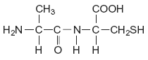
Draw the structure of the alternative dipeptide that could be formed by these two amino acids.

(1)

(d) The amino acids serine and aspartic acid are shown below.
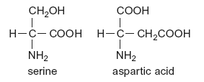
(i) Give the IUPAC name of serine.
.............................................................................................................
(1)

(ii) Draw the structure of the species formed when aspartic acid reacts with aqueous sodium hydroxide.

(1)

(iii) Draw the structure of the species formed when serine reacts with dilute hydrochloric acid.

(1)

(iv) Draw the structure of the species formed when serine reacts with an excess of bromomethane.

(1)
(Total 16 marks)

Q15. (a) Some scientists thought that the waste water from a waste disposal factory contained two sodium halides.
They tested a sample of the waste water.
They added three reagents, one after the other, to the same test tube containing the waste water.
The table below shows their results.

Reagent added | Observations
1. Silver nitrate solution (acidified  with dilute nitric acid) | A cream precipitate formed
2. Dilute ammonia solution | A yellow precipitate remained
3. Concentrated ammonia solution | The yellow precipitate did not dissolve

(i) Identify the yellow precipitate that did not dissolve in concentrated ammonia solution.
Write the simplest ionic equation for the formation of this precipitate from silver ions and the correct halide ion.
Identify the other sodium halide that must be present in this mixture of two sodium halides.
.............................................................................................................
.............................................................................................................
.............................................................................................................
.............................................................................................................
(3)

(ii) Give one reason why the silver nitrate solution was acidified before it was used in this test.
.............................................................................................................
.............................................................................................................
.............................................................................................................
(1)

(iii) The method that the scientists used could not detect one type of halide ion. Identify this halide ion.
Give one reason for your answer.
.............................................................................................................
.............................................................................................................
.............................................................................................................
.............................................................................................................
(2)

(b) The scientists thought that the waste water also contained dissolved barium ions. An aqueous solution of sodium sulfate can be used to test for the presence of dissolved barium ions.
Write the simplest ionic equation for the reaction between barium ions and sulfate ions to form barium sulfate.
State what is observed in this reaction.
Give a use for barium sulfate in medicine and explain why this use is possible, given that solutions containing barium ions are poisonous.
......................................................................................................................
......................................................................................................................
......................................................................................................................
......................................................................................................................
......................................................................................................................
......................................................................................................................
......................................................................................................................
......................................................................................................................
(4)

(c) The scientists also analysed the exhaust gases from an incinerator used to destroy waste poly(ethene).
Mass spectrometry showed that there was a trace gas with a precise M_{r} = 28.03176 in the exhaust gases from the incinerator.
The table below contains some precise relative atomic mass data.

Atom | Precise relative atomic mass
¹²C | 12.00000
¹H | 1.00794
¹⁶O | 15.99491

Use the data to show that the trace gas is ethene. Show your working.
Suggest why both ethene and carbon monoxide might have been identified as the trace gas if the scientists had used relative atomic masses to a precision of only one decimal place.

Write an equation for the incomplete combustion of ethene to form carbon monoxide and water only.
Ethene is used to make poly(ethene).
Draw the displayed formula for the repeating unit of poly(ethene).
Name this type of polymer.
......................................................................................................................
......................................................................................................................
......................................................................................................................
......................................................................................................................
......................................................................................................................
......................................................................................................................
......................................................................................................................
......................................................................................................................
......................................................................................................................
......................................................................................................................
(5)
(Total 15 marks)

Q16.Common substances used in everyday life often contain organic compounds.
(a) State an everyday use for each of the following compounds.
(i) CH₃(CH₂)₁₇COO– Na⁺ ......................................................................
(1)

(ii) CH₃(CH₂)₁₉COOCH₃ ..........................................................................
(1)

(iii) [C₁₆H₃₃N(CH₃)₃]⁺ Br– ..........................................................................
(1)

(b) The following structures are the repeating units of two different condensation polymers.
For each example, name the type of condensation polymer. Give a common name for a polymer of this type.
(i) 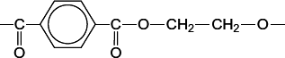
Type of condensation polymer .............................................................
Common name ....................................................................................
(2)

(ii) 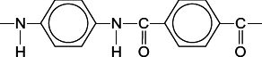
Type of condensation polymer .............................................................
Common name ....................................................................................
(2)

(iii) Explain why the polymer in part (b)(ii) has a higher melting point than the polymer in part (b)(i).
...............................................................................................................
...............................................................................................................
...............................................................................................................
(Extra space) ........................................................................................
...............................................................................................................
(2)

(Total 9 marks)

Q17.Acyl chlorides and acid anhydrides are important compounds in organic synthesis.
(a) Outline a mechanism for the reaction of CH₃CH₂COCl with CH₃OH and name the organic product formed.
Mechanism

Name of organic product ...............................................................................
(5)

(b) A polyester was produced by reacting a diol with a diacyl chloride. The repeating unit of the polymer is shown below.
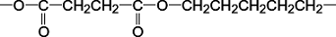
(i) Name the diol used.
...............................................................................................................
(1)

(ii) Draw the displayed formula of the diacyl chloride used.

(1)

(iii) A shirt was made from this polyester. A student wearing the shirt accidentally splashed aqueous sodium hydroxide on a sleeve. Holes later appeared in the sleeve where the sodium hydroxide had been.
Name the type of reaction that occurred between the polyester and the aqueous sodium hydroxide. Explain why the aqueous sodium hydroxide reacted with the polyester.
Type of reaction ....................................................................................
Explanation ...........................................................................................
...............................................................................................................
...............................................................................................................
...............................................................................................................
(3)

(c) (i) Complete the following equation for the preparation of aspirin using ethanoic anhydride by writing the structural formula of the missing product.

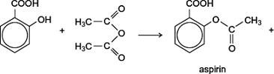 | ......................

(1)

(ii) Suggest a name for the mechanism for the reaction in part (c)(i).
...............................................................................................................
(1)

(iii) Give two industrial advantages, other than cost, of using ethanoic anhydride rather than ethanoyl chloride in the production of aspirin.
Advantage 1 ..........................................................................................
...............................................................................................................
...............................................................................................................
Advantage 2 ..........................................................................................
...............................................................................................................
...............................................................................................................
(2)

(d) Complete the following equation for the reaction of one molecule of benzene-1,2-dicarboxylic anhydride (phthalic anhydride) with one molecule of methanol by drawing the structural formula of the single product
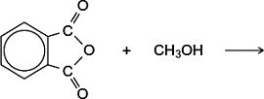
(1)

(e) The indicator phenolphthalein is synthesised by reacting phthalic anhydride with phenol as shown in the following equation.
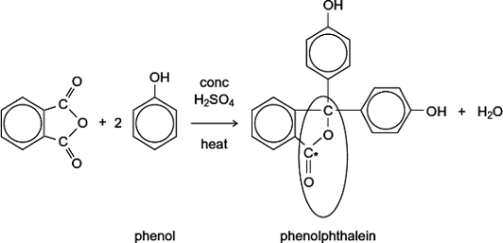
(i) Name the functional group ringed in the structure of phenolphthalein.
...............................................................................................................
(1)

(ii) Deduce the number of peaks in the ¹³C n.m.r. spectrum of phenolphthalein.
...............................................................................................................
(1)

(iii) One of the carbon atoms in the structure of phenolphthalein shown above is labelled with an asterisk (*).
Use Table 3 on the Data Sheet to suggest a range of δ values for the peak due to this carbon atom in the ¹³C n.m.r. spectrum of phenolphthalein.
...............................................................................................................
(1)

(f) Phenolphthalein can be used as an indicator in some acid–alkali titrations.
The pH range for phenolphthalein is 8.3 – 10.0
(i) For each acid.alkali combination in the table below, put a tick () in the box if phenolphthalein could be used as an indicator.

Acid | Alkali | Tick  box ()
sulfuric acid | sodium hydroxide
hydrochloric acid | ammonia
ethanoic acid | potassium hydroxide
nitric acid | methylamine

(2)

(ii) In a titration, nitric acid is added from a burette to a solution of sodium hydroxide containing a few drops of phenolphthalein indicator.
Give the colour change at the end-point.
...............................................................................................................
(1)
(Total 21 marks)

Q18.(a) The tripeptide shown is formed from the amino acids alanine, threonine and lysine.
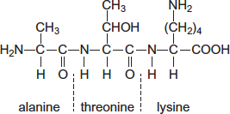
(i) Draw a separate circle around each of the asymmetric carbon atoms in the tripeptide.
(1)

(ii) Draw the zwitterion of alanine.

(1)

(iii) Give the IUPAC name of threonine.
...............................................................................................................
(1)

(iv) Draw the species formed by lysine at low pH.

(1)

(b) The repeating unit shown represents a polyester.
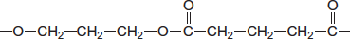
(i) Name this type of polymer.
...............................................................................................................
(1)

(ii) Give the IUPAC name for the alcohol used to prepare this polyester.
...............................................................................................................
(1)

(c) The repeating unit shown represents a polyalkene co-polymer. This co-polymer is made from two different alkene monomers.
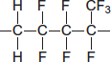
(i) Name the type of polymerisation occurring in the formation of this co-polymer.
...............................................................................................................
(1)

(ii) Draw the structure of each alkene monomer.
Alkene monomer 1 Alkene monomer 2

(2)

(d) One of the three compounds shown in parts (a), (b) and (c) cannot be broken down by hydrolysis.
Write the letter (a), (b) or (c) to identify this compound and explain why hydrolysis of this compound does not occur.
Compound ....................................................................................................
Explanation ....................................................................................................
........................................................................................................................
........................................................................................................................
(2)
(Total 11 marks)

M1. (a) (i) hexane-1,6-diamine or 1,6-diaminohexane (allow ammine)
or 1,6 hexan(e)diamine (1)

(ii) 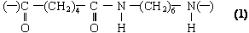
Allow –CONH–
2

(b) (i) 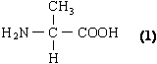

(ii) 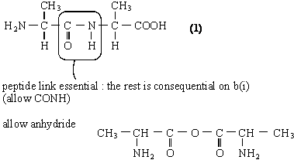
2

(c) (i) quaternary ammonium bromide salt (1)
(not ion, not compound)
Allow quarternery
(ii) Reagent: CH₃Br or bromomethane (1)
penalise CH₃Cl but allow excess for any halomethane
Condition: excess (CH₃Br) (1)
(iii) nucleophilic substitution (1)
4
[8]

M2.(a) 1, 4-diaminobutane or butane -1, 4-diamine (1)
A: BrCH₂CH₂Br or ClCH₂CH₂Cl (1)
B: NC CH₂CH₂CN
Step 1: Br₂ or Cl₂ (1) (ignore aq)
Step 2: KCN (1) (NOT HCN)
Step 3: H₂ / Ni or LiAlH₄ or Na / C₂H₅OH (1) (NOT NaBH₄)
Hydrogenation only for H₂ / Ni, or nucleophilic addition only for LiAlH₄(1)
OR reduction or addition
7

(b) 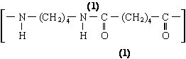
QL hydrogen bonding (1)
Polarity of H-bonding shown or discussed (1)
4

(c) Polyamides / peptide link can be hydrolysed (1)
OR polyalkenes cannot be hydrolysed
QL OH– attacks peptide link or C^{δ+} (1)
poly(ethene) non-polar (1)
3
[14]

M3. (a) (i) 2-methylbut-1-ene (1)
NOT ...butan....
(ii) Repeating unit: 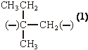or 2 ×
allow C₂H₅
Type of polymerisation: addition or radical (1)

(iii) Name of mechanism: electrophilic substitution (1)
Major product: 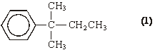
(iv) CH₃CH=CHCH₂CH₃ (1)
6

(b) Repeating unit:
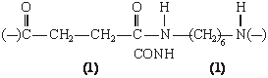
Type of polymerisation: condensation (1)
Name of linkage: (poly)peptide or (poly)amide (1)
allow outer horizontal bonds to be omitted
allow HO–[...........]–H if [......] shows the repeating unit; if brackets missing in the dimer, penalise one
C₂H₄ or C₆H₁₂ first time only
allow CONH
allow polypeptide or polyamide; peptide or amide must be spelled correctly
4

Organic points
(1) Curly arrows: must show movement of a pair of electrons,
i.e. from bond to atom or from lp to atom / space
e.g.

(2) Structures
penalise sticks (i.e. 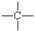) once per paper
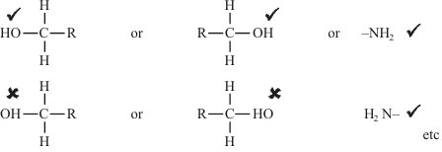
Penalise once per paper
allow CH₃– or –CH₃ or or CH₃
or H₃C–
[10]

M4. (a) (i) 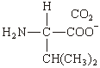 (1)
ignore Na⁺ unless covalently bonded
(ii) 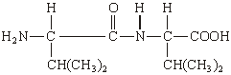 (1)
must be dipeptide, not polymer nor anhydride
allow –CONH– or –COHN–
allow zwitterion
(iii) hydrogen bonding (1)
QL
Allow with dipole-dipole or v derWaals, but not dipole-dipole etc alone
3

(b) (i) Type of polymerisation: addition(al) (1)
Repeating unit: 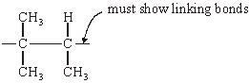 (1)
not multiples
allow n

(ii) CH₃CH=CHCH₂CH₃ (1) C₂H₅
(iii)
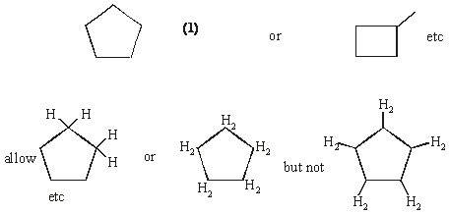
4
[7]

M5. (a) (i)
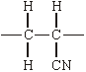
(Ignore n or brackets, but trailing bonds are essential)
1
(ii) Addition or radical
1

(b) (i) 2-aminobutanoic (acid)
1
(ii)
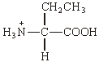
1

(c) (i) C₃H₄O₂
1
(ii)
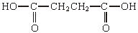
1
(1,4-)butan(e)dioic (acid)
(allow succinic, but not dibutanoic nor butanedicarboxylic acid)
1
(iii) Can be hydrolysed / can react with acid or base or water /
can react with nucleophiles
1
[8]

M6. (a) (i) moles of C₂F₂ = 0.40 mark independently from HC1
1
moles of HC1 = 0.80 not consequential
1

(ii) 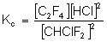
wrong K_{c} means they can only
score for units in (iii) consequ
on their K_{c}
1

(iii) 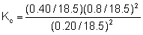
1
= 0.35
1
mol dm^{–3}
1

(b) (i) increase
1
(ii) decrease
1

(c) addition or radical
1
[9]

M7. (a) (i)
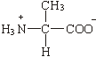
penalise ⁺NH₃— or + on H once per paper
1
zwitterions
1

(ii)
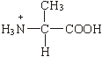
1

(b)
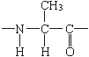

ignore n, but allow one drawn out repeating unit only
1
condensation or (nucleophilic) addition-elimination
1

(c) 3-methylpent-2-ene
1
[6]

M8. (a) polyamide or nylon (2,4)
(allow nylon without numbers but if numbers are present they must be correct)
1
condensation
1
(b)
1

(c) ionic bonding in aminoethanoic acid
(can only score if includes that aminoethanoic is ionic)
1
stronger attractions than Hydrogen bonding in hydroxyethanoic acid
(e.g. stronger Hydrogen bonding in aminoethanoic acid scores 0)
(mention of electrostatic forces between molecules scores 0)
1
[5]

M9. (a) (i) CH₃CH=CHCH₃
1
Addition or radical (QoL)
1

(ii) CH₃CH(OH)CH(OH)CH₃ or with no brackets
1
butan(e)–2,3–diol or 2,3–butan(e)diol
1
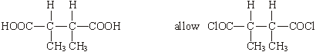
1
2,3–dimethylbutan(e)dioic acid 2,3–dimethylbutan(e)dioyl chloride
ignore –1,4–
1
condensation (QoL)
1

(iii) NaOH or HCl etc or Na₂CO₃
Allow conc sulphuric/nitric
NOT water nor acidified water nor weak acids
1

(b) Structure 1
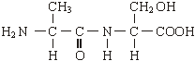

Allow –CONH– and –COHN–
Allow zwitterions
NOT polypeptides/repeating units
1
Structure 2 either of
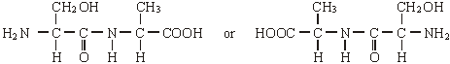
1

(c) (i) CH₃CH₂CH₂Br
allow –Cl, –I
1
(ii) CH₃CH₂CN
1

(iii) (nucleophilic) substitution or from CH₃CH₂CH₂Br
if reduction written here, no further marks
1
further substitution/reaction occurs or other products are formed
Allow reduction forms only one product
1
one of
(CH₃CH₂CH₂)₂NH
(CH₃CH₂CH₂)₃N
(CH₃CH₂CH₂)₄N⁺ Br–
Allow salts including NH₄Br
Allow HBr
1
[15]

M10. (a) (i)
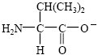
1

(ii)
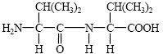
1

(iii) hydrogen bonding (do not allow H-bonding) QWC
do not penalise any error twice.
1

(b) (i)
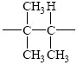
1

(ii)
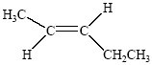
1

(iii) Isomer must be saturated or must not contain a double bond
1

(c)
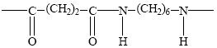
2

(d) (i) heat/reflux with aqu NaOH
1
poly(alkene) is inert/ no reaction
1
polyamide is hydrolysed (or undergoes hydrolysis)
to form acid salt and alcohol QWC
1

(ii) e.g combustion
1
heat energy produced
1
toxic gases produced
1
[14]

M11. (a) (i)
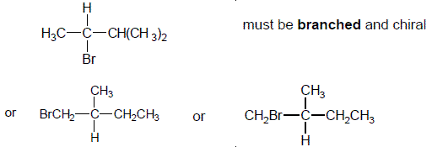
not allow C₃H₇
allow C₂H₅ bonded to C either way round
1

(ii) elimination
allow base – elimination
but penalise any other qualification
1

(iii) Z-pent-2-ene or cis-pent-2-ene either Z or cis is necessary
(allow Z-2-pentene or cis-2-pentene)
with or without brackets around Z
with or without hyphens
1

(b) (i) C
1
(ii) A
1
(iii) B
1
(iv) D
1

(c)
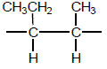
allow C₂H₅ bonded via C or H
must have both trailing bonds
ignore brackets or n
1
addition or radical or step or chain growth
QOL not additional
1

(d) (i)
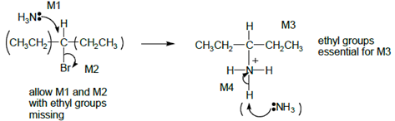
Allow SN1, i.e M2 first then attack of NH₃ on carbocation.
Allow C₂H₅ in M3 bonded either way
Allow with or without NH₃ to remove H⁺ in M4, but lose mark if Br– used.
ignore δ+ or δ– unless wrong
+ on central C instead of δ + loses M2
4

(ii) excess NH₃
ignore reflux
allow conc ammonia in sealed tube
1

(iii)
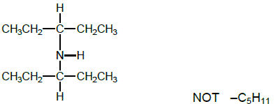
Allow C₂H₅ bonded either way
1

(e) (i)
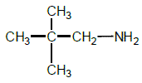
1

(ii)
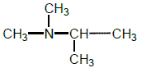
NOT (C₂H₅)₂NCH₃ which is tertiary with 3 peaks but its spectrum has no doublet.
1
[17]

M12. (a) 3-hydroxypropanoic acid
allow 3-hydroxypropionic acid
must be correct spelling
1

(b) (i) must show trailing bonds
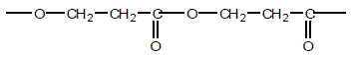
or can start at any point in the sequence, e.g.
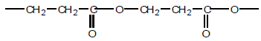
not allow dimer
allow –O–CH₂CH₂COOCH₂CH₂CO–
or –CH₂CH₂COOCH₂CH₂COO–
ignore ( ) or n
NB answer has a total of 6 carbons and 4 oxygens
1

(ii) condensation (polymerisation)
Allow close spelling
1

(c) (i) C=C or carbon-carbon double bond
1
(ii)
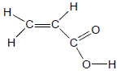
must show ALL bonds including O–H
1

(iii) must show trailing bonds
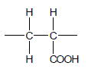
allow polyalkene conseq on their c(ii)
ignore n
1

(d)
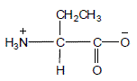
allow NH₃⁺—
allow COO–
1

(e) (i)
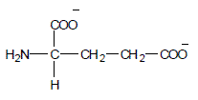
In (e), do not penalise a slip in the number of carbons in the -CH₂CH₂- chain, but all must be bonded correctly
NB two carboxylate groups
Allow COONa or COO– Na⁺ but not covalent bond to Na
allow NH₂–
1

(ii)
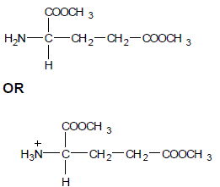
In (e), do not penalise a slip in the number of carbons in the
-CH₂CH₂- chain, but all must be bonded correctly
NB two ester groups
allow NH₂– or ⁺NH₃–
1

(iii)
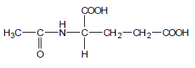
In 4(e), do not penalise a slip in the number of carbons in the -CH₂CH₂- chain, but all must be bonded correctly
allow anhydride formation on either or both COOH groups (see below) with or without amide group formation
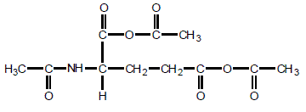
1

(f) M1 phase or eluent or solvent (or named solvent) is moving or mobile
1
M2 stationary phase or solid or alumina/silica/resin
1
M3 separation depends on balance between solubility or affinity
(of compounds) in each phase
OR
different adsorption or retention
OR
(amino acids have) different R_{f} values
OR
(amino acids) travel at different speeds or take different times
1
[13]

M13. (a) Benzene-1,2-dicarboxylic acid
Allow 1,2-benzenedicarboxylic acid
1
(b)
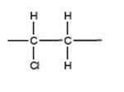
Must show all bonds including trailing bonds
Ignore n
1

(c) (i) 2 C₂H₅OH
NB Two ethanols
1
H₂O
but only one water
1
(ii) 6 or six
1

(iii)
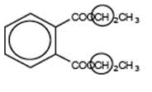
Ignore overlap with O to the left or H to the
right, but must only include this one carbon.
either or allow both (as they are identical)
1

(d)
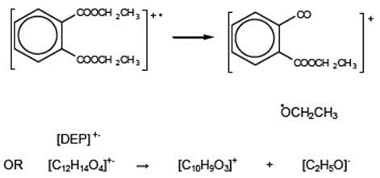
Allow + on C or O in 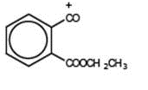
1
Dot must be on O in radical
1

(e) (i) Rate = k[DEP]
Must have brackets but can be ( )
1
(ii) Any two of
• experiment repeated/continued over a long period
• repeated by independent body/other scientists/avoiding
bias
• investigate breakdown products
• results made public
Not just repetition
Ignore animal testing
2 max
[11]

M14. (a) (i)
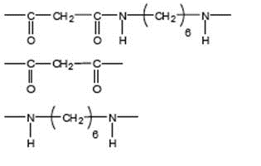
Allow –CONH- or - COHN -
Mark two halves separately
lose 1 each for missing trailing bonds at one or both ends or error in peptide link or either or both of H or OH on ends
1
Not allow –(C₆H₁₂)–
Ignore n
1

(ii) M1 in polyamides - H bonding
1
M2 in polyalkenes - van der Waals forces
Penalise forces between atoms or van der Waals bonds
1
M3 Stronger forces (of attraction) in polyamides
Or H bonding is stronger
(must be a comparison of correct forces to score M3)
Do not award if refer to stronger bonds
1

(b) (i) (nucleophilic) addition elimination
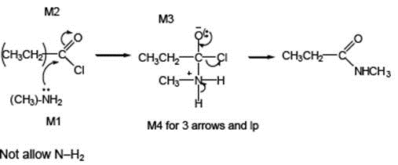

Minus sign on NH₂ loses M1
1
M2 not allowed independent of M1, but allow M1 for correct attack on C+
+ rather than + on C=O loses M2
If Cl lost with C=O breaking, max 1 for M1
M3 for correct structure with charges but
lp on O is part of M4
only allow M4 after correct/ very close M3
For M4, ignore NH₃ removing H⁺ but lose
M4 for Cl removing H⁺ in mechanism,
but ignore HCl as a product
4
(ii) N-methylpropanamide
Not N-methylpropaneamide
1

(c)
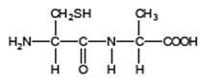
Allow –CONH– or –COHN–
1

(d) (i) 2-amino-3-hydroxypropanoic acid
1
(ii)
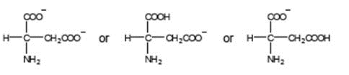
Must be salts of aspartic acid
allow –CO₂–
allow NH₂–
1

(iii) Penalise use of aspartic acid once in d(iii) and d(iv)
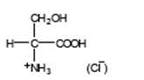
allow –CO₂H
allow ⁺NH₃–
don’t penalize position of + on NH₃
1

(iv) Penalise use of aspartic acid once in d(iii) and d(iv)
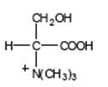(Br–)

allow –CO₂–
must show C-N bond
don’t penalize position of + on N(CH₃)₃
1
[16]

M15. (a) (i) M1 (yellow precipitate is) silver iodide OR AgI (which
may be awarded from the equation)
M2 Ag⁺ + I– → AgI (Also scores M1 unless contradicted)
M3 sodium chloride OR NaCl
For M2
Accept multiples
Ignore state symbols
Allow crossed out nitrate ions, but penalise if not crossed out
3

(ii) The silver nitrate is acidified to
• react with / remove ions that would interfere with the test
• prevent the formation of other silver precipitates / insoluble silver compounds that would interfere with the test
• remove (other) ions that react with the silver nitrate
• react with / remove carbonate / hydroxide / sulfite (ions)
Ignore reference to “false positive”
1

(iii) M1 and M2 in either order
M1 Fluoride (ion) OR F–
M2 • Silver fluoride / AgF is soluble / dissolves (in water)
• no precipitate would form / no visible /observable change
Do not penalise the spelling “fluoride”,
Penalise “fluride” once only
Mark M1 and M2 independently
2

(b) M1 Ba²⁺ + SO₄²⁻ → BaSO₄
(or the ions together)
M2 white precipitate / white solid / white suspension
M3 Barium meal or ( internal ) X-ray or to block X-rays
M4 BaSO₄ / barium sulfate is insoluble (and therefore not toxic)
For M1, ignore state symbols
Allow crossed out sodium ions, but penalise if not crossed out
For M2, ignore “milky”
If BaSO₃ OR BaS used in M1 and M4, penalise once only
For M3 Ignore radio-tracing
For M4 NOT barium ions
NOT barium
NOT barium meal
NOT “It” unless clearly BaSO₄
4

(c) M1 2(12.00000) + 4(1.00794) = 28.03176
M2 Ethene and CO or “they” have an imprecise M_{r} of 28.0 / 28
OR
Ethene and CO or “they” have the same M_{r} to one d.p.
OR
These may be shown by two clear, simple sums identifying
both compounds

M3 C₂H₄ + 2O₂ → 2CO + 2H₂O
(H₂C=CH₂)
M4 Displayed formula
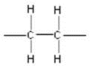

M5 Type of polymer = Addition (polymer)
M1 must show working using 5 d.p.for hydrogen
Penalise “similar” or “close to”, if this refers to the imprecise value in M2, since this does not mean “the same”
For M3, accept CH₂=CH₂ OR CH₂CH₂
For M4, all bonds must be drawn out including those on either side of the unit.
Penalise “sticks”
Ignore brackets around correct repeating unit but penalise “n”
Penalise “additional”
5
[15]

M16.(a) (i) (As a) soap
Allow washing, cleaning, degreasing, detergents
1

(ii) (Bio)diesel or biofuel or fuel for cars/lorries
Allow to make soap
1

(iii) (Cationic) surfactant /detergent /fabric softener /germicide / shampoos /(hair) conditioners /spermicidal jelly
Allow cleaning
1

(b) (i) (Poly)ester
1

Terylene OR PET
Allow polyester
1

(ii) (Poly)amide
1

Kevlar OR nylons
Ignore numbers with nylons Allow polyamide(e)
1

(iii) (Independent marks)
CE = 0
Hydrogen bonding in b(ii)
1

Imfs in (b)(ii) are stronger
OR
H bonding stronger than dipole–dipole/van der Waals/ dispersion/London
forces in b(i)
1
[9]

M17.(a)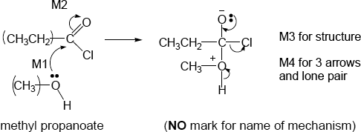
• M2 not allowed independent of M1, but allow M1 for correct attack on C+
• + rather than δ+ on C=O loses M2
• If Cl lost with C=O breaking, max1 for M1
• M3 for correct structure with charges but lp on O is part of M4
• only allow M4 after correct/very close M3
• ignore Cl – removing H⁺
4

1

(b) (i) pentane-1,5-diol
Second ‘e’ and numbers needed
Allow 1,5-pentanediol but this is not IUPAC name
(ii)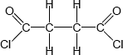
Must show ALL bonds
1

(iii) All three marks are independent
M1 (base or alkaline) Hydrolysis (allow close spelling)
1

Allow (nucleophilic) addition-elimination or saponification
M2 δ+ C in polyester
1

M3 reacts with OH– or hydroxide ion
1

Not reacts with NaOH
1

(c) (i)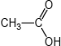
Allow CH₃COOH or CH₃CO₂H
1

(ii) (nucleophilic) addition-elimination
Both addition and elimination needed and in that order
OR
(nucleophilic) addition followed by elimination
Do not allow electrophilic addition-elimination / esterification
Ignore acylation
1

(iii) any two from: ethanoic anhydride is
• less corrosive
• less vulnerable to hydrolysis
• less dangerous to use,
• less violent/exothermic/vigorous reaction OR more controllable rxn
• does not produce toxic/corrosive/harmful fumes (of HCl) OR does not
produce HCl
• less volatile
NOT COST
List principle beyond two answers
2

(d)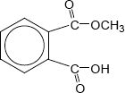
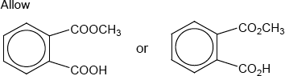
1

(e) (i) ester
Do not allow ether
Ignore functional group/linkage/bond
1

(ii) 12 or twelve (peaks)
1

(iii) 160 – 185
Allow a number or range within these limits
Penalize extra ranges given
Ignore units
1

(f) (i) sulfuric acid | sodium hydroxide
hydrochloric acid | ammonia | X or blank
ethanoic acid | potassium hydroxide
nitric acid | methylamine | X or blank

4 correct scores 2
3 correct scores 1
2 or 1 correct scores 0
2

(ii) Pink to colourless
Allow ‘red’ OR ‘purple’ OR ‘magenta’ instead of ‘pink’
Do not allow ‘clear’ instead of ‘colourless’
1
[21]

M18.(a) (i)
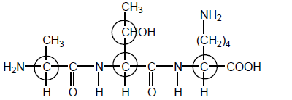
These four only
1

(ii)
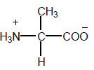
Allow − NH₃⁺ and ⁺NH₃₋
1

(iii) 2-amino-3-hydroxybutanoic acid
Ignore 1 in butan-1-oic acid
Do not penalise commas or missing hyphens
Penalise other numbers
1

(iv)
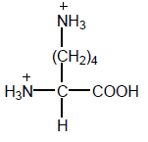
Allow –NH₃⁺ and ⁺NH₃₋
1

(b) (i) Condensation
Allow polyester
1

(ii) propane-1,3-diol
Must have e
Allow 1,3-propanediol
1

(c) (i) Addition
Not additional
1

(ii)
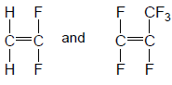
Allow monomers drawn either way round
Allow bond to F in CF₃
1

OR
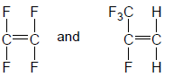
1 for each structure within each pair
1

(d) c
If wrong, CE = 0
1

C-C or C-F bonds too strong
1
[11]

