Q1. The reaction scheme below shows the conversion of epoxyethane into sodium ethanedioate.
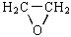 Compound X (COOH)₂ Na₂C₂O₄
(a) Identify compound X. State the reagents and conditions required to convert X into ethanedioic acid. Draw the structure of the anion in sodium ethanedioate.
(4)

(b) The addition of sodium ethanedioate to an aqueous solution containing [Co(H₂O)₆]²⁺ ions results in the formation of a more stable complex ion. Draw the structure of the complex ion formed and explain, in thermodynamic terms, why this substitution reaction occurs.
(4)
(Total 8 marks)

Q2.(a) Compound C, H₂N(CH₂)₄NH₂, can be synthesised from ethene in three steps as shown below.
Step 1 Step 2 Step 3
Ethene Compound Compound Compound
addition A substitution B C
reaction reaction C₄H₄N₂ H₂N(CH₂)₄NH₂
Name compound C and draw a structure for each of compounds A and B.
State the reagent(s) required for each step and name the type of reaction involved in the conversion of B into C.
(7)

(b) Draw the repeating unit of the polyamide formed when C reacts with hexanedioic acid. Discuss the interactions between the chains of the polyamide.
(4)

(c) Explain why polyamides are degraded by sodium hydroxide whereas polymers such as poly(ethene) are not.
(3)
(Total 14 marks)

Q3. The conversion of compound A into compound B can be achieved in two steps as shown below.
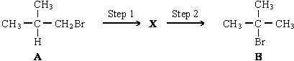
The intermediate compound, X, has an absorption at 1650 cm^{–1} in its infra-red spectrum.
(a) Identify compound X. Explain your answer.
(2)

(b) For each step in this conversion, give the reagents and essential conditions required and outline a mechanism.
(11)
(c) Show how the number of peaks in their proton n.m.r. spectra would enable you to distinguish between compounds A and B.
(2)
(Total 15 marks)

Q4. A possible synthesis of 1,4-diaminobenzene is shown below.
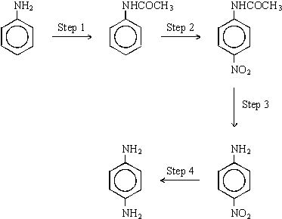
(a) Identify a suitable reagent or combination of reagents for Step 1. Name and outline a mechanism for the reaction.
(6)

(b) Identify a suitable reagent or combination of reagents for Step 2. Name and outline a mechanism for the reaction.
(6)

(c) Identify a suitable reagent or combination of reagents for Step 4. Draw the repeating unit of the polymer formed by reaction of 1,4-diaminobenzene with pentanedioic acid.
(3)
(Total 15 marks)

Q5. Use the data given on the back of the Periodic Table (PT) to help you answer this question.
Compounds A to G are all isomers with the molecular formula C₆H₁₂O₂
(a) Isomer A, C₆H₁₂O₂, is a neutral compound and is formed by the reaction between compounds X and Y in the presence of a small amount of concentrated sulphuric acid.
X and Y can both be formed from propanal by different redox reactions.
X has an absorption in its infra-red spectrum at 1750 cm^{–1}.
Deduce the structural formulae of A, X and Y. Give suitable reagents, in each case, for the formation of X and Y from propanal and state the role of concentrated sulphuric acid in the formation of A.
(7)

(b) Isomers B, C, D and E all react with aqueous sodium carbonate to produce carbon dioxide.
Deduce the structural formulae of the three isomers that contain an asymmetric carbon atom.
The fourth isomer has only three singlet peaks in its proton n.m.r. spectrum. Deduce the structural formula of this isomer and label it E.
(4)

(c) Isomer F, C₆H₁₂O₂, has the structural formula shown below, on which some of the protons have been labelled.
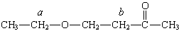
A proton n.m.r. spectrum is obtained for F. Using Table 1 at the back of the Periodic Table (PT), predict a value of δ for the protons labelled a and also for those labelled b. State and account for the splitting patterns of the peaks assigned to the protons a and b.
(6)

(d) Isomer G, C₆H₁₂O₂, contains six carbon atoms in a ring. It has an absorption in its infra-red spectrum at 3270 cm^{–1} and shows only three different proton environments in its proton n.m.r. spectrum. Deduce a structural formula for G.
(2)
(Total 19 marks)

Q6. (a) Describe how propanal, CH₃CH₂CHO, and propanone, CH₃COCH₃, can be distinguished using
(i) a chemical test and
(ii) the number of peaks in their proton n.m.r. spectra.
(5)

(b) Compound Z can be produced by the reaction of compound X with compound Y as shown in the synthesis outlined below.
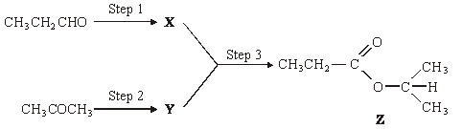
Identify compounds X and Y.
For each of the three steps in the synthesis, name the type of reaction involved and give reagents and conditions. Equations are not required.

(10)
(Total 15 marks)

Q7. Two reactions of benzene are shown below.
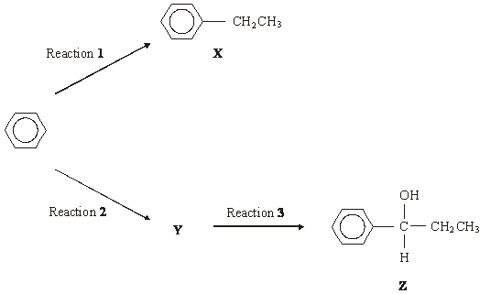
(a) Name X and give the reagent and catalyst required for Reaction 1.
Write an equation for the formation of the reactive intermediate involved in this reaction.
Name and outline a mechanism for the reaction of this reactive intermediate with benzene to form X.
(8)

(b) (i) Deduce the structure of Y and give the organic reagent needed for Reaction 2.
(ii) Give the reagent(s) needed for Reaction 3.
(3)
(Total 11 marks)

Q8. A possible synthesis of phenylethene (styrene) is outlined below.
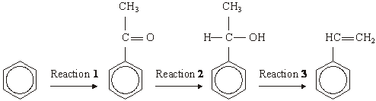
(a) In Reaction 1, ethanoyl chloride and aluminium chloride are used to form a reactive species which then reacts with benzene.
Write an equation to show the formation of the reactive species.
Name and outline the mechanism by which this reactive species reacts with benzene.
(6)

(b) NaBH₄ is a possible reagent for Reaction 2.
Name and outline the mechanism for the reaction with NaBH₄ in Reaction 2.
Name the product of Reaction 2.
(6)
(c) Name the type of reaction involved in Reaction 3 and give a reagent for the reaction.
(2)
(Total 14 marks)

Q9. A chemist has discovered that the labels have fallen off four bottles each of which contains a different organic liquid. These liquids are known to be propan-2-ol, propanal, hexene and 1-bromopropane.
Suggest a series of test-tube reactions which a chemist could use to confirm the identities of the four compounds. State the reagents used and the observations expected.
(Total 10 marks)

Q10. Compound W can be formed via compounds H and S in the three-step synthesis shown below.
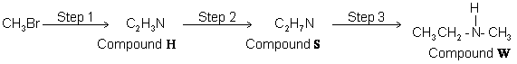
Identify compounds H and S and give reagents and conditions for Steps 1 and 2.
State the type of compound of which W is an example.
W reacts with a large excess of bromomethane to form a solid product. Draw the structure of this product and name the type of mechanism for this reaction.
(Total 9 marks)

Q11. Synthetic dyes can be manufactured starting from compounds such as 4-nitrophenylamine.
A synthesis of 4-nitrophenylamine starting from phenylamine is shown below.
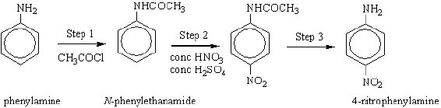
(a) An equation for formation of N-phenylethanamide in Step 1 of the synthesis is shown below.
2C₆H₅NH₂ + CH₃COCl → C₆H₅NHCOCH₃ + C₆H₅NH₃Cl
N-phenylethanamide
(i) Calculate the % atom economy for the production of N-phenylethanamide
(M_{r} = 135.0).

(ii) In a process where 10.0 kg of phenylamine are used, the yield of N-phenylethanamide obtained is 5.38 kg.
Calculate the percentage yield of N-phenylethanamide.
(iii) Comment on your answers to parts (i) and (ii) with reference to the commercial viability of the process.
(7)

(b) Name and outline a mechanism for the reaction in Step 1.
(5)
(c) The mechanism of Step 2 involves attack by an electrophile. Write an equation showing the formation of the electrophile. Outline a mechanism for the reaction of this electrophile with benzene.
(4)
(Total 16 marks)

Q12. Atenolol is an example of the type of medicine called a beta blocker. These medicines are used to lower blood pressure by slowing the heart rate. The structure of atenolol is shown below.
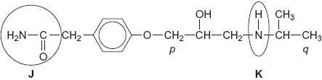
(a) Give the name of each of the circled functional groups labelled J and K on the structure of atenolol shown above.
Functional group labelled J .........................................................................
Functional group labelled K .........................................................................
(2)

(b) The ¹H n.m.r. spectrum of atenolol was recorded.
One of the peaks in the ¹H n.m.r. spectrum is produced by the CH₂ group labelled p in the structure of atenolol.
Use Table 2 on the Data Sheet to suggest a range of δ values for this peak.
Name the splitting pattern of this peak.
Range of δ values .......................................................................................
Name of splitting pattern ……......................................................................
(2)

(c) N.m.r. spectra are recorded using samples in solution.
The ¹H n.m.r. spectrum was recorded using a solution of atenolol in CDCl₃
(i) Suggest why CDCl₃ and not CHCl₃ was used as the solvent.
.............................................................................................................
.............................................................................................................
(1)

(ii) Suggest why CDCl₃ is a more effective solvent than CCl₄ for polar molecules such as atenolol.
.............................................................................................................
.............................................................................................................
(1)

(d) The ¹³C n.m.r. spectrum of atenolol was also recorded.
Use the structure of atenolol given to deduce the total number of peaks in the
¹³C n.m.r. spectrum of atenolol.
......................................................................................................................
(1)

(e) Part of the ¹³C n.m.r. spectrum of atenolol is shown below. Use this spectrum and Table 3 on the Data Sheet, where appropriate, to answer the questions which follow.
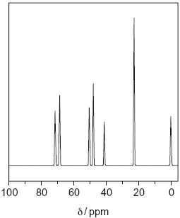
(i) Give the formula of the compound that is used as a standard and produces the peak at δ = 0 ppm in the spectrum.
.............................................................................................................
(1)

(ii) One of the peaks in the ¹³C n.m.r. spectrum above is produced by the CH₃ group labelled q in the structure of atenolol.
Identify this peak in the spectrum by stating its δ value.
.............................................................................................................
(1)

(iii) There are three CH₂ groups in the structure of atenolol. One of these CH₂ groups produces the peak at δ = 71 in the ¹³C n.m.r. spectrum above.
Draw a circle around this CH₂ group in the structure of atenolol shown below.
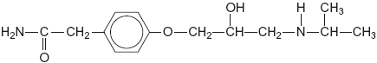
(1)

(f) Atenolol is produced industrially as a racemate (an equimolar mixture of two enantiomers) by reduction of a ketone. Both enantiomers are able to lower blood pressure. However, recent research has shown that one enantiomer is preferred in medicines.
(i) Suggest a reducing agent that could reduce a ketone to form atenolol.
.............................................................................................................
(1)

(ii) Draw a circle around the asymmetric carbon atom in the structure of atenolol shown below.
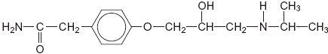
(1)

(iii) Suggest how you could show that the atenolol produced by reduction of a ketone was a racemate and not a single enantiomer.
.............................................................................................................
.............................................................................................................
.............................................................................................................
.............................................................................................................
(2)

(iv) Suggest one advantage and one disadvantage of using a racemate rather than a single enantiomer in medicines.
Advantage ...........................................................................................
.............................................................................................................
Disadvantage ......................................................................................
.............................................................................................................
(2)
(Total 16 marks)

Q13. A student used the infrared spectra of water vapour and of carbon dioxide to try to find a link between infrared radiation and global warming.
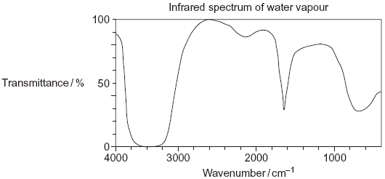
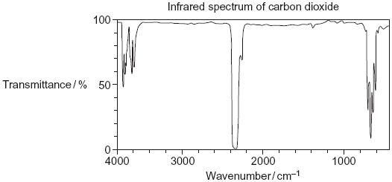
(i) Use information from the infrared spectra to deduce one reason why the student concluded that water vapour is a more effective greenhouse gas than carbon dioxide.
.....................................................................................................................
.....................................................................................................................
(1)

(ii) Use your knowledge of the bonds in CO₂ to state why the infrared spectrum of carbon dioxide is not as might be predicted from the data provided in Table 1 on the Data Sheet.
.....................................................................................................................
.....................................................................................................................
.....................................................................................................................
.....................................................................................................................
(2)
(Total 3 marks)

Q14. Organic chemists use a variety of methods to distinguish between compounds. These methods include analytical and spectroscopic techniques.
(a) The following compounds can be distinguished by observing what happens in test-tube reactions.
For each pair, suggest a suitable reagent or reagents that could be added separately to each compound in order to distinguish them.
Describe what you would observe with each compound.
(i)
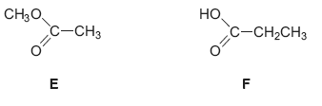
.............................................................................................................
.............................................................................................................
.............................................................................................................
.............................................................................................................
.............................................................................................................
.............................................................................................................
(3)

(ii)
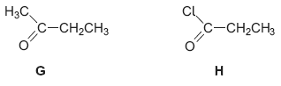
.............................................................................................................
.............................................................................................................
.............................................................................................................
.............................................................................................................
.............................................................................................................
.............................................................................................................
(3)

(iii)
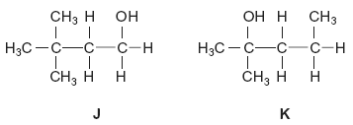
.............................................................................................................
.............................................................................................................
.............................................................................................................
.............................................................................................................
.............................................................................................................
.............................................................................................................
(3)

(b) Compounds J and K can also be distinguished using spectroscopic techniques
such as ¹H n.m.r.
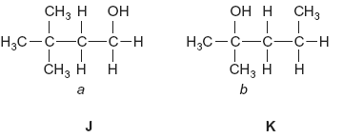
(i) Name compound J.
Give the total number of peaks in the ¹H n.m.r. spectrum of J.
State the splitting pattern, if any, of the peak for the protons labelled a.
.............................................................................................................
.............................................................................................................
.............................................................................................................
.............................................................................................................
.............................................................................................................
.............................................................................................................
(3)

(ii) Name compound K.
Give the total number of peaks in the ¹H n.m.r. spectrum of K.
State the splitting pattern, if any, of the peak for the protons labelled b.
.............................................................................................................
.............................................................................................................
.............................................................................................................
.............................................................................................................
.............................................................................................................
.............................................................................................................
(3)
(Total 15 marks)

Q15.(a) A chemist discovered four unlabelled bottles of liquid, each of which contained a different pure organic compound. The compounds were known to be propan-1-ol, propanal, propanoic acid and 1-chloropropane.
Describe four different test-tube reactions, one for each compound, that could be used to identify the four organic compounds.
Your answer should include the name of the organic compound, the reagent(s) used and the expected observation for each test.
........................................................................................................................
........................................................................................................................
........................................................................................................................
........................................................................................................................
........................................................................................................................
........................................................................................................................
........................................................................................................................
........................................................................................................................
........................................................................................................................
........................................................................................................................
........................................................................................................................
........................................................................................................................

(Extra space) .................................................................................................
........................................................................................................................
........................................................................................................................
........................................................................................................................
(8)

(b) A fifth bottle was discovered labelled propan-2-ol. The chemist showed, using infrared spectroscopy, that the propan-2-ol was contaminated with propanone.
The chemist separated the two compounds using column chromatography. The column contained silica gel, a polar stationary phase.

The contaminated propan-2-ol was dissolved in hexane and poured into the column.
Pure hexane was added slowly to the top of the column. Samples of the eluent (the solution leaving the bottom of the column) were collected.
• Suggest the chemical process that would cause a sample of propan-2-ol to become contaminated with propanone.
• State how the infrared spectrum showed the presence of propanone.
• Suggest why propanone was present in samples of the eluent collected first (those with shorter retention times), whereas samples containing propan-2-ol were collected later.
........................................................................................................................
........................................................................................................................
........................................................................................................................
........................................................................................................................
........................................................................................................................
........................................................................................................................
........................................................................................................................
........................................................................................................................
........................................................................................................................

(Extra space) .................................................................................................
........................................................................................................................
........................................................................................................................
........................................................................................................................
........................................................................................................................
........................................................................................................................
........................................................................................................................
........................................................................................................................
(4)
(Total 12 marks)

Q16.Benzene reacts with ethanoyl chloride in a substitution reaction to form C₆H₅COCH₃.
This reaction is catalysed by aluminium chloride.
(a) Write equations to show the role of aluminium chloride as a catalyst in this reaction.
Outline a mechanism for the reaction of benzene.
Name the product, C₆H₅COCH₃.
........................................................................................................................
........................................................................................................................
........................................................................................................................

(6)

(b) The product of the substitution reaction (C₆H₅COCH₃) was analysed by mass spectrometry. The most abundant fragment ion gave a peak in the mass spectrum with m/z = 105.
Draw the structure of this fragment ion.

(1)

(c) When methylbenzene reacts with ethanoyl chloride and aluminium chloride, a similar substitution reaction occurs but the reaction is faster than the reaction of benzene.
Suggest why the reaction of methylbenzene is faster.
........................................................................................................................
........................................................................................................................
........................................................................................................................
........................................................................................................................
........................................................................................................................
........................................................................................................................
(2)
(Total 9 marks)

Q17.Acyl chlorides and acid anhydrides are important compounds in organic synthesis.
(a) Outline a mechanism for the reaction of CH₃CH₂COCl with CH₃OH and name the organic product formed.
Mechanism

Name of organic product ...............................................................................
(5)

(b) A polyester was produced by reacting a diol with a diacyl chloride. The repeating unit of the polymer is shown below.
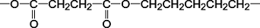
(i) Name the diol used.
...............................................................................................................
(1)

(ii) Draw the displayed formula of the diacyl chloride used.

(1)

(iii) A shirt was made from this polyester. A student wearing the shirt accidentally splashed aqueous sodium hydroxide on a sleeve. Holes later appeared in the sleeve where the sodium hydroxide had been.
Name the type of reaction that occurred between the polyester and the aqueous sodium hydroxide. Explain why the aqueous sodium hydroxide reacted with the polyester.
Type of reaction ....................................................................................
Explanation ...........................................................................................
...............................................................................................................
...............................................................................................................
...............................................................................................................
(3)

(c) (i) Complete the following equation for the preparation of aspirin using ethanoic anhydride by writing the structural formula of the missing product.

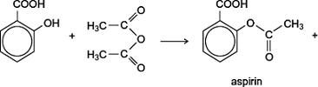 | ......................

(1)

(ii) Suggest a name for the mechanism for the reaction in part (c)(i).
...............................................................................................................
(1)

(iii) Give two industrial advantages, other than cost, of using ethanoic anhydride rather than ethanoyl chloride in the production of aspirin.
Advantage 1 ..........................................................................................
...............................................................................................................
...............................................................................................................
Advantage 2 ..........................................................................................
...............................................................................................................
...............................................................................................................
(2)

(d) Complete the following equation for the reaction of one molecule of benzene-1,2-dicarboxylic anhydride (phthalic anhydride) with one molecule of methanol by drawing the structural formula of the single product
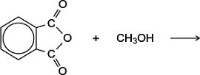
(1)

(e) The indicator phenolphthalein is synthesised by reacting phthalic anhydride with phenol as shown in the following equation.
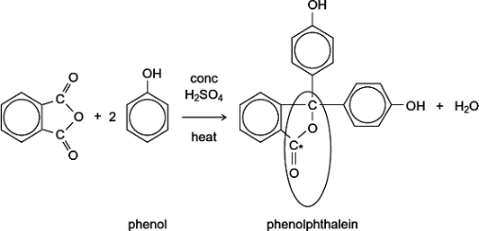
(i) Name the functional group ringed in the structure of phenolphthalein.
...............................................................................................................
(1)

(ii) Deduce the number of peaks in the ¹³C n.m.r. spectrum of phenolphthalein.
...............................................................................................................
(1)

(iii) One of the carbon atoms in the structure of phenolphthalein shown above is labelled with an asterisk (*).
Use Table 3 on the Data Sheet to suggest a range of δ values for the peak due to this carbon atom in the ¹³C n.m.r. spectrum of phenolphthalein.
...............................................................................................................
(1)

(f) Phenolphthalein can be used as an indicator in some acid–alkali titrations.
The pH range for phenolphthalein is 8.3 – 10.0
(i) For each acid.alkali combination in the table below, put a tick () in the box if phenolphthalein could be used as an indicator.

Acid | Alkali | Tick  box ()
sulfuric acid | sodium hydroxide
hydrochloric acid | ammonia
ethanoic acid | potassium hydroxide
nitric acid | methylamine

(2)

(ii) In a titration, nitric acid is added from a burette to a solution of sodium hydroxide containing a few drops of phenolphthalein indicator.
Give the colour change at the end-point.
...............................................................................................................
(1)
(Total 21 marks)

Q18.Describe how you could distinguish between the compounds in the following pairs using one simple test-tube reaction in each case.
For each pair, identify a reagent and state what you would observe when both compounds are tested separately with this reagent.
(a)
Reagent .........................................................................................................
Observation with R.........................................................................................
........................................................................................................................
Observation with S.........................................................................................
........................................................................................................................
(3)

(b)
Reagent .........................................................................................................
Observation with T.........................................................................................
........................................................................................................................
Observation with U.........................................................................................
........................................................................................................................
(3)

(c)
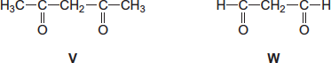
Reagent .........................................................................................................
Observation with V.........................................................................................
........................................................................................................................
Observation with W........................................................................................
........................................................................................................................
(3)
(Total 9 marks)

M1. (a) Identity of A;
ethane-1,2-diol or 1,2 dihydroxyethane or ethylene glycol or formula (1)
N.B. Do NOT allow OHCH₂CH₂OH unless a correct name is also given
K₂Cr₂O₇ / dilute H₂SO₄ or dilute HCl or K₂Cr₂O₇ / H⁺
N.B. Oxidising agent must be a reagent
N.B. Do NOT allow concentrated H₂SO₄

Reflux or warm or heat (1)
Ignore temperature if given
N.B. If a temperature given on its own it must be at or below 200°C
Anion: 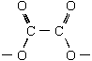 (1)
N.B. Do NOT allow C₂O₄^{2–}
N.B. Ignore lone pairs of electrons
4

(b) Structure : 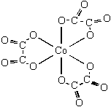
correct co-ordination (1)
bonding through six correct oxygen (1)
Score 2 or zero
N.B. Not essential to show double bonds i.e. C=O in structure
Explanation:
Substitution produces more molecules or particles or more disorder (1)
Entropy change is positive (1)
4
[8]

M2.(a) 1, 4-diaminobutane or butane -1, 4-diamine (1)
A: BrCH₂CH₂Br or ClCH₂CH₂Cl (1)
B: NC CH₂CH₂CN
Step 1: Br₂ or Cl₂ (1) (ignore aq)
Step 2: KCN (1) (NOT HCN)
Step 3: H₂ / Ni or LiAlH₄ or Na / C₂H₅OH (1) (NOT NaBH₄)
Hydrogenation only for H₂ / Ni, or nucleophilic addition only for LiAlH₄(1)
OR reduction or addition
7

(b) 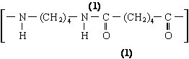
QL hydrogen bonding (1)
Polarity of H-bonding shown or discussed (1)
4

(c) Polyamides / peptide link can be hydrolysed (1)
OR polyalkenes cannot be hydrolysed
QL OH– attacks peptide link or C^{δ+} (1)
poly(ethene) non-polar (1)
3
[14]

M3. (a) Identity of X; 2-methylpropene (1)
Absorption at 1650 cm^{–1} indicates an alkene present (1)
OR a chemical answer e.g. Br₂ (aq) brown to colourless
2

(b) Reagents
Step 1 KOH (allow NaOH) (1) alcoholic (1) warm (1)
Only allow solvent and warm if reagent correct
Step 2 HBr (1)
Mechanism: A → X
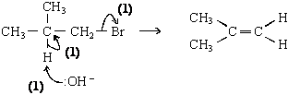
Or a carbocation mechanism
Mechanism X → B
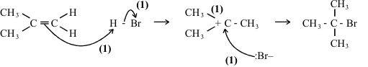
11

(c) A gives three peaks (1)
B gives one peak (1)
Allow one for “A has more peaks than B” when no number of peaks is given
2
[15]

M4. (a) CH₃COCl or (CH₃CO)₂O (1)
AlCl₃ or H₂O or CH₂SO₄ loses this mark
CH₃COOH loses reagent and M3, M4 = max 3
nucleophilic addition–elimination (1)
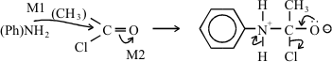
M3: structure
M4: 3 correct arrows
Allow M1 for attack on CH3‑C⁺=O
Penalise Cl– removing H⁺
6

(b) Conc HNO₃ (1)
Conc H₂SO₄ (1)
HNO₃ + 2 H₂SO₄ → NO₂⁺ + H₃O⁺ + 2 HSO₄– (2)
(or H₂SO₄ ) (or H₂O + HSO₄–)
HNO₃ / H₂SO₄ scores 1
Any 2
electrophilic substitution (1)
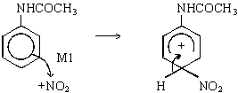
M2 structure
M3 arrow
6

(c) Sn (or Fe) / HCl or Ni / H₂ (1)
NOT LiAlH₄ NaBH₄
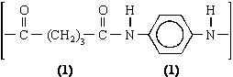
3
[15]

M5. (a) X contains > C=O (1)
if X and Y reversed lose this mark but allow remaining max 6/7
X is CH₃CH₂COOH (1)
Y is CH₃CH₂CH₂OH (1)
A is 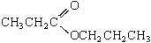 (1)
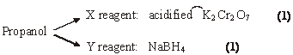
Conc H₂SO₄ : catalyst (1)
7

(b)
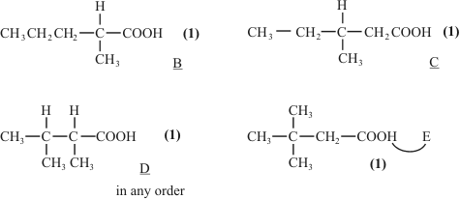
4

(c) 3.1 – 3.9 (1)
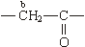 2.1 – 2.6 (1)
a: quartet (1) 3 adjacent H (1)
b: triplet (1) 2 adjacent H (1)
6

(d) 3269 cm^{–1} OH alcohol (1)
G is 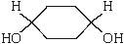 (1)
2

Notes
(a) first mark for C=O stated or shown in X
Ignore wrong names
Y CH₃CH₂CH₂OH
allow C₃H₇ in A if Y correct or vice versa
Allow (1) for A if correct conseq to wrong X and Y
other oxidising agents: acidified KMnO₄; Tollens; Fehlings
other reducing agents: LiAlH₄; Na/ethanol; Ni/H₂; Zn or Sn or Fe/HCl

(b) give (1) for carboxylic acid stated or COOH shown in each suggestion
(1) for correct E
any 2 out of 3 for B, C or D
allow C₃H₇ for either the B or D shown on the mark scheme
i.e. a correct structure labelled B, C or D or E will gain 2.
(c) protons a – quartet must be correct to score 3 adjacent H mark. Same for b
(d) allow (1) for any OH (alcohol) shown correctly in any structure – ignore extra functional groups. Structure must be completely correct to gain second mark
[19]

Organic points
(1) Curly arrows: must show movement of a pair of electrons,
i.e. from bond to atom or from lp to atom / space
e.g.

(2) Structures
penalise sticks (i.e. 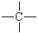) once per paper
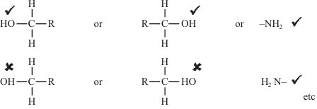
Penalise once per paper
allow CH₃– or –CH₃ or or CH₃
or H₃C–

M6. (a) (i)

Reagent | Tollens | Fehlings or Benedicts | K₂Cr₂O₇/H⁺  or acidified | KMnO₄/H⁺ | I₂/NaOH
Propanal | silver (mirror) | red ppt or goes red  (not red solution) | goes green | goes colourless | No  reaction
Propanone | no reaction | no reaction | no reaction | no reaction | Yellow  (ppt)

(penalise incomplete reagent e.g. K₂Cr₂O₇ or Cr₂O₇^{2–}/H⁺ then mark on)
3
(ii) propanal 3 peaks
ignore splitting even if wrong
1
propanone 1 peak
1

(b) X is CH₃CH₂COOH or propanoic acid if both name and formula given,
both must be correct, but
1
Y is CH₃CH(OH)CH₃ or propan-2-ol allow propanol with correct formula
1
Mark the type of reaction and reagent/condition independently.
The reagent must be correct or close to score condition
Step 1 Oxidation
K₂Cr₂O₇/H⁺ or other oxidation methods as above
allow Cr₂O₇^{2–}H⁺ if penalised above (ecf)
reflux (not Tollens/Fehlings) or heat or warm
1

Step 2 | reduction or nucleophilic  addition | reduction or  nucleophilic addition | reduction or hydrogenation | 1
 | NaBH₄ | LiAlH₄ | H₂ | 1
 | in (m)ethanol or water or ether  or dry | ether or dry | Ni / Pt etc | 1

Step 3 esterification or (nucleophilic) addition-elimination or condensation
1
(conc) H₂SO₄ or HCl
1
warm (allow without acid reagent if X and Y given as reagents)
1
or reflux or heat
1
[15]

M7. (a) ethyl benzene
1
chloroethane or bromoethane (or ethene and hydrogen chloride/bromide)
1
aluminium chloride/bromide or iron(III) chloride /bromide or iron +
chorine/bromine
1
CH₃CH₂Cl + AlCl₃ → CH₃CH₂⁺ + AlCl₄–
1
electrophilic substitution
1
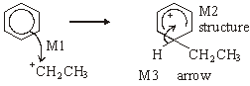
3

(b)
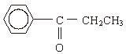
1
CH₃CH₂COCl / propanoyl chloride or (CH₃CH₂CO)₂O / propanoic
anhydride
1
NaBH₄ or LiAlH₄ or H₂/Ni (not Sn/Fe with HCl)
1
[11]

M8. (a) CH₃COCl + AlCl₃ → CH₃O + AlCl
(1) equation (1)
2
penalise wrong alkyl group once at first error
position of + on electrophile can be on O or C or outside [ ]
penalise wrong curly arrow in the equation or lone pair on AlCl₃ else ignore

Electrophilic substitution
NOT F/C acylation
1
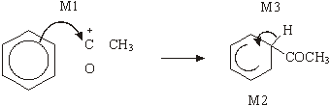
horseshoe must not extend beyond C2 to C6 but can be smaller
+ not too close to C1
M3 arrow into hexagon unless Kekule
allow M3 arrow independent of M2 structure
M1 arrow from within hexagon to C or to + on C
+ must be on C of 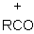
3

(b) Nucleophilic addition
NOT reduction
1
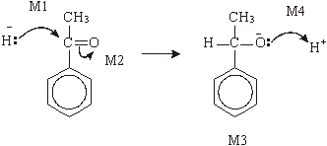

M2 not allowed independent, but can allow M1 for attack of H– on C+ formed
4
1–phenylethan(–1–)ol or (1–hydroxyethyl)benzene
l

(c) dehydration or elimination
1
(conc) H₂SO₄ or (conc) H₃PO₄
allow dilute and Al₂O₃
Do not allow iron oxides
1
[14]

M9. Acidified potassium dichromate(VI)
1
Turns green with propan-2-ol and propanal
1
No reaction with hexene and 1-bromopropane
1
Tollens with propan-2-ol and propanal
1
only propanal gives silver mirror
1
Bromine water
1
Decolourised by hexane
1
No reaction with 1-bromopropane
1
Warm NaOH followed by acidified AgNO₃
1
White ppt with 1-bromopropane
1
[10]

M10. H CH₃CN or ethanenitrile
1
S CH₃CH₂NH₂ or ethylamine 1Step 1 KCN
1
aq/alcoholic
1
Step 2 H₂
1
Ni
1
W secondary amine
1
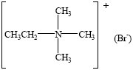
1
nucleophilic substitution
1
[9]

M11.

Mark  Range | The marking scheme for this part of the question includes an overall assessment for the Quality of Written Communication (QWC). There are no discrete marks for the assessment of QWC but the candidates’ QWC in this answer will be one of the criteria used to assign a level and award the marks for this part of the question  Descriptor  an answer will be expected to meet most of the criteria in the level descriptor
4-5 | – claims supported by an appropriate range of evidence  – good use of information or ideas about chemistry, going beyond those given in the question  – argument well structured with minimal repetition or irrelevant points  – accurate and clear expression of ideas with only minor errors of grammar, punctuation and spelling
2-3 | – claims partially supported by evidence  – good use of information or ideas about chemistry given in the question but limited beyond this  – the argument shows some attempt at structure  – the ideas are expressed with reasonable clarity but with a few errors of grammar, punctuation and spelling
0-1 | – valid points but not clearly linked to an argument structure  – limited use of information or ideas about chemistry  – unstructured  – errors in spelling, punctuation and grammar or lack of fluency

(a) (i) M_{r} of C₆H₅NH₂ = 93 M_{r} of CH₃COCl = 78.5
total M_{r} of reagents = 264.5
1
% atom economy = 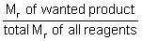 × 100 QWC
1
= 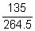 × 100 = 51.0 %
1

(ii) expected yield = × 0.5 × 135 = 7.26 kg
1
% yield = 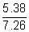 × 100 = 74.1 %
1

(iii) Although yield appears satisfactory (74%) % atom economy
is only 51% QWC
1
nearly half of the material produced is waste and must be
disposed of QWC
1

(b) (nucleophilic) addition-elimination
1
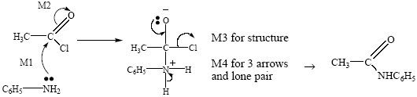
QWC (2)
4

(c) HNO₃ + 2H₂SO₄ → NO₂⁺ + H₃O⁺ + 2HSO₄–
1
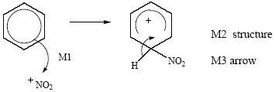
3
[16]

M12. (a) J (acid) amide
not peptide, not N-substituted amide
1
K (secondary) amine or amino
penalise primary or tertiary
allow N-substituted amine
1

(b) (δ =) 3.1-3.9
1
doublet OR duplet
Not 3.7 – 4.1
Not secondary
name required not the number 2
1

(c) (i) Solvent must be proton-free
OR CHCl₃ has protons or has H or gives a peak
1
(ii) CDCl₃ is polar OR CCl₄ is non-polar
1

(d) 11 OR eleven
1
(e) (i) Si(CH₃)₄ OR SiC₄H₁₂
ignore TMS
1
(ii) a single number or a range within 21-25
penalise anything outside this range
1

(iii)
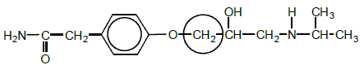
allow ring around the C only and also allow
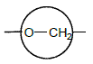
1

(f) (i) NaBH₄
ignore name if formula correct
ignore solvent
allow LiAlH₄ Zn/HCl Sn/HCl H₂/Ni H₂/Pt
1

(ii)
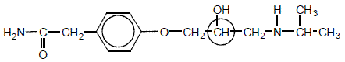
allow ring around the C only
1

(iii) (plane) polarised light OR light in a polarimeter
1
polarised light is not rotated or is unaffected
penalise bent/diffracted/deflected/reflected
Not just solution is optically inactive
1

(iv) adv cheaper medicine due to cost or difficulty of separation or
both can lower blood pressure
OR more effective/beneficial with a reason
or no need to separate
1
disadv may be side effects from one enantiomer in the mixture or
only half the product works or one enantiomer may be
ineffective or double dose required
1
[16]

M13. (i) More absorption/less transmittance of infrared radiation
by it/water vapour
OR broader absorption by OH
OR less absorption/more transmittance of infrared radiation
by carbon dioxide
Must be comparative
This may be described and must not be contradictory
Credit answers which refer correctly to “transmittance”
(more absorption = less transmittance)
1

(ii) M1 CO₂ contains C=O (stated like this or in words or strongly
implied) OR is O=C=O
M2 depends on correct M1
OR expected absorption/peak (for C=O) is missing
OR expected absorption/peak (for C=O) is shifted to 2300 (cm^{–1})
OR asymmetric stretching is occurring (due to C=O)
If M1 and M2 not scored, give one mark for either
No absorption/peak at 1700 (cm^{–1})/1715 (cm^{–1})
OR no absorption in the range 1680 – 1750 (cm^{–1})
Ignore “carbon-oxygen bonds”, “C-O bonds”
Ignore reference to other absorptions
For M2
Allow “dip” OR “spike” OR “low transmittance” as alternatives for absorption.
2
[3]

M14. (a) (i) Single reagent
If wrong single reagent, CE = zero
Incomplete single reagent (e.g. carbonate) or wrong formula (e.g.NaCO₃) loses reagent mark, but mark on
For “no reaction” allow “nothing”
Different reagents
If different tests on E and F; both reagents and any follow
on chemistry must be correct for first (reagent) mark.
Reagent must react: i.e. not allow Tollens on G (ketone) – no reaction.
Second and third marks are for correct observations.
i.e. for different tests on E and F, if one reagent is correct and one wrong, can score max 1 for correct observation with correct reagent.
PCl₅ PCl₃
SOCl₂
1

E ester
Na₂CO₃/NaHCO₃ named carbonate
metal e.g.Mg
no reaction
no reaction
named indicator
no effect
No reaction
1

F acid
Na₂CO₃/NaHCO₃ named carbonate
Effervescence or CO₂
metal e.g.Mg
Effervescence or H₂
named indicator
acid colour
fumes
1

(ii) Single reagent
If wrong single reagent, CE = zero
Incomplete single reagent (e.g. carbonate) or wrong
formula (e.g.NaCO₃) loses reagent mark, but mark on
For “no reaction” allow “nothing”
Different reagents
If different tests on E and F; both reagents and any
follow on chemistry must be correct for first (reagent) mark.
Reagent must react: i.e. not allow Tollens on
G (ketone) – no reaction.
Second and third marks are for correct observations.
1

i.e. for different tests on E and F, if one reagent is correct
and one wrong, can score max 1 for correct observation
with correct reagent.
G ketone
AgNO₃
no reaction
Na₂CO₃/NaHCO₃ named carbonate
water
no reaction
named indicator
no effect
Named alcohol
no reaction
Named amine or ammonia
no reaction
1

H Acyl chloride
AgNO₃
(white) ppt
Na₂CO₃/NaHCO₃ named carbonate
Effervescence or CO₂ or fumes or exothermic
water
fumes
named indicator
acid colour
Named alcohol
Smell or fumes
Named amine or ammonia
fumes
1
Allow iodoform test or Brady’s reagent (2,4,dnph) test (both positive for G)

(iii) Single reagent
If wrong single reagent, CE = zero
Incomplete single reagent (e.g. carbonate) or wrong
formula (e.g.NaCO₃) loses reagent mark, but mark on
For “no reaction” allow “nothing”
Different reagents
If different tests on E and F; both reagents and any follow
on chemistry must be correct for first (reagent) mark.
Reagent must react: i.e. not allow Tollens on
G (ketone) – no reaction.
Second and third marks are for correct observations.
i.e. for different tests on E and F, if one reagent is correct
and one wrong, can score max 1 for correct observation
with correct reagent.
1

J Primary alcohol
K₂Cr₂O₇/ H⁺
goes green
KMnO₄/ H⁺
decolourised / goes brown
Lucas test (ZnCl₂/HCl)
Penalise missing H⁺ but mark on
1

K Tertiary alcohol
K₂Cr₂O₇/ H⁺
No reaction
KMnO₄/ H⁺
no reaction
Lucas test (ZnCl₂/HCl)
Rapid cloudiness
1
If uses subsequent tests e.g. Tollens/Fehlings, test must be on product of oxidation

(b) (i) 3,3-dimethylbutan-1-ol
Allow 3,3-dimethyl-1-butanol
1
4
1
Triplet on three
1

(ii) 2-methylpentan-2-ol
Allow 2-methyl-2-pentanol
1
5
1
Singlet or one or no splitting
1
[15]

M15.(a) If 2 stage test for one compound, award no marks for that compound, eg no mark for ROH or RX to alkene then Br₂ test. If reagent is wrong or missing, no mark for that test; if wrong but close/incomplete, lose reagent mark but can award for correct observation. In each test, penalise each example of wrong chemistry, eg AgClr₂
propan-1-ol
acidifiedpotassiumdichromate
sodium
Named acid + conc H₂SO₄
named acyl chloride
PCl₅
M1
1

(orange) turns green
effervescence
Sweet smell
Sweet smell /misty fumes
Misty fumes
M2
1

propanal
add Tollens or Fehlings / Benedicts
acidifiedpotassiumdichromate
Bradys or 2,4-dnph
if dichromate used for alcohol cannot be used for aldehyde
M3
1

Tollens: silver mirror or Fehlings/ Benedicts: red ppt
(orange) turns green
Yellow or orange ppt
M4
1

propanoic acid
Named carbonate/ hydrogencarbonate
water and UI (paper)
Named alcohol + conc H₂SO₄
sodium or magnesium
PCl₅
if sodium used for alcohol cannot be used for acid
M5
1

effervescence
orange/red
Sweet smell
effervescence
Misty fumes
if PCl₅ used for alcohol cannot be used for acid
M6
1

1-chloro propane
NaOH then acidified AgNO₃
AgNO₃
If acidification missed after NaOH,no mark here but allow mark for observation
M7
1

white ppt
white ppt
M8
1

(b) oxidation (of alcohol by oxygen in air)
M1
1
absorption at 1680 -1750 (due to C=O)
Must refer to the spectrum
M2
1

comparison of polarity of molecules or correct imf statement:propanone is less polar OR propan-2-ol is more polarOR propanone has dipole-dipole forcesOR propan-2-ol has hydrogen bonding
M3
1

about attraction to stationary phase or solubility in moving phasePropan-2-ol has greater affinity for stationary phase or vice versaOR propanone is more soluble in solvent/moving phase or vice versa
M4
1
[12]

M16.(a) CH₃COCl + AlCl₃ CH₃CO⁺ + AlCl₄–
Allow RHS as 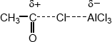
Allow + on C or O in equation but + must be on C in mechanism below
Ignore curly arrows in equation even if wrong.
1

AlCl₄– + H⁺ AlCl₃ + HCl
1

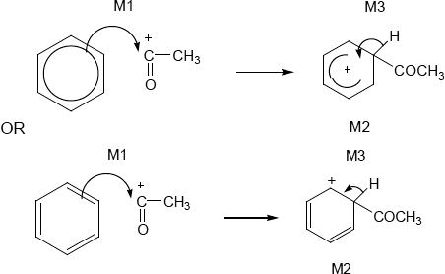
• M1 arrow from within hexagon
to C or to + on C
• + must be on C of RCO in mechanism
• + in intermediate not too close to C1
• gap in horseshoe must be centred approximately around C1
• M3 arrow into hexagon unless Kekule
• allow M3 arrow independent of M2 structure
• ignore base removing H for M3
• NO mark for name of mechanism
3

Phenylethanone ignore 1 in name, penalise other numbers
Note: this is the sixth marking point in (a)
1

(b)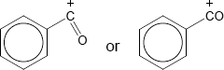
+ must be on C
But allow [C₆H₅CO]⁺
1

(c) M1 about electrons
methyl group has (positive) inductive effect OR increases electron density on
benzene ring OR pushes electrons OR is electron releasing
Ignore reference to delocalisation
1

M2 about attraction
electrophile attracted more
or benzene ring better nucleophile
Allow intermediate ion stabilised
M2 only awarded after correct or close M1
1
[9]

M17.(a)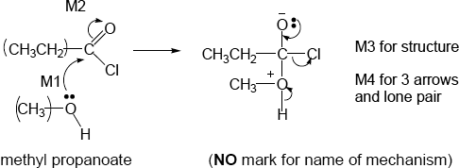
• M2 not allowed independent of M1, but allow M1 for correct attack on C+
• + rather than δ+ on C=O loses M2
• If Cl lost with C=O breaking, max1 for M1
• M3 for correct structure with charges but lp on O is part of M4
• only allow M4 after correct/very close M3
• ignore Cl – removing H⁺
4

1

(b) (i) pentane-1,5-diol
Second ‘e’ and numbers needed
Allow 1,5-pentanediol but this is not IUPAC name
(ii)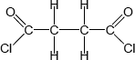
Must show ALL bonds
1

(iii) All three marks are independent
M1 (base or alkaline) Hydrolysis (allow close spelling)
1

Allow (nucleophilic) addition-elimination or saponification
M2 δ+ C in polyester
1

M3 reacts with OH– or hydroxide ion
1

Not reacts with NaOH
1

(c) (i)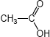
Allow CH₃COOH or CH₃CO₂H
1

(ii) (nucleophilic) addition-elimination
Both addition and elimination needed and in that order
OR
(nucleophilic) addition followed by elimination
Do not allow electrophilic addition-elimination / esterification
Ignore acylation
1

(iii) any two from: ethanoic anhydride is
• less corrosive
• less vulnerable to hydrolysis
• less dangerous to use,
• less violent/exothermic/vigorous reaction OR more controllable rxn
• does not produce toxic/corrosive/harmful fumes (of HCl) OR does not
produce HCl
• less volatile
NOT COST
List principle beyond two answers
2

(d)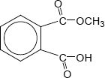
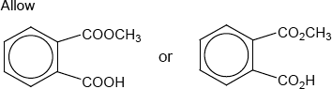
1

(e) (i) ester
Do not allow ether
Ignore functional group/linkage/bond
1

(ii) 12 or twelve (peaks)
1

(iii) 160 – 185
Allow a number or range within these limits
Penalize extra ranges given
Ignore units
1

(f) (i) sulfuric acid | sodium hydroxide
hydrochloric acid | ammonia | X or blank
ethanoic acid | potassium hydroxide
nitric acid | methylamine | X or blank

4 correct scores 2
3 correct scores 1
2 or 1 correct scores 0
2

(ii) Pink to colourless
Allow ‘red’ OR ‘purple’ OR ‘magenta’ instead of ‘pink’
Do not allow ‘clear’ instead of ‘colourless’
1
[21]

M18.In each section
• If wrong or no reagent given, no marks for any observations;
• Penalise incomplete reagent or incorrect formula – but mark observations
• Mark each observation independently
• Allow no reaction for no change / no observable reaction in all three parts, but not none or nothing
• Q says one test. If two tests are given, score zero
(a)

 |  | K₂Cr₂O₇ / H⁺ | KMnO₄ / H⁺ | Lucas test (ZnCl₂ / HCl)

1

 | R  Primary alcohol | (Orange) goes green Penalise wrong starting colour | (purple) goes colourless / decolourises allow goes brown | No cloudiness

1

 | S  Tertiary alcohol | no change / no observable reaction | no change / no observable reaction | Rapid cloudiness

1
Allow acidified potassium manganate and acidified potassium dichromate without oxidation numbers

(b)

 |  | Na₂CO₃ / NaHCO₃ named carbonate | metal eg Mg | named indicator

PCl₅ PCl₃
SOCl₂
Named alcohol + HCl / H₂SO₄
1

 | T  ester | no change / no observable reaction | no change / no observable reaction | no effect

no change / no observable reaction
1

 | U  Acid | Effervescence or (CO₂) gas formed | Effervescence or (H₂) gas formed | acid colour

Fumes / (HCl) gas formed
Sweet smell
1

(c)

 |  | Fehling’s / Benedict’s | Tollens’ / [Ag(NH₃)2]⁺ | K₂Cr₂O₇/ H⁺

I₂ / NaOH
1

 | V  Ketone | no change / no observable reaction | no change / no observable reaction | no change / no observable reaction

Yellow ppt
1

 | W  aldehyde | Red ppt | Silver mirror | (Orange) goes green Penalise wrong starting colour

no change / no observable reaction
1
[9]

