Q1. A student investigates the effect of concentration on the rate of reaction. The student reacts sodium thiosulfate solution with dilute hydrochloric acid. This produces a cloudy mixture.
(a) The cloudiness is produced by the formation of solid sulfur. How should sulfur be written in the chemical equation for this reaction? Tick (✔) one box.

S(aq) |  |  | S(g) |  |  | S(l) |  |  | S(s)
(1)
The diagram shows some of the apparatus the student uses.
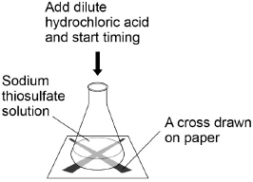
This is the method used.
1. Measure 40 cm ³ sodium thiosulfate solution into a conical flask.
2. Stand the flask on a piece of paper with a cross drawn on it.
3. Add 10 cm ³ of dilute hydrochloric acid to the flask.
4. Time how long it takes the cross to become no longer visible.
5. Repeat steps 1‒4 twice more.
6. Repeat steps 1‒5 with sodium thiosulfate solutions of different concentrations.
(1)
(b) Which apparatus could be used to measure 10 cm³ of dilute hydrochloric acid? Tick (✔) one box.

Beaker
Boiling tube
Measuring cylinder
Test tube
(1)
(c) Draw one line from each type of variable to the description of the variable.
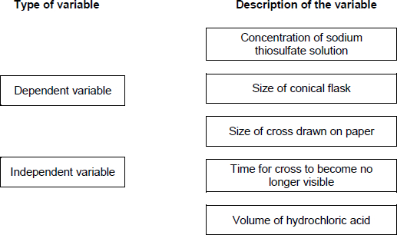
(2)
(d) The student draws a new cross for each experiment.
Suggest why this might give inaccurate results.
___________________________________________________________________
___________________________________________________________________
(1)
(e) The table shows the student’s results for sodium thiosulfate solution with a concentration of 12 g / dm³

Time for cross to become no longer visible in s
Trial 1 | Trial 2 | Trial 3 | Mean
43 | 78 | 41 | X
Calculate value X in the tabble.
Do not use any anomalous results in your calculation.
___________________________________________________________________
___________________________________________________________________
X = ____________________ s
(2)
(f) The graph shows some of the student’s results.
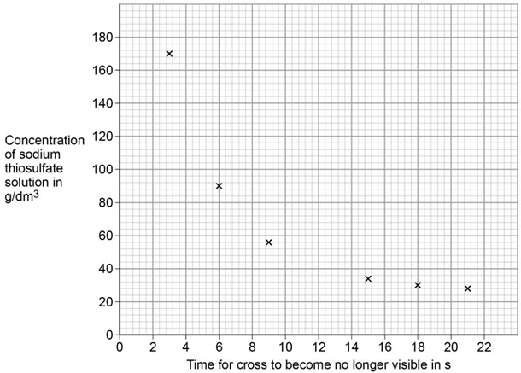
Draw a smooth curve of best fit on the graph above.
(1)
(g) Another student does the same investigation. Both students have a similar pattern in their results. Which word describes investigations performed by different students, which give a similar pattern of results?
Tick (✔) one box.

Accurate
Precise
Reproducible
Valid
(1)
(h) The more concentrated the sodium thiosulfate solution, the less time is taken for the cross to become no longer visible. Give two reasons why. Tick (✔) two boxes.

Particles are more spread out
Particles collide more frequently
Particles have more energy
Particles move more quickly
There are more particles in a fixed volume
(2)
(Total 11 marks)
Q2.
(a) The figure below represents the reaction of sulfur dioxide with oxygen.
Oxygen
Sulfur dioxide 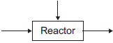 Sulfur trioxide
(i) Complete the word equation for the reaction of sulfur dioxide with oxygen.
sulfur dioxide + __________________ __________________
(1)
(ii) Draw a ring around the correct answer to complete the sentence.

Sulfur dioxide (SO₂) is | a compound.  an element.  a mixture.
(1)
(b) The reactants are gases.
When the pressure of the gases is increased, the reaction gets faster.
Complete the sentence.
When the pressure of the gases is increased,
the frequency of the collisions ___________________________________ .
(1)
(c) The particles need energy to react.
Complete the sentence.
The minimum amount of energy that particles need to react is called
the ___________________________________ energy.
(1)
(d) Give one way of increasing the rate of the reaction other than changing the pressure.
___________________________________________________________________
___________________________________________________________________
(1)
(Total 5 marks)
Q3. When sodium thiosulfate solution reacts with dilute hydrochloric acid, the solution becomes cloudy.
The equation for the reaction is:
Na₂S₂O₃(aq) + 2 HCl(aq) ⟶ 2 NaCl(aq) + SO₂(g) + H₂O(l) + S(s)
(a) Why does the solution become cloudy?
___________________________________________________________________
___________________________________________________________________
___________________________________________________________________
(2)
Some students used this reaction to investigate the effect of concentration on rate of reaction. The diagram shows the apparatus used.
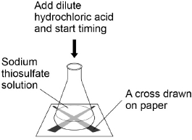
This is the method used.
1. Measure 25 cm³ sodium thiosulfate solution into a conical flask.
2. Stand the conical flask on a cross drawn on paper.
3. Add 10 cm³ of dilute hydrochloric acid.
4. Time how long it takes the cross to become no longer visible.
5. Repeat steps 1–4 with sodium thiosulfate solutions of different concentrations.
(b) The students used a measuring cylinder to measure 25 cm³ of sodium thiosulfate solution. Suggest a more accurate way of measuring 25 cm³ of sodium thiosulfate solution.
___________________________________________________________________
___________________________________________________________________
(1)
(c) Name one control variable the students should use in this investigation.
___________________________________________________________________
(1)
The table shows the students’ results.

Concentration of sodium thiosulfate solution in mol / dm³ | Time for cross to become no longer visible in s
0.020 | 170
0.040 | 90
0.060 | 82
0.080 | 42
0.100 | 34
0.120 | 30
0.140 | 28
(d) Plot the data from the table above on the graph below. Draw a line of best fit.
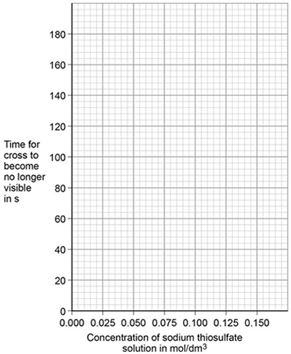
(3)
The students repeated the investigation two more times. They obtained similar results each time.
(e) What word describes an investigation by the same students which gives similar results each time?
___________________________________________________________________
(1)
(f) Describe how the students can use their results to improve the accuracy of the investigation.
___________________________________________________________________
___________________________________________________________________
___________________________________________________________________
(2)
(g) The students analysed their results to give a conclusion and an explanation for their investigation.
Conclusion: ‘The higher the concentration, the lower the rate of reaction.’
Explanation: ‘At higher concentrations, the particles have more energy, so they are moving faster. Therefore the collisions are more energetic.’
The students are not correct. Give a correct conclusion and explanation for the results of the investigation.
Conclusion _________________________________________________________
___________________________________________________________________
___________________________________________________________________
Explanation _________________________________________________________
___________________________________________________________________
___________________________________________________________________
___________________________________________________________________
(3)
(h) A solution containing 0.18 g of sodium thiosulfate reacts with dilute hydrochloric acid in 2 minutes. Calculate the mean rate of reaction in g / s. Give your answer in standard form.
___________________________________________________________________
___________________________________________________________________
___________________________________________________________________
___________________________________________________________________
Mean rate of reaction = ____________________ g / s
(3)
(Total 16 marks)
Q4. Cobalt forms coloured compounds. A pink cobalt compound reacts with hydrochloric acid.
The reaction can be represented as:
pink cobalt compound + hydrochloric acid ⇌ blue cobalt compound + water
The forward reaction is endothermic. When both cobalt compounds are present in a solution at equilibrium, the equilibrium mixture is purple.
(a) What is meant by equilibrium?
___________________________________________________________________
___________________________________________________________________
___________________________________________________________________
(2)
(b) The equilibrium mixture is cooled. Explain what happens to the concentration of the pink cobalt compound.
___________________________________________________________________
___________________________________________________________________
___________________________________________________________________
___________________________________________________________________
(3)
(c) More hydrochloric acid is added. Explain what happens to the colour of the equilibrium mixture
___________________________________________________________________
___________________________________________________________________
___________________________________________________________________
___________________________________________________________________
(3)
(d) Why does cobalt form different coloured compounds?
___________________________________________________________________
(1)
(e) An oxide of cobalt has the formula Co₂O₃
Which cobalt ion is present in this oxide?
Tick (✔) one box.

Co⁺
Co²⁺
Co³⁺
Co⁴⁺
(1)
(f) Cobalt compounds can act as catalysts.
Which two statements about cobalt compounds are correct?
Tick (✔) two boxes.

They allow reactions to reach equilibrium more quickly.
They are reactants in reactions catalysed by cobalt compounds.
They are used up when acting as catalysts.
They increase the equilibrium yield of reactions.
They provide a different reaction pathway.
(2)
(g) The reaction of hydrogen with carbon monoxide is catalysed by cobalt metal.
Balance the equation for the reaction.
H₂ + CO ⟶ C₆H₁₄ + H₂O
(1)
(h) C₆H₁₄ is an alkane.
What is the formula of an alkane containing 18 hydrogen atoms?
__________________________________
(1)

(i) The graph shows a reaction profile diagram for a reaction without a catalyst.
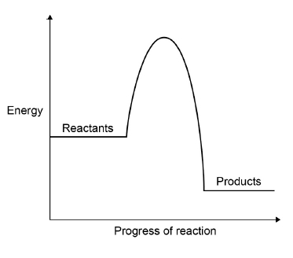
On the graph:
• draw the reaction profile diagram for a catalysed reaction
• draw and label an arrow to show the activation energy for the reaction without a catalyst.
(2)
(Total 16 marks)
Q5.
A student investigated the rate of reaction between marble chips and hydrochloric acid.
Figure 1 shows the apparatus the student used.
Figure 1
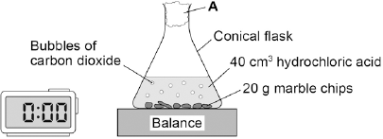
(a) What is A?

Tick one box.
cotton wool
limestone
poly(ethene)
rubber bung
(1)
(b) Table 1 shows the student’s results for one investigation.
Table 1

 | Time  in s | Mass lost  in g
 | 0 | 0.0
 | 20 | 1.6
 | 40 | 2.6
 | 60 | 2.9
 | 80 | 3.7
 | 100 | 4.0
 | 120 | 4.0
On Figure 2:
• Plot these results on the grid.
• Draw a line of best fit.
Figure 2
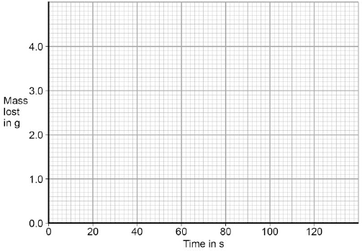
(3)
(c) Use Figure 2 to complete Table 2.
Table 2

Mass lost after 0.5 minutes | ______ g
Time taken to complete the reaction | ______ s
(2)
(d) The equation for the reaction is:
2HCl(aq) + CaCO₃(s) → CaCl₂(aq) + H₂O(l) + CO₂(g)
Explain why there is a loss in mass in this investigation.
___________________________________________________________________
___________________________________________________________________
___________________________________________________________________
(2)
(e) Another student investigated the rate of a different reaction.
Table 3 shows the results from the different reaction.
Table 3

Mass lost when the reaction was complete | 9.85 g
Time taken to complete the reaction | 2 minutes 30  seconds
Calculate the mean rate of the reaction using Table 3 and the equation:
mean rate of reaction =
Give your answer to two decimal places.
___________________________________________________________________
___________________________________________________________________
Mean rate of reaction = _____________________ g / s
(2)
(f) The student measured the change in mass of the reactants.
Describe another method, other than measuring the change in mass of the reactions, that the student could have used to find the rate of the reaction between marble chips and hydrochloric acid.
___________________________________________________________________
___________________________________________________________________
___________________________________________________________________
___________________________________________________________________
(2)
(g) Another student planned to investigate the effect of temperature on the rate of reaction.
The student predicted that the rate of reaction would increase as the temperature was increased.
Give two reasons why the student’s prediction is correct.

Tick two boxes.
The particles are more concentrated.
The particles have a greater mass.
The particles have a larger surface area.
The particles have more energy.
The particles move faster.
(2)
(Total 14 marks)
Q6. A student investigated the rate of reaction of magnesium and hydrochloric acid.
Mg(s) + 2HCl(aq) MgCl₂(aq) + H₂(g)
The student studied the effect of changing the concentration of the hydrochloric acid.
She measured the time for the magnesium to stop reacting.
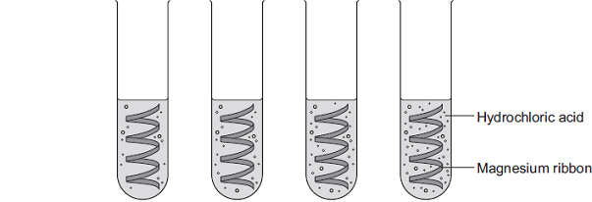
Concentration of hydrochloric acid in moles per dm³ | 0.5 | 1.0 | 1.5 | 2.0
(a) The student changed the concentration of the hydrochloric acid.
Give two variables that the student should control.
1. _________________________________________________________________
2. _________________________________________________________________
(2)
(b) (i) The rate of reaction increased as the concentration of hydrochloric acid increased.
Explain why.
______________________________________________________________
______________________________________________________________
______________________________________________________________
______________________________________________________________
(2)
(ii) Explain why increasing the temperature would increase the rate of reaction.
______________________________________________________________
______________________________________________________________
______________________________________________________________
______________________________________________________________
______________________________________________________________
______________________________________________________________
(3)
(c) (i) The student had a solution of sodium hydroxide with a concentration of 0.100 moles per dm³. She wanted to check the concentration of a solution of hydrochloric acid.
She used a pipette to transfer 5.00 cm³ of the hydrochloric acid into a conical flask.
She filled a burette with the 0.100 moles per dm³ sodium hydroxide solution.
Describe how she should use titration to obtain accurate results.
______________________________________________________________
______________________________________________________________
______________________________________________________________
______________________________________________________________
______________________________________________________________
______________________________________________________________
______________________________________________________________
______________________________________________________________
(4)
(ii) Sodium hydroxide neutralises hydrochloric acid as shown in the equation:
NaOH(aq) + HCl(aq) NaCl(aq) + H₂O(l)
The student found that 27.20 cm³ of 0.100 moles per dm³ sodium hydroxide neutralised 5.00 cm³ of hydrochloric acid. Calculate the concentration of the hydrochloric acid in moles per dm³. Give your answer to three significant figures.
______________________________________________________________
______________________________________________________________
______________________________________________________________
______________________________________________________________
______________________________________________________________
Concentration of hydrochloric acid = _______________ moles per dm³
(3)
(Total 14 marks)
Q7. A student investigated the effect of temperature on the rate of a reaction.
The picture below shows an experiment.
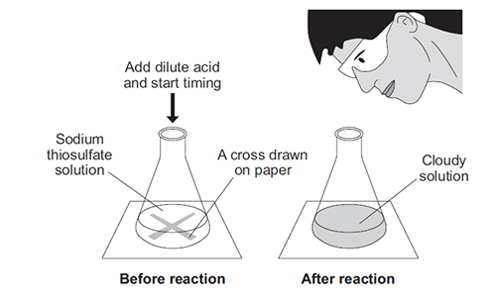
The student:
• put sodium thiosulfate solution into a conical flask
• heated the sodium thiosulfate solution to the required temperature
• put the flask on a cross drawn on a piece of paper
• added dilute hydrochloric acid and started a stopclock
• stopped the stopclock when the cross could no longer be seen
• repeated the experiment at different temperatures.
The equation for the reaction is:
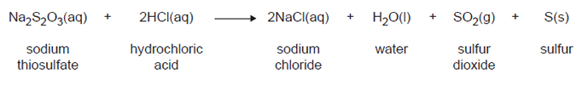
(a) Explain why the solution goes cloudy.
___________________________________________________________________
___________________________________________________________________
___________________________________________________________________
___________________________________________________________________
(2)
(b) Give two variables the student must control to make the investigation a fair test.
1. _________________________________________________________________
2. _________________________________________________________________
(2)
(c) State the effect that increasing the temperature of the sodium thiosulfate solution has on the rate of the reaction.
Explain this effect in terms of particles and collisions.
___________________________________________________________________
___________________________________________________________________
___________________________________________________________________
___________________________________________________________________
___________________________________________________________________
___________________________________________________________________
___________________________________________________________________
___________________________________________________________________
___________________________________________________________________
(4)
(d) Suggest how the student should change the method to investigate the rate of reaction at 5°C.
___________________________________________________________________
___________________________________________________________________
(1)
(Total 9 marks)
Q8. This question is about reversible reactions and chemical equilibrium.
(a) Reversible reactions can reach equilibrium in a closed system.
(i) What is meant by a closed system?
______________________________________________________________
______________________________________________________________
(1)
(ii) Explain why, when a reversible reaction reaches equilibrium, the reaction appears to have stopped.
______________________________________________________________
______________________________________________________________
______________________________________________________________
______________________________________________________________
(2)
(b) In the Haber process, the reaction of nitrogen with hydrogen to produce ammonia is reversible.
N₂(g) + 3 H₂(g) 2 NH₃(g)
(i) Name a natural resource from which hydrogen is produced.
______________________________________________________________
(1)
(ii) The Haber process uses a catalyst to speed up the reaction.
Explain how a catalyst speeds up a reaction.
______________________________________________________________
______________________________________________________________
______________________________________________________________
______________________________________________________________
(2)
(iii) What happens to the amount of ammonia produced at equilibrium if the pressure is increased? Give a reason for your answer.
______________________________________________________________
______________________________________________________________
______________________________________________________________
______________________________________________________________
(2)

(c) The decomposition of hydrogen iodide into hydrogen and iodine is reversible.
2HI(g) H₂(g) + I₂(g)
The forward reaction is endothermic.
The energy level diagram shown below is for the forward reaction.
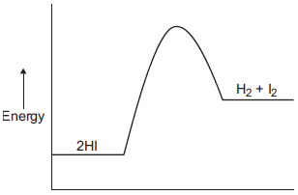
(i) Draw an arrow to show the activation energy on the diagram.
(1)
(ii) How does the diagram show that the reaction is endothermic?
______________________________________________________________
______________________________________________________________
(1)
(iii) Suggest what effect, if any, increasing the temperature will have on the amount of hydrogen iodide at equilibrium.
Give a reason for your answer.
______________________________________________________________
______________________________________________________________
______________________________________________________________
______________________________________________________________
(2)
(Total 12 marks)

Q1.This question is about hydrocarbons.
The table gives information about four hydrocarbons.
The hydrocarbons are four successive members of a homologous series.

Hydrocarbon | Formula | Boiling point in °C
A | C₄H₁₀ | 0
B |  | 36
C | C₆H₁₄ | 69
D | C₇H₁₆ | 98
(a) What is the formula of hydrocarbon B?
Tick (✔) one box.

C₄H₁₂
C₅H₁₂
C₅H₁₂
C₆H₁₂
(1)
(b) What is the simplest ratio of carbon : hydrogen atoms in a molecule of hydrocarbon A?
Ratio = 2 : _______
(1)
(c) Which hydrocarbon is a gas at room temperature (25 °C)?
Tick (✔) one box.

A |  |  | B |  |  | C |  |  | D
(1)
(d) Which hydrocarbon is most flammable?
Tick (✔) one box.

A |  |  | B |  |  | C |  |  | D
(1)

(e) Which two substances are produced when a hydrocarbon completely combusts in air?
Tick (✔) two boxes.

Carbon
Carbon dioxide
Hydrogen
Sulfur dioxide
Water
(2)
The diagram shows the displayed structure of a hydrocarbon molecule.
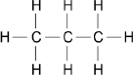
(f) What is the name of the hydrocarbon in the diagram above?
Tick (✔) one box.

Butane
Ethane
Methane
Propane
(1)
(g) Calculate the relative formula mass (M_{r}) of the hydrocarbon in the diagram above.
Relative atomic masses (A_{r}): H = 1 C = 12
___________________________________________________________________
___________________________________________________________________
Relative formula mass (M_{r}) = ____________________
(2)
(Total 9 marks)
Q2. This question is about alkenes and crude oil.
(a) Pentene is an alkene molecule containing five carbon atoms.
Complete the formula for pentene.
C _____ H _____
(1)
(b) Butene is an alkene molecule containing four carbon atoms.
The diagram shows all of the atoms and some of the bonds in the displayed formula for butene.
Complete the displayed formula by adding the remaining bonds.
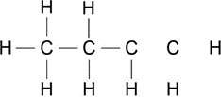
(1)
Pentene and butene are produced from crude oil.
The table shows the percentages of different fractions in two samples of crude oil.

Fraction | Percentages by mass in %
 | Crude oil A | Crude oil B
Liquefied petroleum gases | 14.7 | 7.1
Petrol | 28.6 | 11.1
Diesel oil | 20.5 | 17.2
Kerosene | 15.4 | 38.5
Heavy fuel oil | 12.0 | 16.0
Other fractions | 8.8 | 10.1

The graph shows the percentages of different fractions in crude oil A.
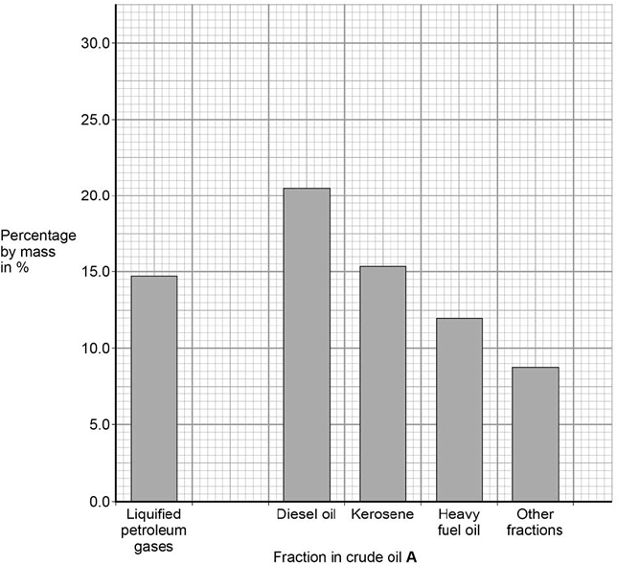
(c) Plot the data for petrol in the table above on the graph.
(1)
(d) What mass of crude oil A is needed to obtain 12 tonnes of heavy fuel oil?.
Use the table above.

10 tonnes
100 tonnes
1000 tonnes
10 000 tonnes
(1)
(e) What mass of crude oil A is needed to obtain 12 tonnes of heavy fuel oil?.
Calculate the total mass of car fuel that can be produced from 2000 kg of crude oil B.
Use the table above.
___________________________________________________________________
___________________________________________________________________
___________________________________________________________________
___________________________________________________________________
Mass of car fuel = ____________________ kg
(3)
(f) Crude oil B is a better source of hydrocarbons for cracking than crude oil A.
Suggest why.
Use the table above.
___________________________________________________________________
___________________________________________________________________
(1)
(g) Alkenes are obtained from crude oil using fractional distillation followed by cracking.
Explain how alkenes are produced using fractional distillation followed by cracking.
(6)
(Total 14 marks)
Q3.
The table below gives information about four alcohols.

Alcohol | Formula | Melting point  in °C | Boiling point  in °C
Methanol | CH₃OH | −94 | 65
Ethanol | CH₃CH₂OH | −118 | 78
Propanol | CH₃CH₂CH₂OH | −129 | 97
Butanol | CH₃CH₂CH₂CH₂OH | −89 | 118
(a) Which alcohol in the table is liquid over the greatest temperature range?
__________________________________
(1)

(b) Which statement is correct?

Tick one box.
A molecule of ethanol has 5 hydrogen atoms
Butanol has the highest boiling point
Methanol has the largest molecules
Propanol has the highest melting point
(1)
(c) A molecule of methanol has five single covalent bonds. Draw the missing bonds in Figure 1 to complete the displayed formula for methanol.
Figure 1
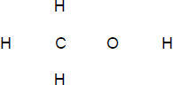
(1)
(d) Figure 2 shows a flow diagram of the process to produce ethanol.
Figure 2
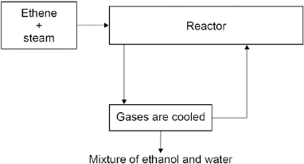
Complete the word equation for the reaction to produce ethanol.
______________________ + ______________________ → ethanol
(1)
(e) What happens to the unreacted ethene?
___________________________________________________________________
___________________________________________________________________
(1)
(f) Wine contains ethanol.
A bottle of wine was left open in air.
After a few days, the wine tasted of vinegar.
Vinegar is a solution of ethanoic acid in water.
Explain how oxidation causes the wine to taste of vinegar after a few days.
___________________________________________________________________
___________________________________________________________________
___________________________________________________________________
___________________________________________________________________
___________________________________________________________________
___________________________________________________________________
___________________________________________________________________
(3)
(Total 8 marks)
Q4.
This question is about organic compounds. Hydrocarbons can be cracked to produce smaller molecules. The equation shows the reaction for a hydrocarbon, C₁₈H₃₈
C₁₈H₃₈ → C₆H₁₄ + C₄H₈ + 2 C₃H₆ + C₂H₄
(a) Which product of the reaction shown is an alkane?

Tick one box.
C₂H₄
C₃H₆
C₄H₈
C₆H₁₄
(1)
(b) The table below shows the boiling point, flammability and viscosity of C₁₈H₃₈ compared with the other hydrocarbons shown in the equation.

 | Boiling point | Flammability | Viscosity
A | highest | lowest | highest
B | highest | lowest | lowest
C | lowest | highest | highest
D | lowest | highest | lowest
Which letter, A, B, C or D, shows how the properties of C₁₈H₃₈ compare with the properties of C₂H₄, C₃H₆, C₄H₈ and C₆H₁₄?

Tick one box.
A
B
C
D
(1)
(c) The hydrocarbon C₄H₈ was burnt in air. Incomplete combustion occurred.
Which equation, A, B, C or D, correctly represents the incomplete combustion reaction?
A C₄H₈ + 4O → 4CO + 4H₂
B C₄H₈ + 4O₂ → 4CO + 4H₂O
C C₄H₈ + 6O₂ → 4CO₂ + 4H₂O
D C₄H₈ + 8O → 4CO₂ + 4H₂

Tick one box.
A
B
C
D
(1)
(d) Propanoic acid is a carboxylic acid.
Which structure, A, B, C or D, shows propanoic acid?
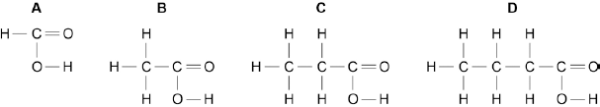

Tick one box.
A
B
C
D
(1)
(e) Propanoic acid is formed by the oxidation of which organic compound?

Tick one box.
Propane
Propene
Propanol
Polyester
(1)
(Total 5 marks)
Q5.The diagrams represent two compounds, A and B.
Compound A Compound B
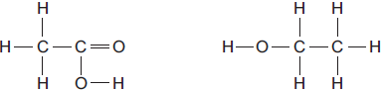
(a) (i) Compound B is an alcohol. Name compound B.
______________________________________________________________
(1)
(ii) Use the correct answer from the box to complete the sentence.

burned | decomposed | oxidised
To form compound A,
compound B is ___________________________________
(1)
(iii) Compounds A and B are both colourless liquids. A test tube contains a colourless liquid, which could be either compound A or compound B. Describe a simple chemical test to show which compound, A or B, is in the test tube.
______________________________________________________________
______________________________________________________________
______________________________________________________________
______________________________________________________________
(2)
(b) Compounds A and B react to produce compound C and compound D.

Compound A Compound B Compound C
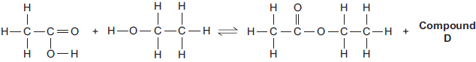
(i) What is the formula of compound D?
______________________________________________________________
(1)
(ii) Compound C is an ester. Name compound C.
______________________________________________________________
(1)
(iii) State one use of esters.
______________________________________________________________
(1)
(Total 7 marks)
Q6. This question is about organic compounds.
(a) Ethanol is an alcohol. One use of ethanol is in alcoholic drinks. Give two other uses of ethanol.
___________________________________________________________________
___________________________________________________________________
(2)
(b) Which gas is produced when sodium reacts with ethanol?

Tick () one box.
Carbon dioxide
Carbon monoxide
Hydrogen
Oxygen
(1)
(c) Ethanoic acid (CH₃COOH) can be produced from ethanol (CH₃CH₂OH).
(i) What type of reaction produces ethanoic acid from ethanol?
______________________________________________________________
(1)
(ii) Complete the displayed structure of ethanoic acid.
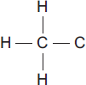
(1)
(iii) Solutions of ethanoic acid and hydrochloric acid with the same concentration have different pH values.
Explain why the solution of ethanoic acid has a higher pH than the solution of hydrochloric acid.
______________________________________________________________
______________________________________________________________
______________________________________________________________
______________________________________________________________
(2)
(d) Ethanol and ethanoic acid react in the presence of a catalyst to form an ester.
(i) Name the ester made from ethanol and ethanoic acid.
______________________________________________________________
(1)
(ii) What type of chemical is used as a catalyst in this reaction?
______________________________________________________________
(1)
(iii) Esters are used in perfumes because they smell pleasant and are volatile.
What does volatile mean?
______________________________________________________________
(1)
(Total 10 marks)
Q7. This question is about organic compounds.
(a) Ethanol burns in air. Use the correct answer from the box to complete the word equation for the reaction.

carbon | hydrogen | oxygen
ethanol + _______________ carbon dioxide + water
(1)
(b) Use the correct answer from the box to complete the sentence.

milk | hard water | vinegar
Ethanoic acid is in ______________________________ .
(1)
(c) Ethanoic acid is a carboxylic acid. Which diagram, A, B or C, has a ring around the functional group of a carboxylic acid? Write your answer in the box.
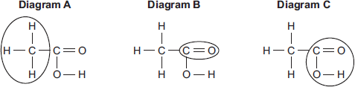

Diagram
(1)
(d) Ethyl propanoate is produced by reacting ethanol with propanoic acid. What type of organic compound is ethyl propanoate?

Tick () one box.
Alcohol
Carboxylic acid
Ester
(1)
(e) Organic compounds such as ethyl propanoate are used in perfumes.
Give two properties of these compounds that make them suitable for use in perfumes.
___________________________________________________________________
___________________________________________________________________
(2)
(Total 6 marks)
Q8. Ethene is used to produce poly(ethene).
(a) Draw the bonds to complete the displayed formulae of ethene and poly(ethene) in the equation.
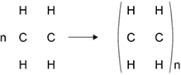
(2)
(b) Polyesters are made by a different method of polymerisation.
The equation for the reaction to produce a polyester can be represented as:
Compare the polymerisation reaction used to produce poly(ethene) with the polymerisation reaction used to produce a polyester.
___________________________________________________________________
___________________________________________________________________
___________________________________________________________________
___________________________________________________________________
___________________________________________________________________
___________________________________________________________________
(4)
(Total 6 marks)
Q9. This question is about ethanol.
(a) Ethanol can be made by fermentation of sugars from plants.
(i) What is a suitable temperature for fermentation?
Draw a ring around the correct answer.

0 °C | 25 °C | 450 °C
(1)
(ii) Fermentation produces a dilute solution of ethanol in water.
Name the process used to obtain ethanol from this dilute solution.
______________________________________________________________
(1)
(b) Ethanol made by fermentation can be used as a biofuel.
(i) Explain why increasing the use of biofuels may cause food shortages.
______________________________________________________________
______________________________________________________________
______________________________________________________________
______________________________________________________________
(2)
(ii) Explain why burning biofuels contributes less to climate change than burning fossil fuels.
______________________________________________________________
______________________________________________________________
______________________________________________________________
______________________________________________________________
______________________________________________________________
(2)
(c) In this question you will be assessed on using good English, organising information clearly and using specialist terms where appropriate.
Ethanol can also be made by reacting ethene with steam in the presence of a catalyst.
C₂H₄(g) + H₂O(g) C₂H₅OH(g)
Figure 1 shows how the percentage yield of ethanol changes as the pressure is changed at three different temperatures.
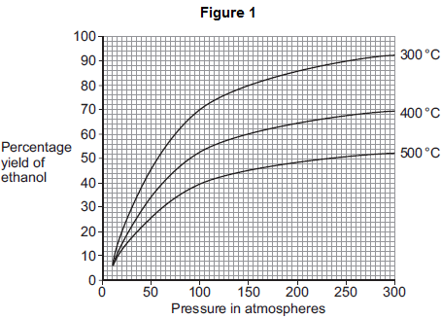

Figure 2 shows how the rate of reaction changes as the temperature changes at three different pressures.
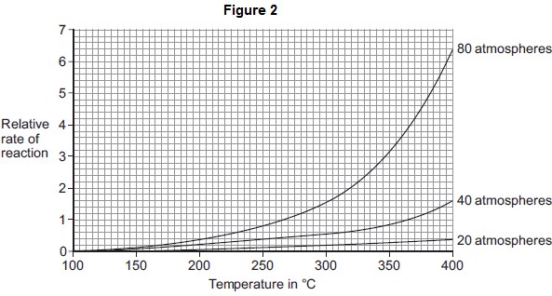
In one process for the reaction of ethene with steam the conditions are:
• 300 °C
• 65 atmospheres
• a catalyst.
Use the information in Figure 1 and Figure 2, and your own knowledge, to justify this choice of conditions.
___________________________________________________________________
___________________________________________________________________
___________________________________________________________________
___________________________________________________________________
___________________________________________________________________
___________________________________________________________________
___________________________________________________________________
___________________________________________________________________
___________________________________________________________________
___________________________________________________________________
(6)
(Total 12 marks)

Q10. This question is about polymers.
(a) The polymer polyvinyl chloride (PVC) is non-biodegradable. Give one problem caused by non-biodegradable polymers.
___________________________________________________________________
___________________________________________________________________
(1)
(b) Figure 1 shows a short section of a PVC molecule.
Figure 1
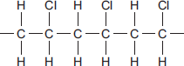
PVC is produced from a monomer that contains two carbon atoms.
Complete the structure of the monomer.

C | C
(2)
(c) Figure 2 represents a few short chains of PVC molecules.
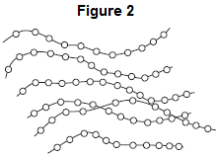
Explain why PVC softens and melts when heated.
Use Figure 2 and your knowledge of structure and bonding to help you to answer the question.
___________________________________________________________________
___________________________________________________________________
___________________________________________________________________
___________________________________________________________________
___________________________________________________________________
___________________________________________________________________
___________________________________________________________________
(3)
(d) Monomer A and monomer B react to form polymer C.
The displayed structures of monomer A, monomer B and a short section of polymer C are shown in Figure 3. The functional group of each structure is shown in a box.
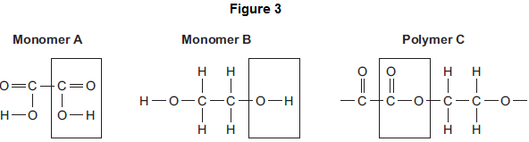
Complete the Table below below by writing the names of the functional groups for monomer A and polymer C.
Table

 | Name of functional group
Monomer A | ___________________________________
Monomer B | alcohol
Polymer C | ___________________________________
(2)
(Total 8 marks)
Q11. This question is about energy changes in chemical reactions.
(a) Complete the word equation for the combustion of hydrogen.
hydrogen + oxygen → ___________________
(1)
(b) Figure 1 shows a simple energy level diagram.
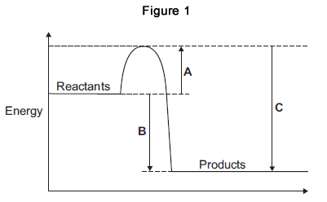
(i) Which arrow, A, B or C, shows the activation energy?

Tick (✔) one box.
A
B
C
(1)
(ii) What type of reaction is shown by the energy level diagram in Figure 1?
Give a reason for your answer.
Type of reaction _________________________________________________
Reason _______________________________________________________
______________________________________________________________
(2)
(iii) For a reaction, the value of A is 1370 kJ and C is 3230 kJ.
Calculate the value of B.
______________________________________________________________
______________________________________________________________
B = _______________________________ kJ
(1)
(c) Alcohols are used as fuels.
A group of students investigated the amount of energy released when different alcohols are burned.
The students used the apparatus shown in Figure 2.
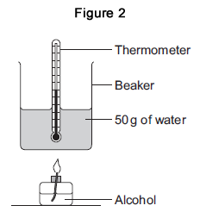
(i) Figure 3 shows the start temperature and the final temperature of the water.
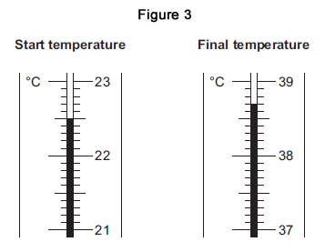
Write the start temperature and the final temperature of the water in Table 1.
Work out the increase in temperature to complete Table 1.

Table 1
Start temperature of the water in °C
Final temperature of the water in °C
Increase in temperature in °C
(3)
(ii) The students worked out the heat energy released by burning 1 g of each alcohol.
The students used the equation: Look at Figure 2. What is the value of m?

Heat energy released = m × 4.2 × increase in temperature
m = _______________________________ g
(1)
(iii) Table 2 shows the students’ results.

Table 2
Name of alcohol | Number of carbon atoms in one molecule of alcohol | Heat energy released when 1 g of alcohol is burned in kJ
Methanol | 1 | 11.4
Ethanol | 2 | 13.5
Propanol | 3 | 20.1
Butanol | 4 | 16.8
Pentanol | 5 | 17.2
Which value of heat energy released is anomalous?
____________________________________
(1)
(iv) Look at Table 2. What is the relationship between the number of carbon atoms in one molecule of alcohol and the heat energy released when 1 g of the alcohol is burned?
______________________________________________________________
______________________________________________________________
(1)
(v) The value in a data book for the amount of heat energy released when 1 g of butanol is burned completely is 36.2 kJ. Suggest two reasons why the students’ result for butanol is lower than the data book value.
1. ____________________________________________________________
______________________________________________________________
2. ____________________________________________________________
______________________________________________________________
(2)
(vi) The displayed structure of butanol is:
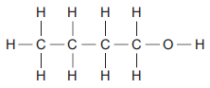
What is the functional group of the alcohol?

Tick (✔) one box.
–– C –– C
–– C –– H
–– O –– H
(1)
(Total 14 marks)
Q12. In industry ethanol is produced by the reaction of ethene and steam at 300°C and 60 atmospheres pressure using a catalyst.
The equation for the reaction is:
C₂H₄ (g) + H₂O (g) C₂H₅OH (g)
The figure below shows a flow diagram of the process.
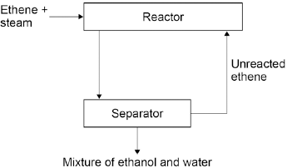
(a) Why does the mixture from the separator contain ethanol and water?
___________________________________________________________________
___________________________________________________________________
(1)
(b) The forward reaction is exothermic. Use Le Chatelier’s Principle to predict the effect of increasing temperature on the amount of ethanol produced at equilibrium. Give a reason for your prediction.
___________________________________________________________________
___________________________________________________________________
___________________________________________________________________
(2)
(c) Explain how increasing the pressure of the reactants will affect the amount of ethanol produced at equilibrium.
___________________________________________________________________
___________________________________________________________________
___________________________________________________________________
___________________________________________________________________
(2)
(Total 5 marks)
Q1. Burgundy Mixture is a formulation used to kill fungi on grapevines.
It is made by mixing two compounds, A and B. The ratio by mass of A : B in the mixture is 1 : 8
(a) Calculate the mass of A needed in a mixture containing 125 g of B.
___________________________________________________________________
___________________________________________________________________
Mass of A = ____________________ g
(2)
Scientists test a solution of compound A. The table shows their results.

Test | Result
Add sodium hydroxide solution | Blue precipitate
Add dilute hydrochloric acid and barium chloride solution | White precipitate
(b) Which two ions are in compound A? Choose the answers from the box.

bromide | chloride | copper
iron(II) | iron(III) | sulfate
___________________ ions and ___________________ ions
(2)
(c) The scientists think that compound B is sodium carbonate.
Describe how the scientists can test a solution of B to see if sodium ions are present.
Give the result of the test if sodium ions are present.
___________________________________________________________________
___________________________________________________________________
___________________________________________________________________
(2)
(d) Describe how the scientists can test a solution of B to see if carbonate ions are present.
Give the result of the test if carbonate ions are present.
___________________________________________________________________
___________________________________________________________________
___________________________________________________________________
___________________________________________________________________
___________________________________________________________________
(3)
(Total 9 marks)
Q2. A student investigated a food colouring using paper chromatography. This is the method used.
1. Put a spot of food colouring X on the start line.
2. Put spots of three separate dyes, A, B and C, on the start line.
3. Place the bottom of the paper in water and leave it for several minutes.
(a) Figure 1 shows the apparatus the student used.
Figure 1
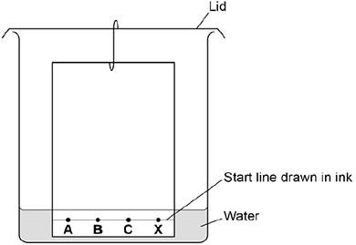
Give two mistakes the student made in setting up the experiment.

Tick two boxes.
The lid was on the beaker.
The paper did not touch the bottom of the beaker.
The spots were too small.
The start line was drawn in ink.
The water level was above the spots.
(2)
(b) Another student set the experiment up correctly.
Figure 2 shows the student’s results.
Figure 2
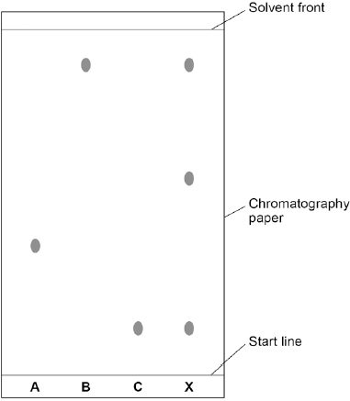
How many dyes were in X? Tick one box.

1 |  |  | 3 |  |  | 4 |  |  | 6
(1)
(c) Which dye, A, B or C, is not in X?

Write your answer in the box.
(1)
(d) Use Figure 2 to complete the table below. Calculate the value for R_{f} for dye A.

 | Distance in mm
Distance moved by dye A | ______________
Distance from start line to solvent front | ______________
Use the equation: Give your answer to two significant figures.
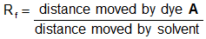
___________________________________________________________________
___________________________________________________________________
___________________________________________________________________
R_{f} value = ________________________________
(5)
(Total 9 marks)
Q3. This question is about chemical tests.
- Solutions of copper(II) ions and iron(III) ions produce coloured precipitates with sodium hydroxide solution. Draw one line from each metal ion to the colour of the precipitate it produces.
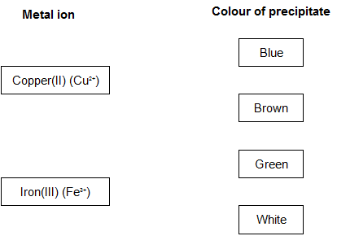
(2)
(b) Sodium hydroxide solution was added to a solution containing ions of a metal. A white precipitate was produced. The white precipitate dissolved in excess sodium hydroxide solution. Use the correct answer from the box to complete the sentence.

aluminium | magnesium | potassium
The ions in the solution were ions of ______________________________ .
(1)
(c) Low sodium salt contains sodium chloride and potassium chloride. A student used a flame test on low sodium salt.
(i) What is the colour produced by sodium ions in a flame test?
______________________________________________________________
(1)
(ii) What is the colour produced by potassium ions in a flame test?
______________________________________________________________
(1)
(iii) Why is it not possible to tell from the flame test that both ions are present in low sodium salt?
______________________________________________________________
______________________________________________________________
(1)
(Total 6 marks)
Q4. Colours are used to coat some chocolate sweets. Some of these colours are given E-numbers.
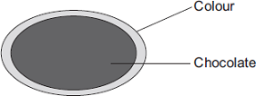
(a) Use the correct word from the box to complete the sentence.

additive | element | fuel
An E-number is used to identify a permitted food ____________________________
(1)

(b) Chromatography was used to compare three of the colours used to coat the chocolate sweets.
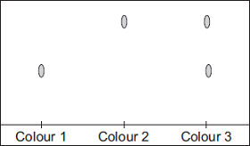
What do these results tell you about these three colours?
___________________________________________________________________
___________________________________________________________________
___________________________________________________________________
___________________________________________________________________
(3)
(Total 4 marks)
Q5. A student investigated food dyes using paper chromatography. This is the method used.
1. Put a spot of food colouring X on the start line.
2. Put spots of four separate dyes, A, B, C and D, on the start line.
3. Place the bottom of the paper in water and leave it for several minutes.
Figure 1 shows the apparatus the student used.
Figure 1
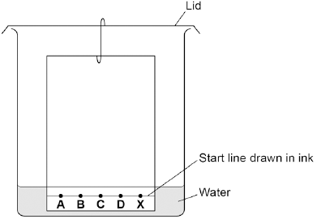
(a) Write down two mistakes the student made in setting up the experiment and explain what problems one of the mistakes would cause.
___________________________________________________________________
___________________________________________________________________
___________________________________________________________________
(2)
(b) Another student set up the apparatus correctly. Figure 2 shows the student’s results. The result for dye D is not shown.
Figure 2
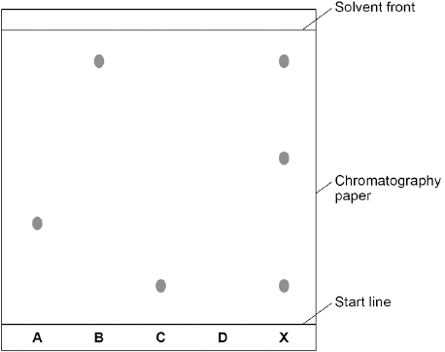
Calculate the R_{f} value of dye A Give your answer to two significant figures.
___________________________________________________________________
___________________________________________________________________
___________________________________________________________________
R_{f} value = ______________________
(3)
(c) Dye D has an R_{f} value of 0.80. Calculate the distance that dye D moved on the chromatography paper.
___________________________________________________________________
___________________________________________________________________
Distance moved by dye D = ______________________
(1)
(d) Explain how the different dyes in X are separated by paper chromatography.
___________________________________________________________________
___________________________________________________________________
___________________________________________________________________
___________________________________________________________________
___________________________________________________________________
(4)
(e) Flame emission spectroscopy can be used to analyse metal ions in solution.
Figure 3 gives the flame emission spectra of five metal ions, and of a mixture of two metal ions.
Figure 3
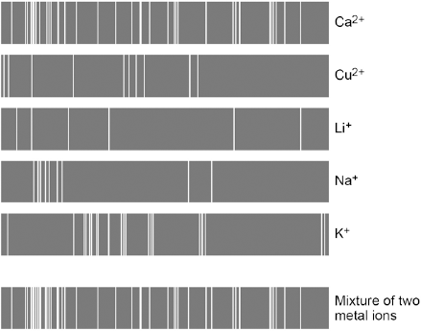
Use the spectra to identify the two metal ions in the mixture.
___________________________________________________________________
___________________________________________________________________
(2)
(f) Explain why a flame test could not be used to identify the two metal ions in the mixture.
___________________________________________________________________
___________________________________________________________________
___________________________________________________________________
___________________________________________________________________
(2)
(g) Two students tested a green compound X.
The students added water to compound X.
Compound X did not dissolve.
The students then added a solution of ethanoic acid to compound X.
A gas was produced which turned limewater milky.
Student A concluded that compound X was sodium carbonate.
Student B concluded that compound X was copper chloride.
Which student, if any, was correct?
Explain your reasoning.
___________________________________________________________________
___________________________________________________________________
___________________________________________________________________
___________________________________________________________________
___________________________________________________________________
___________________________________________________________________
(4)
(Total 18 marks)
Q6. Ethene can be identified using instrumental methods.
(i) Name one instrumental method used to identify elements or compounds.
___________________________________________________________________
___________________________________________________________________
(1)
(ii) Give one advantage of using instrumental methods compared with chemical tests.
___________________________________________________________________
___________________________________________________________________
(1)
(Total 2 marks)
Q7. Alums are salts. They have been used since ancient times in dyeing and medicine and still have many uses today. Three alums are shown in the table:

Name | Ions present
Ammonium alum | NH₄⁺ Al³⁺ SO₄^{2–}
Potassium alum | K⁺ Al³⁺ SO₄^{2–}
Sodium alum | Na⁺ Al³⁺ SO₄^{2–}
A student tested these alums to show which ions were present.
(a) The student did a flame test on these alums. A sample of each alum was held on a wire in a colourless flame.
In (a)(i) and (a)(ii) use the correct word from the box to complete each sentence.

blue | lilac | yellow | green
(i) Sodium ions give a _________________________ flame. (1)
(ii) Potassium ions give a _________________________ flame. (1)
(iii) Draw a ring around the correct answer to complete the sentence.

 | density.
The wire used in a flame test should have a high | electrical conductivity.
 | melting point.
(1)
(b) Draw a ring around the correct word to complete the sentences.
(i) The student tested a solution of each salt for sulfate ions (SO₄^{2–} ).

 | barium chloride
The student added dilute hydrochloric acid and | nitric acid | solution and
 | silver nitrate

 | gas
a white | liquid | was formed.
 | solid
(2)
(ii) The student tested a solution of each salt for aluminium ions (Al³⁺ ).

 | green
The student added sodium hydroxide solution and a | red | precipitate
 | white
was formed. When excess sodium hydroxide solution was added, the

 | boiled.
precipitate | condensed.
 | dissolved.
(2)
(Total 7 marks)
Q8. Limestone is used as a building material. Acid rain erodes limestone.
(a) Limestone contains calcium carbonate.The symbol equation for the reaction of calcium carbonate with hydrochloric acid is shown.
CaCO₃(s) + 2HCl(aq) → CaCl₂(aq) + H₂O(l) + CO₂(g)
Describe a test to show that carbon dioxide is produced in this reaction. Give the result of the test.
___________________________________________________________________
___________________________________________________________________
___________________________________________________________________
(2)
(b) Gases from vehicle exhausts produce sulfuric acid and nitric acid. A student investigated the reaction of these two acids with calcium carbonate (limestone).The type of acid was changed but all other variables were kept the same.The student measured the volume of carbon dioxide produced each minute for a total of 10 minutes. He did this first for the reaction between dilute sulfuric acid and a cube of calcium carbonate (limestone).
The student repeated the experiment using dilute nitric acid in place of the dilute sulfuric acid.The results are shown below.
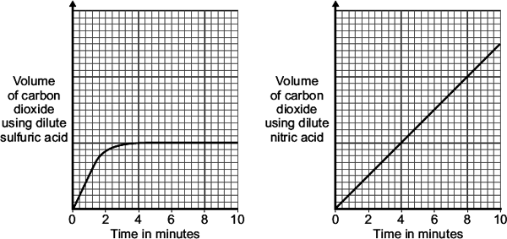
(i) State two variables that must be kept the same for this investigation.
______________________________________________________________
______________________________________________________________
______________________________________________________________
(2)
(i) Reacting calcium carbonate with sulfuric acid gave different results to nitric acid.
The symbol equations for the reaction of calcium carbonate with sulfuric acid and with nitric acid are shown below.
CaCO₃(s) + H₂SO₄(aq) → CaSO₄(s) + H₂O(l) + CO₂(g)
CaCO₃(s) + 2HNO₃(aq) → Ca(NO₃)₂(aq) + H₂O(l) + CO₂(g)
Describe how the results for sulfuric acid are different and use the symbol equations to explain this difference.
______________________________________________________________
______________________________________________________________
______________________________________________________________
______________________________________________________________
______________________________________________________________
______________________________________________________________
______________________________________________________________
(3)
(Total 7 marks)
Q9.
Four bottles of chemicals made in the 1880s were found recently in a cupboard during a Health and Safety inspection at Lovell Laboratories.

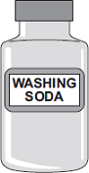  Sodium carbonate | 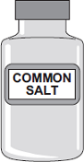  Sodium chloride
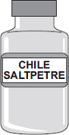  Sodium nitrate | 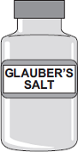  Sodium sulfate
The chemical names are shown below each bottle.
(a) You are provided with the following reagents:
• aluminium powder
• barium chloride solution acidified with dilute hydrochloric acid
• dilute hydrochloric acid
• silver nitrate solution acidified with dilute nitric acid
• sodium hydroxide solution.
• limewater
• red litmus paper
(i) Describe tests that you could use to show that these chemicals are correctly named.
In each case give the reagent(s) you would use and state the result.
Test and result for carbonate ions:
______________________________________________________________
______________________________________________________________
______________________________________________________________
Test and result for chloride ions:
______________________________________________________________
______________________________________________________________
______________________________________________________________
Test and result for nitrate ions:
______________________________________________________________
______________________________________________________________
______________________________________________________________
Test and result for sulfate ions:
______________________________________________________________
______________________________________________________________
______________________________________________________________
(4)
(ii) Suggest why a flame test would not distinguish between these four chemicals.
______________________________________________________________
(1)
(b) Instrumental methods of analysis linked to computers can be used to identify chemicals.
Give two advantages of using instrumental methods of analysis.
___________________________________________________________________
___________________________________________________________________
___________________________________________________________________
___________________________________________________________________
(2)
(Total 7 marks)
Q10. This question is about chemical analysis.
(a) A student has solutions of three compounds, X, Y and Z.
The student uses tests to identify the ions in the three compounds.
The student records the results of the tests in the table.

 | Test
Compound | Flame test | Add sodium hydroxide solution | Add hydrochloric acid and barium chloride solution | Add nitric acid and silver nitrate solution
X | no colour | green precipitate | white precipitate | no reaction
Y | yellow flame | no reaction | no reaction | yellow precipitate
Z | no colour | brown precipitate | no reaction | cream precipitate
Identify the two ions present in each compound, X, Y and Z.
X ____________________________________________________________
Y ____________________________________________________________
Z ____________________________________________________________
(3)
(b) A chemist needs to find the concentration of a solution of barium hydroxide.
Barium hydroxide solution is an alkali. The chemist could find the concentration of the barium hydroxide solution using two different methods.
Method 1
• An excess of sodium sulfate solution is added to 25 cm³ of the barium hydroxide solution. A precipitate of barium sulfate is formed.
• The precipitate of barium sulfate is filtered, dried and weighed.
• The concentration of the barium hydroxide solution is calculated from the mass of barium sulfate produced.
Method 2
• 25 cm³ of the barium hydroxide solution is titrated with hydrochloric acid of known concentration.
• The concentration of the barium hydroxide solution is calculated from the result of the titration.
Compare the advantages and disadvantages of the two methods.
___________________________________________________________________
___________________________________________________________________
___________________________________________________________________
___________________________________________________________________
___________________________________________________________________
___________________________________________________________________
___________________________________________________________________
___________________________________________________________________
___________________________________________________________________
___________________________________________________________________
(5)
(Total 8 marks)
Q11. The colours of fireworks are produced by chemicals.
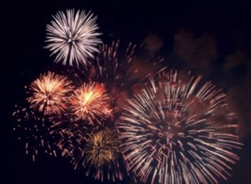
(a) Information about four chemicals is given in the table. Complete the table below.

Chemical | Colour produced in firework
barium chloride | green
_____________ carbonate | crimson
sodium nitrate | _____________
calcium sulfate | red
(2)
(b) Describe a test to show that barium chloride solution contains chloride ions. Give the result of the test.
___________________________________________________________________
___________________________________________________________________
___________________________________________________________________
___________________________________________________________________
(2)
(c) A student did two tests on a solution of compound X.
Test 1
Sodium hydroxide solution was added.
A blue precipitate was formed.
Test 2
Dilute hydrochloric acid was added.
Barium chloride solution was then added.
A white precipitate was formed.
The student concluded that compound X is iron(II) sulfate.
Is the student’s conclusion correct? Explain your answer.
___________________________________________________________________
___________________________________________________________________
___________________________________________________________________
___________________________________________________________________
___________________________________________________________________
___________________________________________________________________
(3)
(Total 7 marks)
Q1. The Earth has a layered structure and is surrounded by an atmosphere.
(a) The diagram shows the layers of the Earth.
Complete the labels on the diagram.
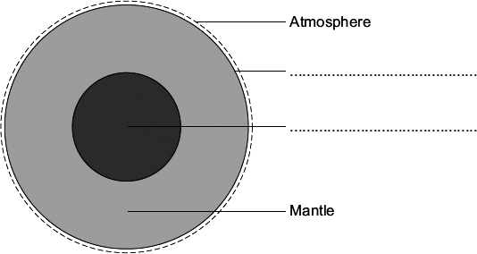
(2)
(b) The data in the table shows the percentages of the gases in the Earth’s atmosphere.

Name of gas | Percentage (%) of gas
Nitrogen | 78
Oxygen | 21
Other gases | 1
Present the data in the table on the grid below.
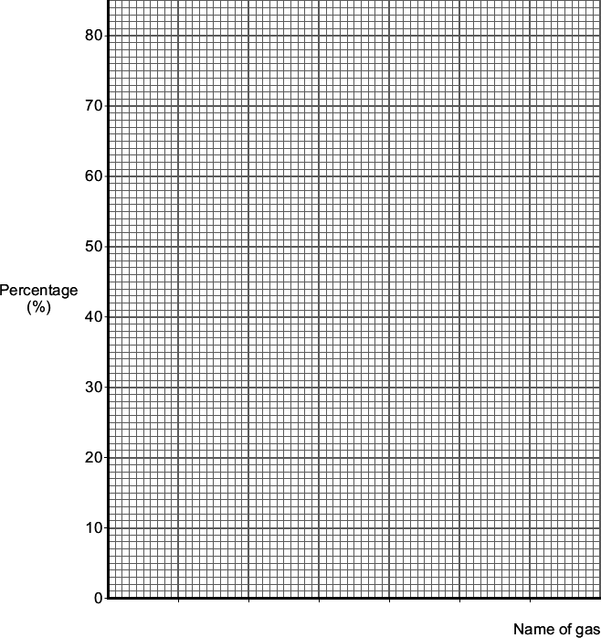
(3)

(c) Millions of years ago a large meteorite hit the Earth.
The meteorite heated limestone in the Earth’s crust to a very high temperature.
The heat caused calcium carbonate in the limestone to release large amounts of carbon dioxide.
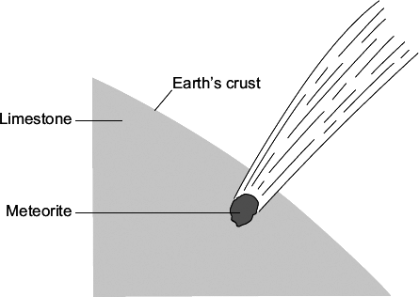
Draw a ring round the correct answer to complete each sentence.

 |  | decomposed.
(i) | Carbon dioxide was released because the calcium carbonate was | evaporated.
 |  | reduced.
(1)

 |  | acid rain.
(ii) | More carbon dioxide in the Earth’s atmosphere causes | global dimming.
 |  | global warming.
(1)
(Total 7 marks)
Q2. Coal is used as a fuel in power stations.
The table shows the percentage of carbon and sulfur in four different coal samples.

Sample | Percentage (%) by mass in coal
 | Carbon | Sulfur
A | 22.1 | 0.4
B | 46.8 | 0.6
C | 66.3 | 0.9
D | 92.0 | 0.7

(a) Sulfur produces a gas that causes acid rain. Name the gas.
___________________________________________________________________
(1)
(b) Give one environmental effect caused by acid rain.
___________________________________________________________________
(1)
(c) Which coal sample produces the most acid rain from 1 kg of coal? Use the table above.
Give a reason for your answer.
Sample __________
Reason ____________________________________________________________
___________________________________________________________________
(2)
(d) Calculate the mass of coal sample A that would produce the same amount of carbon dioxide as 1 kg of coal sample C.
___________________________________________________________________
___________________________________________________________________
Mass of coal sample A = ____________________ kg
(2)
(e) Incomplete combustion of coal can produce carbon monoxide.
Carbon monoxide is a toxic gas.
Give two reasons why people may be unaware of the presence of carbon monoxide.
1. _________________________________________________________________
___________________________________________________________________
2. _________________________________________________________________
___________________________________________________________________
(2)
(Total 8 marks)
Q3. This question is about life, the Earth and its atmosphere.
(a) There are many theories about how life was formed on Earth.
Suggest one reason why there are many theories.
___________________________________________________________________
___________________________________________________________________
(1)
(b) In this question you will be assessed on using good English, organising information clearly and using specialist terms where appropriate.
This Earth and its atmosphere today are not like the early Earth and its atmosphere.
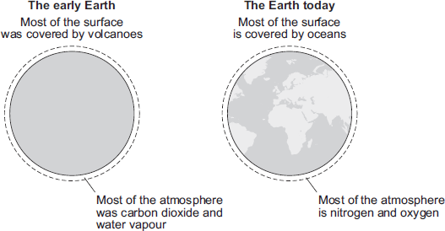
Describe and explain how the surface of the early Earth and its atmosphere have changed to form the surface of the Earth and its atmosphere today.
___________________________________________________________________
___________________________________________________________________
___________________________________________________________________
___________________________________________________________________
___________________________________________________________________
___________________________________________________________________
___________________________________________________________________
___________________________________________________________________
___________________________________________________________________
___________________________________________________________________
(6)
(Total 7 marks)
Q4. Scientists study the atmosphere on planets and moons in the Solar System to understand how the Earth’s atmosphere has changed.
(a) Millions of years ago the Earth’s atmosphere was probably just like that of Mars today.

The table shows data about the atmosphere of Mars and Earth today.

Mars today |  | Earth today
nitrogen | 3% | nitrogen | 78%
oxygen | trace | oxygen | 21%
water | trace | water | trace
Carbon dioxide | 95% | Carbon dioxide | trace
Average surface temperature −23°C |  | Average surface temperature 15°C
The percentages of some gases in the Earth’s atmosphere of millions of years ago have changed to the percentages in the Earth’s atmosphere today.
For two of these gases describe how the percentages have changed and suggest what caused this change.
___________________________________________________________________
___________________________________________________________________
___________________________________________________________________
___________________________________________________________________
(2)
(b) Titan is the largest moon of the planet Saturn.
Titan has an atmosphere that contains mainly nitrogen.
Methane is the other main gas.

Main gases in  Titan's atmosphere | Percentage (%) | Boiling point in °C
Nitrogen | 95 | −196
Methane | 5 | −164
Average surface temperature −178°C
When it rains on Titan, it rains methane! Use the information above and your knowledge and understanding to explain why.
___________________________________________________________________
___________________________________________________________________
___________________________________________________________________
___________________________________________________________________
___________________________________________________________________
___________________________________________________________________
(2)
(c) Ultraviolet radiation from the Sun produces simple alkenes, such as ethene (C₂H₄) and propene (C₃H₆) from methane in Titan’s atmosphere.
State the general formula for alkenes.
___________________________________________________________________
(1)
(Total 5 marks)
Q5. Life on Earth would not exist without the atmosphere. Billions of years ago the composition of the Earth’s atmosphere was very different from the composition today.
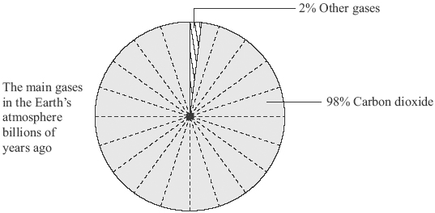
(a) Label the pie chart below to show the percentages and names of the two main gases in the Earth’s atmosphere today.
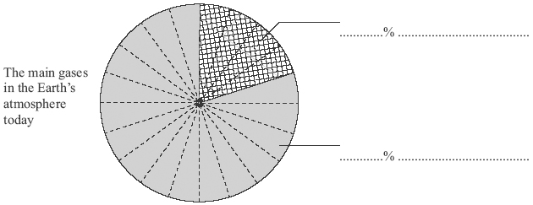
(2)

(b) There is evidence that the composition of the Earth’s atmosphere is still changing. One possible reason is that many power stations generate electricity by burning fossil fuels such as coal, oil or natural gas. Sulfur dioxide, SO₂, is produced when coal burns in air.
(i) What environmental problem does sulfur dioxide cause?
______________________________________________________________
______________________________________________________________
(1)
(ii) How could this environmental problem be reduced in coal-fired power stations?
______________________________________________________________
______________________________________________________________
(1)
(iii) Gas-fired power stations burn methane, CH₄, in air.
Complete the word equation for this reaction.
methane + ________________ → carbon dioxide + ________________
(2)
(c) Excess carbon dioxide should be prevented from entering the atmosphere. Explain why.
___________________________________________________________________
___________________________________________________________________
___________________________________________________________________
___________________________________________________________________
(2)
(d) Carbon dioxide is produced when fossil fuels burn in power stations. The diagram represents one idea to prevent excess carbon dioxide from entering the atmosphere.
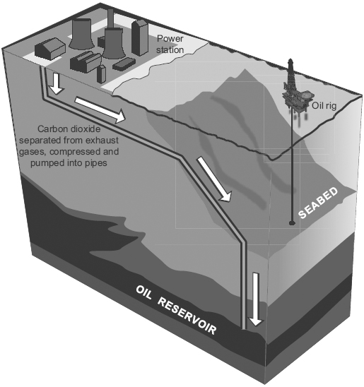
Use the diagram to explain how carbon dioxide can be prevented from entering the atmosphere.
___________________________________________________________________
___________________________________________________________________
___________________________________________________________________
(2)
(Total 10 marks)
Q6. The Earth is shaped like a ball and is surrounded by an atmosphere.
(a) The diagram shows the layered structure of the Earth.
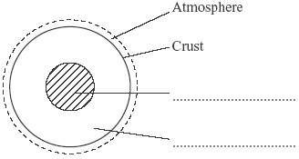
Choose words from the box to complete the labels on the diagram.

core | mantle | plate
(2)
(b) Some theories suggest that the Earth’s early atmosphere was like the atmosphere of Mars today. The bar charts show the three most common gases in each atmosphere today.
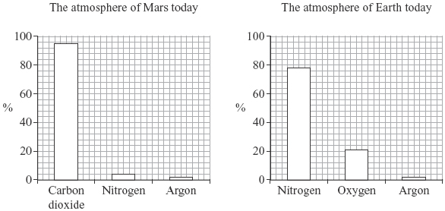
(i) Use the bar charts to complete the sentence by writing in the correct gases.
In the atmosphere of Mars today there is mainly _____________________
and no _____________________ .
(2)
(ii) Use the bar charts to complete the sentence by writing in the correct number.
These theories suggest that there was about _____________________ % nitrogen in the Earth’s early atmosphere.
(1)
(iii) The atmosphere of the Earth today has much more nitrogen than in the early atmosphere. Denitrifying bacteria released most of this nitrogen into the atmosphere.
There are other differences between the Earth’s early atmosphere and the atmosphere of the Earth today. Use the bar charts to describe and explain two of these other differences.
______________________________________________________________
______________________________________________________________
______________________________________________________________
______________________________________________________________
______________________________________________________________
______________________________________________________________
(3)
(Total 8 marks)
Q7. Greenhouse gases affect the temperature of the Earth.
(a) Which gas is a greenhouse gas?

Tick one box.
Argon
Methane
Nitrogen
Oxygen
(1)
(b) An increase in global temperature will cause climate change.
What is one possible effect of climate change?

Tick one box.
Deforestation
Global dimming
Sea levels rising
Volcanic activity
(1)
(c) Carbon dioxide is also a greenhouse gas.
The figure below shows how the concentration of carbon dioxide in the atmosphere has changed since 1850.
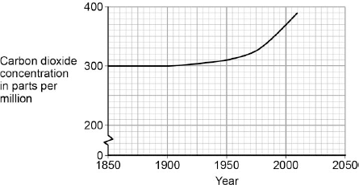

Which process is the reason for the change in carbon dioxide concentration shown on the figure above?

Tick one box.
Burning of fossil fuels
Carbon capture
Formation of sedimentary rocks
Photosynthesis
(1)
(d) Give three conclusions that can be made from the figure above.
1. _________________________________________________________________
___________________________________________________________________
2. _________________________________________________________________
___________________________________________________________________
3. _________________________________________________________________
___________________________________________________________________
(3)
(Total 6 marks)
Q8. This question is about climate change.
Figure 1 shows the changes in the global mean air temperature and global mean sea level from 1992 to 2016.
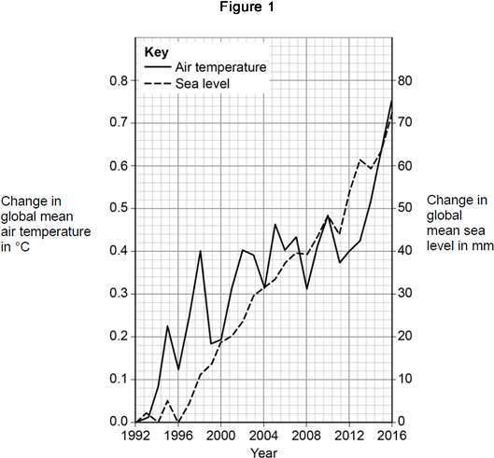
(a) Calculate the mean yearly increase in sea level between 1992 and 2016. Use Figure 1.
___________________________________________________________________
___________________________________________________________________
___________________________________________________________________
Mean yearly increase in sea level = ____________________ mm / year
(2)
Most scientists think carbon dioxide and methane are a cause of global climate change.
Figure 2 shows the amounts of these gases in the atmosphere from 1992 to 2016.
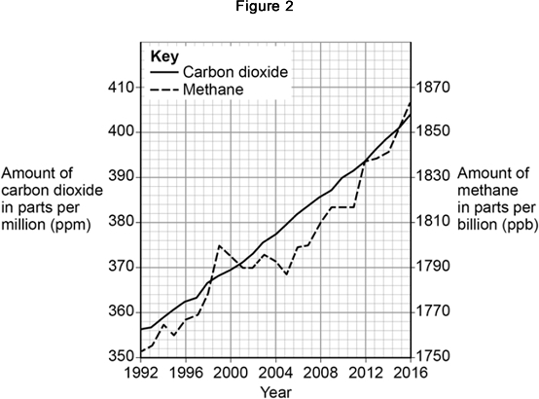
(b) Describe the changes in Figure 1 and in Figure 2.
Explain how these changes have taken place.
(6)
(c) The data was collected by a single scientific group.
Give two reasons why more evidence is needed to support any conclusions made by this scientific group.
1. _________________________________________________________________
___________________________________________________________________
2. _________________________________________________________________
___________________________________________________________________
(2)
(Total 10 marks)
Q9. This question is about copper.
(a) Copper can be extracted by smelting copper-rich ores in a furnace.
The equation for one of the reactions in the smelting process is:
Cu₂S(s) + O₂(g) 2 Cu(s) + SO₂(g)
Explain why there would be an environmental problem if sulfur dioxide gas escaped into the atmosphere.
___________________________________________________________________
___________________________________________________________________
___________________________________________________________________
___________________________________________________________________
(2)
(b) The impure copper produced by smelting is purified by electrolysis, as shown below.
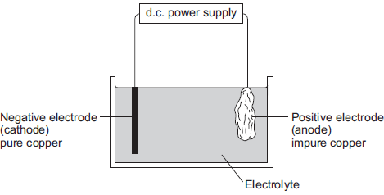
Copper atoms are oxidised at the positive electrode to Cu²⁺ ions, as shown in the half equation.
Cu(s) Cu²⁺(aq) + 2e⁻
(i) How does the half equation show that copper atoms are oxidised?
______________________________________________________________
______________________________________________________________
(1)
(ii) The Cu²⁺ ions are attracted to the negative electrode, where they are reduced to produce copper atoms.
Write a balanced half equation for the reaction at the negative electrode.
______________________________________________________________
(1)
(iii) Suggest a suitable electrolyte for the electrolysis.
______________________________________________________________
(1)
(c) Copper metal is used in electrical appliances.
Describe the bonding in a metal, and explain why metals conduct electricity.
___________________________________________________________________
___________________________________________________________________
___________________________________________________________________
___________________________________________________________________
___________________________________________________________________
___________________________________________________________________
___________________________________________________________________
(4)
(d) Soil near copper mines is often contaminated with low percentages of copper compounds.
Phytomining is a new way to extract copper compounds from soil. Describe how copper compounds are extracted by phytomining.
___________________________________________________________________
___________________________________________________________________
___________________________________________________________________
___________________________________________________________________
___________________________________________________________________
___________________________________________________________________
(3)
(e) A compound in a copper ore has the following percentage composition by mass:
55.6% copper, 16.4% iron, 28.0% sulfur.
Calculate the empirical formula of the compound.
Relative atomic masses (A_{r}): S = 32; Fe = 56; Cu = 63.5
You must show all of your working.
___________________________________________________________________
___________________________________________________________________
___________________________________________________________________
___________________________________________________________________
___________________________________________________________________
Empirical formula = ______________________________
(4)
(Total 16 marks)
Q10. Sulfur is a non-metal.
Sulfur burns in the air to produce sulfur dioxide, SO₂
(a) Why is it important that sulfur dioxide is not released into the atmosphere?
Tick (✔) one box.
Sulfur dioxide causes acid rain.
Sulfur dioxide causes global dimming.
Sulfur dioxide causes global warming.
(1)
(b) Sulfur dioxide dissolves in water.
What colour is universal indicator in a solution of sulfur dioxide?
Give a reason for your answer.
___________________________________________________________________
___________________________________________________________________
___________________________________________________________________
___________________________________________________________________
(2)
(c) Sulfur dioxide is a gas at room temperature. The bonding in sulfur dioxide is covalent.
Explain, in terms of its structure and bonding, why sulfur dioxide has a low boiling point.
___________________________________________________________________
___________________________________________________________________
___________________________________________________________________
___________________________________________________________________
___________________________________________________________________
(3)
(d) In this question you will be assessed on using good English, organising information clearly and using specialist terms where appropriate.
Sulfur dioxide is produced when fossil fuels are burned. It is important that sulfur dioxide is not released into the atmosphere. Three of the methods used to remove sulfur dioxide from gases produced when fossil fuels are burned are:
• wet gas desulfurisation (W)
• dry gas desulfurisation (D)
• seawater gas desulfurisation (S).
Information about the three methods is given in the bar chart and in Table 1 and Table 2.
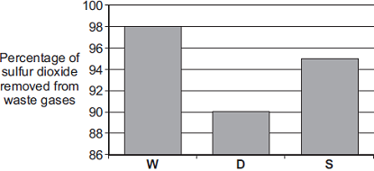
Method of removing sulfur dioxide
Table 1

Method | Material used | How material is obtained
W | Calcium carbonate, CaCO₃ | Quarrying
D | Calcium oxide, CaO | Thermal decomposition of calcium carbonate:  CaCO₃ CaO + CO₂
S | Seawater | From the sea
Table 2

Method | What is done with waste material
W | Solid waste is sold for use in buildings.  Carbon dioxide is released into the atmosphere.
D | Solid waste is sent to landfill.
S | Liquid waste is returned to the sea.
Evaluate the three methods of removing sulfur dioxide from waste gases. Compare the three methods and give a justified conclusion.
___________________________________________________________________
___________________________________________________________________
___________________________________________________________________
___________________________________________________________________
___________________________________________________________________
___________________________________________________________________
___________________________________________________________________
___________________________________________________________________
___________________________________________________________________
___________________________________________________________________
___________________________________________________________________
___________________________________________________________________
___________________________________________________________________
___________________________________________________________________
___________________________________________________________________
(6)
(Total 12 marks)
Q1. This question is about water. River water needs to be treated before it is safe to drink.
(a) The diagram shows two stages of the treatment of river water.
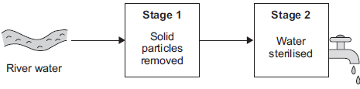
(i) What is the name of the process used to remove solid particles in Stage 1?
Tick () one box.

Crystallisation
Fermentation
Filtration
(1)
(ii) What is added in Stage 2 to sterilise the water? Tick () one box.

Chlorine
Fluoride
Potassium
(1)
(b) Toxic substances in river water are removed by adding very small amounts of iron oxide nanoparticles.
(i) How is the size of nanoparticles different from normal-sized particles?
______________________________________________________________
______________________________________________________________
(1)
(ii) Nanoparticles are needed in only very small amounts. Suggest why.
______________________________________________________________
______________________________________________________________
(1)
(c) In certain areas of the UK, tap water contains aluminium ions. What would you see when sodium hydroxide solution is added drop by drop to tap water containing aluminium ions?
___________________________________________________________________
___________________________________________________________________
___________________________________________________________________
___________________________________________________________________
(2)
(Total 6 marks)
Q2. This question is about drinking water.
(a) The flow diagram below shows how water is made suitable for drinking.
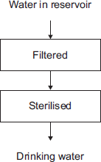
(i) What is removed when the water is filtered?

Tick () one box.
Gases
Liquids
Solids
(1)
(ii) What is used to sterilise the water?

Tick () one box.
Carbon
Chlorine
Sodium chloride
(1)
(iii) Why is the water sterilised?
______________________________________________________________
______________________________________________________________
(1)
(b) Water can be purified by distillation. Drinking water is not usually purified by distillation because distillation is expensive.
Complete the sentence.
Distillation is expensive because it requires a lot of
___________________________________________________________________
(1)
(c) Why do some water companies add fluoride to drinking water?
___________________________________________________________________
___________________________________________________________________
(1)
(Total 5 marks)
Q3. The diagram shows three stages in the treatment of reservoir water.
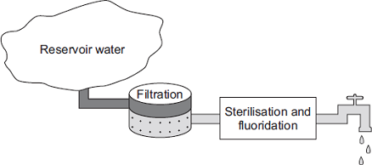
(a) (i) What is separated from the reservoir water during filtration? Tick (✔) one box.
Bacteria
Dissolved nitrates
Solids
(1)
(ii) What is added to sterilise the water? Tick (✔) one box.
Calcium
Chlorine
Magnesium
(1)
(iii) State one advantage of adding fluoride to drinking water.
______________________________________________________________
______________________________________________________________
(1)
(b) The diagram shows a water filter used in the home.
Water in
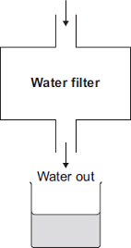

A student collected a sample of water from the filter. The student could show that the filtered water contains dissolved salts without using a chemical test. Describe how.
___________________________________________________________________
___________________________________________________________________
___________________________________________________________________
___________________________________________________________________
(2)
(c) Seawater is forced through a membrane to make drinking water.
Seawater
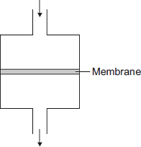
Drinking water
Suggest why water molecules can pass through the membrane, but sodium ions and chloride ions cannot.
___________________________________________________________________
___________________________________________________________________
(1)
(Total 6 marks)

Q4. Iron is extracted from its ore.
(a) Iron ore is quarried.
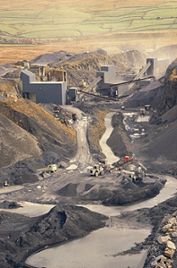
Quarrying iron ore has impacts that cause environmental problems. Tick () two impacts of quarrying that cause environmental problems.

Impact of quarrying | Tick ()
puts off tourists
causes dust pollution
increases jobs
increases traffic
(2)
(b) The diagrams represent the atoms in iron and the atoms in two alloys of iron.
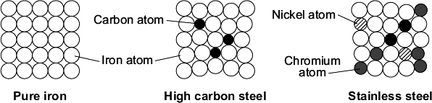
Use the diagrams to help you to answer these questions.
(i) Complete the sentence.
Pure iron does not have many uses because _________________________
______________________________________________________________
(1)
(ii) Stainless steel is more expensive than pure iron. Suggest why.
______________________________________________________________
______________________________________________________________
(1)
(c) Draw a ring around the correct answer to complete each sentence.

 |  | a compound.
(i) | Pure iron is | an element.
 |  | a mixture.
(1)

 |  | brittle.
(ii) | High carbon steel is used for a drill bit because it is | easily bent.
 |  | hard.
(1)

 |  | contains three different atoms.
(iii) | Stainless steel is used to make cutlery because it | melts at a very high temperature.
 |  | is resistant to corrosion.
(1)
(Total 7 marks)
Q5. Copper is a transition metal.
(a) (i) Where is copper in the periodic table?

Tick () one box.
in the central block
in Group 1
in the noble gas group
(1)
(ii) What is a property of copper?

Tick () one box.
breaks easily
conducts electricity
does not conduct heat
(1)
(b) Copper ores are quarried by digging large holes in the ground, as shown in Figure 1.
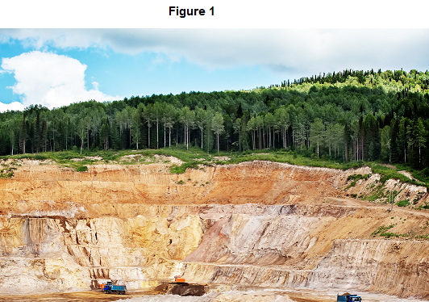

Give two reasons why quarrying is bad for the environment.
___________________________________________________________________
___________________________________________________________________
___________________________________________________________________
___________________________________________________________________
(2)
(c) Some copper ores contain only 2% copper. Most of the ore is rock that is not needed. In one ore, the main compound is copper carbonate (CuCO₃).
Figure 2 shows the stages used in the extraction of copper from this ore.
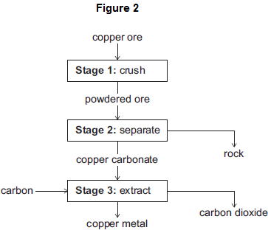
(i) Why is Stage 2 important?
______________________________________________________________
______________________________________________________________
(1)
(ii) The equation for the reaction in Stage 3 is:
2 CuCO₃ + C 2 Cu + 3 CO₂
From the symbol equation, a company calculated that 247 tonnes of copper carbonate are needed to produce 127 tonnes of copper and 132 tonnes of carbon dioxide are released. Calculate the mass of carbon needed to make 127 tonnes of copper.
______________________________________________________________
______________________________________________________________
(2)
(iii) Suggest one reason why it is important for the company to calculate the mass of reactants in Stage 3.
______________________________________________________________
______________________________________________________________
(1)
(Total 8 marks)
Q6. Cans for food and drinks are made from steel or aluminium.The main metal in steel is iron.
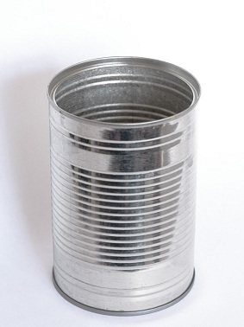
(a) Iron is extracted by heating a mixture of iron oxide and carbon in a blast furnace.
(i) Name this type of reaction.
______________________________________________________________
(1)
(ii) Balance the symbol equation for this reaction.
2Fe₂O₃ + ______ C → ______ Fe + ______ CO₂
(1)
(b) Aluminium ore, bauxite, contains aluminium oxide, iron oxide and silicon dioxide. Aluminium is extracted by electrolysis of aluminium oxide.
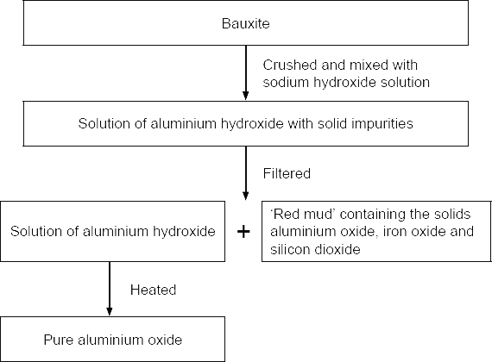
The 'red mud' which is dumped in very large ponds contains:

Name of solid | Percentage (%)
Aluminium oxide | 10
Iron oxide | 65
Silicon dioxide | 25
(i) 100 tonnes of bauxite produced 50 tonnes of pure aluminium oxide and 50 tonnes of 'red mud'. What percentage of aluminium oxide did the bauxite contain?
______________________________________________________________
Answer = _____________________ %
(1)
(ii) Apart from the solids shown in the table, name one other substance that would be in the 'red mud'.
______________________________________________________________
(1)
(iii) The purification of the aluminium oxide is usually done near to the bauxite quarries.
Suggest one reason why.
______________________________________________________________
(1)
(c) Aluminium is used to make many things including cans.
During one year in the USA:
• 100 billion aluminium cans were sold
• 55 billion aluminium cans were recycled.
Give one environmental impact of recycling aluminium cans and one ethical or social impact of recycling aluminium cans.
Environmental _______________________________________________________
___________________________________________________________________
Ethical or social ______________________________________________________
___________________________________________________________________
(2)
(Total 7 marks)
Q7.The diagram represents an electrolysis cell for extracting aluminium.
The current will only flow when the electrolyte is molten.
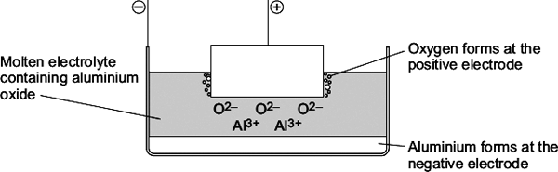
(a) The electrolyte is aluminium oxide mixed with another substance.
(i) What is the name of the other substance in the electrolyte?
Draw a ring around the correct answer.

cryolite | rock salt | limestone
(1)
(ii) Draw a ring around the correct answer to complete the sentence.

 | condense the aluminium oxide.
This other substance is added to | lower the melting point of the aluminium oxide.
 | raise the boiling point of the aluminium oxide.
(1)
(b) (i) Oxide ions (O²⁻) move to the positive electrode. Explain why.
______________________________________________________________
______________________________________________________________
______________________________________________________________
______________________________________________________________
(2)
(ii) Oxygen is formed at the positive electrode. The oxygen then forms carbon dioxide.
The equation for the reaction is shown below.
C + O₂ → CO₂
Complete the sentence.
The name of the element which reacts with oxygen is _________________
(1)
(iii) The positive electrode gets smaller. Suggest why.
______________________________________________________________
______________________________________________________________
(1)
(c) Aluminium is used in an alloy with magnesium to make drinks cans.
The diagrams show the arrangement of atoms in pure aluminium and in the alloy.

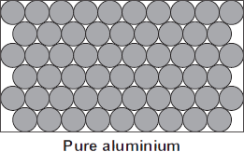 | 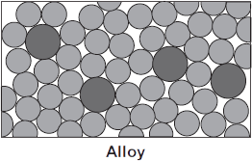
The alloy is harder than pure aluminium. Explain why. Use the diagrams to help you.
___________________________________________________________________
___________________________________________________________________
___________________________________________________________________
___________________________________________________________________
(2)
(Total 8 marks)
Q8.
Where copper ore has been mined there are areas of land that contain very low percentages of copper compounds. One way to extract the copper is to grow plants on the land.
The plants absorb copper compounds through their roots.
The plants are burned to produce copper oxide.
The copper oxide produced from plants can be reacted to produce copper or copper sulfate solution, as shown in Figure 1.
Figure 1
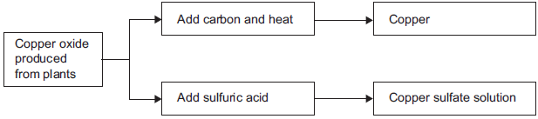
(a) Draw a ring around the correct answer to complete each sentence.

(i) | Copper ores contain enough copper to make extraction of the metal | carbon neutral.  economical.  reversible.
(1)

(ii) | Using plants to extract metals is called | photosynthesis.  phytomining.  polymerisation.
(1)

(iii) | Copper oxide reacts with carbon to produce copper and | carbon dioxide.  oxygen.  sulfur dioxide.
(1)
(b) Copper is produced from copper sulfate solution by displacement using iron or by electrolysis.
(i) Complete the word equation.
copper sulfate + iron ___________ + ___________
(2)
(ii) Figure 2 shows the electrolysis of copper sulfate solution.
Figure 2
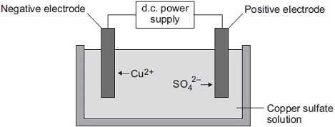
Why do copper ions go to the negative electrode?
______________________________________________________________
______________________________________________________________
(1)
(c) Suggest two reasons why copper should not be disposed of in landfill sites.
___________________________________________________________________
___________________________________________________________________
___________________________________________________________________
___________________________________________________________________
(2)
(Total 8 marks)
Q9. This question is about copper.
(a) Most of the copper extracted is used in electric circuits.
The figure below shows how impurities change the electrical conductivity of copper.
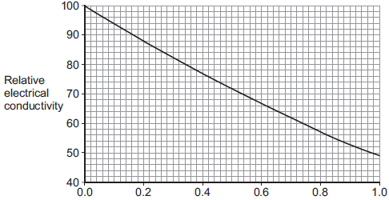
Percentage of impurities in copper
Copper extracted by smelting is about 99% pure. The 99% pure copper produced by smelting is purified to 99.9999% pure copper by electrolysis. Use values from the graph to explain why copper is purified to 99.9999%.
___________________________________________________________________
___________________________________________________________________
___________________________________________________________________
(2)
(b) In this question you will be assessed on using good English, organising information clearly and using specialist terms where appropriate.
Read the information in the box.

Copper extraction
World demand for copper for the year 2011 was about 20 million tonnes.
World reserves of copper are estimated to be 700 million tonnes.
Most of the copper used is obtained from copper ores, which are mined.
The copper ore chalcopyrite is heated in a furnace to produce copper sulfide, CuS
The furnace is heated by burning fossil fuels.
Air is then blown through the hot copper sulfide, to produce copper and sulfur dioxide.
CuS + O₂ → Cu + SO₂
A scientist made the statement: ‘Copper should be recycled’.
Use the information in the box and your own knowledge and understanding to justify the scientist’s statement.
___________________________________________________________________
___________________________________________________________________
___________________________________________________________________
___________________________________________________________________
___________________________________________________________________
___________________________________________________________________
___________________________________________________________________
___________________________________________________________________
___________________________________________________________________
___________________________________________________________________
___________________________________________________________________
___________________________________________________________________
___________________________________________________________________
___________________________________________________________________
___________________________________________________________________
___________________________________________________________________
(6)
(c) Phytomining is used to obtain copper from land that contains very low percentages of copper compounds. Describe how copper compounds are obtained by phytomining.
___________________________________________________________________
___________________________________________________________________
___________________________________________________________________
___________________________________________________________________
___________________________________________________________________
___________________________________________________________________
___________________________________________________________________
___________________________________________________________________
(3)
(Total 11 marks)
Q10. This question is about metals. Figure 1 shows the metals used to make pylons and the wires of overhead cables.
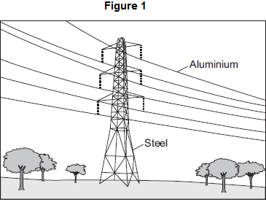
(a) An ore contains a metal compound. A metal is extracted from its ore in three main stages, as shown in Figure 2.
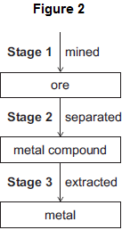
Explain why Stage 2 needs to be done.
___________________________________________________________________
___________________________________________________________________
___________________________________________________________________
___________________________________________________________________
(2)
(b) Cast iron from a blast furnace contains 96% iron and 4% carbon.
(i) Cast iron is not suitable for the manufacture of pylons. Give one reason why.
______________________________________________________________
______________________________________________________________
(1)
(ii) Most cast iron is converted into steel, as shown in Figure 3.
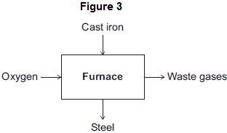
Describe how cast iron is converted into steel.
Use Figure 3 to help you to answer this question.
______________________________________________________________
______________________________________________________________
______________________________________________________________
______________________________________________________________
(2)
(c) Aluminium and copper are good conductors of electricity.
(i) State one property that makes aluminium more suitable than copper for overhead cables.
______________________________________________________________
______________________________________________________________
(1)
(ii) How can you tell that copper is a transition metal and aluminium is not a transition metal from the position of each metal in the periodic table?
______________________________________________________________
______________________________________________________________
______________________________________________________________
______________________________________________________________
(2)
(iii) Copper can be extracted from solutions of copper salts by adding iron. Explain why.
______________________________________________________________
______________________________________________________________
______________________________________________________________
______________________________________________________________
(2)
(Total 10 marks)
Using our Resources
(GCSE CHEM ONLY) (Chemistry Paper 2)
Q1. The Haber Process is used to produce ammonia from nitrogen and hydrogen.The equation for the reaction is:
N₂ + 3H₂ ⇌ 2NH₃
(a) An ammonia molecule has the formula NH₃
How many atoms are there in one molecule of ammonia? Tick (✔) one box.

2 |  |  | 3 |  |  | 4 |  |  | 6
(1)
(b) What does the symbol ⇌ mean?
___________________________________________________________________
(1)
(c) Draw one line from each gas to the source of that gas.
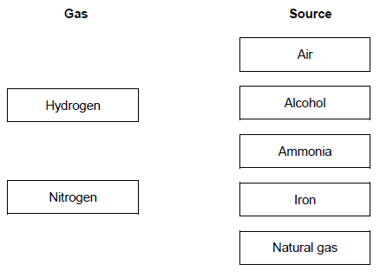
(2)
The diagram shows the Haber process.
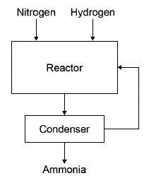
A mixture of ammonia, hydrogen and nitrogen gases leave the reactor. Table 1 shows the boiling points of the gases.

Table 1
Gas | Boiling point in °C
Ammonia | – 33
Nitrogen | – 196
Hydrogen | – 253
(d) The mixture is cooled to a temperature at which only the ammonia condenses to a liquid.
Which temperature could be used? Tick (✔) one box.

− 20 °C
− 40 °C
− 200 °C
− 260 °C
(1)
(e) What happens to the unreacted nitrogen? Tick (✔) one box.

Collected and sold
Recycled to the reactor
Released into the air
Used as a catalyst
(1)
Ammonia from the Haber process can be used to produce fertilisers.
Table 2 gives information about two compounds used in fertilisers.

Table 2
Fertiliser | Compound | Cost in £ / kg
A | Potassium chloride | 0.24
B | Diammonium phosphate | 0.35
(f) What type of bonding is present in potassium chloride? Tick (✔) one box.

Covalent
Ionic
Metallic
(1)
(g) Diammonium phosphate has the chemical formula (NH₄)₂HPO₄
Which two elements in (NH₄)₂HPO₄ improve agricultural productivity? Tick (✔) two boxes.

Chlorine
Hydrogen
Nitrogen
Oxygen
Phosphorus
A farmer uses fertilisers A and B on a field with an area of 0.05 km²
(2)
(h) 50 kg of fertiliser A will cover an area of 0.01 km² Calculate the cost of fertilising a field with an area of 0.05 km² with fertiliser A. Use Table 2.
___________________________________________________________________
Cost = £ ____________________
(2)
(i) Fertiliser B is more expensive than fertiliser A. Suggest why the farmer uses both fertilisers.
___________________________________________________________________
(1)
(Total 12 marks)
Q2. Gold is mixed with other metals to make jewellery. The figure below shows the composition of different carat values of gold.
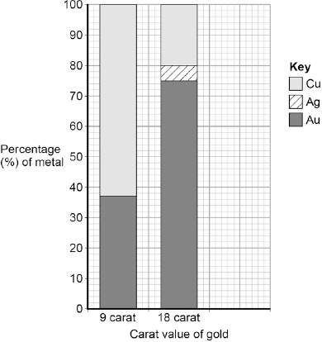
(a) What is the percentage of gold in 12 carat gold? Tick one box.

12 % |  |  | 30 % |  |  | 50 % |  |  | 80 %
(1)
(b) Give the percentage of silver in 18 carat gold.
Use the figure above to answer this question.
Percentage = _____________________________ %
(1)
(c) Suggest two reasons why 9 carat gold is often used instead of pure gold to make jewellery.
1. _________________________________________________________________
___________________________________________________________________
2. _________________________________________________________________
___________________________________________________________________
(2)
(Total 4 marks)
Q3. (a) PEX is a material that is used as an alternative to copper for hot water pipes.
PEX is made from poly(ethene).
(i) Describe how ethene forms poly(ethene).
______________________________________________________________
______________________________________________________________
______________________________________________________________
(2)
(ii) PEX is a shape memory polymer. What property does a shape memory polymer have?
______________________________________________________________
______________________________________________________________
(1)
(iii) The simplified structures of poly(ethene) and PEX are shown.
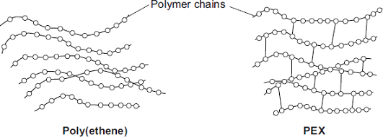
Poly(ethene) is a thermoplastic that softens easily when heated.
Suggest and explain how the structure of PEX changes this property.
______________________________________________________________
______________________________________________________________
______________________________________________________________
(3)
(b) Copper is a suitable material to use for hot water pipes. PEX is now used as an alternative material for hot water pipes. Copper is extracted from its ore by a series of processes.
1 The low-grade copper ore is powdered and concentrated.
2 The concentrated powdered copper ore is blown into a furnace with air to produce impure, molten copper. (This furnace is heated to 1100 °C using a hydrocarbon fuel.)
3 Oxygen is blown into the impure, molten copper to remove any sulfur. The molten copper is cast into rectangular slabs.
4 The final purification of copper is done by electrolysis.
PEX is made from crude oil by a series of processes:
• fractional distillation of crude oil
• cracking of naphtha fraction
• polymerisation of ethene
• conversion of poly(ethene) into PEX.
Use the information above and your knowledge and understanding to suggest possible environmental advantages of using PEX instead of copper for hot water pipes.
___________________________________________________________________
___________________________________________________________________
___________________________________________________________________
___________________________________________________________________
___________________________________________________________________
___________________________________________________________________
___________________________________________________________________
___________________________________________________________________
___________________________________________________________________
___________________________________________________________________
(4)
(Total 10 marks)
Q4. Tablet containers are often made from two different polymers.
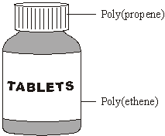
(a) Ethene, C₂H₄, and propene, C₃H₆, can be made from crude oil.
(i) Complete the following sentence.
Ethene and propene are called hydrocarbons because they are made up of
carbon and ___________________________ atoms only.
(1)
(ii) Ethene molecules are used to form poly(ethene) molecules.
Complete the diagram to show the poly(ethene) molecule.
Ethene molecules Poly(ethene) molecule
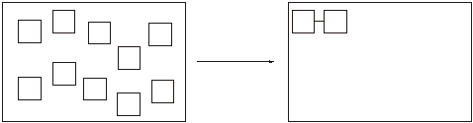
(2)
(b) The tablet containers could be disposed of in a landfill site or could be recycled.
(i) Suggest two reasons why disposing of the tablet containers in a landfill site could cause problems.
1. ____________________________________________________________
______________________________________________________________
2. ____________________________________________________________
______________________________________________________________
(2)
(ii) Suggest one reason why recycling the tablet containers would be difficult.
______________________________________________________________
______________________________________________________________
(1)
(Total 6 marks)
Q5. The figure below shows six test tubes a student set up to investigate the rusting of iron.
This is the method used for each test tube.
1. Measure the mass of the nail using a balance.
2. Leave the nail in the test tube for 6 days.
3. Measure the mass of the nail after 6 days.
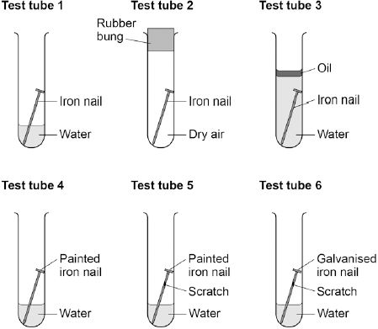
The table below shows the student’s measurements.

Test tube | Mass of nail in g | Mass of nail after  6 days in g
1 | 8.45 | 8.91
2 | 8.46 | 8.46
3 | 8.51 | 8.51
4 | 9.65 | 9.65
5 | 9.37 | 9.45
6 | 9.79 | 9.79
(a) What is the resolution of the balance the student used?

Tick one box.
1 × 10⁻³ g
1 × 10⁻² g
1 × 10⁻¹ g
1 × 10² g
(1)
(b) Calculate the difference in percentage increase in mass after 6 days of the nail in test tube 1 and the nail in test tube 5. Give your answer to three significant figures.
___________________________________________________________________
___________________________________________________________________
___________________________________________________________________
___________________________________________________________________
___________________________________________________________________
Difference in percentage increase in mass = __________ %
(4)
(c) Use the results of the student’s investigations to draw conclusions about the factors affecting the rusting of iron. Include an evaluation of the effectiveness of different coatings at preventing the rusting of iron.
___________________________________________________________________
___________________________________________________________________
___________________________________________________________________
___________________________________________________________________
___________________________________________________________________
___________________________________________________________________
___________________________________________________________________
___________________________________________________________________
(6)
(d) Rust is hydrated iron(III) oxide. Complete the word equation for the reaction.
__________ + __________ + __________ → hydrated iron(III) oxide
(2)
(Total 13 marks)
Q6. Gold and gold ions are used as catalysts.
(a) An atom of gold is represented as:
197
Au
79
Complete the sentences.
The atomic number of gold is __________________________
The number of electrons in an atom of gold is ________________
(2)
(b) Scientists have found that gold nanoparticles are very good catalysts. Draw a ring around the correct answer to complete the sentence.

 | hundred
A gold nanoparticle contains a few | thousand | atoms.
 | million
(1)
(c) The formation of a gold ion (Au³⁺) from a gold atom (Au) is shown in the symbol equation.
Au → Au³⁺ + 3e–
(i) Complete the sentence.
The particles lost when a gold atom becomes a gold ion
are called ___________________________
(1)
(ii) Draw a ring around the correct answer to complete the sentence.

 | one.
The number of these particles lost when a gold atom becomes a gold ion is | two.
 | three.
(1)
(d) Gold ions are used as a catalyst in the reaction to make chloroethene. How does a catalyst help a reaction?
___________________________________________________________________
(1)
(e) Chloroethene can react to make a thermosoftening polymer.
(i) Draw a ring around the correct answer to complete the sentence.

 | dissolve.
When heated, a thermosoftening polymer will | melt.
 | solidify.
(1)
(ii) Polymer B is a different type of polymer. The diagram shows the structure of polymer B.
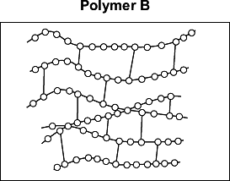
How can you tell from the diagram that polymer B is not thermosoftening?
______________________________________________________________
______________________________________________________________
(1)
(Total 8 marks)
Q7.In the UK, railway sleepers are often made from concrete.
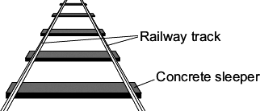
A scientist was asked to find the best concrete mixture to use so that railway sleepers would not break easily. The scientist made:
• a mould to make small models of concrete sleepers
• concrete mixtures using crushed rock, sand, cement and water
• the equipment shown to add 0.1 kg masses until the model sleeper broke.
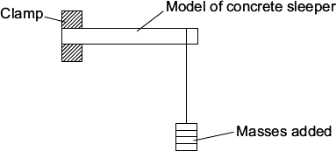
The scientist’s results are shown in the table.

Concrete mixture  in % by volume |  |  | Total mass added to break the model sleeper  in kg
Cement | Sand | Crushed  rock | Test 1 | Test 2 | Test 3 | Mean
10 | 70 | 20 | 1.1 | 1.3 | 1.2 | 1.2
20 | 60 | 20 | 2.6 | 2.5 | 2.4
30 | 50 | 20 | 3.3 | 3.3 | 3.3 | 3.3
40 | 40 | 20 | 3.8 | 4.0 | 3.3 | 3.9
50 | 30 | 20 | 4.5 | 4.2 | 4.3 | 4.3
(a) (i) Calculate the mean total mass added to break the model sleeper that has 20% cement by volume.
______________________________________________________________
Mean = ______________ kg
(1)
(ii) Choose one result in the table that the scientist should check and test again.
Result: % cement by volume ____________ Test number ____________
Explain why you chose this result.
______________________________________________________________
______________________________________________________________
(2)

(iii) What is the relationship between the total mass to break the model sleeper and the percentage (%) of cement by volume in the concrete mixture?
______________________________________________________________
______________________________________________________________
(1)
(iv) Suggest one other variable that the scientist should have recorded in the table of results.
______________________________________________________________
(1)
(b) The scientist thought that full-size railway sleepers should be made from 30% cement,
50% sand and 20% crushed rock.
What other information about these three materials is needed before the scientist recommends using this mixture to make a full-size railway sleeper?
___________________________________________________________________
___________________________________________________________________
___________________________________________________________________
___________________________________________________________________
(2)
(Total 7 marks)
Q8. Iron will rust in damp air.
(a) Iron reacts with water and oxygen to produce rust.
(i) As iron rusts there is a colour change.
Draw a ring around the correct answer to complete the sentence.
During the reaction iron changes from grey to
blue brown green
(1)
(ii) Rust is hydrated iron oxide.
Write a word equation for the reaction of iron with oxygen and water.
______________________________________________________________
(1)
(b) A student set up the apparatus shown in Figure 1.
Figure 1
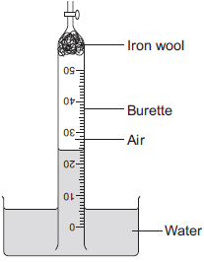
The student left the apparatus for a few days. The water level in the burette slowly went up and then stopped rising. Figure 2 shows the water level in the burette at the start of the experiment and after a few days.
Figure 2
At start After a few days
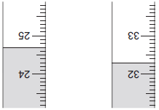
(i) Complete the table below to show the reading on the burette after a few days.

Burette reading at start | 24.7 cm³
Burette reading after a few days | _________________cm³
(1)
(ii) Calculate the volume of oxygen used up in the reaction.
______________________________________________________________
Volume = _________________________ cm³
(1)
(iii) The percentage of air that is oxygen can be calculated using the equation:
percentage of air that is oxygen = 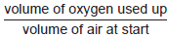 × 100
The student cannot use his results to calculate the correct percentage of air that is oxygen. Explain why.
______________________________________________________________
______________________________________________________________
______________________________________________________________
______________________________________________________________
______________________________________________________________
(2)
(c) A student investigated the rusting of an iron nail at different temperatures. This is the method the student used:
• measure the mass of a nail
• set up apparatus as shown in Figure 3
• leave for 3 days
• measure the mass of the rusted nail.
Figure 3
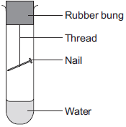
The student repeated the experiment at different temperatures using a new, identical, nail each time. The student’s results are shown on the graph in Figure 4.

Figure 4
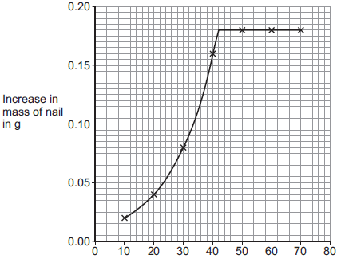
Temperature in °C
(i) Why does the mass of the nail increase when it rusts?
______________________________________________________________
______________________________________________________________
(1)
(ii) Use the graph to describe the relationship between the temperature and the increase in mass of the nail.
______________________________________________________________
______________________________________________________________
______________________________________________________________
______________________________________________________________
______________________________________________________________
(3)
(iii) The increase in mass of the nail after 3 days is a measure of the rate of rusting.
The student’s graph does not correctly show how increasing the temperature above 42 °C changes the rate of rusting. How could the experiment be changed to show the effect of temperatures above 42 °C on the rate of rusting?
Give a reason for your answer.
______________________________________________________________
______________________________________________________________
______________________________________________________________
______________________________________________________________
(2)
(Total 12 marks)
Q9. In 1909 Fritz Haber invented a process to produce ammonia from nitrogen and hydrogen.
(a) Complete and balance the chemical equation for the production of ammonia from nitrogen and hydrogen.
N₂ + 3 H₂ __________
(2)
(b) The figure below shows how the equilibrium yield of ammonia changes with pressure at different temperatures.
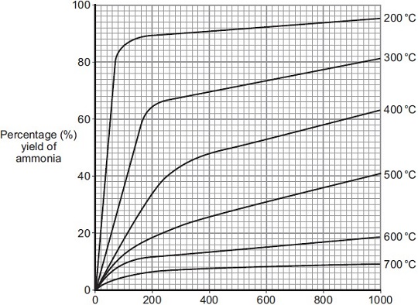
Pressure in atmospheres
(i) Use the information in given in the figure to complete the sentence.
The temperature on the graph that gives the highest yield of ammonia is
_________ °C.
(1)
(ii) The temperature used in the Haber process for the production of ammonia is 450 °C.
Why is a temperature much lower than 450 °C not used for the Haber process?
______________________________________________________________
______________________________________________________________
(1)
(iii) Use the information in the figure to answer this question.
Draw a ring around the pressure that gives the highest yield of ammonia.

100 | 200 | 300 | 400
(1)
(iv) The pressure used in the Haber process for the production of ammonia is 200 atmospheres. Why is a pressure lower than 200 atmospheres not used for the Haber process?
______________________________________________________________
______________________________________________________________
(1)
(c) Explain how ammonia is separated from unreacted nitrogen and hydrogen in the Haber process.
___________________________________________________________________
___________________________________________________________________
___________________________________________________________________
___________________________________________________________________
(2)
(Total 8 marks)
Q10. Dental braces are made from nitinol wires. Nitinol is a mixture of metals.
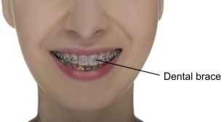
(a) Nitinol can return to its original shape after being deformed.
Draw a ring around the correct answer to complete the sentence.

Nitinol is a shape memory | alloy.  catalyst.  polymer.
(1)
(b) Figure 1 shows the arrangement of atoms in a pure metal and in a mixture of metals.
Figure 1

Pure metal | Mixture of metals
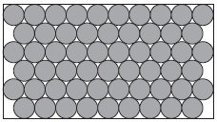 | 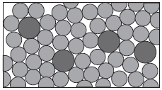
The mixture of metals is harder than the pure metal. Use Figure 1 to explain why.
___________________________________________________________________
___________________________________________________________________
___________________________________________________________________
___________________________________________________________________
(2)
(c) Gold and stainless steel are also used for dental braces.
Suggest two factors to consider when choosing which metal to use for dental braces.
___________________________________________________________________
___________________________________________________________________
___________________________________________________________________
___________________________________________________________________
(2)
(d) A thermosetting polymer is used to hold dental braces on the teeth.
Figure 2 shows the structure of a thermosetting polymer.
Figure 2
Thermosetting polymer
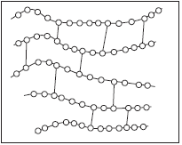
How can you tell from Figure 2 that the polymer is thermosetting?
___________________________________________________________________
___________________________________________________________________
(1)
(Total 6 marks)
Q11. Plastic and glass can be used to make milk bottles.The figure below shows the percentage of milk bottles made from glass between 1975 and 2010.
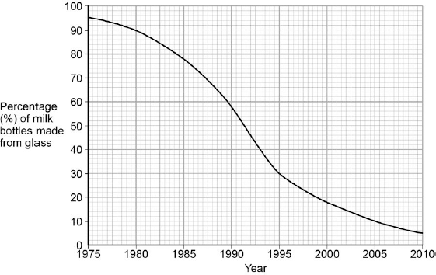
(a) Plot the points and draw a line on the figure above to show the percentage of milk bottles made from materials other than glass between 1975 and 2010.
(3)
(b) The table below gives information about milk bottles.

 | Glass milk bottle | Plastic milk bottle
Raw materials | Sand, limestone, salt | Crude oil
Bottle material | Soda-lime glass | HD poly(ethene)
Initial stage in  production of bottle  material | Limestone and salt  used to produce  sodium carbonate. | Production of naphtha fraction.
Maximum temperature  in production process | 1600 °C | 850 °C
Number of times bottle can be used for milk | 25 | 1
Size(s) of bottle | 0.5 dm³ | 0.5 dm³, 1 dm³, 2 dm³, 3 dm³
Percentage (%) of recycled material used in new bottles | 50 % | 10 %
Evaluate the production and use of bottles made from soda-lime glass and those made from HD poly(ethene).
Use the information given and your knowledge and understanding to justify your choice of material for milk bottles.
___________________________________________________________________
___________________________________________________________________
___________________________________________________________________
___________________________________________________________________
___________________________________________________________________
___________________________________________________________________
___________________________________________________________________
___________________________________________________________________
___________________________________________________________________
(6)
(Total 9 marks)
Q12. This question is about ammonia and fertilisers.
(a) Ammonia is produced by a reversible reaction.
The equation for the reaction is:
N₂ + 3H₂ ⇌ 2NH₃
Complete the sentence.
The forward reaction is exothermic, so the reverse reaction
is _______________________
(1)
(b) Calculate the percentage by mass of nitrogen in ammonia (NH₃).
Relative atomic masses (A_{r}): H = 1; N = 14
You must show how you work out your answer.
___________________________________________________________________
___________________________________________________________________
___________________________________________________________________
___________________________________________________________________
___________________________________________________________________
___________________________________________________________________
Percentage by mass of nitrogen = ___________________ %
(3)
(c) A neutral solution can be produced when ammonia reacts with an acid.
(i) Give the pH of a neutral solution.
pH __________________________________
(1)
(ii) Which of these ionic equations shows a neutralisation reaction?

Tick (✔) one box.
H⁺ + OH⁻ → H₂O
NH₄⁺ + OH⁻ → NH₄OH
H⁺ + Cl⁻ → HCI
H⁺ + H₂O → H₃O⁺
(1)
(iii) Name the salt produced when ammonia reacts with hydrochloric acid.
_____________________________________
(1)
(d) In this question you will be assessed on using good English, organising information clearly and using specialist terms where appropriate.
Farmers use ammonium nitrate as a fertiliser for crops. Rainwater dissolves ammonium nitrate in the soil. Some of the dissolved ammonium nitrate runs off into rivers and lakes.
The graphs A, B and C below show information about the use of ammonium nitrate as a fertiliser. A hectare is a measurement of an area of land.
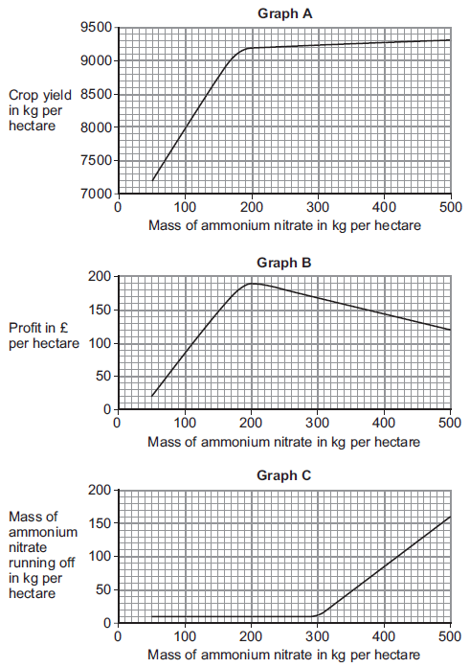
Suggest how much ammonium nitrate farmers should use per hectare. Give reasons for your answer.
Use information from graphs A, B and C.
___________________________________________________________________
___________________________________________________________________
___________________________________________________________________
___________________________________________________________________
___________________________________________________________________
___________________________________________________________________
___________________________________________________________________
___________________________________________________________________
___________________________________________________________________
___________________________________________________________________
___________________________________________________________________
___________________________________________________________________
___________________________________________________________________
(6)
(Total 13 marks)
Q13.This question is about metals and alloys.
(a) Explain how electricity is conducted in a metal.
To gain full marks you must include a description of the structure and bonding of a metal.
___________________________________________________________________
___________________________________________________________________
___________________________________________________________________
___________________________________________________________________
___________________________________________________________________
___________________________________________________________________
(4)
(b) Describe how the structure of an alloy is different from the structure of a pure metal.
___________________________________________________________________
___________________________________________________________________
___________________________________________________________________
(2)
(c) Alloys are used to make dental braces and coins.
(i) Nitinol is an alloy used in dental braces. Why is Nitinol used in dental braces?
______________________________________________________________
______________________________________________________________
(1)
(ii) Suggest one reason why coins are not made of pure copper. Do not give cost as a reason.
______________________________________________________________
______________________________________________________________
(1)
(iii) Some coins are made from an alloy of aluminium. Complete the sentence.
Aluminium is manufactured by the electrolysis of a molten mixture of cryolite
and __________________________ .
(1)
(iv) Banks keep coins in poly(ethene) bags. These bags are made from low density poly(ethene). High density poly(ethene) can also be made from the same monomer.
How can the same reaction produce two different products?
______________________________________________________________
______________________________________________________________
(1)
(d) Give two reasons why instrumental methods of analysis are used to detect impurities in metals.
___________________________________________________________________
___________________________________________________________________
___________________________________________________________________
(1)
(Total 11 marks)
Q14. The graph in Figure 1 shows a flow diagram for the Haber process.
Figure 1
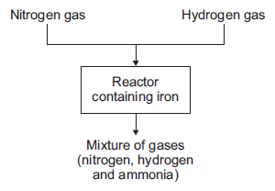
(a) (i) Hydrogen gas is obtained from methane. Name one source of methane.
____________________________________
(1)
(ii) Air is the source used to produce nitrogen for the Haber process.
Suggest why air must not get into the reactor.
______________________________________________________________
______________________________________________________________
______________________________________________________________
(2)
(iii) Describe what happens to the mixture of gases from the reactor.
______________________________________________________________
______________________________________________________________
______________________________________________________________
______________________________________________________________
______________________________________________________________
______________________________________________________________
(3)
(b) The graph in Figure 2 shows the percentage yield of ammonia using different conditions.
Figure 2
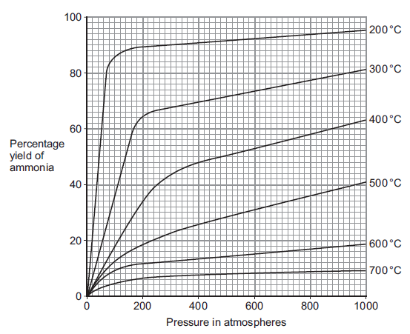
(i) Use Figure 2 to suggest the conditions that produce the greatest yield of ammonia.
______________________________________________________________
______________________________________________________________
(1)
(ii) Use Figure 2 to suggest and explain why the conditions used to produce ammonia in the Haber process are a temperature of 450 °C and a pressure of 200 atmospheres.
______________________________________________________________
______________________________________________________________
______________________________________________________________
______________________________________________________________
______________________________________________________________
______________________________________________________________
______________________________________________________________
______________________________________________________________
______________________________________________________________
______________________________________________________________
(5)
(Total 12 marks)

Mark schemes
Q1.
(a) S(s)
1
(b) measuring cylinder
1
(c) 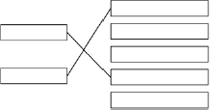
1
allow for 1 mark an answer of dependent variable --- concentration of sodium thiosulfate solution and independent variable --- time for cross to become no longer visible
1
(d) cross might be darker or paler
allow cross may not be the same size / shape
1
(e) 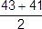
an answer of 42 (s) scores 2 marks
1
= 42 (s)
an answer of 54 (s) scores 1 mark
1
(f) smooth curve through all points
must touch all crosses do not allow straight lines between points
ignore attempt to plot X
1
(g) reproducible
1
(h) particles collide more frequently
1
there are more particles in a fixed volume
1
[11]
Q2. (a) (i) oxygen, sulfur trioxide both needed for mark
1
(ii) compound
1
(b) increases
accept (goes) higher / (goes) up / (is) faster) / (are) more frequent
1
(c) activation
1
(d) catalyst or increase temperature
1
[5]
Q3.
(a) sulfur
1
precipitate
allow solid
1
(b) any one from:
• (volumetric) pipette
• burette
1
(c) any one from:
• concentration of hydrochloric acid
• volume of hydrochloric acid
• volume of sodium thiosulfate solution
• temperature (of solution)
• darkness of cross
allow same cross
• same stirring / swirling
1
(d) 7 points plotted correctly
allow tolerance of ± half a small square
allow 5 or 6 points plotted correctly for 1 mark
2
line of best fit
must avoid anomalous point
1
(e) repeatable
do not accept reproducible
1
(f) discard any anomalous results
1
calculate a mean
1

(g) conclusion:
the higher the concentration, the higher the rate of reaction
1
explanation:
(at higher concentrations) there are more particles in a fixed volume
1
(therefore the) collisions are more frequent
1
allow converse
(h) 120 (s)
1
0.18 / 120
allow 0.0015
1
= 1.5 × 10⁻³ (g / s)
an answer of 9 × 10⁻² scores 2 marks
allow an answer of 0.09 for 1 mark
1
an answer of 1.5 × 10⁻³ (g / s) scores 3 marks
[16]
Q4.
(a) in a closed system
1
the rate of the forward and backward reactions are equal
1
(b) concentration increases
1
(because) reaction / equilibrium moves to the left / reactant side
1
(since the) reverse reaction is exothermic
allow (so that) temperature increases
1
(c) becomes blue
1
(because) reaction / equilibrium moves to the right / product side
1
(so) concentration of blue cobalt compound increases
allow (so that) concentration of hydrochloric acid decreases
1
(d) (cobalt has) ions with different charges
allow (cobalt is a) transition metal
1
(e) Co³⁺
1
(f) they allow reactions to reach equilibrium more quickly
1
they provide a different reaction pathway
1
(g) 13H₂ + 6CO → C₆H₁₄ + 6H₂O
allow multiples
1
(h) C₈H₁₈
1
(i) curve below printed curve
do not accept different reactant or product levels
1
vertical arrow from reactant level to peak of printed curve
1
an answer of:
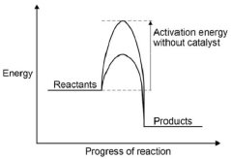
scores 2 marks
[16]
Q5.
(a) cotton wool
1
(b) all points correct ± ½ small square
2
allow 1 mark if 5 or 6 of the points are correct
best fit line must not deviate towards anomalous point
1
(c) (mass)
2.1 (g) allow ecf from drawn best fit line
1
(time)
100 (s)
1
(d) a gas is produced
1
which escapes from the flask
1
(e)
1
0.07 (g / s)
allow ecf answer correctly calculated to 2 decimal places
1
(f) collect the gas in a gas syringe
1
measured the volume of gas
allow carbon dioxide for gas
1
allow for 1 mark
collected gas
or
counted bubbles
(g) The particles have more energy
1
The particles move faster
1
[14]
Q6.
(a) any two from:
• temperature (of the HCl)
• mass or length of the magnesium
• surface area of the magnesium
• volume of HCl
2
(b) (i) (a greater concentration has) more particles per unit volume
allow particles are closer together
1
therefore more collisions per unit time or more frequent collisions.
1
(ii) particles move faster
allow particles have more (kinetic) energy
1
therefore more collisions per unit time or more frequent collisions
1
collisions more energetic (therefore more collisions have energy greater than the activation energy) or more productive collisions
1
(c) (i) add (a few drops) of indicator to the acid in the conical flask
allow any named indicator
1
add NaOH (from the burette) until the indicator changes colour or add the NaOH dropwise
candidate does not have to state a colour change but penalise an incorrect colour change.
1
repeat the titration
1
calculate the average volume of NaOH or repeat until concordant results are obtained
1
(ii) moles of NaOH
0.10 × 0.0272 = 0.00272 moles
correct answer with or without working gains 3 marks
1
Concentration of HCl
0.00272 / 0.005 = 0.544
allow ecf from mp1 to mp2
1
correct number of significant figures
1
[14]
Q7.
(a) because sulfur / S (forms)
1
(which) is solid / insoluble / a precipitate / a suspension
1
(b) any two from:
• volume of sodium thiosulfate
ignore amount of sodium thiosulfate
• volume of (hydrochloric) acid
ignore amount of (hydrochloric) acid
• concentration of sodium thiosulfate
• concentration of (hydrochloric) acid
if no other mark, allow 1 mark for same cross or same flask or unspecified volume or unspecified concentration
ignore same person
do not accept references to temperature
2
(c) rate increases
1
because particles move faster
accept particles have more energy
1
so frequency of collisions increases
accept particles are more likely to collide or more chance of collisions
ignore more collisions
1
more particles / collisions have energy greater than (or equal to) the activation energy
1
(d) cool
accept refrigerate or method to decrease temperature
or
decrease the temperature (of the solutions)
1
[9]
Q8.
(a) (i) nothing can enter and nothing can leave the reaction
allow sealed reaction vessel
1
(ii) forward and backward reactions have same rate
1
so there is no (overall) change in quantities of reactants and products
allow concentrations of reactants and products
1
(b) (i) natural gas
allow methane / CH₄
allow fossil fuels / hydrocarbons
allow water
1
(ii) provides an alternative reaction pathway
1
which has a lower activation energy ignore references to collisions
1
(iii) the amount (of ammonia) increases allow yield increases
1
the equilibrium moves to the side (of the equation) with fewer (gaseous) molecules / moles allow it favours the forward reaction
1
(c) (i) vertical arrow from reactants to maximum
1
(ii) (energy of) products higher than (energy of) reactants
allow converse
1
(iii) amount of hydrogen iodide decreases
1
equilibrium moves in the direction of the endothermic reaction
allow it favours the forward reaction
1
[12]
Mark schemes
Q1.
(a) C₅H₁₂
1
(b) 2:5
1
(c) A
1
(d) A
1
(e) carbon dioxide
1
water
1
(f) propane
1
(g) (8 × 1) + (3 × 12)
1
= 44
1
an answer of 44 scores 2 marks
[9]
Q2.
(a) C₅H₁₀
1
(b) 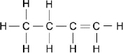
1
(c) bar labelled petrol to 28.6 (%)
allow a tolerance of ± a square
1
(d) 100 tonnes
1
(e) 7.1 + 11.1 + 17.2 = 35.4
1
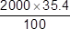 allow ecf from step 1
1
= 708 (kg) an answer of 1276 (kg) gains 2 marks
1
(f) higher percentage (by mass) of heavier fractions
or
higher percentage of larger molecules
1
(g) Level 3 (5-6 marks):
Relevant points (reasons/causes) are identified, given in detail and logically linked to form a clear account.
Level 2 (3-4 marks):
Relevant points (reasons/causes) are identified, and there are attempts at logical linking. The resulting account is not fully clear.
Level 1 (1-2 marks):
Points are identified and stated simply, but their relevance is not clear and there is no attempt at logical linking.
Level 0
No relevant content.
Indicative content
fractional distillation
• oil heated / boiled / vaporised
• fractionating column used
• fractions have different boiling ranges / temperatures
• column hotter at bottom
or
column cooler at top
• fractions condense at different levels
• heavy fractions collect at bottom
or
light fractions collect at top
cracking
• high temperature
• catalyst or steam
• large molecules split into small molecules
• mixture of alkanes and alkenes produced
6
[14]
Q3. (a) Propanol
1
(b) Butanol has the highest boiling point
1
(c) 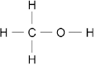
1
(d) ethene + water (→ ethanol)
allow answers in either order allow steam for water
1
(e) goes back to reactor allow is recycled
1
(f) air contains oxygen
1
which oxidises ethanol allow ethanol reacted with oxygen
1
to produce ethanoic acid
1
[8]
Q4. (a) C₆H₁₄
1
(b) A
1
(c) B
1
(d) C
1
(e) Propanol
1
[5]
Q5. (a) (i) ethanol
1
(ii) oxidised
1
(iii) Test
add any named carbonate or hydrogen carbonate the first mark is for the test; the second is for the result if the test is incorrect award 0 marks.
1
Result
A will effervesce (carbon dioxide) or B will not effervesce. if the result is incorrect, award the first mark only
1
or
candidates do not have to name a gas but penalise an incorrect gas.
Test
add a named (magnesium, aluminium, zinc, iron or tin) metal
give credit to any test that will work.
Result
A will effervesce (hydrogen), B will not allow a test that would identify B.
or
Test
add an acid-base indicator
Result
credit any acid colour for that indicator eg for universal indicator allow red, yellow or orange give credit for the neutral colour for B
or
Test
add an alcohol (+ acid catalyst)
Result
sweet or fruity smell of esters.
(b) (i) H₂O
1
(ii) ethyl ethanoate
1
(iii) any one from:
• flavourings
• perfumes
• solvents
• plasticisers
allow any correct use of esters
1
[7]
Q6. (a) any two from:
• fuel
allow source of energy
• solvent
allow perfume / aftershave
• antiseptic
allow antibacterial
2
(b) Hydrogen
1
(c) (i) oxidation
do not allow redox
1
(ii) correct structure
1
(iii) ethanoic acid is a weak / weaker acid
it = ethanoic acid
1
because it does not completely ionise.
allow because it does not completely dissociate
allow it has a lower concentration of hydrogen ions
allow converse for hydrochloric acid
do not allow ionising
1
(d) (i) ethyl ethanoate
1
(ii) acid
allow any strong acid
allow correct formulae
1
(iii) evaporates easily / quickly
allow low boiling point
do not allow flammable
1
[10]
Q7.
(a) oxygen
allow correct answer shown in box if answer line blank
1
(b) vinegar
allow correct answer shown in box if answer line blank
1
(c) C
1
(d) Ester
1
(e) pleasant smell
1
volatile
allow low boiling point / evaporates
1
[6]
Q8.
(a) (ethene)
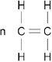
1
(polyethene)
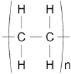
1
(b) any four from:
• poly(ethene) produced by addition polymerisation whereas polyester by condensation polymerisation
• poly(ethene) produced from one monomer wheareas polyester produced
from two different monomers
• poly(ethene) produced from ethene / alkene whereas polyester from a (di)carboxylic acid and a diol / alcohol
• poly(ethene) is the only product formed whereas polyester water also
produced
• poly(ethene) repeating unit is a hydrocarbon whereas polyester has an ester linkage
4
[6]
Q9.
(a) (i) 25 °C
1
(ii) (fractional) distillation
1
(b) (i) (fertile) land is used to grow fuel crops or crops are grown for fuel or farmers get a better price for crops for fuel or crops for biofuels take up space
ignore biofuels are made from food or plants
1
less food grown or food prices rise or less (fertile) land to grow food
1
(ii) (crops / plants) take in carbon dioxide (while growing / during photosynthesis)
1
so the CO₂ given out was previously taken in
do not accept burning biofuels does not release CO₂ or releases less CO₂ unqualified
if no other mark awarded, a statement of “carbon neutral” scores 1 mark
1
(c) Marks awarded for this answer will be determined by the Quality of Communication (QC) as well as the standard of the scientific response. Examiners should also refer to the information in the Marking Guidance and apply a ‘best–fit’ approach to the marking.
0 marks
No relevant content
Level 1 (1−2 marks)
At least one statement about the effect of a condition on either rate or yield.
Level 2 (3−4 marks)
Correct statements about the effect of at least one condition on rate and yield.
Level 3 (5−6 marks)
Correct statements about the effect of at least one condition on rate and yield and at least one correct statement about compromise conditions.
Examples of the points made in the response
Temperature
• a higher temperature gives a lower yield
• a higher temperature gives a faster rate
Pressure
• a higher pressure gives a higher yield
• increase in yield gets less as pressure increases
• a higher pressure gives a faster rate
• increase in rate increases as pressure increases
Catalyst
• using a catalyst speeds up reaction
• catalysts allow a lower temperature to be used and so save energy / reduce energy costs
Compromise
• a higher pressure gives a greater yield but increases costs / (safety) risks
• a high pressure gives a faster rate but increases costs / risks
• a high temperature makes reaction faster but reduces yield
• a catalyst makes reaction faster so a lower temperature can be used which will increase the yield
6
[12]
Q10. (a) any one from:
• disposal or does not decompose (in landfill sites) or collection or sorting for recycling
ignore non-biodegradable alone
• lack of space or more landfill sites
• other specified problems with waste (eg. litter or eyesore or harm to animals or destroys habitats)
ignore pollution unqualified.
1
(b)
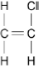
if 2 marks not awarded, award 1 mark for one of the following:
• a double bond between the two carbons and no
additional trailing bonds
• two C atoms bonded together with three single
bonds to hydrogen atoms and one single bond to
a chlorine atom. no additional Cl or H.
2
(c) intermolecular forces or forces between the chains
allow intermolecular bonds
1
(intermolecular forces are) weak
ignore references to no cross links between chains.
allow 1 mark for weak forces between layers.
1
which are easily overcome (by heat) or need little energy to overcome or chains / molecules can slide over one another (when heated)
if weak bonds or breaking covalent bonds mentioned only the third marking point is available.
1
(d) Monomer A − carboxylic acid
do not allow carbolic
1
Polymer C - ester (linkage)
1
[8]

Q11.
(a) water / H₂O
allow steam or hydrogen oxide
1
(b) (i) A
1
(ii) exothermic
1
products (energy) lower than reactants (energy)
1
(iii) 1860 (kJ)
1
(c) (i) 22.5
1
38.7
1
16.2
allow ecf for correct subtraction
1
(ii) 50 (g)
1
(iii) 20.1 (kJ)
allow propanol
ignore 3
1
(iv) as the number of carbon atoms (in one molecule of alcohol) increases the heat energy given out increases (when the alcohol is burned)
1
(v) any two from:
• no lid
• no insulation
• no draught shield
Allow heat / energy loss to surroundings for any one of these marks
• incomplete combustion
• inaccurate measurement
• no repeats (to calculate a mean)
2
(iv) -O-H
1
[14]
Q12.
(a) both water vapour and ethanol will condense
allow steam for water vapour
allow they both become liquids
allow ethane condenses at a lower temperature
allow some of the steam hasn’t reacted
allow it is a reversible reaction / equilibrium
1
(b) amount will decrease
1
because the equilibrium will move to the left
1
(c) more ethanol will be produced
1
because system moves to least / fewer molecules
1
[5]

Mark schemes
Q1.
(a)
1
= 15.6(25) (g)
1
an answer of 15.6(25) (g) scores 2 marks
(b) copper (ions)
allow in either order
1
sulfate (ions)
1
(c) flame test
1
yellow (flame)
1
(d) add dilute acid
allow named acid
1
(bubble gas produced through) limewater
1
(turns) cloudy / milky
allow forms white precipitate
1
[9]
Q2.
(a) The start line was drawn in ink
1
The water level was above the spots
1
(b) 3
1
(c) A
1
(d) (distance moved by dye A) 38 (mm)
allow values in range 36-40
1
(distance from start line to solvent front)
102 (mm)
allow values in range 101-103
1
allow ecf from Table 1
1
0.37254 …
allow values in range 0.35 − 0.39
1
0.37
1
accept 0.37 with no working shown for 5 marks
[9]
Q3.
(a) copper (II) → blue
iron (III) → brown
more than one line from any box negates the mark
1
1
(b) aluminium
allow correct answer shown in box if answer line blank
1
(c) (i) yellow
allow orange
1
(ii) lilac
allow purple
1
(iii) one colour masks the other
allow colours mixed
1
[6]
Q4.
(a) additive
1
(b) colour 3 is a mixture of colours 1 and 2
any two from:
accept E-number or additive instead of colour
ignore comments about height / level
1
• colour 1 is made up of only one colour / dye
• colour 2 is made up of only one colour / dye
• colour 3 is made up of two colours / dyes
or
more colours (than colours 1 and 2)
2
[4]
Q5.
(a) water level above the start line
and
start line drawn in ink
allow water level too high
1
water level
food colours would dissolve into water
or
start line
the ink would ‘run’ on the paper
1
(b) (distance moved by A) 2.8cm and 8.2 cm (distance moved by solvent)
allow values in range 2.7 − 2.9 cm and 8.1 − 8.3 cm
1
1
0.34
allow 0.33 or 0.35
allow ecf from incorrect measurement to final answer for 2 marks if given to 2 significant figures
accept 0.34 without working shown for 3 marks
1
(c) 6.6 cm
allow values between 6.48 and 6.64 cm
1
(d) solvent moves through paper
1
different dyes have different solubilities in solvent
1
and different attractions for the paper
1
and so are carried different distances
1
(e) calcium ions
allow Ca²⁺
1
sodium ions
allow Na⁺
1
(f) two different colours
or
Ca²⁺ / one is orange-red and Na⁺ / the other is yellow
allow brick red for Ca²⁺ and / or orange for Na⁺
allow incorrect colours if consistent with answer to 7.5
1
(so) colours mix
or
(so) one colour masks the other
1
(g) (Student A was incorrect)
because sodium compounds are white not green
or
because sodium carbonate is soluble
1
so can’t contain sodium ions
1
(Student B was incorrect)
because adding acid to carbonate produces carbon dioxide
1
so must contain carbonate not chloride ions
1
[18]
Q6.
(i) correct named instrumental method
eg
atomic absorption spectroscopy / spectrometry
accept atomic / absorption spectroscopy
accept aas
or
mass spectrometry / spectroscopy
accept mass spec
or
infrared (spectrometry) / IR
or
ultraviolet / spectroscopy / UV
or
nuclear magnetic spectroscopy / nmr
or
gas-liquid chromatography / GLC
1
(ii) any one from:
• fast / quick or comment about speed
ignore lost
ignore human error
• small amount
accept operators do not need chemical skills
• sensitive / accurate / precise
ignore safe / easier to use
• ease of automation
• reliable / efficient
• can be left to run / continuous analysis
1
[2]

Q7.
(a) (i) yellow
1
(ii) lilac
1
(iii) melting point
1
(b) (i) barium chloride
1
solid
1
(ii) white
1
dissolved
1
[7]
Q8.
(a) limewater or calcium hydroxide solution
1
(reacts with carbon dioxide and) turns cloudy / milky
linked to first point
if no other mark awarded ‘puts out lighted splint’ gains 1 mark
1
(b) (i) any two from:
• same volume / amount of the acids
• concentration of the acids
• temperature
• same surface area / size / mass / amount of calcium carbonate
• same measuring equipment
2
(ii) any three from:
• (after about 4 minutes) the sulfuric acid stops reacting or nitric acid continues to react
accept more CO₂ with nitric acid at any time after 4 minutes
• (initially) the reaction with sulfuric acid is faster
• (the reaction stops) because calcium sulfate is a solid
allow sulfuric acid produces a solid
• (the reaction continues) because calcium nitrate is soluble / in solution / aqueous
allow nitric acid produces an (aqueous) solution
• because the calcium sulfate prevents the sulfuric acid reacting with the calcium carbonate
• (the rate is faster) because sulfuric acid contains two hydrogens
3
[7]

Q9.
(a) (i) Na₂CO₃: HCl → gas / effervescence / bubbles (1)
CO₂ / carbon dioxide / turns lime water milky (1)
1
NaCl: AgNO₃ → white ppt (1)
silver chloride (1)
1
NaNO₃: Al + NaOH → pungent / sharp smell / choking gas (1)
NH₃ / ammonia / turns (red) litmus blue(1)
1
Na₂SO₄: BaCl₂ → white ppt (1)
barium sulfate (1)
1
each correct test and one result = 1 mark
one other result for any test = 1 mark this mark can only be awarded once
(ii) all would give a yellow / yellow-orange (flame) / same coloured (flame) / same results
allow orange (flame) 1
or
they all contain sodium
1
(b) any two from:
ignore cost/errors
• fast / quick or comment about speed
allow precise
• small amounts/sensitive
allow can be left to run/continuous analysis
• accurate
• ease of automation
accept operators do not need chemical skills
• sample not used up
• reliable / efficient
2
[7]
Q10.
(a) X:
Fe²⁺ / iron(II), SO₄²⁻ / sulfate
allow iron(II) sulfate
or FeSO₄
1
Y:
Na⁺ / sodium, I⁻ / iodide
allow sodium iodide
or NaI
1
Z:
Fe³⁺ / iron(III), Br⁻ / bromide
allow iron(III) bromide
or FeBr₃
correct identification of any two ions = one mark
correct identification of any four ions = two marks
1
(b) any five from:
allow converse arguments
method 1
• weighing is accurate
• not all barium sulfate may be precipitated
• precipitate may be lost
• precipitate may not be dry
• takes longer
• requires energy
allow not all the barium hydroxide has reacted
method 2
• accurate
• works for low concentrations
allow reliable / precise
5
[8]
Q11.
(a) lithium
allow Li⁺ / Li
1
yellow
allow orange
1
(b) silver nitrate (solution)
incorrect test = 0 marks
ignore (nitric) acid
do not allow other named acids
1
white precipitate
1
(c) blue precipitate (with sodium hydroxide) indicates copper ions
allow Cu²⁺
1
and white precipitate (with barium chloride) indicates sulfate ions
allow SO₄²⁻
accept compound X is copper sulfate / CuSO₄ for 1 mark
1
but iron(II) ions produce a green precipitate (with sodium hydroxide)
1
[7]
Mark schemes
Q1.
(a) crust
ignore Earth’s
1
core
ignore inner and/or outer
1
(b) bar chart
1
all heights are correct
accept correctly plotted points
1
all labels are correct for nitrogen, oxygen and other / argon
1
(c) (i) decomposed
1
(ii) global warming
1
[7]
Q2.
(a) sulfur dioxide
1
(b) any one from:
• kills aquatic animals / plants
• damages limestone buildings / statues
• damage to forests
1
(c) (sample) C
1
contains most sulfur
or
produces most sulfur dioxide
1
(d) 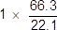
1
= 3 (kg)
1
an answer of 3 (kg) scores 2 marks
(e) any two from:
• not easily detected
• colourless
allow cannot see it
• odourless
allow cannot smell it
2
[8]
Q3.
(a) any one from:
• not enough evidence or proof
allow no evidence or no proof
• (life and the Earth were created) billions of years ago
allow a long time ago
ignore different beliefs or no one was there.
1
(b) Marks awarded for this answer will be determined by the Quality of Written Communication (QWC) as well as the standard of the scientific response. Examiners should also refer to the information in the Marking Guidance and apply a ‘best–fit’ approach to the marking.
0 marks
No relevant content
Level 1 (1−2 marks)
Statements based on diagrams
Level 2 (3−4 marks)
Description of how one change occurred
Level 3 (5−6 marks)
Descriptions of how at least two changes occurred
Examples of chemistry points made in the response could include:
Main changes
• oxygen increased because plants / algae developed and used carbon dioxide for photosynthesis / growth producing oxygen; carbon dioxide decreased because of this
• carbon dioxide decreased because oceans formed and dissolved / absorbed carbon dioxide; carbon dioxide became locked up in sedimentary / carbonate rocks and / or fossil fuels
• oceans formed because the Earth / water vapour cooled and water vapour in the atmosphere condensed
• continents formed because the Earth cooled forming a supercontinent / Pangaea which formed the separate continents
• volcanoes reduced because the Earth cooled forming a crust.
Other changes
• nitrogen has formed because ammonia in the Earth’s early atmosphere reacted with oxygen / denitrifying bacteria.
6
[7]
Q4.
(a) any two from:
asks for cause therefore no marks for just describing the change
must link reason to a correct change in a gas
carbon dioxide has decreased due to:
accept idea of ‘used’ to indicate a decrease
• plants / microorganisms / bacteria / vegetation / trees
• photosynthesis
ignore respiration
• ‘locked up’ in (sedimentary) rocks / carbonates / fossil fuels
• dissolved in oceans
ignore volcanoes
oxygen has increased due to:
accept idea of ‘given out / produced’
• plants / bacteria / microorganisms / vegetation / trees
• photosynthesis
ignore respiration
nitrogen increased due to:
accept idea of ‘given out / produced’
• ammonia reacted with oxygen
• bacteria / micro organisms
ignore (increase in) use of fossil fuels / deforestation
2
(b) (because methane’s) boiling point is greater than the average / surface temperature or Titan’s (average / surface) temperature is below methane’s boiling point
ignore references to nitrogen or water
1
any methane that evaporates will condense
accept boils for evaporates
accept cooling and produce rain for condensing
1
(c) C_{n}H_{2n}
1
[5]
Q5.
(a) oxygen and nitrogen
1
20 – 21 % and 78 – 80 %
accept any two correct responses in the correct space for one mark
1
(b) (i) acid rain
accept toxic gas or consequence of acid rain
1
(ii) idea of the removal or use of sulfur
dioxide gas (from the waste gases)
do not accept remove sulfur from coal
1
(iii) oxygen
accept O₂
1
water
accept H₂O
accept hydrogen oxide / steam
1
(c) any two from:
• it’s a ‘greenhouse gas’ or increase greenhouse effect
accept action of a ‘greenhouse gas’
• causes global warming or increase in the Earth’s temperature
• sea-levels rise or flooding
• climate change
• (polar) ice-caps melt
• extension of deserts
mention of ozone / acid rain / global dimming = max 1 mark
2
(d) idea trap / store / lock the carbon dioxide
1
in the oil reservoir or under the sea bed
do not accept ‘into the oil’ / ‘under the sea’
1
[10]
Q6.
(a) core
ignore outer or inner
1
mantle
1
(b) (i) carbon dioxide
accept formula CO₂
1
oxygen
accept formulae O₂ / O
1
(ii) 4%
1
(iii) carbon dioxide has decreased / from 95% to 0%
1
oxygen has increased / from 0% to 21%
1
any one from:
(carbon dioxide decrease)
• carbon dioxide used during photosynthesis / by plants
• carbon dioxide dissolves in oceans
• carbon dioxide is locked up in rocks / carbonates / fossil fuels
(oxygen increase)
• oxygen released during photosynthesis / by plants
1
Q7.
(a) Methane
1
(b) Sea levels rising
1
(c) Burning of fossil fuels
1
(d) carbon dioxide concentration stayed constant from 1850 to 1900
1
carbon dioxide concentration slowly increased from 1900
1
carbon dioxide concentration increased more rapidly from 1965
allow values from 1965 − 1975
1
[6]
Q8.
(a) 72/24
an answer of 3 (mm / year) scores 2 marks
1
= 3 (mm / year)
an answer of 3.125 (mm / year) scores 1 mark
1
(b) Level 3 (5-6 marks):
Relevant points (reasons / causes) are identified, given in detail and logically linked to form a clear account.
Level 2 (3-4 marks):
Relevant points (reasons / causes) are identified, and there are attempts at logical linking. The resulting account is not fully clear.
Level 1 (1-2 marks):
Points are identified and stated simply, but their relevance is not clear and there is no attempt at logical linking.
Level 0
No relevant content
Indicative content
description
• global air temperature has risen overall / erratically
• mean sea level has risen (steadily)
• carbon dioxide has risen steadily
• methane has risen overall / erratically
explanations
• (carbon dioxide increase because) increase in fossil fuel combustion
or
• (carbon dioxide increase because) increase in deforestation
• methane from cattle / landfill / rice plantations
• carbon dioxide and / or methane trap heat
or
• carbon dioxide and / or methane are greenhouse gases
• polar ice caps melt
or
• seawater expands
linked explanation
• greenhouse gases linked to temperature rise
• temperature rise linked to seawater level
6
(c) any two from:
• bias
• simplified models
• lack of peer review
ignore reproducible
2
[10]
Q9.
(a) because sulfur dioxide causes acid rain
1
which kills fish / aquatic life or dissolves / damages statues / stonework or kills / stunts growth of trees
if no other mark awarded then award 1 mark for sulfur dioxide is toxic or causes breathing difficulties.
1
(b) (i) electrons are lost
1
(ii) Cu²⁺ + 2e⁻→ Cu
allow Cu²⁺→ Cu − 2e⁻
ignore state symbols
1
(iii) copper sulfate
allow any ionic copper compound
1
(c) (lattice of) positive ions
1
delocalised electrons
accept sea of electrons
1
(electrostatic) attraction between the positive ions and the electrons
1
electrons can move through the metal / structure or can flow
allow electrons can carry charge through the metal / structure
if wrong bonding named or described or attraction between oppositely charged ions then do not award M1 or M3 − MAX 2
1
(d) (copper compounds are absorbed / taken up by) plants
allow crops
1
which are burned
1
the ash contains the copper compounds
do not award M3 if the ash contains copper (metal)
1

(e) | / A_{r} | 55.6 / 63.5 | 16.4 / 56 | 28.0 / 32
 | moles | 0.876 | 0.293 | 0.875
 | ratio | 3 | 1 | 3
 | formula | Cu₃FeS₃
award 4 marks for Cu₃FeS₃ with some correct working
award 3 marks for Cu₃FeS₃ with no working
if the answer is not Cu₃FeS₃ award up to 3 marks for correct steps from the table apply ecf
if the student has inverted the fractions award 3 marks for an answer of CuFe₃S
4
[16]
Q10.
(a) Sulfur dioxide causes acid rain.
1
(b) red / orange / yellow
do not accept any other colours
1
because sulfur dioxide (when in solution) is an acid
1
(c) (there are) weak forces (of attraction)
do not accept any reference to covalent bonds breaking
1
between the molecules
do not accept any other particles
1
(these) take little energy to overcome
award third mark only if first mark given
1
(d) Marks awarded for this answer will be determined by the Quality of Communication (QC) as well as the standard of the scientific response. Examiners should also refer to the information on page 5 and apply a ‘best-fit’ approach to the marking.
0 marks
No relevant content
Level 1 (1 – 2 marks)
A relevant comment is made about the data.
Level 2 (3 – 4 marks)
Relevant comparisons have been made, and an attempt made at a conclusion.
Level 3 (5 – 6 marks)
Relevant, detailed comparisons made and a justified conclusion given.
examples of the points made in the response
effectiveness
• W removes the most sulfur dioxide
• D removes the least sulfur dioxide
material used
• Both W and D use calcium carbonate
• Calcium carbonate is obtained by quarrying which will create scars on landscape / destroy habitats
• D requires thermal decomposition, this requires energy
• D produces carbon dioxide which may cause global warming / climate change
• S uses sea water, this is readily available / cheap
waste materials
• W product can be sold / is useful
• W makes carbon dioxide which may cause global warming / climate change
• D waste fill landfill sites
• S returned to sea / may pollute sea / easy to dispose of
6
[12]

Mark schemes
Q1.
(a) (i) Filtration
1
(ii) Chlorine
1
(b) (i) nanoparticles are small / smaller / much smaller / tiny
allow any in range 1−100 nm or 1 × 10⁻⁹ m − 1 × 10⁻⁷ m or a few hundred atoms in size
ignore numbers if stated smaller
1
(ii) they have a high surface area to volume ratio
reference to surface area without volume ratio is insufficient
allow nanoparticles are very reactive or nanoparticles are more reactive than normal particles.
1
(c) (sodium hydroxide) produces a white precipitate
accept solid / suspension or ppt or ppte for precipitate.
ignore cloudy / milky
1
which (then) dissolves / disappears (in excess sodium hydroxide)
M2 cannot be awarded unless a solid of some sort has been made
ignore names or formulae of compounds
1
[6]
Q2.
(a) (i) Solids
1
(ii) Chlorine
1
(iii) kill microbes / bacteria
allow to make the water safe to drink
ignore disinfect
ignore remove / get rid of microbes
1
(b) energy
allow heat
1
(c) improve dental health
allow reduce tooth decay
allow (local) government requirement
allow help teeth
1
[5]
Q3.
(a) (i) Solids
1
(ii) Chlorine
1
(iii) improves dental health or reduces tooth decay
1
(b) put a sample of the filtered water in an evaporating basin or leave to evaporate
accept any description of evaporation (using a Bunsen or leaving on the windowsill)
1
there will be crystals of salt left
1
(c) sodium and / or chloride ions are bigger than water (molecules) or ions are charged or molecules are not charged
do not accept sodium chloride molecules as ions is given in the question
1
[6]
Q4.
(a) causes dust pollution
1
increases traffic
1
(b) (i) it is soft
accept the layers of atoms can slide over each other
ignore other properties
1
(ii) contains chromium / nickel
allow contains other metals
1
(c) (i) an element
1
(ii) hard
1
(iii) is resistant to corrosion
1
[7]

Q5.
(a) (i) central block
1
(ii) conducts electricity
1
(b) any two from:
• visual pollution
• noise pollution
• dust pollution
• habitat destruction.
2
(c) (i) to concentrate the ore / copper carbonate
or
to remove / separate the rock
1
(ii) 12 (tonnes)
If answer is incorrect allow one mark for (127 + 132) − 247 or
259 - 247
2
(iii) any one from:
• so no reactant is wasted / left unreacted
• so they know how much product they will make
• need to record / compensate for the carbon dioxide produced
allow so they can work out their carbon footprint.
1
[8]
Q6.
(a) (i) reduction
accept redox / smelting
1
(ii) 3 4 3
1
(b) (i) 55
ignore other units
(ii) Water
accept sodium hydroxide
accept correct formulae H₂O or NaOH
1
(iii) any one from:
• save energy / fuel for transporting the ore
accept less (cost of) transport allow transported quickly
• (old) quarries nearby for waste/red mud
1
(c) Environmental
any one from:
• less mining / quarrying (of bauxite)
allow loss of habitat / less qualified noise pollution
• less landfill space needed / used
allow less red mud / waste
• less use of fossil fuels / energy
• less carbon dioxide produced
1
Ethical or social
any one from:
• saves resources
allow using resources more than once
• creates (local) employment
if answers reversed and both correct award 1 mark
• more people aware of the need for recycling
allow less qualified noise pollution if not given in environmental
1
[7]

Q7.
(a) (i) cryolite
1
(ii) lower the melting point of the aluminium oxide
1
(b) (i) opposite charges or oxide ions are negative
1
attract
1
(ii) carbon
1
(iii) reacts with oxygen or forms carbon dioxide
accept burns
1
(c) Structure mark:
either Al (atoms) in layers / rows
accept Al (atoms) all the same size
allow Al (atoms) in lines
or alloy (atoms) not in layers / rows
accept different sizes of atoms in alloy
allow alloy (atoms) not in lines
1
Sliding mark:
either so (Al layers) can slide
or so (alloy) layers cannot slide
1
[8]

Q8.
(a) (i) economical
1
(ii) phytomining
1
(iii) carbon dioxide
1
(b) (i) copper / Cu
1
iron sulfate / FeSO₄
1
(ii) copper / ions have a positive charge
it = copper ions
allow copper ions have a different charge
accept copper / ions are free to move
accept to gain electrons
accept copper / ions are attracted to the negative electrode or opposite charges attract
1
(c) any two from:
ignore not biodegradable or does not decay
• copper ores are limited / running out
allow copper is running out
• copper can be recycled
• copper can be reused
• copper is expensive
• landfill sites are filling up
• copper compounds are toxic
allow copper is toxic
2
[8]
Q9.
(a) pure copper is twice as good a conductor as 99% pure copper
accept reverse argument
accept answers quoting 2 correct values from the graph scores 2
qualitative answer (e.g. pure copper is a better conductor than impure copper) scores 1
or
answers quoting a conductivity value from the graph scores 1
2
(b) Marks awarded for this answer will be determined by the Quality of Communication (QC) as well as the standard of the scientific response.
0 marks
No relevant content
Level 1 (1–2 marks)
Simple list of a limited number of points given, with no linking between ideas
Level 2 (3–4 marks)
A broader set of points made. There will probably not be links between ideas
Level 3 (5–6 marks)
Answer includes linking between ideas, showing the consequence of either not recycling or the advantage of recycling. Answers such as less fossil fuel needed so less carbon dioxide produced or less carbon dioxide produced so less global warming
examples of the points made in the response
resources
(recycling) conserves supplies of ores
copper available for longer
as (at present rate of use) copper ores will run out in about 35 years
(recycling) conserves supplies of fossil fuels or energy
less fuel used at a lower cost
land pollution
mining scars landscape or produces noise pollution
mining destroys wildlife habitats
(recycling) less need to mine ores / fossil fuels
so less habitat destroyed or less scarring of landscape
(recycling) less need to use landfill for waste
atmospheric pollution
burning fossil fuels produces carbon dioxide / greenhouse gas
which (may) cause global warming or climate change
extraction produces sulfur dioxide
which causes acid rain
which can kill trees / fish
6
(c) grow plants
accept plants absorb copper (through roots)
1
then plants are burned
1
ash (from burning) contains copper compounds
1
[11]
Q10.
(a) The ore is not pure or contains impurities or the ore does not contain 100% of the metal compound
allow to concentrate the metal or metal compound
1
rock / other compounds need to be removed / separated
1
(b) (i) (cast iron is) brittle
allow not strong
ignore weak
1
(ii) the oxygen reacts with carbon
allow carbon burns in oxygen or is oxidised
1
reducing the percentage of carbon in the mixture
or producing carbon dioxide
1
(c) (i) aluminium has a low density
1
(ii) (because copper) is in the central / middle (block of the periodic table)
1
whereas aluminium is in Group 3 (of the periodic table)
1
(iii) iron is more reactive (than copper)
ignore cost
1
so copper is displaced / reduced
1
[10]

Mark schemes
Q1.
(a) 4
1
(b) reversible (reaction)
1
(c) 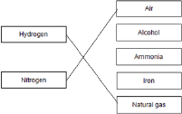
1
1
(d) −40 °C
1
(e) recycled to the reactor
1
(f) ionic
1
(g) nitrogen
1
phosphorus
1
(h) 0.24 × 50 × 5
allow £87.50
1
= £60
1
an answer of £60 scores 2 marks
(i) may need to use nitrogen, phosphorus and potassium
allow neither fertiliser has all the elements / nutrients needed.
[12]
Q2.
(a) 50
1
(b) 5%
1
(c) any two from:
• cost (9 carat is cheaper)
• pure gold is soft
or
24 carat gold is soft
or
9 carat gold is harder
allow 9 carat gold is stronger
allow gold is an alloy in 9 carat gold
• can change the colour
2
[4]
Q3.
(a) (i) many ethene / molecules / monomers
accept double bonds open / break
accept addition polymerisation
1
join to form a long hydrocarbon / chain / large molecule
ignore references to ethane
correct equation gains 2 marks
1
(ii) (can be deformed but) return to their original shape (when heated or cooled)
ignore ‘it remembers its shape’
1
(iii) cross links / extra bonds in PEX
it = PEX throughout
accept inter-molecular bonds
ignore inter-molecular forces
1
molecules / chains in PEX are held in position
accept rigid structure
1
molecules / chains in PEX unable to slide past each other / move
1
(b) any four from:
ignore costs / sustainability / non-renewable
• less (hydrocarbon) fuels used
allow less energy
• less / no electrical energy used
allow no electrolysis
• reduce carbon / carbon dioxide emissions
allow less global warming
• reduce / no pollution by sulfur dioxide / acid rain
allow less / no transportation
• continuous process
• conserve copper which is running out or only low-grade ores available
allow less waste
• reduce the amount of solid waste rock that needs to be disposed
allow less mining
• reduce the need to dig large holes (to extract copper ores)
4
[10]
Q4.
(a) (i) hydrogen
must be name
1
(ii) a line of four or more ethene molecules joined to the original two
with single bonds
at least two other ethene molecules joined to the original two in a chain gains 1 mark
2
(b) (i) any two from:
• non-biodegradable
accept remains a long time
• landfill sites are filling up / limited
accept land / space used up
• waste of a resource / could be recycled / reused
ignore references to tablets / animals
2
(ii) any one from:
• (two) different polymers / plastics / materials
• need to be separated
• limited collection points / many need to be collected
• tablets may still be present
1
[6]
Q5.
(a) 1 × 10⁻² g
1
(b)
1
(test tube 1) 5.44 %
and
(test tube 2) 0.854 %
1
4.586
1
4.59
1
allow ecf answer correctly calculated to 3 significant figures
allow 4.59 with no working for 4 marks
allow 4.586 with no working for 3 marks
(c) Level 3 (5–6 marks):
Detailed and coherent conclusions based on the evidence together with an evaluation
are given in a response that is coherent and well-structured. A range of relevant points is made demonstrating a broad understanding of the key scientific ideas.
Level 2 (3–4 marks):
An attempt to relate relevant points and draw conclusions or to make an evaluation. The logic may be inconsistent at times but builds towards a coherent argument.
Level 1 (1–2 marks):
Simple descriptive statements are made. The logic may be unclear and any conclusions,
if present, may not be consistent with the reasoning.
0 marks:
No relevant content.
Indicative content
Simple statements
• nail rusted in test tubes 1 and 5
• test tubes 1 and 4 contained air / oxygen and water
• nail did not rust in test tubes 2, 3 and 4
• test tube 2 no water present
• test tube 3 no air / oxygen present
• test tube 4 paint stopped rusting
• test tube 6 scratched galvanised iron did not rust
• test tube 6 galvanising stopped rusting
Conclusions
• both water and oxygen are required for rusting
• coatings that prevent water and oxygen reaching the metal prevent rusting
• when paint is scratched, iron comes into contact with water and oxygen and the iron rusts
• in test tube 5 less iron exposed so less rusting than in test tube 1
• galvanising is better at resisting rusting than paint when scratched
• zinc is more reactive than iron, so when galvanised metal is scratched, zinc reacts with water and oxygen first / sacrificially
Evaluation
• oil and paint are effective at preventing rusting when the coating is intact
galvanising is the most effective coating because it prevents rusting even
when scratched.
6
(d) iron + oxygen + water
all three needed for 2 marks
2 correct = 1 mark
ignore air
2
[13]
Q6.
(a) 79
1
79
1
(b) hundred
1
(c) (i) electron(s)
1
(ii) three
1
(d) changes rate of reaction
accept lowers activation energy
or
speeds up / slows down reaction
accept reduces costs
1
(e) (i) melt
1
(ii) crosslinking
allow answers on diagram
or
(covalent) bonds between polymers / chains
allow bonds between layers
do not allow intermolecular
1
[8]

Q7.
(a) (i) 2.5(kg)
ignore units
1
(ii) 40% (cement) and Test 3
ignore units
1
because it is anomalous or because it is much lower than the other
two readings
accept value not used to calculate mean
ignore outlier
1
(iii) as the percentage of cement increases the mass needed to break the
sleeper increases
allow ‘strength’ for ‘mass needed’
allow correct relationship using percentage of sand
1
(iv) volume/percentage / amount of water
accept temperature
1
(b) any two from:
• availability (of the raw materials)
• cost of the raw materials
• purity (of the raw materials)
2
[7]

Q8.
(a) (i) brown
1
(ii) oxygen + iron + water hydrated iron oxide / rust
allow correct symbol equation
ignore oxidation numbers for product
1
(b) (i) 32.3
1
(ii) 7.6
ecf from (b)(i)
1
(iii) do not know start volume of air
1
because the burette not graduated to the end
allow iron wool takes up some of the space
if no other marks awarded accept all iron may have rusted (1) or still some oxygen left / not all used up (1)
1
(c) (i) gains oxygen and water or oxygen and water are added
allow reacts with or gains oxygen
allow reacts with or gains water
allow reacts with or gains elements which add to mass
ignore iron oxide forms
1
(ii) as temperature increases (from 10 °C to 42 °C or to 50 °C) the increase in mass of nail increases
accept positive correlation
accept mass increases
1
rate of increase gets faster as temperature goes up
accept exponential
ignore non linear
1
no further increase at temperatures over 42 °C
accept no further increase at high temperatures
exponential increase scores 2 marks
1
(iii) use a (bigger) flask or let air into the tube or leave for less time or
ignore more water
1
to make sure sufficient oxygen / air or not all oxygen used up
accept converse
if no other marks awarded allow change in surface area for rusting or change in number of nails for 1 mark
1
[12]
Q9.
(a) 2NH₃
allow NH₃ with incorrect or missing balancing for 1 mark
allow multiples
2
(b) (i) 200
1
(ii) rate of reaction (too) slow
allow converse
ignore references to yield / cost
1
(iii) 400
1
(iv) lower yield
allow converse
accept shifts equilibrium to left
allow favours the backward reaction
allow favours side with more (gaseous) molecules
allow lower rate
1
(c) (gases) cooled
it = ammonia
1
ammonia liquefied
accept ammonia condensed
accept ammonia cooled below boiling point for 2 marks
1
[8]
Q10.
(a) alloy
1
(b) in mixture:
different sized / bigger atoms
1
so there are no layers / rows / lines (to slide)
accept converse
1
(c) any two from:
ignore references to bend and mould
• cost
• toxicity
• strength
• appearance of brace
• unreactive or resistant to corrosion / saliva
allow rusting as alternative to corrosion
2
(d) crosslinks
allow lines / bonds between the rows / chains
1
[6]
Q11.
(a) all points correct
±1 small square
allow 1 mark for 6 or 7 plots
2

Year | Percentage (%) of  bottles made from  other materials
1975 | 5
1980 | 10
1985 | 22
1990 | 42
1995 | 70
2000 | 72
2005 | 90
2010 | 95
1
(b) Level 3 (5–6 marks):
A detailed and coherent argument is provided which considers a range of issues and comes to a conclusion consistent with the reasoning.
Level 2 (3–4 marks):
An attempt to describe the advantages and disadvantages of the production and uses is made, which comes to a conclusion. The logic may be inconsistent at times but builds towards a coherent argument.
Level 1 (1–2 marks):
Simple statements made. The logic may be unclear and the conclusion, if present, may not be consistent with the reasoning.
0 marks:
No relevant content.
Indicative content
• glass – 2 stages in production of soda-lime glass
• glass – second stage, heating sand, limestone and sodium carbonate
• HDPE – 3 stages in production
• HDPE – second stage, cracking of naphtha to obtain ethene
• HDPE – third stage, polymerisation of ethene
• fewer stages in glass production, may be quicker
• higher temperature in glass manufacture, therefore maybe higher energy requirement
• glass bottle can be reused
• consideration of collection / cleaning costs to reuse glass bottles
• other glass products can be made from recycled glass
• plastic has greater range of sizes
• both produced from limited raw materials
• higher percentage recycled materials in glass conserves raw materials
This indicative content is not exhaustive, other creditworthy
responses should be awarded marks as appropriate.
6
[9]
Q12.
(a) endothermic
1
(b) 82 (%)
correct answer with working gains 3 marks
if 17 or 34 not shown in working max 2 marks
accept 82.4
accept 82.35 to full calculator display (82.35294...) correctly rounded to at least 2 sf
if no answer or incorrect answer, then
(M_{r} =) 17 gains 1 mark or
14/17 gains 2 marks
OR
(2M_{r} =) 34 gains 1 mark or
28/34 gains 2 marks
OR
14/their M_{r} shown gains 1 mark or
correct calculation of 14/their M_{r} gains 2 marks
3
(c) (i) 7 / seven
1
(ii) H⁺ + OH– → H₂O
1
(iii) ammonium chloride
allow NH₄Cl
1
ignore an incorrect formula
(d) Marks awarded for this answer will be determined by the Quality of Written Communication (QWC) as well as the standard of the scientific response. Examiners should also apply a ‘best-fit’ approach to the marking.
Level 3 (5 – 6 marks):
Suggestion with reasons from all three graphs, and linking of ideas which may explain a compromise.
Level 2 (3 – 4 marks):
Suggestion with reasons referring to more than one graph.
Level 1 (1 – 2 marks):
Suggestion with a reference to a graph.
0 marks:
No relevant content.
Examples of chemistry points made in response:
A reasonable suggested amount of fertiliser would be in the region of 200 kg (per ha).
Accept any suggestion from about 180 kg (per ha) to 500 kg (per ha).
Yield:
• Using fertiliser improves yield.
• Yield improved most up to about 200 kg (per ha) of fertiliser.
• Yield only increased slightly above about 200 kg (per ha).
Profit:
• About 200 kg of fertiliser gives the most profit.
• Above about 200 kg (per ha) of fertiliser profit declines.
Run off:
• Run off is at low levels until about 300 kg (per ha) of fertiliser.
• Above about 300 kg (per ha) of fertiliser, run off increases.
Examples of linking of ideas:
• Overall 200 kg gives high crop yield and most profit.
• In conclusion 200 kg gives high crop yield and low run off.
• 200 kg gives most profit and low run off.
Examples of compromise:
• Profits go down after about 200 kg (per ha) of fertiliser because cost of fertiliser is not covered by increased yield.
• 200 kg gives the highest profit although it is not the highest yield.
• 500 kg gives the best yield but has the most runoff.
6
[13]
Q13.
(a) giant structure / lattice / layers / close packed
first 3 marks can be obtained from a suitably labelled diagram
incorrect structure or bonding or particle = max 3
1
made up of atoms / positive ions
1
with delocalized / free electrons
1
so electrons can move / flow through the metal
accept so electrons can carry charge through the metal
accept so electrons can form a current
1
(b) an alloy (is a metal which) has different types / sizes of atoms
accept converse for pure metal throughout
both marks can be obtained from suitable diagrams
allow made of different metals
allow mixture of metals / atoms / elements
ignore particles
ignore properties
do not accept compound
1
alloy has distorted layers
allow layers are unable to slide
1
(c) (i) can return to its original shape
accept shape memory alloy
accept smart alloy
ignore other properties
1
(ii) (pure copper is too) soft
accept converse
accept malleable or bends
accept copper is running out
ignore references to strength and weakness
1
(iii) aluminium oxide
accept alumina
accept Al₂O₃
ignore bauxite / aluminium ore
1
(iv) any one from:
• different conditions
• different catalyst
• different pressure
allow different concentration
• different temperature.
do not accept different monomers
1
(d) any two from:
• accurate
• sensitive
• rapid
• small sample.
both needed for 1 mark
1
[11]
Q14.
(a) (i) natural gas
allow fossil fuels / biogas generator
1
(ii) air contains oxygen
1
this would react with / oxidise the hydrogen
allow this would react with / oxidise the iron
ignore nitrogen
1
(iii) cooled
1
ammonia condenses / liquefies (so can be separated)
1
nitrogen and hydrogen (remain as gases and) are returned to the reactor
allow recycled
1
(b) (i) 200 °C and 1000 atmospheres
1
(ii) the reaction is reversible
allow stated as equilibrium or forward / backward reaction anywhere in answer
1
forward reaction is exothermic so increased temperature lowers the yield of ammonia
allow converse
1
a lower temperature would decrease rate of reaction
allow converse
1
a higher pressure would increase the yield of ammonia because the forward reaction produces the least number of (gaseous) molecules / moles
allow converse
1
higher pressures would involve high cost / energy
1
ignore risk / explosion
[12]

