Questions
Q1.
The spectra of the compounds with the formulae CH₃CH(OH)CH₃ and CH₃CH₂CH₂OH can be distinguished by
A the value of m/e of the molecular ion in the mass spectrum.
B the presence of a fragment with m/e =15 in the mass spectrum.
C the presence of an absorption peak due to O−H in the infrared spectrum.
D the number of peaks in the nmr spectrum.
(Total for question = 1 mark)

Q2.
During the preparation of a liquid compound, samples were taken of the product at
various stages in the purification procedure. Which of the following techniques would
be most suitable for showing the change in composition of these samples during the
purification procedure?
A Gas-liquid chromatography
B Fractional distillation
C Filtration
D Distillation
(Total for question = 1 mark)

Q3.
A solution of 2,4-dinitrophenylhydrazine (Brady's reagent) is used as a test for organic functional groups.
(a) The positive result of the test is the formation of
(1)

A a yellow solution.
B an orange precipitate.
C a red solution.
D a green precipitate.
(b) Which of the following gives a positive result with a solution of 2,4-dinitrophenylhydrazine?
(1)

A Only aldehydes
B Only ketones
C Only aldehydes and ketones
D Any compound containing the CO group
(c) The initial attack by 2,4-dinitrophenylhydrazine, when it reacts, is by
(1)

A a free radical.
B an electrophile.
C a nucleophile.
D a negative ion.
(d) The product of a positive test, a 2,4-dinitrophenylhydrazone, contains which of the following bonds?
(1)

A NN
B CN
C CC
D CO
(Total for Question = 4 marks)

Q4.
The main reason for hardening vegetable oils when producing low-fat spreads is to

A prevent oxidation.
B make the oil less viscous.
C increase the melting temperature.
D decrease the cholesterol content.
(Total for Question = 1 mark)

Q5.
In one type of high-performance liquid chromatography (HPLC), the stationary phase is non-polar and a polar solvent is used as the eluent. Which of the following would travel through the chromatography column most quickly?

A Tetrachloromethane
B Chloromethane
C Iodomethane
D Hexane
(Total for Question = 1 mark)

Q6.
This question is about four compounds with molecular formula C₄H₈O.
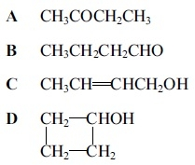
(a) The compounds which react when heated with a mixture of potassium dichromate(VI) and sulfuric acid are (1)
A
B
C
D
(b) The compound which produces a yellow precipitate when heated with a mixture of iodine and sodium hydroxide is (1)
A
B
C
D
(c) There would not be a significant peak at mass/charge ratio of 15 in the mass spectrum of (1)
A Titrations A and B only.
B Titrations A, B and D only.
C Titration C only.
D Titrations A, B, C and D.
(Total for question = 3 marks)

Q7.
In gas chromatography, mixtures are passed through a long tube containing a liquid as the stationary phase. The mixtures are separated into their components because the components differ in
A relative molecular mass.
B melting temperature.
C volatility.
D force of attraction to the liquid.
(Total for question = 1 marks)

Q8.
HPLC stands for
A high pressure liquid column.
B high performance liquid chromatography.
C heterogeneous phase liquid chromatography.
D homogenous phase liquid column.
(Total for question = 1 mark)

Q9.
In high performance liquid chromatography, HPLC, which of these factors does not
affect the time taken for a component to pass through the column?
A Type of detector
B Material of stationary phase
C Particle size of stationary phase
D Temperature of column
(Total for question = 1 mark)

Q10.
Not all molecules will absorb infrared radiation. Those that do
A change their dipole moment when their bonds stretch or bend.
B undergo homolytic fission.
C must be polar.
D are always organic substances.
(Total for question = 1 mark)

Q11.
The IR spectrum of a substance is shown below.
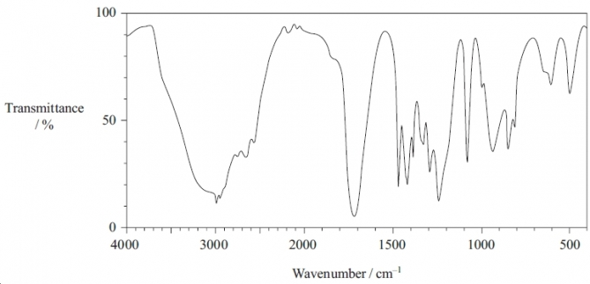
Which of the following substances has this spectrum?
You may use the information on page 6 of the data booklet.
A Propan-1-ol
B Propanal
C Propanone
D Propanoic acid
(Total for question = 1 mark)

Q12.
Two ketones, CH₃COCH₂CH₂CH₃ and CH₃CH₂COCH₂CH₃, both have M_{r} = 86. Which peak due to fragmentation into singly charged ions would you expect to be present in the mass spectrum of one but not the other?
A 71
B 57
C 43
D 29
(Total for question = 1 mark)

Q13.
Which of the following interacts with the nuclei of hydrogen atoms in a nuclear magnetic resonance spectrometer?
A Gamma rays
B X-rays
C Microwaves
D Radio waves
(Total for question = 1 mark)

Q14.
The radio waves used in proton nmr
A must not be absorbed by the sample.
B cause electron transitions in the hydrogen atom.
C can only be used with organic substances.
D cause the hydrogen nucleus to change its spin state.
(Total for question = 1 mark)

Q15.
Which of the following has two singlet peaks in its nmr spectrum?
A Methanal, HCHO
B Methanol, CH₃OH
C Chloromethane, CH₃Cl
D Dichloromethane, CH₂Cl₂
(Total for question = 1 mark)

Q16.
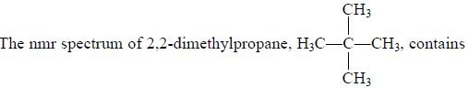
A one singlet peak.
B four singlet peaks.
C one quartet peak.
D four quartet peaks.
(Total for question = 1 mark)

Q17.
The formula for oleic acid, which is present in fingerprints, is shown below.
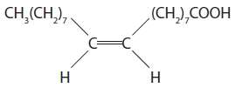
(a) The systematic name for oleic acid is
(1)
A E-octadec-9-enoic acid.
B Z-octadec-9-enoic acid.
C E-octadec-8-enoic acid.
D Z-octadec-8-enoic acid.
(b) Which intermolecular forces are present between oleic acid molecules?
(1)
A Hydrogen bonds only.
B Hydrogen bonds and permanent dipole-dipole forces only.
C Hydrogen bonds, permanent dipole-dipole forces and London forces.
D Hydrogen bonds and London forces only.
(c) Which of the following species is most likely to cause a peak at m/e = 45 in the mass spectrum of oleic acid?
(1)
A CH₂CH₂OH
B CH₂CH₂OH⁺
C COOH
D COOH⁺
(d) What would you expect to see if oleic acid is tested separately with bromine water and with phosphorus(V) chloride, PCl₅?
(1)
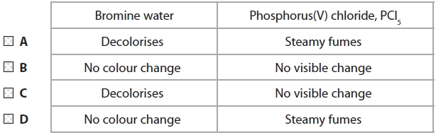

(Total for question = 4 marks)

Q18.
UV light is useful in initiating some reactions because it
A lowers the activation energy of the reaction.
B causes bonds in molecules to stretch and bend.
C causes molecules to form ions.
D causes molecules to form free radicals.
(Total for question = 1 mark)

Q19.
Which atoms are not detected by X-rays but are detected by nuclear magnetic resonance imaging which also shows their environments?

A Carbon
B Hydrogen
C Nitrogen
D Oxygen
(Total for Question = 1 mark)

Q20.
The formula for oleyl alcohol, which is present in sperm whale oil and was used as a lubricant, is shown below.
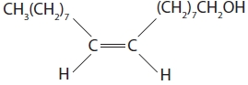
(a) The systematic name for oleyl alcohol is
(1)
A E-octadec-9-en-1-ol.
B Z-octadec-9-en-1-ol.
C E-octadec-8-en-1-ol.
D Z-octadec-8-en-1-ol.
(b) Which intermolecular forces are present between oleyl alcohol molecules?
(1)
A London forces only
B Hydrogen bonds and London forces only
C Hydrogen bonds and permanent dipole–dipole forces only
D Hydrogen bonds, permanent dipole–dipole and London forces
(c) Which of the following is the most likely structure of the species to cause a peak at m/e 31 in the mass spectrum of oleyl alcohol?
(1)
A CH₃O
B CH₂OH
C CH₃O⁺
D CH₂OH⁺
(d) What would you expect to see if oleyl alcohol is tested separately with bromine water and heated with acidified sodium dichromate(VI) solution?
(1)
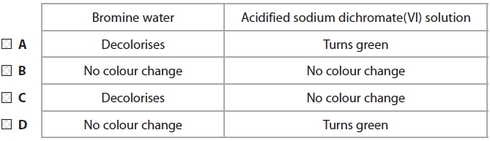

(Total for question = 4 marks)

Mark Scheme
Q1.

Q2.

Q3.
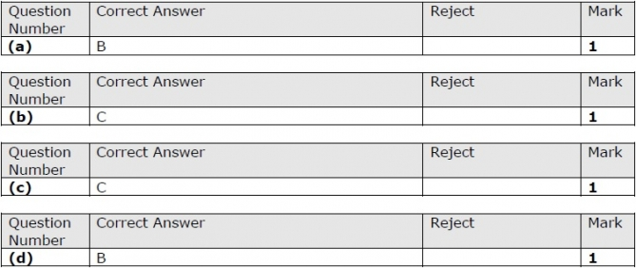

Q4.

Q5.

Q6.

Q7.

Q8.
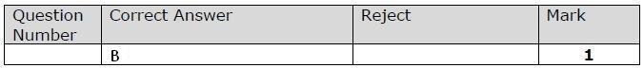

Q9.

Q10.

Q11.

Q12.

Q13.
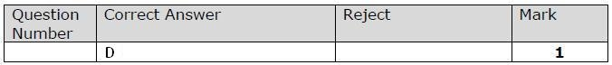

Q14.

Q15.

Q16.

Q17.
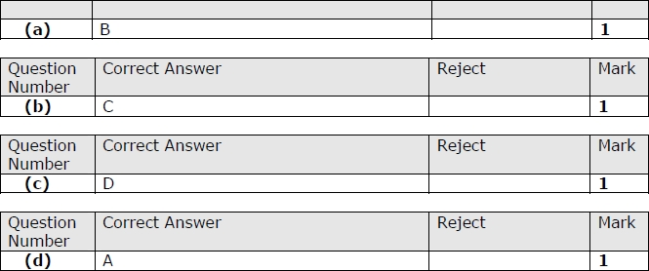

Q18.

Q19.

Q20.
