Questions
Q1.
A solution of iodine in aqueous potassium iodide is brown. The following equilibrium exists in this solution.
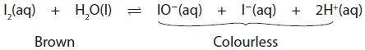
What would be the effect, if any, on the colour of the solution if five drops of dilute sodium hydroxide solution were added to 5 cm³ of the iodine solution?
A No visible change.
B The colour gets lighter.
C The mixture turns colourless.
D The mixture goes a darker colour.

(Total for question = 1 mark)

Q2.
Which of the following cannot alter the position of a chemical equilibrium?

A Increasing the amount of catalyst
B Increasing the reactant concentration
C Increasing the temperature
D Increasing the total pressure
(Total for Question = 1 mark)

Q3.
For the reversible reaction
which of the following could represent the change in the concentrations of X and Y with
time, starting with a mixture of both X and Y? Equilibrium is reached at time t_{eqm}.
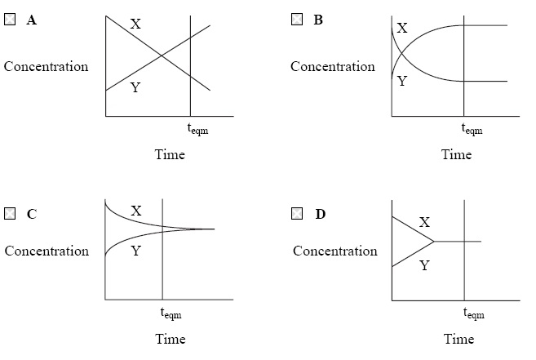
(Total for question = 1 mark)

Q4.
Brown nitrogen dioxide, NO₂, exists in equilibrium with colourless dinitrogen tetroxide, N₂O₄.
(a) The pressure is increased. When equilibrium is restored, the appearance of the mixture of gases will be
(1)
A colourless.
B unchanged.
C paler brown.
D darker brown.
(b) The temperature is increased. When equilibrium is restored, the appearance of the mixture of gases will be
(1)
A colourless.
B unchanged.
C paler brown.
D darker brown.
(Total for question = 2 marks)

Q5.
The following system was allowed to reach equilibrium at 300 °C.
(a) What would you see if the equilibrium mixture was cooled to 250 °C?
(1)
A No visible change.
B The colour gets lighter.
C The mixture turns colourless.
D The mixture goes a darker purple.
(b) The equilibrium mixture at 300 °C was compressed in a gas syringe to occupy a smaller volume. What would be seen immediately?
(1)
A No visible change.
B The colour gets lighter.
C The mixture turns colourless.
D The mixture goes a darker purple.

(Total for question = 2 marks)

Q6.
In the equilibrium below, what effect would the changes described have on the system?
(a) Increase in temperature
(1)
A increase rate, decrease yield
B increase rate, increase yield
C decrease rate, decrease yield
D decrease rate, increase yield
(b) Decrease in pressure
(1)
A increase rate, decrease yield
B increase rate, increase yield
C decrease rate, decrease yield
D decrease rate, increase yield
(Total for question = 2 marks)

Q7.
The indicator methyl orange is a weak acid and may be represented by the formula HA(aq). The equation for its dissociation is shown below.
Under certain conditions, at equilibrium, a solution of HA has a yellow colour. On addition of a small volume of dilute sodium hydroxide, the colour of this solution would
A change from yellow to red.
B change from yellow to orange.
C change from yellow to orange and then to red.
D not change.

(Total for question = 1 mark)

Q8.
When sodium is added to ethanol, which of the following observations would be made?
A Colour change of orange to green
B Effervescence
C Yellow flame
D No change

(Total for question = 1 mark)

Q9.
What is the oxidation number of chlorine in Cl₂O₇?

A −1
B +1
C −7
D +7
(Total for Question = 1 mark)

Q10.
In the reaction between Ag⁺(aq) ions and Fe²⁺(aq) ions, what would be the effect of
increasing the concentration of Ag⁺(aq) ions?
A Rate of reaction increases, yield of Fe³⁺(aq) stays the same.
B Rate of reaction increases, yield of Fe³⁺(aq) decreases.
C Rate of reaction decreases, yield of Fe³⁺(aq) stays the same.
D Rate of reaction increases, yield of Fe³⁺(aq) increases.
(Total for question = 1 mark)

Mark Scheme
Q1.

Q2.

Q3.

Q4.

Q5.

Q6.

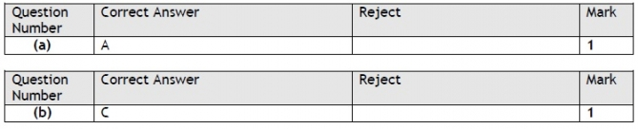

Q7.

Q8.

Q9.

Q10.

