Q1. (a) The reaction between aqueous persulphate ions, , and iodide ions, I–(aq), is catalysed by Fe²⁺(aq) ions. Suggest why this reaction has a high activation energy.
Write equations to explain the catalytic action of Fe²⁺(aq) ions.
Suggest why V³⁺(aq) ions will also act as a catalyst for this reaction but Mg²⁺(aq) ions will not.
(6)

(b) Outline a mechanism for the reaction between benzene and ethanoyl chloride and explain why AlCl₃ acts as a Lewis acid catalyst for this reaction. Predict, with an explanation in each case, the suitability of FeCl₃ and of NH₄Cl to act as a catalyst for this reaction.
(9)
(Total 15 marks)

Q2. Ethylbenzene is made by the reaction shown below.
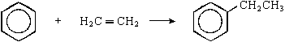
(a) Identify two other substances required as catalysts in this preparation.
Substance 1 ….............................................................................................
Substance 2 .................................................................................................
......................................................................................................................
(2)

(b) Write an equation for the reaction of these two substances with ethene to form the reactive intermediate involved in the formation of ethylbenzene.
......................................................................................................................
(1)

(c) Name and outline a mechanism for the reaction between this reactive intermediate and benzene.
Name of mechanism ....................................................................................
Mechanism

(4)

(d) Draw the structure of the product formed in a similar reaction between benzene and cyclohexene.

(1)

(e) Ethylbenzene is used to make phenylethene which can be polymerised to form poly(phenylethene). Name this type of polymerisation and draw the structure of the repeating unit in the polymer.
Type of polymerisation .................................................................................

Repeating unit …...........................................................................................
(2)
(Total 10 marks)

Q3. (a) The hydrocarbon M has the structure shown below.
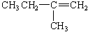
(i) Name hydrocarbon M.
.............................................................................................................

(ii) Draw the repeating unit of the polymer which can be formed from M. State the type of polymerisation occurring in this reaction.
Repeating unit

Type of polymerisation ........................................................................

(iii) The reaction between M and benzene in the presence of HCl and AlCl₃ is similar to the reaction between ethene and benzene under the same conditions. Name the type of mechanism involved and draw the structure of the major product formed in the reaction between M and benzene.
Name of mechanism ...........................................................................
Major product

(iv) Draw a structural isomer of M which shows geometrical isomerism.

(6)

(b) Draw the repeating unit of the polymer formed by the reaction between butanedioic acid and hexane-1,6-diamine. State the type of polymerisation occurring in this reaction and give a name for the linkage between the monomer units in this polymer.
Repeating unit

Type of polymerisation ................................................................................
Name of linkage ...........................................................................................
(4)
(Total 10 marks)

Q4.(a) Outline a mechanism for the reaction of CH₃CH₂CH₂CHO with HCN and name the product.
Mechanism

Name of product ..........................................................................................
(5)

(b) Outline a mechanism for the reaction of CH₃OH with CH₃CH₂COCl and name the organic product.
Mechanism

Name of organic product ..............................................................................
(5)

(c) An equation for the formation of phenylethanone is shown below. In this reaction a reactive intermediate is formed from ethanoyl chloride. This intermediate then reacts with benzene.
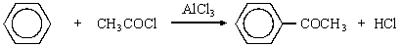
(i) Give the formula of the reactive intermediate.
.............................................................................................................

(ii) Outline a mechanism for the reaction of this intermediate with benzene to form phenylethanone.

(4)
(Total 14 marks)

Q5. (a) Use the following data to show the stability of benzene relative to the hypothetical cyclohexa-1,3,5-triene.
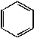
Give a reason for this difference in stability.
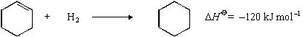
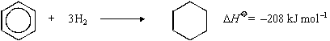
(4)

(b) Consider the following reaction sequence which starts from phenylamine.
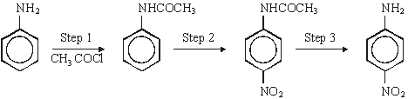
(i) State and explain the difference in base strength between phenylamine and ammonia.

(ii) Name and outline a mechanism for the reaction in Step 1 and name the organic product of Step 1.
(iii) The mechanism of Step 2 involves attack by an electrophile. Give the reagents used in this step and write an equation showing the formation of the electrophile.
Outline a mechanism for the reaction of this electrophile with benzene.
(iv) Name the type of linkage which is broken in Step 3 and suggest a suitable reagent for this reaction.
(17)
(Total 21 marks)

Q6. Propanoyl chloride can be used, together with a catalyst, in Step 1 of the synthesis of 1-phenylpropene from benzene via compounds P and Q as shown below.
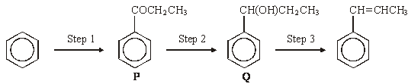
(a) The mechanism of Step 1 is an electrophilic substitution. Write an equation to show the formation of the electrophile from propanoyl chloride. Outline the mechanism of the reaction of this electrophile with benzene in Step 1.
(5)

(b) The mass spectrum of P contains a molecular ion peak at m/z = 134 and major fragmentation peaks at m/z = 105 and 77. Identify the species responsible for the peak at m/z = 105 and also that responsible for the peak at m/z = 77. Write an equation for the formation, from the molecular ion, of the species responsible for the peak at m/z = 105.
(4)

(c) NaBH₄ can be used in the reaction in Step 2. Name the mechanism involved in this reaction. Molecules of Q show optical isomerism but the sample of Q formed in Step 2 is optically inactive. State, in terms of their structure, why molecules of Q show optical isomerism. Explain, by reference to the mechanism, why the sample of Q obtained in Step 2 is not optically active.
(7)

(d) Identify a suitable reagent for the reaction in Step 3.
Name the type of stereoisomerism shown by the product of this reaction. State what is required in the structure of molecules to allow them to show this type of stereoisomerism.
(4)
(Total 20 marks)

Q7. The following reaction scheme shows the formation of two amines, K and L, from methylbenzene.
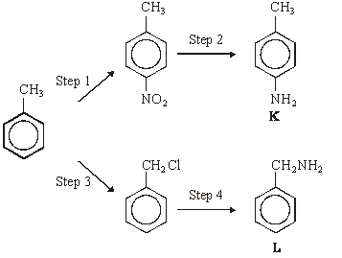
(a) (i) Give the reagents needed to carry out Step 1. Write an equation for the formation from these reagents of the inorganic species which reacts with methylbenzene.
Reagents ............................................................................................
Equation .........….................................................................................

(ii) Name and outline a mechanism for the reaction between this inorganic species and methylbenzene.
Name of mechanism ............................................................................
Mechanism

(7)

(b) Give a suitable reagent or combination of reagents for Step 2.
......................................................................................................................
(1)

(c) (i) Give the reagent for Step 4 and state a condition to ensure that the primary amine is the major product.
Reagent .............................................................................................
Condition ........................................................….................................

(ii) Name and outline a mechanism for Step 4.
Name of mechanism ...........................................................................
Mechanism

(7)

(d) Explain why amine K is a weaker base than ammonia.
......................................................................................................................
......................................................................................................................
......................................................................................................................
(2)

(e) Draw the structure of the organic compound formed when a large excess of bromomethane reacts with amine L.

(1)

(f) Draw the structure of the organic compound formed when ethanoyl chloride reacts with amine L in an addition–elimination reaction.

(1)
(Total 19 marks)

Q8. (a) Name and outline a mechanism for the reaction between propanoyl chloride,
CH₃CH₂COCl, and methylamine, CH₃NH₂
Draw the structure of the organic product.
(6)

(b) Benzene reacts with propanoyl chloride in the presence of aluminium chloride. Write equations to show the role of aluminium chloride as a catalyst in this reaction. Outline a mechanism for this reaction of benzene.
(5)

(c) Write an equation for the reaction of propanoyl chloride with water. An excess of water is added to 1.48 g of propanoyl chloride. Aqueous sodium hydroxide is then added from a burette to the resulting solution.
Calculate the volume of 0.42 mol dm^{–3} aqueous sodium hydroxide needed to react exactly with the mixture formed.
(5)
(Total 16 marks)

Q9. Consider the following reaction sequence.
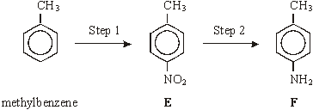
(a) For Step 1, name the mechanism and give the reagents involved.
Name of mechanism ....................................................................................
Reagents ......................................................................................................
(3)

(b) For Step 2, give a reagent or combination of reagents. Write an equation for this reaction using [H] to represent the reductant.
Reagent(s) ...................................................................................................

Equation .......................................................................................................
(2)

(c) Give the m/z value of a major peak which could appear in the mass spectrum of methylbenzene, but not in the spectrum of either E or F.
......................................................................................................................
(1)

(d) Draw the structure of the species formed by F in an excess of hydrochloric acid.

(1)

(e) Compounds G and H are both monosubstituted benzenes and both are isomers of F.
G is a primary amine and H is a secondary amine. Draw the structures of G and H below.
G

H

(2)
(Total 9 marks)

Q10. Two reactions of benzene are shown below.
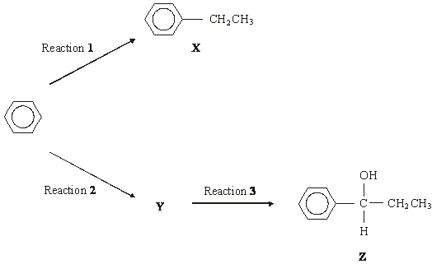
(a) Name X and give the reagent and catalyst required for Reaction 1.
Write an equation for the formation of the reactive intermediate involved in this reaction.
Name and outline a mechanism for the reaction of this reactive intermediate with benzene to form X.
(8)

(b) (i) Deduce the structure of Y and give the organic reagent needed for Reaction 2.
(ii) Give the reagent(s) needed for Reaction 3.
(3)
(Total 11 marks)

Q11. A possible synthesis of phenylethene (styrene) is outlined below.
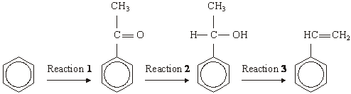
(a) In Reaction 1, ethanoyl chloride and aluminium chloride are used to form a reactive species which then reacts with benzene.
Write an equation to show the formation of the reactive species.
Name and outline the mechanism by which this reactive species reacts with benzene.
(6)

(b) NaBH₄ is a possible reagent for Reaction 2.
Name and outline the mechanism for the reaction with NaBH₄ in Reaction 2.
Name the product of Reaction 2.
(6)
(c) Name the type of reaction involved in Reaction 3 and give a reagent for the reaction.
(2)
(Total 14 marks)

Q12. Three isomers of C₆H₄(NO₂)₂ are shown below.
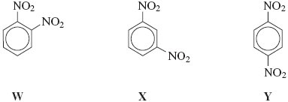
(a) (i) Give the number of peaks in the ¹³C n.m.r. spectrum of each isomer.
.............................................................................................................
.............................................................................................................
.............................................................................................................
(3)

(ii) Draw the displayed formula of the compound used as a standard in recording these spectra.

(1)

(b) Isomer X is prepared from nitrobenzene by reaction with a mixture of concentrated nitric acid and concentrated sulfuric acid.
The two acids react to form an inorganic species that reacts with nitrobenzene to form X.
(i) Give the formula of this inorganic species formed from the two acids and write an equation to show its formation.
.............................................................................................................
.............................................................................................................
.............................................................................................................
(2)

(ii) Name and outline a mechanism for the reaction of this inorganic species with nitrobenzene to form X.

(4)

(c) Isomer Y is used in the production of the polymer Kevlar.
Y is first reduced to the diamine shown below.
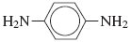
(i) Identify a suitable reagent or mixture of reagents for the reduction of Y to form this diamine. Write an equation for this reaction using [H] to represent the reducing agent.
.............................................................................................................
.............................................................................................................
.............................................................................................................
.............................................................................................................
(2)

(ii) This diamine is then reacted with benzene-1, 4-dicarboxylic acid to form Kevlar.
Draw the repeating unit of Kevlar.

(2)

(iii) Kevlar can be used as the inner lining of bicycle tyres. The rubber used for the outer part of the tyre is made of polymerised alkenes.
State the difference in the biodegradability of Kevlar compared to that of rubber made of polymerised alkenes.
Use your knowledge of the bonding in these polymer molecules to explain this difference.
.............................................................................................................
.............................................................................................................
.............................................................................................................
.............................................................................................................
.............................................................................................................
.............................................................................................................
(4)
(Total 18 marks)

Q13. Consider compound P shown below that is formed by the reaction of benzene with an electrophile.
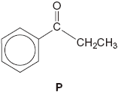
(a) Give the two substances that react together to form the electrophile and write an equation to show the formation of this electrophile.
......................................................................................................................
......................................................................................................................
......................................................................................................................
......................................................................................................................
......................................................................................................................
......................................................................................................................
(3)

(b) Outline a mechanism for the reaction of this electrophile with benzene to form P.

(3)

(c) Compound Q is an isomer of P that shows optical isomerism. Q forms a silver mirror when added to a suitable reagent.
Identify this reagent and suggest a structure for Q.
......................................................................................................................
......................................................................................................................
......................................................................................................................
......................................................................................................................
......................................................................................................................
......................................................................................................................
(2)
(Total 8 marks)

Q14. Many synthetic routes need chemists to increase the number of carbon atoms in a molecule by forming new carbon–carbon bonds. This can be achieved in several ways including
• reaction of an aromatic compound with an acyl chloride
• reaction of an aldehyde with hydrogen cyanide.
(a) Consider the reaction of benzene with CH₃CH₂COCl
(i) Write an equation for this reaction and name the organic product.
Identify the catalyst required in this reaction.
Write equations to show how the catalyst is used to form a reactive intermediate and how the catalyst is reformed at the end of the reaction.
.............................................................................................................
.............................................................................................................
.............................................................................................................
.............................................................................................................
.............................................................................................................
.............................................................................................................
.............................................................................................................
.............................................................................................................
(5)

(ii) Name and outline a mechanism for the reaction of benzene with this reactive intermediate.
.............................................................................................................
.............................................................................................................
.............................................................................................................
.............................................................................................................
.............................................................................................................
.............................................................................................................
.............................................................................................................
.............................................................................................................
(4)

(b) Consider the reaction of propanal with HCN
(i) Write an equation for the reaction of propanal with HCN and name the product.
.............................................................................................................
.............................................................................................................
.............................................................................................................
(2)

(ii) Name and outline a mechanism for the reaction of propanal with HCN
.............................................................................................................
.............................................................................................................
.............................................................................................................
.............................................................................................................
.............................................................................................................
.............................................................................................................
.............................................................................................................
.............................................................................................................
(5)

(iii) The rate-determining step in the mechanism in part (b) (ii) involves attack by the nucleophile.
Suggest how the rate of reaction of propanone with HCN would compare with the rate of reaction of propanal with HCN
Explain your answer.
.............................................................................................................
.............................................................................................................
.............................................................................................................
.............................................................................................................
.............................................................................................................
.............................................................................................................
.............................................................................................................
.............................................................................................................
(2)
(Total 18 marks)

Q15. The hydrocarbons benzene and cyclohexene are both unsaturated compounds.
Benzene normally undergoes substitution reactions, but cyclohexene normally
undergoes addition reactions.
(a) The molecule cyclohexatriene does not exist and is described as hypothetical.
Use the following data to state and explain the stability of benzene compared with the hypothetical cyclohexatriene.
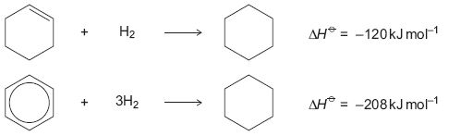
......................................................................................................................
......................................................................................................................
......................................................................................................................
......................................................................................................................
......................................................................................................................
......................................................................................................................
......................................................................................................................
......................................................................................................................
(Extra space) ...............................................................................................
......................................................................................................................
......................................................................................................................
......................................................................................................................
(4)

(b) Benzene can be converted into amine U by the two-step synthesis shown below.
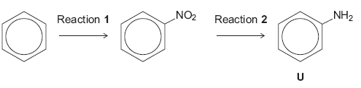
The mechanism of Reaction 1 involves attack by an electrophile.
Give the reagents used to produce the electrophile needed in Reaction 1.
Write an equation showing the formation of this electrophile.
Outline a mechanism for the reaction of this electrophile with benzene.
......................................................................................................................
......................................................................................................................
......................................................................................................................
......................................................................................................................
......................................................................................................................
......................................................................................................................
......................................................................................................................
......................................................................................................................
(Extra space) ................................................................................................
......................................................................................................................
......................................................................................................................
......................................................................................................................
......................................................................................................................
......................................................................................................................
......................................................................................................................
(6)

(c) Cyclohexene can be converted into amine W by the two-step synthesis shown below.
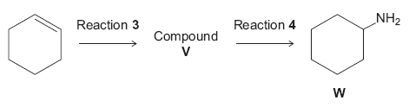
Suggest an identity for compound V.
For Reaction 3, give the reagent used and name the mechanism.
For Reaction 4, give the reagent and condition used and name the mechanism.

Equations and mechanisms with curly arrows are not required.
......................................................................................................................
......................................................................................................................
......................................................................................................................
......................................................................................................................
......................................................................................................................
......................................................................................................................
......................................................................................................................
(Extra space) ...............................................................................................
......................................................................................................................
......................................................................................................................
......................................................................................................................
......................................................................................................................
......................................................................................................................
(6)

(d) Explain why amine U is a weaker base than amine W.
......................................................................................................................
......................................................................................................................
......................................................................................................................
......................................................................................................................
......................................................................................................................
(Extra space) ................................................................................................
......................................................................................................................
......................................................................................................................
(3)
(Total 19 marks)

Q16.Many aromatic nitro compounds are used as explosives. One of the most famous is 2-methyl-1,3,5-trinitrobenzene, originally called trinitrotoluene or TNT. This compound, shown below, can be prepared from methylbenzene by a sequence of nitration reactions.
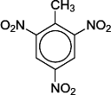
(a) The mechanism of the nitration of methylbenzene is an electrophilic substitution.
(i) Give the reagents used to produce the electrophile for this reaction.
Write an equation or equations to show the formation of this electrophile.
Reagents ..............................................................................................
...............................................................................................................
Equation ................................................................................................
...............................................................................................................
(3)

(ii) Outline a mechanism for the reaction of this electrophile with methylbenzene to produce 4-methylnitrobenzene.

(3)

(b) Deduce the number of peaks in the ¹³C n.m.r. spectrum of TNT.
........................................................................................................................
(1)

(C) Deduce the number of peaks in the ¹H n.m.r. spectrum of TNT.
........................................................................................................................
(1)

(d) Using the molecular formula (C₇H₅N₃O₆), write an equation for the decomposition reaction that occurs on the detonation of TNT. In this reaction equal numbers of moles of carbon and carbon monoxide are formed together with water and nitrogen.

........................................................................................................................
(1)
(Total 9 marks)

Q17.Benzene reacts with ethanoyl chloride in a substitution reaction to form C₆H₅COCH₃.
This reaction is catalysed by aluminium chloride.
(a) Write equations to show the role of aluminium chloride as a catalyst in this reaction.
Outline a mechanism for the reaction of benzene.
Name the product, C₆H₅COCH₃.
........................................................................................................................
........................................................................................................................
........................................................................................................................

(6)

(b) The product of the substitution reaction (C₆H₅COCH₃) was analysed by mass spectrometry. The most abundant fragment ion gave a peak in the mass spectrum with m/z = 105.
Draw the structure of this fragment ion.

(1)

(c) When methylbenzene reacts with ethanoyl chloride and aluminium chloride, a similar substitution reaction occurs but the reaction is faster than the reaction of benzene.
Suggest why the reaction of methylbenzene is faster.
........................................................................................................................
........................................................................................................................
........................................................................................................................
........................................................................................................................
........................................................................................................................
........................................................................................................................
(2)
(Total 9 marks)

Q18.Acyl chlorides and acid anhydrides are important compounds in organic synthesis.
(a) Outline a mechanism for the reaction of CH₃CH₂COCl with CH₃OH and name the organic product formed.
Mechanism

Name of organic product ...............................................................................
(5)

(b) A polyester was produced by reacting a diol with a diacyl chloride. The repeating unit of the polymer is shown below.
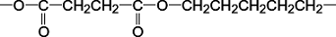
(i) Name the diol used.
...............................................................................................................
(1)

(ii) Draw the displayed formula of the diacyl chloride used.

(1)

(iii) A shirt was made from this polyester. A student wearing the shirt accidentally splashed aqueous sodium hydroxide on a sleeve. Holes later appeared in the sleeve where the sodium hydroxide had been.
Name the type of reaction that occurred between the polyester and the aqueous sodium hydroxide. Explain why the aqueous sodium hydroxide reacted with the polyester.
Type of reaction ....................................................................................
Explanation ...........................................................................................
...............................................................................................................
...............................................................................................................
...............................................................................................................
(3)

(c) (i) Complete the following equation for the preparation of aspirin using ethanoic anhydride by writing the structural formula of the missing product.

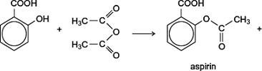 | ......................

(1)

(ii) Suggest a name for the mechanism for the reaction in part (c)(i).
...............................................................................................................
(1)

(iii) Give two industrial advantages, other than cost, of using ethanoic anhydride rather than ethanoyl chloride in the production of aspirin.
Advantage 1 ..........................................................................................
...............................................................................................................
...............................................................................................................
Advantage 2 ..........................................................................................
...............................................................................................................
...............................................................................................................
(2)

(d) Complete the following equation for the reaction of one molecule of benzene-1,2-dicarboxylic anhydride (phthalic anhydride) with one molecule of methanol by drawing the structural formula of the single product
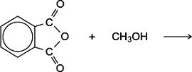
(1)

(e) The indicator phenolphthalein is synthesised by reacting phthalic anhydride with phenol as shown in the following equation.
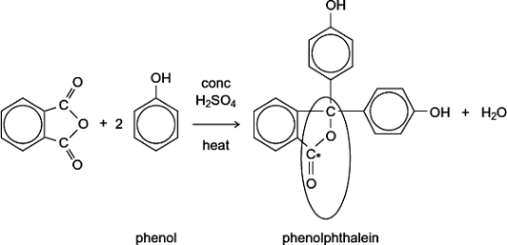
(i) Name the functional group ringed in the structure of phenolphthalein.
...............................................................................................................
(1)

(ii) Deduce the number of peaks in the ¹³C n.m.r. spectrum of phenolphthalein.
...............................................................................................................
(1)

(iii) One of the carbon atoms in the structure of phenolphthalein shown above is labelled with an asterisk (*).
Use Table 3 on the Data Sheet to suggest a range of δ values for the peak due to this carbon atom in the ¹³C n.m.r. spectrum of phenolphthalein.
...............................................................................................................
(1)

(f) Phenolphthalein can be used as an indicator in some acid–alkali titrations.
The pH range for phenolphthalein is 8.3 – 10.0
(i) For each acid.alkali combination in the table below, put a tick () in the box if phenolphthalein could be used as an indicator.

Acid | Alkali | Tick  box ()
sulfuric acid | sodium hydroxide
hydrochloric acid | ammonia
ethanoic acid | potassium hydroxide
nitric acid | methylamine

(2)

(ii) In a titration, nitric acid is added from a burette to a solution of sodium hydroxide containing a few drops of phenolphthalein indicator.
Give the colour change at the end-point.
...............................................................................................................
(1)
(Total 21 marks)

Q19.Acyl chlorides such as CH₃COCl are useful compounds in synthesis.
(a) The acyl chloride CH₃COCl reacts with benzene.
(i) Write an equation for this reaction and name the organic product.
Identify a catalyst for the reaction.
Write an equation to show how this catalyst reacts with CH₃COCl to produce a reactive intermediate.
...............................................................................................................
...............................................................................................................
...............................................................................................................
...............................................................................................................
...............................................................................................................
...............................................................................................................
...............................................................................................................
...............................................................................................................
(4)

(ii) Name and outline a mechanism for the reaction of benzene with the reactive intermediate in part (a)(i).
Name of mechanism .........................................................................................................
Mechanism

(4)

(b) Nucleophiles such as alcohols can react with CH₃COCl
The ion CH₃COO⁻ can act as a nucleophile in a similar way.
State the meaning of the term nucleophile.
Draw the structure of the organic product formed by the reaction of CH₃COO⁻ with CH₃COCl
Name the functional group produced in this reaction.
........................................................................................................................
........................................................................................................................
........................................................................................................................
........................................................................................................................
........................................................................................................................
........................................................................................................................
........................................................................................................................
........................................................................................................................
........................................................................................................................
(3)
(Total 11 marks)

Q20.Each of the following conversions involves reduction of the starting material.
(a) Consider the following conversion.
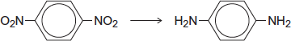
Identify a reducing agent for this conversion.
Write a balanced equation for the reaction using molecular formulae for the nitrogen-containing compounds and [H] for the reducing agent.
Draw the repeating unit of the polymer formed by the product of this reaction with benzene-1,4-dicarboxylic acid.
........................................................................................................................
........................................................................................................................
........................................................................................................................
........................................................................................................................
........................................................................................................................
........................................................................................................................
........................................................................................................................
(Extra space) .................................................................................................
........................................................................................................................
........................................................................................................................
........................................................................................................................
........................................................................................................................
........................................................................................................................
(5)

(b) Consider the following conversion.
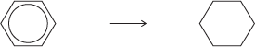
Identify a reducing agent for this conversion.
State the empirical formula of the product.
State the bond angle between the carbon atoms in the starting material and the bond angle between the carbon atoms in the product.
........................................................................................................................
........................................................................................................................
........................................................................................................................
........................................................................................................................
........................................................................................................................
........................................................................................................................
(4)

(c) The reducing agent in the following conversion is NaBH₄
(i) Name and outline a mechanism for the reaction.
Name of mechanism ............................................................................
Mechanism

(5)

(ii) By considering the mechanism of this reaction, explain why the product formed is optically inactive.
...............................................................................................................
...............................................................................................................
...............................................................................................................
...............................................................................................................
...............................................................................................................
...............................................................................................................
...............................................................................................................
...............................................................................................................
(3)
(Total 17 marks)

M1. (a) High E_{a}: S₂O₈^{2–} repels I– or both ions negative (1)
2Fe²⁺ + S₂O₈^{2–} → 2Fe³⁺ + 2SO₄^{2–} (1)
2Fe³⁺ + 2I– → 2Fe²⁺ + I₂ (1)
N.B. Ignore additional incorrect equations
Vanadium is a transition element or Magnesium is not a transition element (1)
Vanadium has variable oxidation states (1)
Magnesium only forms Mg²⁺, or has only one oxidation state (1)
N.B. Score two marks for “Only vanadium has variable oxidation states”
6

(b) AlCl₃ + Cl-COCH₃ → AlCl₄– + CH₃CO⁺ (1)
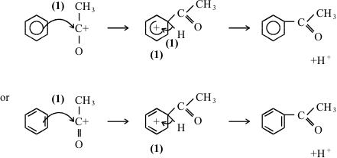
H⁺ + AlCl₄– → AlCl₃ + HCl (1)
Lewis acid: AlCl₃ accepts electron pair
N.B. penalise incorrect acyl chloride by one
N.B. penalise chloroethane by two marks i.e. first equation mark, attack on benzene mark

NH₄Cl: Not a catalyst (1)
FeCl₃: A catalyst (1)
has a low energy vacant shell
or has spaces or vacancies in d shell
or has a partially filled d shell
or able to accept an electron pair
or can form FeCl₄– (1)
9
[15]

M2. (a) Substance 1: HCl or HBr (1)
Substance 2: AlCl₃ / AlBr₃ / FeCl₃ / FeBr₃ (1)
2

(b) H₂C=CH₂ + HCl +AlCl₃ → CH₃CH₂⁺ + AlCl₄– (1)
Allow 2 equations
1

(c) Name of mechanism: electrophilic substitution (1)

Mechanism:
4

(d)
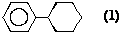
1

(e) Type of polymerisation: addition (1)
Repeating unit: 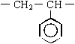 (1)
2
[10]

M3. (a) (i) 2-methylbut-1-ene (1)
NOT ...butan....
(ii) Repeating unit: 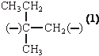or 2 ×
allow C₂H₅
Type of polymerisation: addition or radical (1)

(iii) Name of mechanism: electrophilic substitution (1)
Major product: 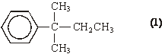
(iv) CH₃CH=CHCH₂CH₃ (1)
6

(b) Repeating unit:
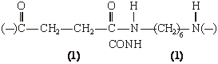
Type of polymerisation: condensation (1)
Name of linkage: (poly)peptide or (poly)amide (1)
allow outer horizontal bonds to be omitted
allow HO–[...........]–H if [......] shows the repeating unit; if brackets missing in the dimer, penalise one
C₂H₄ or C₆H₁₂ first time only
allow CONH
allow polypeptide or polyamide; peptide or amide must be spelled correctly
4

Organic points
(1) Curly arrows: must show movement of a pair of electrons,
i.e. from bond to atom or from lp to atom / space
e.g.

(2) Structures
penalise sticks (i.e. 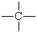) once per paper
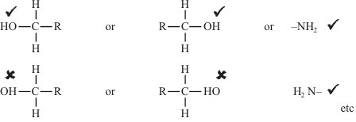
Penalise once per paper
allow CH₃– or –CH₃ or or CH₃
or H₃C–
[10]

M4.(a) Mechanism
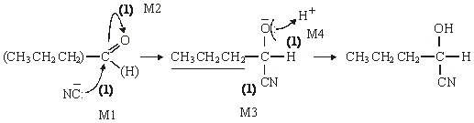

Allow C₃H₇ if structure shown elsewhere
penalise HCN splitting if wrong
Name of product: 2-hydroxypenta(neo)nitrile (1)
or 1-cyanobutan-1-ol
5

(b) Mechanism
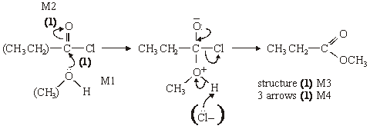
Name of organic product: methylpropanoate (1)
5

(c) (i) ([) CH₃CO (])⁺ (1)
(ii)
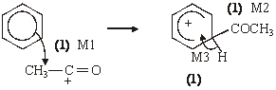
4

Notes
(abc) extra curly arrows are penalised
(a) be lenient on position of negative sign on : CN– but arrow must come from lp
(a)/(b) alone loses M2 but can score M1 for attack on C+, similarly
(a) allow 2-hydroxypentanonitrile or 2-hydroxypenta(ne)nitrile ... pentylnitrile
(b) in M4, allow extra: Cl– attack on H, showing loss of H⁺
(c) (i) allow formula in an “equation”(balanced or not)
be lenient on the position of the + on the formula
(ii) for M1 the arrow must go to the C or the + on the C
don’t be too harsh about the horseshoe, but + must not be close to the saturated C
M3 must be final step not earlier; allow M3 even if structure (M2) is wrong
[14]

Organic points
(1) Curly arrows: must show movement of a pair of electrons,
i.e. from bond to atom or from lp to atom / space
e.g.

(2) Structures
penalise sticks (i.e. ) once per paper
Penalise once per paper
allow CH₃– or –CH₃ or or CH₃
or H₃C–

M5. (a) Cyclohexane evolves 120 kJ mol^{–1}
(expect triene to evole) 360 kJ mol^{–1} (1) or 3 × 120
360 – 208 = 152 kJ (1) NOT 150
152 can score first 2
QofL: benzene lower in energy / more (stated) stable (1)
Not award if mentions energy required for bond breaking
due to delocalisation (1) or explained
4

(b) (i) phenylamine weaker (1)
if wrong no marks
lone pair on N (less available) (1)
delocalised into ring (1) or “explained”
3

(ii) addition – elimination (1)
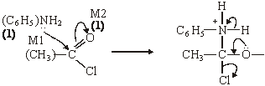
structure (1) M3
3 arrows (1) M4
N-phenyl ethanamide (1)
6

(iii) conc HNO₃ (1)
conc H₂SO₄ (1)
HNO₃ + 2H₂SO₄ → O₂ + H₃O⁺ + 2HSO₄– (1)
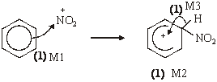
6

(iv) peptide / amide (1)
NaOH (aq) (1)
HCl conc or dil or neither
H₂SO₄ dil NOT conc
NOT just H₂O
2

Notes
(a) • 360 or 3 × 120 or in words (1);
• 152 NOT 150 (1); (152 can get first two marks)
• Q of L benzene more stable but not award if ΔH values used to say
that more energy is required by benzene for hydrogenation compared with
the triene or if benzene is only compared with cyclohexene (1);
• delocalisation or explained (1)

(b) (ii) or N-phenylacetamide or acetanilide
mechanism: if shown as substitution can only gain M1
if CH₃CO+ formed can only gain M1
lose M4 if Cl– removes H⁺
be lenient with structures for M1 and M2 but must be correct for M3
alone loses M2

(iii) No marks for name of mechanism in this part
if conc missing can score one for both acids (or in equation)
allow two equations
allow HNO₃ + H₂SO₄ → NO²⁺ + HSO₄– + H₂O
ignore side chain in mechanism even if wrong
arrow for M1 must come from niside hexagon
arrow to NO₂⁺ must go to N but be lenient over position of +
+ must not be too near “tetrahedral” Carbon
horseshoe from carbons 2-6 but don’t be too harsh

(iv) reagent allow NaOH
HCl conc or dil or neither
H₂SO₄ dil or neither but not conc
not just H₂O
[21]

M6. (a) [CH₃CH₂CO]⁺
1
CH₃CH₂COCl + AlCl₃ → [CH₃CH₂CO]⁺ + AlCl₄–
(Penalise wrong arrows in the equation or lone pair on Al
In the equation, the position of the + on the electrophile can be on O or C or outside square brackets,
Can score electrophile mark in mechanism if not previously gained)
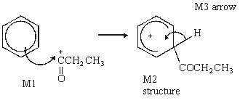
1
(Arrow for M1 must be to C or to the + on C
penalize + in intermediate if too close to C1 ;
horseshoe should extend from C2 to C6 )
3

(b) m/z = 105 C₆H₅CO⁺
1
m/z = 77 C₆H₅⁺
(not Wheland intermediate)
(Penalise missing + once)
Allow position of + on O or C of CO or outside [ ] for the fragment ion [C₆H₅CO]⁺
Allow position of + on H or C or outside [ ] for the fragment ion [C₆H₅]⁺
[C₆H₅COCH₂CH₃]⁺˙ C₆H₅CO⁺ + CH₃CH₂˙
(˙ must be on H or C of CH₂ or outside bracket)
1
(1) for molecular ion (1) for RHS
Allow molecular formulae, i.e. C₉H₁₀O⁺ . C₇H₅O⁺ + C₂H₅ .
2

(c) Nucleophilic addition
1 Q contains asymmetric carbon or chiral centre or are chiral molecules
2 with 4 different groups/atoms attached (stated)
not molecules attached
1
3 planar C=O
4 attack from each side
5 equally likely or equal amounts of each isomer formed
6 Racemic mixture or racemate (Q of L)
7 of mirror images or enantiomers or d/l or +/– or R/S or drawn
max 6

(d) Conc H₂SO₄ or conc H₃PO₄ or Al₂O₃ or iron oxides Not HCl or HBr
1
Geometrical or cis-trans
1
Double bond or C=C not just π cloud
(stated not just drawn)
1
2 Different atoms/groups on each C (not molecules)
(stated not just drawn)
1
[20]

M7. (a) (i) conc HNO₃
1
conc H₂SO₄
allow 1 for both acids if either conc missing
1
HNO₃ + 2H₂SO₄ → NO₂⁺ + H₃O⁺ + 2HSO₄–
or HNO₃ + H₂SO₄ → NO₂⁺ + H₂O + HSO₄–
1

(iii) electrophilic substitution CH₃
1
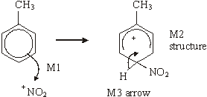
horseshoe must not extend beyond C2 to C6 but can be smaller
+ must not be too close to Cl
3

(b) Sn or Fe / HCl (conc or dil or neither)
or Ni / H₂ not NaBH₄ LiAlH₄
1

(c) (i) NH₃
1
Use an excess of ammonia
1
(ii) nucleophilic substitution
1
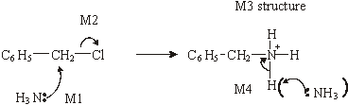
4

(d) lone pair on N less available (in correct context)
1
delocalised into the ring (Q of L)
1

(e)
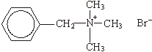

ignore Br
+ must be on N or outside a
square bracket
1

(f)
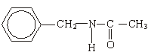
1
[19]

M8. (a) (nucleophilic) addition-elimination;
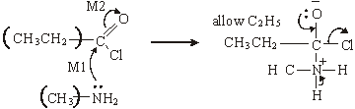

(M3 for structure)
(M4 for 3 arrows and lone pair)
(M2 not allowed independent of M1, but allow M1 for correct attack
on C+ if M2 show as independent first.)
(+on C of C=O loses M2 but ignore δ+ if correct)
(Cl– removing Ft loses M4)
1

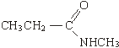
(If MS lost above for wrong C chain, do not penalise same error again here)
5

(b) CH₃CH₂COCl + AlCl₃ → [CH₃CH₂CO]⁺ + AlCl₄–;
(penalise wrong alkyl group once at first error)
(position of + on electrophile can be on O or C or outside [ ]) (penalise wrong curly arrow in the equation or lone pair on AlCl₃)
1

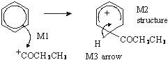  (M1 arrow from within hexagon to C or to + on C)  (don’t penalise position of + on C of RCO+) | (horseshoe must not extend beyond C2 to C6 but can be smaller)  (+ not too close to C1)  (penalise M2 if CH₃ chain wrong again but allow M1 and M3)  (M3 arrow into hexagon unless Kekule)  (allow M3 arrow independent of M2 structure)

3
(or can be gained in mechanism);
1

(c) M1 CH₃CH₂COCl + H₂O → CH₃CH₂COOH + HCl 1
(penalise wrong alkyl group once at first error)
1
M2 M_{r} of CH₃CH₂COCl = 92.5 1
(if Mr wrong, penalise M2 only)
1
M3 moles of CH₃CH₂COCl = 1.48/92.5 = 0.016 1
1
M4 moles NaOH = 2 × 0.016 = 0.032 1
(allow for × 2 conseq to wrong no of moles)
1
M5 volume of NaOH = 0.032/0.42 = 0.0762 dm³ or 76.2 cm³ 1
(with correct units)
(if ×2 missed in M4 lose M5 also)
1
[16]

M9. (a) electrophilic substitution;
1
cone HNO₃;
1
cone H₂SO₄ either or both cone missing scores one for both acids;
1

(b) Sn or Fe/HCl (cone or dil or neither);
(ignore extra NaOH)
1
Sn or Fe/H₂SO₄ (dil or neither)
(not HNO₃ at all)
or H₂/Ni
(not NaBH₄/ LiAlH₄ or Na/C₂H₅OH)
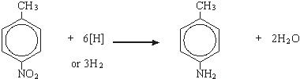
1

(c) 77 or 92;
1

(d)
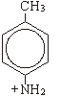
1
(allow -NH₃⁺)

(e) G
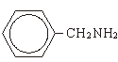
1
H
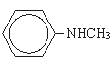
1
[9]

M10. (a) ethyl benzene
1
chloroethane or bromoethane (or ethene and hydrogen chloride/bromide)
1
aluminium chloride/bromide or iron(III) chloride /bromide or iron +
chorine/bromine
1
CH₃CH₂Cl + AlCl₃ → CH₃CH₂⁺ + AlCl₄–
1
electrophilic substitution
1
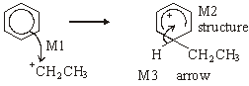
3

(b)
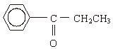
1
CH₃CH₂COCl / propanoyl chloride or (CH₃CH₂CO)₂O / propanoic
anhydride
1
NaBH₄ or LiAlH₄ or H₂/Ni (not Sn/Fe with HCl)
1
[11]

M11. (a) CH₃COCl + AlCl₃ → CH₃O + AlCl
(1) equation (1)
2
penalise wrong alkyl group once at first error
position of + on electrophile can be on O or C or outside [ ]
penalise wrong curly arrow in the equation or lone pair on AlCl₃ else ignore

Electrophilic substitution
NOT F/C acylation
1
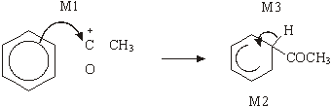
horseshoe must not extend beyond C2 to C6 but can be smaller
+ not too close to C1
M3 arrow into hexagon unless Kekule
allow M3 arrow independent of M2 structure
M1 arrow from within hexagon to C or to + on C
+ must be on C of 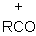
3

(b) Nucleophilic addition
NOT reduction
1
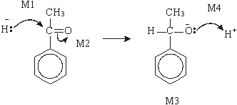

M2 not allowed independent, but can allow M1 for attack of H– on C+ formed
4
1–phenylethan(–1–)ol or (1–hydroxyethyl)benzene
l

(c) dehydration or elimination
1
(conc) H₂SO₄ or (conc) H₃PO₄
allow dilute and Al₂O₃
Do not allow iron oxides
1
[14]

M12. (a) (i) W 3
1
X 4
1
Y 2
1

(ii)
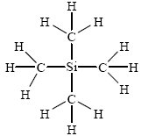
displayed formula shows ALL bonds
1

(b) (i) NO₂⁺
allow + anywhere
can score in equation
1
HNO₃ + 2H₂SO₄ → NO₂⁺ + 2HSO₄– + H₃O⁺
1
OR
HNO₃ + H₂SO₄ → NO₂⁺ + HSO₄– + H₂O
or use two equations via H₂NO₃⁺

(ii) electrophilic substitution
Not Friedel Crafts
1
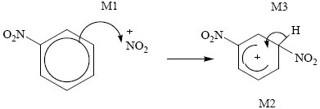
Allow Kekule structures
+ must be on N of ⁺NO₂ (which must be correct)
both NO₂ must be correctly positioned and bonded to gain M2
M1 arrow from circle or within it to N or to + on N
horseshoe must not extend beyond C2 to C6 but can be smaller
+ not too close to C1
M3 arrow into hexagon unless Kekule
allow M3 arrow independent of M2 structure
ignore base removing H in M3
3

(c) (i) H₂/Ni or H₂/Pt or Sn/HCl or Fe/HCl (conc or dil or neither)
allow dil H₂SO₄
ignore mention of NaOH
Not NaBH₄
Not LiAlH₄
Not Na/C₂H₅OH
not conc H₂SO₄ or any HNO₃
1
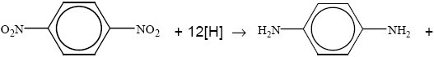
4H₂O
Or 6H₂
allow C₆H₄(NO₂)₂ etc ,
allow NO₂– NH₂–
i.e. be lenient on structures, the mark is for balancing equ
1

(ii)
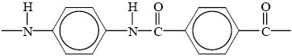
allow –CONH
ignore [ ]_{n} as in polymer
1st mark for correct peptide link
2nd mark for the rest correct including trailing bonds
2

(iii) M1 Kevlar is biodegradeable but polyalkenes not
allow Kevlar is more biodegradeable
1
M2 Kevlar has polar bonds/is a (poly) amide/has peptide link
comment on structure of Kevlar
1
M3 can be hydrolysed/attacked by nucleophiles/acids/
bases/enzymes
1
M4 polyalkenes non polar/has non-polar bonds
comment on structure of polyalkenes but not just strong bonds
1
[18]

M13. (a) CH₃CH₂COCl OR CH₃CH₂CClO OR propanoyl chloride
OR (CH₃CH₂CO)₂O OR propanoic anhydride
penalize contradiction in formula and name e.g. propyl chloride
could score in equation
1
AlCl₃ or FeCl₃ or names
could score in equation
1
CH₃CH₂COCl + AlCl₃ → CH₃CH₂CO⁺ + AlCl₄–
Allow RCOCl in equation but penalise above
allow + on C or O in equation
1

(b)
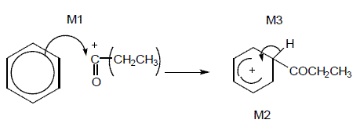
M1 arrow from circle or within it to C or to + on C
Horseshoe must not extend beyond C2 to C6 but can be smaller + not too close to C1
M3 arrow into hexagon unless Kekule
allow M3 arrow independent of M2 structure
Ignore base removing H in M3
3

(c) Tollens or ammoniacal silver nitrate
1
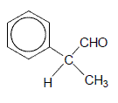
penalise wrong formula
1
[8]

M14. (a) (i) C₆H₆ + CH₃CH₂COCl → C₆H₅COCH₂CH₃ + HCl
OR
C₆H₆ + CH₃CH₂CO⁺ → C₆H₅COCH₂CH₃ + H⁺
allow C₂H₅
penalise C₆H₅–CH₃CH₂CO
allow + on C or O in equation
1
Phenylpropanone
OR ethylphenylketone OR phenylethylketone
Ignore 1 in formula, but penalise other numbers
1

AlCl₃
can score in equation
1
CH₃CH₂COCl + AlCl₃ → CH₃CH₂CO⁺ + AlCl₄–
allow C₂H₅
allow + on C or O in equation
1
AlCl₄– + H⁺ → AlCl₃ + HCl
1

(ii) electrophilic substitution
can allow in (a)(i) if no contradiction
1
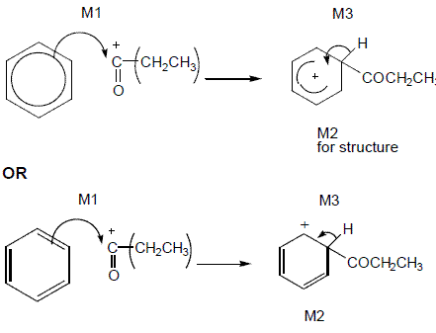
M1 arrow from circle or within it to C or to + on C
horseshoe must not extend beyond C2 to C6 but can be smaller
+ not too close to C1
M2 penalise C₆H₅–CH₃CH₂CO (even if already penalized in (a)(i))
M3 arrow into hexagon unless Kekule
allow M3 arrow independent of M2 structure
ignore base removing H in M3
3

(b) (i) CH₃CH₂CHO + HCN → CH₃CH₂CH(OH)CN OR
C₂H₅CH(OH)CN
aldehyde must be –CHO brackets optional
1
2-hydroxybutanenitrile OR 2-hydroxybutanonitrile
no others
1

(ii) nucleophilic addition
1
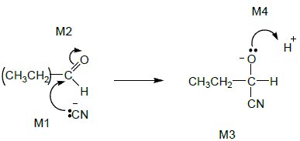
M1 includes lp and arrow to Carbonyl C and minus charge (on either C or N)
Not allow M2 before M1, but allow M1 to C⁺ after non-scoring carbonyl arrow
Ignore δ+, δ– on carbonyl group, but if wrong way round or full + charge on C lose M2
M3 for correct structure including minus sign. Allow C₂H₅
M4 for lp and curly arrow to H⁺
4

(iii) (propanone) slower OR propanal faster
1
inductive effects of alkyl groups
OR
C of C=O less δ+ in propanone
OR
alkyl groups in ketone hinder attack
OR
easier to attack at end of chain
if wrong, no further marks
1
[18]

M15. (a) M1 Benzene is more stable than cyclohexatriene
more stable than cyclohexatriene must be stated or implied
If benzene more stable than cyclohexene, then penalise M1 but mark on
If benzene less stable: can score M2 only
1
M2 Expected ΔH^{ο} hydrogenation of C₆H₆ is 3(–120)
= –360 kJ mol⁻¹
Allow in words e.g. expected ΔH^{ο} hydrog is three times the ΔH^{ο} hydrog of cyclohexene
1

M3 Actual ΔH^{ο} hydrogenation of benzene is
152 kJ mol⁻¹ (less exothermic)
or 152 kJ mol⁻¹ different from expected
Ignore energy needed
1
M4 Because of delocalisation or electrons spread out or resonance
1

(b) No mark for name of mechanism
Conc HNO₃
If either or both conc missing, allow one;
1
Conc H₂SO₄
this one mark can be gained in equation
1
2 H₂SO₄ + HNO₃ → 2 HSO₄– + NO₂⁺ + H₃O⁺
OR
H₂SO₄ + HNO₃ → HSO₄– + NO₂⁺ + H₂O
OR via two equations
H₂SO₄ + HNO₃ → HSO₄– + H₂NO₃⁺
H₂NO₃+ → NO₂⁺ + H₂O
Allow + anywhere on NO₂⁺
1

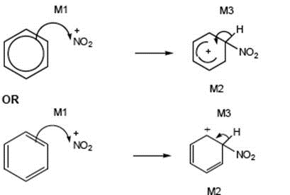
M1 arrow from within hexagon to N or + on N
Allow NO₂⁺ in mechanism
horseshoe must not extend beyond C2 to C6 but can be smaller
+ not too close to C1
M3 arrow into hexagon unless Kekule
allow M3 arrow independent of M2 structure
ignore base removing H in M3
+ on H in intermediate loses M2 not M3
3

(c) If intermediate compound V is wrong or not shown, max 4 for 8(c)
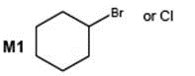
or chlorocyclohexane or bromocyclohexane
1

Reaction 3
M2 HBr
1
M3 Electrophilic addition
Allow M2 and M3 independent of each other
1

Reaction 4
M4 Ammonia if wrong do not gain M5
1
Allow M4 and M6 independent of each other
M5 Excess ammonia or sealed in a tube or under pressure
1
If CE e.g. acid conditions, lose M4 and M5
M6 Nucleophilic substitution
1

(d) Lone or electron pair on N
No marks if reference to “lone pair on N” missing
1
Delocalised or spread into ring in U
1
Less available (to accept protons) or less able to donate (to H⁺)
1
[19]

M16.(a) (i) Conc HNO₃
If either or both conc missing, allow one;
1

Conc H₂SO₄
this one mark can be gained in equation`
1

2 H₂SO₄ + HNO₃ 2 HSO₄– + NO₂⁺ + H₃O⁺
1

OR H₂SO₄ + HNO₃ HSO₄– + NO₂⁺ + H₂O
Allow + anywhere on NO₂⁺
OR via two equations
H₂SO₄ + HNO₃ HSO₄– + H₂NO₃⁺
H₂NO₃⁺ NO₂⁺ + H₂O
(ii)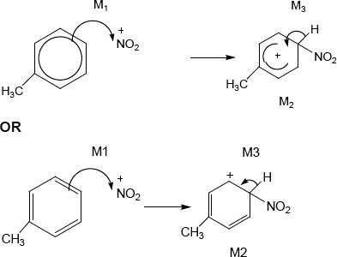
• ignore position or absence of methyl group in M1 but must be in correct position for M2
• M1 arrow from within hexagon to N or + on N
• Allow NO₂⁺ in mechanism
• Bond to NO₂ must be to N
• horseshoe must not extend beyond C2 to C6 but can be smaller
• + not too close to C1
• M3 arrow into hexagon unless Kekule
• allow M3 arrow independent of M2 structure
• ignore base removing H in M3
• + on H in intermediate loses M2 not M3
3

(b) 5
1

(c) 2
1

(d) 2C₇H₅N₃O₆ 5H₂O + 3N₂ + 7C + 7CO
Or halved
1
[9]

M17.(a) CH₃COCl + AlCl₃ CH₃CO⁺ + AlCl₄–
Allow RHS as 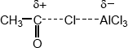
Allow + on C or O in equation but + must be on C in mechanism below
Ignore curly arrows in equation even if wrong.
1

AlCl₄– + H⁺ AlCl₃ + HCl
1

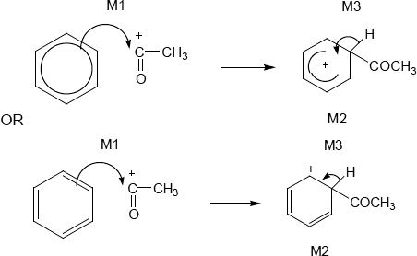
• M1 arrow from within hexagon
to C or to + on C
• + must be on C of RCO in mechanism
• + in intermediate not too close to C1
• gap in horseshoe must be centred approximately around C1
• M3 arrow into hexagon unless Kekule
• allow M3 arrow independent of M2 structure
• ignore base removing H for M3
• NO mark for name of mechanism
3

Phenylethanone ignore 1 in name, penalise other numbers
Note: this is the sixth marking point in (a)
1

(b)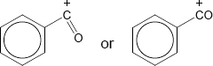
+ must be on C
But allow [C₆H₅CO]⁺
1

(c) M1 about electrons
methyl group has (positive) inductive effect OR increases electron density on
benzene ring OR pushes electrons OR is electron releasing
Ignore reference to delocalisation
1

M2 about attraction
electrophile attracted more
or benzene ring better nucleophile
Allow intermediate ion stabilised
M2 only awarded after correct or close M1
1
[9]

M18.(a)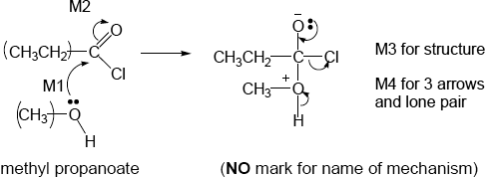
• M2 not allowed independent of M1, but allow M1 for correct attack on C+
• + rather than δ+ on C=O loses M2
• If Cl lost with C=O breaking, max1 for M1
• M3 for correct structure with charges but lp on O is part of M4
• only allow M4 after correct/very close M3
• ignore Cl – removing H⁺
4

1

(b) (i) pentane-1,5-diol
Second ‘e’ and numbers needed
Allow 1,5-pentanediol but this is not IUPAC name
(ii)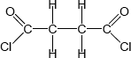
Must show ALL bonds
1

(iii) All three marks are independent
M1 (base or alkaline) Hydrolysis (allow close spelling)
1

Allow (nucleophilic) addition-elimination or saponification
M2 δ+ C in polyester
1

M3 reacts with OH– or hydroxide ion
1

Not reacts with NaOH
1

(c) (i)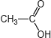
Allow CH₃COOH or CH₃CO₂H
1

(ii) (nucleophilic) addition-elimination
Both addition and elimination needed and in that order
OR
(nucleophilic) addition followed by elimination
Do not allow electrophilic addition-elimination / esterification
Ignore acylation
1

(iii) any two from: ethanoic anhydride is
• less corrosive
• less vulnerable to hydrolysis
• less dangerous to use,
• less violent/exothermic/vigorous reaction OR more controllable rxn
• does not produce toxic/corrosive/harmful fumes (of HCl) OR does not
produce HCl
• less volatile
NOT COST
List principle beyond two answers
2

(d)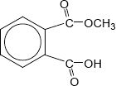
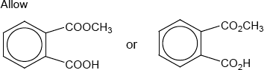
1

(e) (i) ester
Do not allow ether
Ignore functional group/linkage/bond
1

(ii) 12 or twelve (peaks)
1

(iii) 160 – 185
Allow a number or range within these limits
Penalize extra ranges given
Ignore units
1

(f) (i) sulfuric acid | sodium hydroxide
hydrochloric acid | ammonia | X or blank
ethanoic acid | potassium hydroxide
nitric acid | methylamine | X or blank

4 correct scores 2
3 correct scores 1
2 or 1 correct scores 0
2

(ii) Pink to colourless
Allow ‘red’ OR ‘purple’ OR ‘magenta’ instead of ‘pink’
Do not allow ‘clear’ instead of ‘colourless’
1
[21]

M19.(a) (i) CH₃COCl + C₆H₆ → C₆H₅COCH₃ + HCl
Not molecular formulae Not allow C₆H₅CH₃CO
1

OR
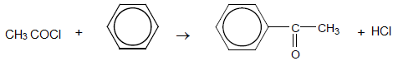
phenylethanone
Ignore number 1 in name but penalise other numbers
1

AlCl₃ can be scored in equation
1

Allow RHS as 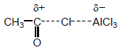

Allow + on C or O in equation but + must be on C in mechanism below
Ignore curly arrows in balanced equation even if wrong
1

(ii) Electrophilic substitution
1

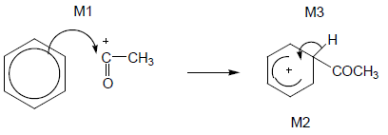
OR
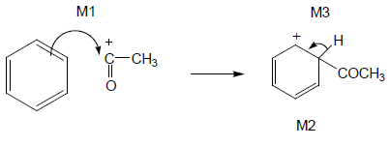
• M1 arrow from within hexagon
to C or to + on C
• + must be on C of CH₃CO in mechanism
• + in intermediate not too close to C1
• Gap in horseshoe must be centred approximately around C1
• M3 arrow into hexagon unless Kekulé
• Allow M3 arrow independent of M2 structure,
• ie + on H in intermediate loses M2 not M3
• Ignore base removing H for M3
3

(b) Electron pair donor or lone pair donor
Allow donator
Allow lone pair used in description of (dative) bond formation
1

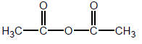
Allow (CH₃CO)₂O
1

(acid) anhydride
Allow ethanoic anhydride but not any other anhydride
1
[11]

M20.(a) Sn / HCl OR Fe / HCl not conc H₂SO₄ nor any HNO₃
Ignore subsequent use of NaOH
Ignore reference to Sn as a catalyst with the acid
Allow H₂ (Ni / Pt) but penalise wrong metal
But NOT NaBH₄ LiAlH₄ Na / C₂H₅OH
1

Equation must use molecular formulae
C₆H₄N₂O₄ + 12 [H]
12[H] and 4H₂O without correct molecular formula scores 1 out of 2
1

→C₆H₈N₂ + 4H₂O
Allow .... + 6H₂ if H₂ / Ni used
Allow −CONH− or −COHN− or −C₆H₄−
1

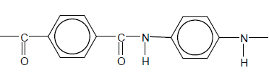
Mark two halves separately: lose 1 each for
• error in diamine part
• error in diacid part
• error in peptide link
• missing trailing bonds at one or both ends
• either or both of H or OH on ends
Ignore n
2

(b) H₂ (Ni / Pt) but penalise wrong metal
NOT Sn / HCl, NaBH₄ etc.
1

CH₂
1

In benzene 120°
1

In cyclohexane 109° 28’ or 109½°
Allow 108° - 110°
If only one angle stated without correct qualification, no mark awarded
1

(c) (i) Nucleophilic addition
1

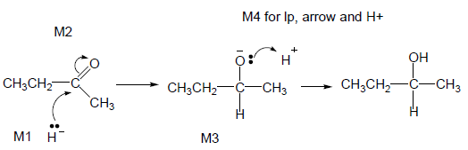
• M2 not allowed independent of M1, but allow M1 for correct attack on C+
• + rather than δ+ on C=O loses M2
• M3 is for correct structure including minus sign but lone pair is part of M4
• Allow C₂H₅
• M1 and M4 include lp and curly arrow
• Allow M4 arrow to H in H₂O (ignore further arrows)
4

(ii) M1 Planar C=O (bond / group)
Not just planar molecule
1

M2 Attack (equally likely) from either side
Not just planar bond without reference to carbonyl
1

M3 (about product): Racemic mixture formed OR 50:50 mixture or
each enantiomer equally likely
1
[17]

