Required Practicals - watch on Youtube (click text for link)
Science Revision 2018
Biology Revision
- Required practical 1 - Using a light microscope
- Required practical 2 - Effect of antiseptics on bacterial growth (Triple only)
- Required practical 3 - Osmosis
- Required practical 4 - Food tests
- Required practical 5 - Enzymes
- Required practical 6 - Photosynthesis
- Required practical 7 - Human reaction time
- Required practical 8 - Germinating seedlings (Triple only)
- Required practical 9 - Guidance on how to use quadrats
- Required practical 10 - Decay model (Triple only)

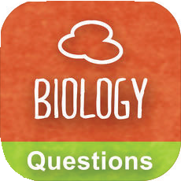
Biology Apps (click text for link)

LearnersCloud.com Biology GCSE 9-1 AQA

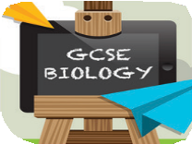
Revision Buddies GCSE Biology
Biology Guru App

Biology Books
GCSE Biology
For AQA (Grade 9-1) Revision Guide

- Required practical 1 - Prepare a salt from insoluble metal carbonate or oxide
- Required practical 2 - Titration to investigate reacting volumes (Triple only)
- Required practical 3 - Electrolysis
- Required practical 4 - Temperature changes
- Required practical 5 - Concentration on rate of reaction
- Required practical 6 - Calculating Rf values
- Required practical 7 - Identifying unknown compounds
- Required practical 8 - Purify and test water

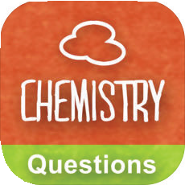
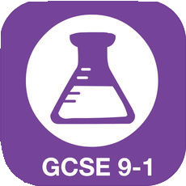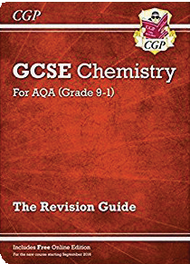Chemistry Apps (click text for link)

LearnersCloud.com Chemistry GCSE 9-1 AQA

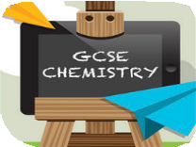
Revision Buddies GCSE Chemistry
Chemistry Guru App

Chemistry Books
GCSE Chemistry
For AQA (Grade 9-1) Revision Guide

- Determining Specific Heat Capacity
- Investigating thermal insulators (Triple only)
- Investigating resistance
- Investigating electrical components
- Investigating densities
- Investigating the relationship between force and extension for a spring
- Investigating force and acceleration
- Investigating plane waves in a ripple tank
- Investigating the reflection and refraction of light (Triple only)
- Investigating infrared radiation

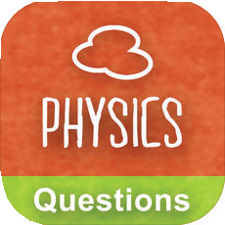
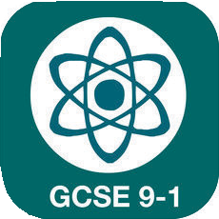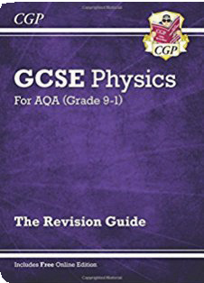Physics Apps (click text for link)

LearnersCloud.com Physics GCSE 9-1 AQA

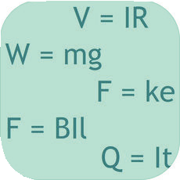
GCSE Physics Equations Alixander Price

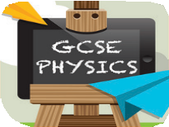
Revision Buddies GCSE Physics
Physics Guru App

Physics Books
GCSE Physics
For AQA (Grade 9-1) Revision Guide

for link)

Focus eLearning

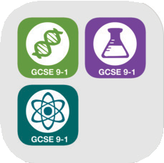
General Apps (click text for link)

My GCSE Science Videos Trilogy Bundle GCSE 9-1

