8Questions
Q1.
Which of the following molecules does not absorb infrared radiation?
A N₂
B NO₂
C CO
D CO₂
(Total for Question = 1 mark)

Q2.
The following liquids all have the same number of electrons in each molecule. Which
one is likely to have the lowest boiling point?
A CH₃CH₂CH₂CH₂OH
B CH₃CH₂CH₂CH₂CH₃
C CH₃C(CH₃)₂CH₃
D CH₃CH(CH₃)CH₂CH₃
(Total for question = 1 mark)

Q3.
Which of these isomers has the highest boiling temperature?
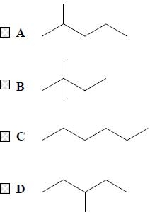
(Total for question = 1 mark)

Q4.
Ethanol is soluble in water. The best explanation for this is
A ethanol molecules form hydrogen bonds with water molecules.
B ethanol molecules form London (dispersion) forces with water molecules.
C ethanol molecules form permanent dipole interactions with water molecules.
D ethanol and water are miscible liquids.
(Total for question = 1 mark)

Q5.
Consider the following compounds, P, Q, R and S.
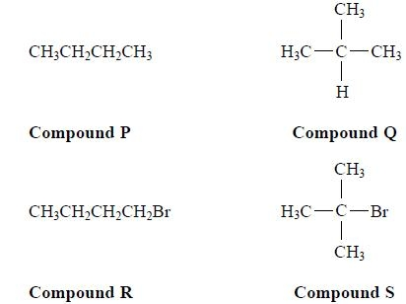
The boiling temperatures of compounds P, Q, R and S increase in the order
A P Q R S
B R S P Q
C Q S P R
D Q P S R
(Total for question = 1 mark)

Q6.
For parts (a) and (b), use your knowledge of intermolecular forces to predict the
compound with the highest boiling temperature.
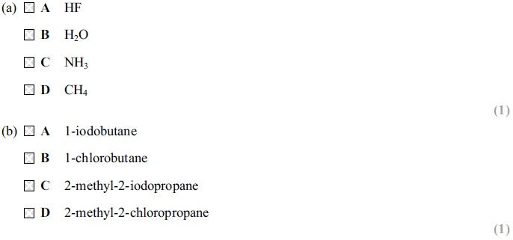
(Total for question = 2 marks)

Q7.
Which list below shows the compounds in order of increasing boiling temperature?
A CH₄, HCl, HF
B HF, CH₄, HCl
C HCl, HF, CH₄
D HF, HCl, CH₄
(Total for question = 1 mark)

Q8.
Which of the following has the highest boiling temperature?
A Pentane, CH₃CH₂CH₂CH₂CH₃
B Hexane, CH₃CH₂CH₂CH₂CH₂CH₃
C 2-methylbutane, CH₃CH(CH₃)CH₂CH₃
D 2-methylpentane, CH₃CH(CH₃)CH₂CH₂CH₃
(Total for question = 1 mark)

Q9.
Which of the following has dipole-dipole interactions between its molecules, but no
hydrogen bonding?
A Methane, CH₄
B Methanol, CH₃OH
C Ammonia, NH₃
D Hydrogen iodide, HI
(Total for question = 1 mark)

Q10.
Which of these is likely to be the best solvent for cyclohexanol?
A H₂O(l)
B CH₃COCH₃(l)
C NaCl(aq)
D CH₃CH₂CH₂CH₂CH₂CH₃(l)
(Total for question = 1 mark)

Q11.
Which of the following molecules has the lowest boiling temperature?
A
B
C
D

(Total for question = 1 mark)

Q12.
Which of the following molecules has the highest melting temperature?
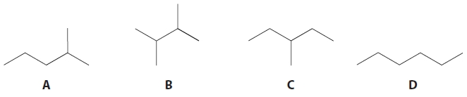
A
B
C
D

(Total for question = 1 mark)

Q13.
Hydrogen iodide has a higher boiling temperature than hydrogen bromide. This is because
A the H—I bond is stronger than the H—Br bond.
B hydrogen iodide has stronger London forces than hydrogen bromide.
C hydrogen iodide has a larger permanent dipole than hydrogen bromide.
D hydrogen iodide forms hydrogen bonds but hydrogen bromide does not.
(Total for question = 1 mark)

Q14.
Which of the following compounds shows hydrogen bonding in the liquid state?
A Hydrogen bromide, HBr
B Hydrogen sulfide, H₂S
C Silane, SiH₄
D Ammonia, NH₃
(Total for question = 1 mark)

Q15.
The diagram below is taken from a student's examination paper. It shows the hydrogen bonding between two water molecules.
Identify the error in the diagram.
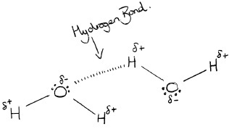

A The H—O—H bond angle within each water molecule should be 90°.
B There should only be one lone pair of electrons on each oxygen atom.
C The O—H—O bond angle between the water molecules should be 180°.
D The hydrogen atoms should be ⁻ and the oxygen atoms should be ⁺.
(Total for Question = 1 mark)

Q16.
The difference in boiling temperature between methane (T_{b} = 109 K) and ethane (T_{b} = 185 K) is best explained by the different numbers of
A protons.
B electrons.
C covalent bonds.
D hydrogen bonds.
(Total for question = 1 mark)

Q17.
Which intermolecular forces exist between molecules of ethoxyethane?
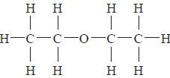
A Instantaneous dipole − induced dipole only
B Permanent dipole − permanent dipole only
C Instantaneous dipole − induced dipole and hydrogen bonds
D Instantaneous dipole − induced dipole and permanent dipole − permanent
dipole
(Total for question = 1 mark)

Q18.
What are the strongest forces between molecules of hydrogen fluoride, HF?

A Dipole-dipole forces.
B Hydrogen bonds.
C Ionic interactions.
D London forces.
(Total for Question = 1 mark)

Q19.
The ability of a liquid to flow is linked to the strength of its intermolecular forces.
Suggest which of these liquids flows the slowest when poured.
A Propane-1,2,3-triol
B Propane-1,2-diol
C Pentane
D Butane
(Total for question = 1 mark)

Q20.
Which of the following substances does not have intermolecular hydrogen bonds?
A Ethanoic acid, CH₃COOH
B Propanone, CH₃COCH₃
C Methanol, CH₃OH
D Water, H₂O

(Total for question = 1 mark)

Q21.
Butane has a higher boiling temperature than 2–methylpropane. This is because butane has
A stronger C—H bonds.
B more electrons.
C a larger surface area.
D hydrogen bonds.
(Total for question = 1 mark)

Mark Scheme
Q1.

Q2.

Q3.

Q4.

Q5.

Q6.

Q7.

Q8.

Q9.

Q10.

Q11.

Q12.

Q13.

Q14.

Q15.

Q16.

Q17.

Q18.

Q19.

Q20.

Q21.

