Questions
Q1.
The dissociation of ethanoic acid in aqueous solution is represented by
Which of the following statements is true for this equilibrium?
A CH₃COOH is an acid and its conjugate base is CH₃COO⁻.
B H₂O is an acid and its conjugate base is OH⁻.
C At equilibrium, the concentrations of each substance are the same.
D At equilibrium, the reaction from left to right and the reaction from right to
left have stopped.
(Total for question = 1 mark)

Q2.
Which of the following is not a reaction of a Brønsted-Lowry acid and base?
A CH₃Cl + OH⁻ → CH₃OH + Cl⁻
B NH₃ + HCl → NH₄⁺ + Cl⁻
C H₂O + HSO₄⁻ → H₂SO₄ + OH⁻
D HCO₃⁻ + H₂O → CO₃²⁻ + H₃O⁺
(Total for question = 1 mark)

Q3.
The reaction between concentrated sulfuric acid and pure ethanoic acid is
CH₃COOH + H₂SO₄ CH₃COOH₂⁺ + HSO₄⁻
The Brønsted-Lowry acids in this equilibrium are

A CH₃COOH and H₂SO₄
B CH₃COOH₂ + and HSO₄⁻
C H₂SO₄ and CH₃COOH₂⁺
D CH₃COOH and HSO₄⁻
(Total for Question = 1 mark)

Q4.
Which of the following statements is true about all substances that form acidic solutions in water?

A They are corrosive.
B They are liquids.
C They contain hydrogen atoms.
D They form H⁺(aq) ions.
(Total for Question = 1 mark)

Q5.
The dissociation constant of water, K_{w}, increases with increasing temperature. When the temperature increases, water

A remains neutral.
B dissociates less.
C becomes acidic.
D becomes alkaline.
(Total for Question = 1 mark)

Q6.
An aqueous solution of ethanoic acid is gradually diluted. Which of the following statements is incorrect?

A The pH decreases.
B The value of K_{a} is unchanged.
C The concentration of ethanoic acid molecules decreases.
D The proportion of ethanoic acid molecules which dissociates increases.
(Total for Question = 1 mark)

Q7.
Methyl orange and phenolphthalein are both acid-base indicators. In the titration of a strong acid against a weak alkali

A methyl orange is a suitable indicator but phenolphthalein is not.
B phenolphthalein is a suitable indicator but methyl orange is not.
C both phenolphthalein and methyl orange are suitable indicators.
D neither phenolphthalein nor methyl orange is a suitable indicator.
(Total for Question = 1 mark)

Q8.
In which of these reactions is the hydrogensulfate ion, HSO₄⁻, behaving as a Brønsted-Lowry base?
A HSO₄⁻ + H₃O⁺ → H₂SO₄ + H₂O
B HSO₄⁻ + Ba²⁺ → BaSO₄ + H⁺
C HSO₄⁻ + H₂O → SO₄²⁻+ H₃O⁺
D HSO₄⁻ + CO₃²⁻ → SO₄²⁻+ HCO₃⁻
(Total for question = 1 mark)

Q9.
Ammonia reacts with water in a reversible reaction. Which are the Brønsted-Lowry bases?
A H₂O and OH⁻
B NH₃ and OH⁻
C NH₄⁺ and H₂O
D NH₄⁺ and NH₃

(Total for question = 1 mark)

Q10.
In liquid ammonia the following equilibrium is present.
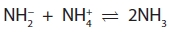
Identify the Brønsted-Lowry base(s).
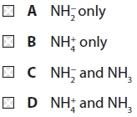

(Total for question = 1 mark)

Q11.
When equimolar amounts of the solutions below are mixed, which forms a buffer
solution with a pH less than 7?
A Hydrochloric acid and sodium chloride
B Ethanoic acid and sodium ethanoate
C Sodium hydroxide and sodium chloride
D Ammonia and ammonium chloride
(Total for question = 1 mark)

Q12.
A buffer solution is made from ammonia and ammonium chloride. When a small
amount of acid is added to this buffer
A hydrogen ions in the acid combine with chloride ions to make HCl.
B hydrogen ions in the acid combine with NH₃ to make NH₄⁺.
C NH₄⁺ ions dissociate to make more NH₃.
D the hydrogen ions in the acid prevent dissociation of the NH₄Cl.
(Total for question = 1 mark)

Q13.
Which of the following mixtures would form the best buffer solution with pH 9 for use in a school laboratory?
A Ethanoic acid and sodium ethanoate
B Sodium chloride and sodium hydroxide
C Hydrocyanic acid and sodium cyanide
D Ammonium chloride and ammonia

(Total for question = 1 mark)

Q14.
Which of the following mixtures would form the best buffer solution with pH 5 for use in a school laboratory?
A Ethanoic acid and sodium ethanoate
B Hydrochloric acid and sodium chloride
C Sodium hydroxide and sodium methanoate
D Ammonium chloride and ammonia

(Total for question = 1 mark)

Q15.
Which of the following solutions, when mixed, would make a buffer with pH more than 7?
A Methanoic acid and sodium methanoate.
B Sodium hydroxide and sodium chloride.
C Ammonia and ammonium chloride.
D Ammonium chloride and ammonium ethanoate.
(Total for question = 1 mark)

Q16.
What is the conjugate base of the acid, HCO₃⁻?
A H₂CO₃
B CO₃²⁻
C OH⁻
D CO²
(Total for question = 1 mark)

Q17.
At 100 °C, pure water has a pH of 6, whereas at 25 °C it has a pH of 7. This is because
A the dissociation of water is endothermic, so the concentration of hydrogen
ions is lower at 100 °C than it is at 25 °C.
B the dissociation of water is exothermic, so the concentration of hydrogen ions
is lower at 100 °C than it is at 25 °C.
C the dissociation of water is endothermic, so the concentration of hydrogen
ions is higher at 100 °C than it is at 25 °C.
D at 100 °C, water has a higher concentration of hydrogen ions than of
hydroxide ions.
(Total for question = 1 mark)

Q18.
Why are aqueous solutions of sodium ethanoate slightly alkaline?
A The sodium ions react with water to give an alkali.
B The ethanoate ions react with water to give hydroxide ions.
C All sodium salts give alkaline solutions.
D The sodium ethanoate is fully ionized in solution.
(Total for question = 1 mark)

Q19.
Which one of the following indicators is most suitable for titrating ethanoic acid with 0.1 mol dm⁻³ sodium hydroxide?
(Refer to page 19 of your data booklet.)
A Thymol blue (acid)
B Bromothymol blue
C Thymol blue (base)
D Alizarin yellow R
(Total for question = 1 mark)

Q20.
In which of the following reactions is nitric acid acting as a base?
A HNO₃ + NaOH → NaNO₃ + H₂O
B HNO₃ + H₂O → H₃O⁺ + NO₃⁻
C HNO₃ + H₂SO₄ → H₂NO₃⁺ + HSO₄⁻
D HNO₃ + NaHCO₃ → NaNO₃ + H₂O + CO₂
(Total for question = 1 mark)

Q21.
Which of the following solutions has the lowest pH?
A 0.010 mol dm⁻³ hydrochloric acid.
B 0.100 mol dm⁻³ hydrochloric acid.
C 0.010 mol dm⁻³ ethanoic acid.
D 0.100 mol dm⁻³ ethanoic acid.
(Total for question = 1 mark)

Q22.
The pH of a 1.5 mol dm⁻³ solution of hydrochloric acid, HCl(aq), is
A −1.50
B −0.18
C 0.18
D 1.50
(Total for question = 1 mark)

Q23.
What is the approximate pH of a buffer solution containing 0.20 mol of a weak acid, HA, (pK_{a} = 4.8) and 0.20 mol of the sodium salt of the acid, NaA, in a total volume of 1 dm³ of solution?
A 7.0
B 5.8
C 4.8
D 3.8
(Total for question = 1 mark)

Q24.
A solution of hydrochloric acid has pH 3.0. When it is made 10 times more dilute, the pH is
A 0.3
B 2.0
C 4.0
D 13.0
(Total for question = 1 marks)

Q25.
An aqueous solution of ammonium chloride, NH₄Cl, has a pH of less than 7 because
A the ammonium ions donate protons to water molecules giving rise to
oxonium ions, H₃O⁺(aq).
B the chloride ions combine with hydrogen ions from water to form
hydrochloric acid, HCl(aq).
C an aqueous solution of ammonium chloride is unstable and evolves ammonia
gas, NH₃(g), leaving dilute hydrochloric acid.
D the ammonium chloride reacts with carbon dioxide from the atmosphere
giving ammonium carbonate, (NH₄)₂CO₃(aq), and hydrochloric acid, HCl(aq).
(Total for question = 1 mark)

Q26.
Select the correct pH for each of the following solutions.
(a) 2 mol dm⁻³ nitric acid.
(1)
A −2
B −0.3
C +0.3
D +2
(b) 0.10 mol dm⁻³ barium hydroxide, Ba(OH)₂. K_{w} = 1.0 × 10⁻¹⁴ mol² dm⁻⁶.
(1)
A 13.0
B 13.3
C 13.7
D 14.3
(c) A mixture of 20 cm³ of 1.0 mol dm⁻³ hydrochloric acid and 10 cm³ of 1.0 mol dm⁻³ sodium hydroxide.
(1)
A 13.0
B 13.3
C 13.7
D 14.3

(Total for question = 3 marks)

Q27.
Suggest the most likely pH for each of the following solutions.
(a) 5.0 mol dm⁻³ hydrochloric acid.
(1)
A +5
B +0.7
C −0.7
D −5
(b) 0.20 mol dm⁻³ strontium hydroxide, Sr(OH)₂
K_{w} = 1.0 × 10⁻¹⁴ mol² dm⁻⁶
(1)
A 13.3
B 13.6
C 14.0
D 14.3
(c) A mixture of 20 cm³ of 1.0 mol dm⁻³ nitric acid and 10 cm³ of 1.0 mol dm⁻³ sodium hydroxide.
(1)
A 0
B 0.30
C 0.48
D 7

(Total for question = 4 marks)

Q28.
Information about four samples of acid is shown below.
Sample 1: 1.0 mol dm⁻³ HCl
Sample 2: 1.0 mol dm⁻³ H₂SO₄
Sample 3: 0.1 mol dm⁻³ HCl
Sample 4: 0.1 mol dm⁻³ CH₃COOH
Which of the following lists shows the samples in order of increasing pH?
A 1, 2, 3, 4
B 4, 3, 2, 1
C 2, 1, 3, 4
D 4, 3, 1, 2
(Total for question = 1 mark)

Q29.
Why does phenolphthalein, which is colourless in acidic solutions, turn pink in alkaline
solutions?
A It is oxidized to a pink compound by hydroxide ions.
B It forms a pink anion by loss of H⁺ ions.
C It forms a pink anion by gain of H⁺ ions.
D It forms a pink cation by gain of H⁺ ions.
(Total for question = 1 mark)

Q30.
A solution of a weak acid cannot be titrated with a weak base using an indicator to find
the end-point because
A the pH change is too gradual close to the equivalence point.
B there are too few H⁺ ions to affect the indicator.
C there are too few OH⁻ ions to affect the indicator.
D the pH change occurs outside the range of any indicator.
(Total for question = 1 mark)

Q31.
The titration curves below were obtained using different acids and bases, each with concentration 0.1 mol dm⁻³.
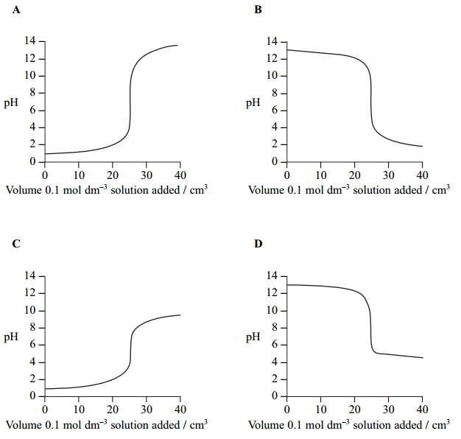
(a) Which curve is produced by adding ammonia to 25 cm³ of hydrochloric acid? (1)
A
B
C
D
(b) Which curve is produced by adding ethanoic acid to 25 cm³ of sodium hydroxide? (1)
A
B
C
D
(c) An indicator with pK_{In} 8.5 is suitable for the following titrations. (1)
A Titrations A and B only.
B Titrations A, B and D only.
C Titration C only.
D Titrations A, B, C and D.
(Total for question = 3 marks)

Mark Scheme
Q1.

Q2.

Q3.

Q4.

Q5.

Q6.

Q7.

Q8.
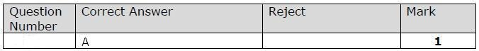

Q9.

Q10.

Q11.

Q12.

Q13.

Q14.

Q15.

Q16.

Q17.

Q18.

Q19.

Q20.

Q21.

Q22.

Q23.

Q24.

Q25.

Q26.

Q27.
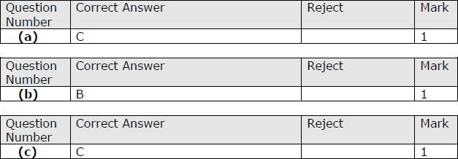

Q28.

Q29.

Q30.

Q31.

