Questions
Q1.
Which of the arrows, A, B, C, D, indicates the activation energy for a catalysed reaction on the reaction profile shown?
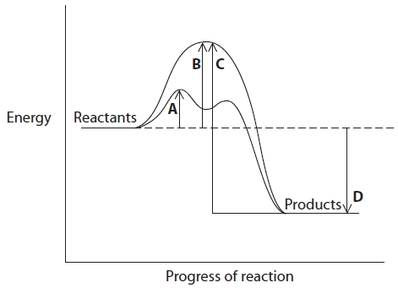
A
B
C
D

(Total for question = 1 mark)

Q2.
In a chemical reaction, which of the following factors increases the proportion of particles that have sufficient energy to react?

A A decrease in concentration
B An increase in concentration
C A decrease in temperature
D An increase in temperature
(Total for Question = 1 mark)

Q3.
In the industrial process involving gas phase reactions to produce ammonia, many collisions between molecules are unsuccessful because

A gas phase reactions are reversible.
B the collisions are not energetic enough to break the bonds in the molecules.
C gas phase reactions can only occur when a catalyst is present.
D gas phase reactions can only occur when UV light is present.
(Total for Question = 1 mark)

Q4.
In the equilibrium below, what effect would the changes described have on the system?
(a) Increase in temperature
(1)
A increase rate, decrease yield
B increase rate, increase yield
C decrease rate, decrease yield
D decrease rate, increase yield
(b) Decrease in pressure
(1)
A increase rate, decrease yield
B increase rate, increase yield
C decrease rate, decrease yield
D decrease rate, increase yield
(Total for question = 2 marks)

Q5.
Which of the following will not affect the rate of the reaction below?
CaCO₃(s) + 2HCl(aq) → CaCl₂(aq) + H₂O(l) + CO₂(g)
A Surface area
B Concentration
C Pressure
D Temperature

(Total for question = 1 mark)

Q6.
The Maxwell-Boltzmann distribution of molecular energies is useful for explaining why increasing temperature affects the rate of a chemical reaction.
(a) Which of the following statements describes how the shape of the Maxwell-Boltzmann distribution curve changes as temperature increases?
(1)
A The peak decreases in height and moves to the left.
B The peak increases in height and moves to the left.
C The peak decreases in height and moves to the right.
D The peak increases in height and moves to the right.
(b) The main reason that reaction rates increase with temperature is that
(1)
A all the molecules move faster.
B all the molecules collide more frequently.
C more molecules collide with the correct orientation.
D a larger proportion of molecules have high energies.
(Total for question = 2 marks)

Q7.
The diagram below shows the Maxwell-Boltzmann distribution of molecular energies for a catalysed reaction.
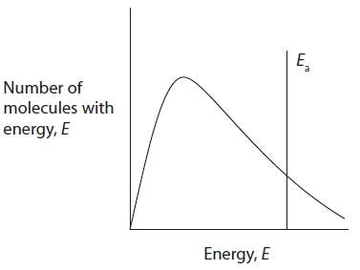?
(a) If the temperature were lowered, what would be the effect on the shape of the curve?
(1)
A The peak would shift to the left and be higher.
B The peak would shift to the left and be lower.
C The peak would shift to the right and be higher.
D The peak would shift to the right and be lower.
(b) Which of the following would shift the activation energy line to the right?
(1)
A An increase in reactant concentration.
B The removal of the product.
C The removal of the catalyst.
D The use of smaller particles with a larger surface area.

(Total for question = 2 marks)

Q8.
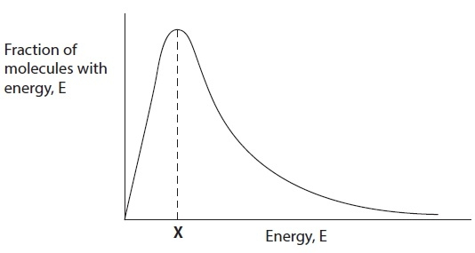
The energy marked X in the Maxwell-Boltzmann distribution shows

A the most common energy of the molecules.
B the activation energy of the reaction.
C the activation energy of a catalysed reaction.
D the number of molecules with energy greater than the activation energy.
(Total for Question = 1 mark)

Q9.
The diagram below shows the Maxwell-Boltzmann distribution of molecular energies for a gaseous system at two temperatures.
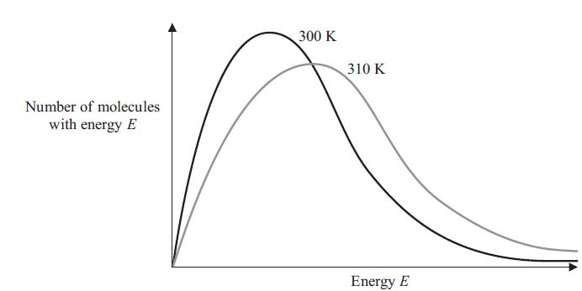
(a) The energy plotted on the horizontal axis is mainly
(1)
A activation.
B kinetic.
C rotation.
D vibration.
(b) The rate of a chemical reaction increases with temperature mainly because
(1)
A the activation energy increases.
B the activation energy decreases.
C more collisions occur with energy greater than the activation energy.
D the molecules collide more frequently.
(c) The total area under each curve
(1)
A decreases with increasing temperature.
B increases with increasing temperature.
C increases or decreases with increasing temperature, depending on the size of the molecules.
D does not change with temperature.
(Total for question = 3 marks)

Q10.
In the reaction between Ag⁺(aq) ions and Fe²⁺(aq) ions, what would be the effect of
increasing the concentration of Ag⁺(aq) ions?
A Rate of reaction increases, yield of Fe³⁺(aq) stays the same.
B Rate of reaction increases, yield of Fe³⁺(aq) decreases.
C Rate of reaction decreases, yield of Fe³⁺(aq) stays the same.
D Rate of reaction increases, yield of Fe³⁺(aq) increases.
(Total for question = 1 mark)

Q11.
When steam is passed over heated magnesium, which of the following occurs?
A Mg + H₂O → MgO + H₂
B Mg + H₂O → MgOH + ½H₂
C Mg + 2H₂O → Mg(OH)₂ + H₂
D There is no reaction with the magnesium.

(Total for question = 1 mark)

Q12.
In the reaction profile below, which energy change would alter if a catalyst was added to
the reaction?
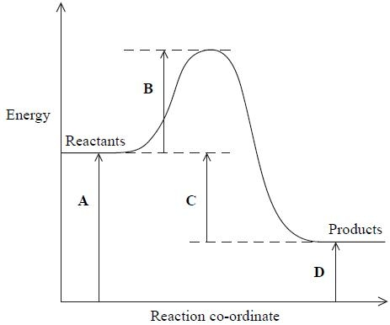
A
B
C
D
(Total for question = 1 mark)

Q13.
The reaction profile for an endothermic reaction is shown below.
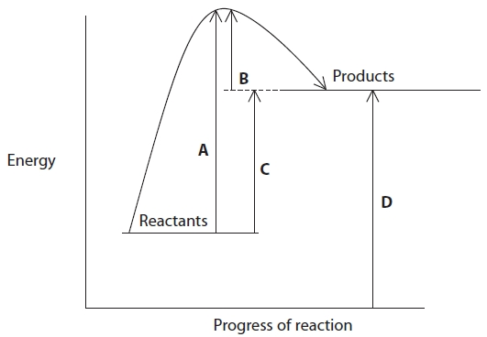
(a) Which arrow represents the activation energy for the forward reaction?
(1)
A
B
C
D
(b) Which arrow represents the activation energy for the backward reaction?
(1)
A
B
C
D

(Total for question = 2 marks)

Mark Scheme
Q1.

Q2.

Q3.

Q4.

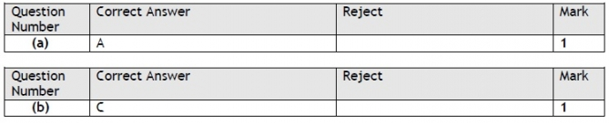

Q5.

Q6.

Q7.

Q8.

Q9.

Q10.

Q11.

Q12.

Q13.
