Combined Chemistry

Cheeky 1 Markers

Paper 1
- Give the relative charge of a proton | +1
- Give the relative charge of a neutron | 0 (neutral)
- Give the relative charge of an electron | -1
- Give the relative mass of a proton | 1
- Give the relative mass of a neutron | 1
- Give the relative mass of an electron | Very small
- Define the term element | A substance made up of only 1 type of atom
- Define the term compound | A substance made up of 2 or more types of atoms chemically bonded together
- Describe how a mixture of a solid and liquid can be separated | filteration
- Describe how a mixture of a 2 or more liquids can be separated | distillation
- Explain why atoms bond | Atoms without a full outer shell are unstable, so they will bond to fill their outershell
- Atoms are very small, give the approximate radius size of an atom | 0.1nm
- Give the number of protons, neutrons and electrons in sodium | 11 protons, 11 electrons and (23-11=)12 neutrons
- Define The term relative atomic mass | The average mass of an atom taking into account the abundance of the isotopes of the element.
- Describe how the periodic table is organised in terms of protons and electrons | The periodic table is arranged in order of increasing proton number
- Describe how the periodic table is organised in terms of electrons | The group number of an element is the number of electrons in it’s outer shell. The period the element is in is the number of electron shells the element has.
- Why did Mendeleev leave gaps in his periodic table | So that elements with similar properties would be placed in the same group
- Give the charge of the ions formed by metals | positive
- Give the charge of the ions formed by non-metals | negative
- Explain why the elements in group 0 are unreactive | Because they have a full outershell
- Describe how covalent bonds are formed | Non-metal atoms share electrons to have a full outer shell
- Describe how ionic bonds form | Non-metal atoms gain electrons and form negative ions to have a full outer shell, metal ions lose electrons and form a positive ion to have a full outer shell, there is an electrostatic attraction between the oppositely charged ions
- Describe the bonding in metals (metallic bonding) | A giant lattice of positive metal ions surrounded by delocalised electrons, there is an electrostatic attraction between the positive ions and the electrons
- Describe why ionic compounds have high melting points | These compounds have a giant lattice of strong ionic bonds, these bonds take lots of energy to overcome
- Describe why metals have high melting points | These compounds have a giant lattice with strong metallic bonds, these bonds take lots of energy to overcome
- Describe why simple covalent molecules have low boiling points | These compounds have weak intermolecular forces between the molecules which only need small amounts of energy to overcome
- Name 3 allotropes of carbon | Diamond, graphite, graphene, Buckminster fullerene (only 3 though because of LIST RULE)
- Chemists use state symbols to show the states of substances in symbol equations. Give the state symbols and their meanings | (s) – solid  (l) – liquid  (g) – gas  (aq) – dissolved in water (aqueous)
- Describe the structure of a polymer | A polymer is a very large molecule made from lots of smaller molecules (monomer) these are linked by strong covalent bonds with intermolecular forces between the polymer chains.
- Explain why Giant covalent structures, such as diamond have high melting points | These are giant structures with strong covalent bonds, this means that the bonds will need lots of energy to be overcome when the substance melts.
- Describe the structure of metals | Giant lattice of metal ions surrounded by delocalised electrons, there is an electrostatic attraction between the ions and the delocalised electrons.
- Explain why alloys are stronger than pure metal | In pure metals the layers of atoms (ions) can easily slide past each other, whereas in an alloy there is more than one type of element with different sized atoms, the layers become distorted and can no longer move past each other.
- Explain why metals can conduct electricity | Metals have delocalised electrons, these can move through the structure carrying electrical charge.
- Compare the structure and bonding in diamond and graphite | Both of these substances are made out of carbon atoms, diamond has more bonds per carbon (4), whereas graphite only forms 3 bonds per carbon, forming hexagonal rings in layers and contains delocalised electrons
- Explain why graphene conducts electricity | Each carbon only forms 3 covalent bonds, this means there is a delocalised electron which can move carrying charge through the structure
- Calculate the formula mass of C₂H₅OH | C + (6x H)+O  12 + 6 +16 = 34
- Describe oxidation and reduction in terms of oxygen | Oxidation is the gain of oxygen, reduction is the loss of oxygen
- Describe oxidation and reduction in terms of electrons | Loss of electrons is oxidation , gain of electrons is reduction (LEO the lion says GER)
- Write a word equation for the reduction of copper oxide using carbon | Copper oxide +carbon Copper + carbon dioxide
- Name the gas produced when a metal reacts with an acid | Hydrogen
- Name 2 substances which can neutralise an acid | Alkali’s (soluble hydroxides) and Bases (insoluble metal hydroxides and metal oxides)
- Describe how a sample of pure crystals of Copper Chloride could be made from the reaction of copper oxide with Hydrochloric acid | Add excess copper oxide to Hydrochloric acid, heat to increase the rate of the reaction. Filter the solution to remove the excess Copper oxide and pour into an evaporating basin. The heat gently with a Bunsen burner and then leave for the Water to evaporate – leaving behind the crystals of Copper Chloride.
- Name the ion in Acidic solutions | H⁺ or hydrogen ions
- Name the ion present in aqueous soltions of alkalis | OH⁻ or Hydoxide ions
- Give the pH of an acidic solution | 0-6
- Give the pH of a neutral solution | 7
- Give the pH of an alkaline solution | 8-14
- Define the term strong acid and give examples of strong acids | A strong acid completely ionises in aqueous solution. Examples are Hydrochloric acid, sulfuric acid and nitric acid
- Define the term weak acid and give examples of weak acids | A weak acid only partially ionises in aqueous solution. Examples are ethanoic acid, citric acid and carbonic acid
- Explain why ionic compounds can conduct electricity when molten or dissolved in water | The ions are free to move carrying charge through the solution.
- Describe how the temperature changes during an exothermic reaction | During an exothermic reaction energy is transferred to the surroundings, so the temperature increases.
- Explain the term “exothermic” in terms of bond energies | In an exothermic reaction the energy taken in breaking bonds is less than the energy released making bonds
- Describe how the temperature changes during an exothermic reaction | During an endothermic reaction, energy is taken in from the surroundings, so the temperature decreases.
- Explain the term “endothermic” in terms of bond energies | In an endothermic reaction the energy taken in breaking bonds is greater than the energy released making bonds.
- Draw a reaction profile diagram for an exothermic reaction, label the reactants, products, activation energy and the energy change | 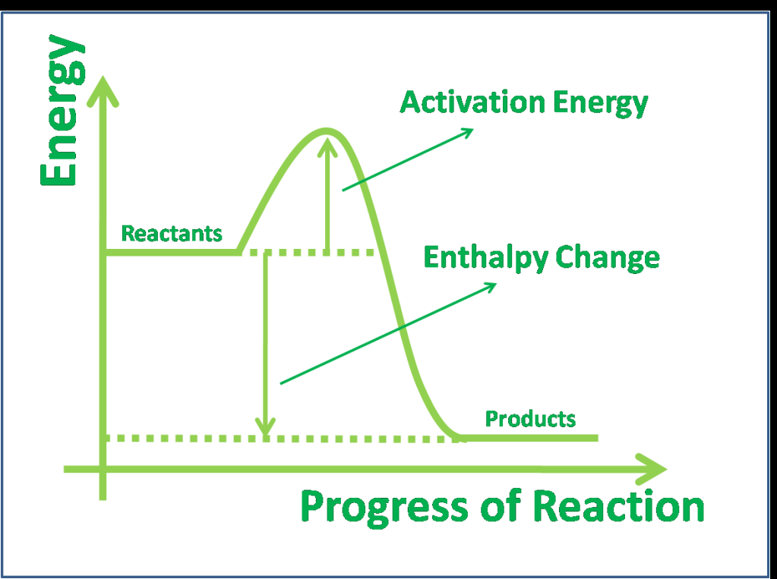
- Draw a reaction profile diagram for an endothermic reaction, label the reactants, products, activation energy and the energy change | 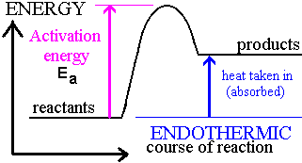
- Explain how increasing the temperature affects the rate of reaction | Increasing the temperature will increase the rate of reaction because the particles have a higher kinetic energy and will move faster, increasing the frequency of collisions. Also the collisions will have more energy, therefore increasing the number of successful collisions.
- Explain how increasing the concentration of a solution will affect the rate of reaction | The rate will increase because there will be more reacting particles in the same volume of solution, therefore collisions will occur more frequently
- Explain how increasing the pressure of gases will affect the rate of reaction | The rate will increase because there will be less space between the gas particles, therefore collisions will occur more frequently
- Define the term activation energy | The minimum amount of energy that particles must have to react

Paper 2
- Describe how a catalyst increases the rate of reaction | A catalyst lowers the activation by providing an alternative reaction route, so more collisions will be successful.
- Give the symbol for a reversible reaction | 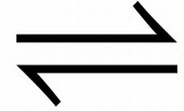
- Define the term equilibrium. | Equilibrium means that the rat of the forward reaction is equal to the rate of the reverse reaction. This can ONLY occur in a closed system.
- Draw a molecule of ethane | 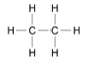
- Define the term hydrocarbon | A molecule made of only hydrogen and carbon only.
- Give the general formula of alkanes | C_{n}H_{2n+2}
- Describe how the hydrocarbons in crude oil can be separated | Use fractional distillation. Heat the crude oil and it will evaporate, the vapours will rise and as they rise they will cool. Once molecules cool to their boiling point they will condense and can be removed from the column. Big molecules are removed from the bottom of the column as they have high boiling points, and small molecules are removed at the top of the column as they have low boiling points. (BIG HOT BOTTOM!)
- Describe how the viscosity of hydrocarbons changes when the chain length increases | As the chain length increases the viscosity increases.
- Explain why smaller chain alkanes such as petrol are more useful as fuels | Smaller chain molecules are more flammable so can be burned are easily.
- Describe the test for alkenes and give the result | Add bromine water, if the bromine water decolourises then an alkene is present (unsaturated), because the bromine reacts with the double bond.
- Define the term “pure” substance | A substance made up of only one type of element of compound.
- Describe how we can use melting (or boiling) points to distinguish a pure substance | Pure substances melt (and boil) at fixed temperatures, mixtures melt (and boil) over a range of temperature.
- Give the equation to calculate the Rf value in chromatography | 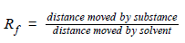
- Give the test for Hydrogen gas | Put a lit splint in the gas, a poping sound will be heard
- Give the test for oxygen gas | Place a glowing splint in the gas and it will relight
- Give the test for chlorine gas | Dip damp litmus into the gas and it will bleach and turn white
- Give the test for Carbon dioxide gas | Bubble the gas through limewater and the limewater will turn cloudy
- Give the names of the main gases in the atmosphere and their percentages | Nitrogen ~ 80%  Oxygen ~ 20%  Small amounts of Carbon dioxide and other gases.
- Describe and explain how the atmosphere has changed from the early Earth’s atmosphere | The hater vapour % decreased because the Earth cooled and the water vapour condensed forming oceans. Carbon dioxide % has decreased because it dissolved into the oceans, was locked up in sedimentary rocks and fossil fuels and plants take this gas in. The Nitrogen % and the oxygen % increased because this is produced by plants in photosynthesis
- Give the effect of Carbon dioxide, carbon monoxide, Carbon particles, sulfur dioxide and oxides of nitrogen on the atmosphere | Carbon dioxide causes global warming  carbon monoxide is toxic  Carbon particles cause global dimming  sulfur dioxide and oxides of nitrogen cause acid rain
- Name 2 greenhouse gases | Carbon dioxide, methane and water (2 only because of LIST rule)
- Define the term potable water | Water which is safe to drink.
- Give a sterilising agent used for potable water | Chlorine, ozone or UV light.
- Describe how potable water can be obtained from salt water by distillation | Heat the salt water, the water will evaporate, collect the vapours and cool these to condense them (to reform the liquid)
- Give the boiling point of water | 100^{O}C
- Give some effects of global climate change | Rising sea levels, loss of habitat, changes in weather patterns
- Describe how phytomining is carried our | Grow plants on land containing low grade ores, copper salts are absorbed by the plants. The plants are then burned to produce ash that contains copper compounds.
- Give ways in which we could reduce the use of limited resources | Recycle metals, plastics and glass  Reduce our use of fossil fuels by using more alternative fuels such as biofuels or hydrogen fuel cells.

