BBC bitesize Trilogy: https://www.bbc.com/education/examspecs/z8r997h
My GCSE Science:
https://www.my-gcsescience.com/aqa/biology/
https://www.my-gcsescience.com/aqa/chemistry/
https://www.my-gcsescience.com/aqa/physics/
Tassomai: https://www.tassomai.com/login
Educake: https://www.educake.co.uk/
Primrose kitten (you tube videos on examined content)
Biology: https://www.youtube.com/playlist?list=PL7O6CcKg0HaGnykp12D8yVee_SEQdaEHH
Chemistry: https://www.youtube.com/playlist?list=PL7O6CcKg0HaGhn5E_LwNPH69bagsYQaJs
Physics: https://www.youtube.com/playlist?list=PL7O6CcKg0HaFYC_J92AxS1pfepJJK8kxt

iPhone Apps

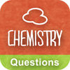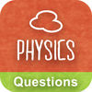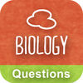

1.
GCSE Chemistry Questions Rev 2. GCSE Physics Questions 3. GCSE Biology Questions
View in iTunes View in iTunes View in iTunes

6.
GCSE Revision Videos
View in iTunes

