Questions
Q1.
The bonding in gaseous hydrogen halides is best described as
A mainly covalent with an increasing tendency towards ionic as you go down the
group.
B mainly covalent with an increasing tendency towards ionic as you go up the
group.
C mainly ionic with an increasing tendency towards covalent as you go down the
group.
D mainly ionic with an increasing tendency towards covalent as you go up the
group.
(Total for question = 1 mark)

Q2.
Which of the following statements is true?
A Calcium hydroxide is more soluble in water than magnesium hydroxide.
B Chlorine is more electronegative than fluorine.
C Iodine is a stronger oxidizing agent than bromine.
D The first ionization energy of barium is greater than that of strontium.
(Total for question = 1 mark)

Q3.
Which of the following statements about electronegativity is true?

A Non-metals have lower electronegativity than metals.
B Electronegativity decreases across a period in the Periodic Table.
C Electronegativity decreases going down a group in the Periodic Table.
D The bonds between atoms with equal electronegativity are always weak.
(Total for Question = 1 mark)

Q4.
A charged rod is held beside a stream of liquid coming from a burette. Which of the following liquids would NOT be significantly deflected?

A H₂O
B CCl₄
C C₂H₅OH
D C₂H₅Br
(Total for Question = 1 mark)

Q5.
Consider the following organic liquids:
A ethanal
B ethanol
C tetrachloromethane
D trichloromethane
(a) Each liquid is run from a burette. Which liquid would not be deflected significantly by a charged rod?
(1)
A
B
C
D
(b) Which liquid would react with phosphorus(V) chloride to give a gas which fumes in moist air?
(1)
A
B
C
D
(c) Which liquid would you expect to have the peak at the greatest mass/charge ratio in its mass spectrum?
(1)
A
B
C
D
(d) Which liquid has an infrared spectrum with a broad absorption due to hydrogen bonding?
(1)
A
B
C
D
(Total for question = 4 marks)

Q6.
An electric field can affect the direction of a stream of some liquids. Which of these
liquids would be affected by an electric field?
A 1-chloropropane
B Pentane
C Tetrachloromethane
D Cyclopentane
(Total for question = 1 mark)

Q7.
Which of these four molecules, PCl₃, CO, CO₂ and CCl₄, are polar?
A All four
B PCl₃ and CO
C CO and CCl₄
D PCl₃ and CO₂
(Total for question = 1 mark)

Q8.
The electronegativities of four pairs of elements are given below. Which pair would form the compound with the greatest ionic character?
A 0.7 and 4.0
B 0.7 and 3.5
C 1.0 and 4.0
D 0.8 and 2.8
(Total for question = 1 mark)

Q9.
In which series of compounds does the covalent character increase, going from left to right?

A NaCl, MgCl₂, AlCl₃, SiCl₄
B SiO₂, Al₂O₃, MgO, Na₂O
C LiI, NaI, KI, RbI
D KI, KBr, KCl, KF
(Total for Question = 1 mark)

Q10.
Which of the following molecules is polar?
A CO₂
B SO₂
C SO₃
D O₂

(Total for question = 1 mark)

Q11.
Tetrachloromethane, CCl₄, is a
A polar molecule with polar bonds.
B polar molecule with non-polar bonds.
C non-polar molecule with polar bonds.
D non-polar molecule with non-polar bonds.
(Total for question = 1 mark)

Q12.
Which of the following molecules is non-polar?
A CH₃Cl
B CH₂Cl₂
C CHCl₃
D CCl₄
(Total for Question = 1 mark)

Q13.
Which of the following molecules is polar?
A Carbon dioxide, CO₂
B Beryllium chloride, BeCl₂
C Ammonia, NH₃
D Boron trifluoride, BF₃
(Total for question = 1 mark)

Q14.
Which of the following molecules contains polar bonds but is not a polar molecule?
A Chlorine, Cl₂
B Hydrogen chloride, HCl
C Trichloromethane, CHCl₃
D Tetrachloromethane, CCl₄
(Total for question = 1 mark)

Mark Scheme
Q1.

Q2.

Q3.

Q4.

Q5.

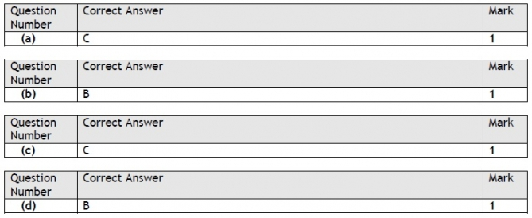

Q6.

Q7.

Q8.

Q9.

Q10.

Q11.

Q12.

Q13.

Q14.

