Leisure and Tourism Revision Guide
Leisure – is what people do for fun and recreation in their spare time.
Tourism – is visiting another place.
Leisure and tourism destination – is somewhere where people choose to go for leisure and tourism purposes. This can either be for the day or for a longer stay e.g. a holiday.

People visit these destinations for different reasons:
- Holidays,
- Day trips,
- Business tourism, and
- Visiting family and relatives.

Different types of leisure and tourism destinations are:
- Beach resorts – these are popular for sun, sea and sand holidays.
e.g. UK – Bournemouth/Blackpool/Brighton. Overseas, Benidorm, Spain,
- City destinations – these are usually large or historic towns or cities with famous monuments and art galleries.
e.g. UK – London/Edinburgh/Cardiff. Overseas – New York,
- Overseas ski/snow sports – these are found in mountainous areas
e.g. Cervinia, Italy,
- UK National Park – these are large areas of countryside, which usually have wild and attractive landscapes.
e.g. The New Forest, Hampshire.

CASE STUDIES:

UK Beach Resort – Bournemouth
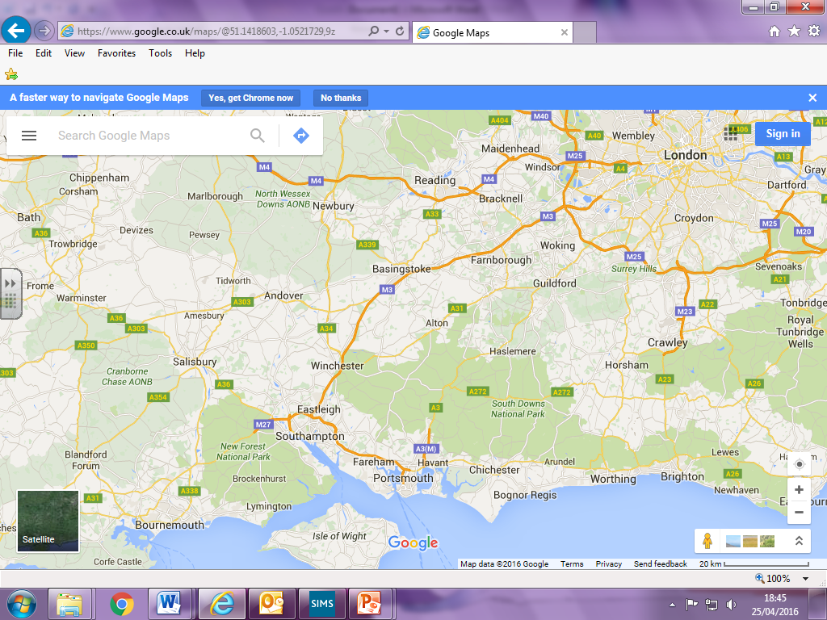
4) A338 in south westerly direction towards Bournemouth
3) Join M27 (west) in a south westerly direction, then onto the A31 to Bournemouth
2) M3 motorway in a south westerly direction towards Southampton
1) Farnborough
5) Bournemouth

Bournemouth is in the south of the UK. It is about 107 south west of London and would take about 2 hours 15 minutes to drive there from London on the M3, M27, A31 and A338. It is approx. 74 miles in a south westerly direction from Farnborough, Hampshire, and would take about 1 hour 20 minutes to drive there. Bournemouth has a train station, a bus station which is for National Express coaches from around the UK and an airport for short haul flights. This means that everyone in the UK could easily get to Bournemouth either by driving (Motorways and main roads), rail, coach or plane.

Bournemouth meets the needs of different groups of people due to:

Couples:
- 7 miles of beach to sunbathe on, take romantic walks on, and swim in the sea,
- 2,000 acres of public gardens and park areas to relax in and take romantic walks in,
- excellent cycle routes (you can hire bikes from ‘Front Bike Hire’) to spend time together,
- the ‘Level8ight The Sky Bar’ at the top of the ‘Hilton Hotel’. It’s the south west’s highest bar. Couples can look out over the town or the English Channel, whilst enjoying cocktails, food or afternoon tea served with champagne.
- see a concert at Bournemouth Pavilions,
- Hermitage Hotel – a 4* hotel on the sea front.

Families with children:
- 7 miles of beach to play on and sea to swim in,
- 2,000 acres of park areas to play in,
- excellent cycle routes (you can hire bikes from ‘Front Bike Hire’) to spend time together as family,
- the ‘Aruba family restaurant and beach bar’. It’s open for breakfast, lunch and dinner 7 days a week. Affordable prices and location on the beach for beautiful views and to play on,
- ‘All fired up ceramics cafe’ making and painting pottery,
- Oceanarium - the Bournemouth Aquarium,
- Laser Quest,
- 6D cinema simulator,
- ‘Alum Chine Family Beach Flat’ - 5 minutes’ walk to Blue Flag beach, children’s playground and paddling pool.

Groups:
- 7 miles of beach to sunbathe on and play group games like volleyball and cricket,
- Surf Steps surfing school,
- Open-top bus sightseeing tours,
- Pizza Express sells a variety of food that everyone will like,
- pedestrianised high street with a delightful mix of department stores, brand name stores, high street fashion stores and intriguing independent stores,
- ‘All fired up ceramics cafe’ making and painting pottery,
- Laser Quest,
- ‘Camel Bar’ night club,
- ‘Riviera Holiday Apartments’ - sleep from 2 to 7 people, some with two bedrooms, and all have a lounge, kitchen and a bathroom.

Elderly:
- 7 miles of beach to stroll down,
- ‘Gala Bingo’,
- Queen’s Park Golf Course,
- ‘Chez Food’ fish and chips and homemade food. Good value for money,
- ‘Balincourt’ Guest House - old-fashioned hospitality and traditional home cooking.

Overseas beach resort – Benidorm, Spain

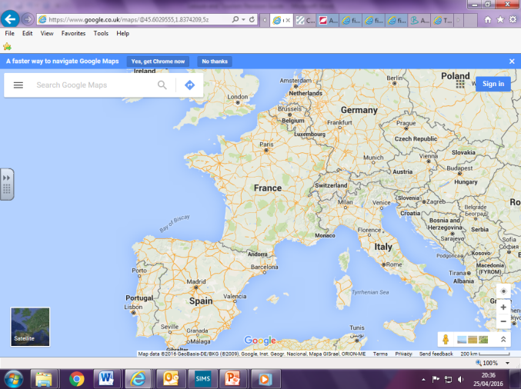
Farnborough. Travel on the M3 in a south westerly direction. Drive on M27 (East) and then the A335 to Southampton Airport. Fly to Alicante.
Benidorm is in south east Spain, between Valencia and Murcia. The nearest airport is Alicante.

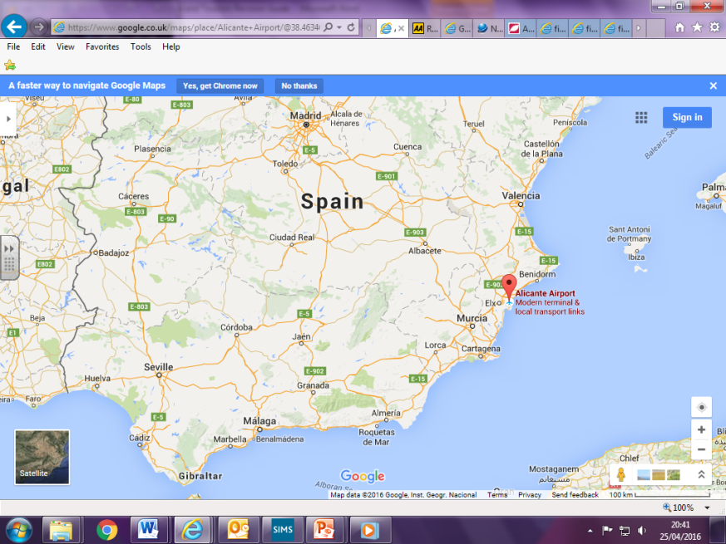
Benidorm.
Arrive at Alicante Airport and drive in a north easterly direction along the A-70 and N-332 for about 35 miles. It will take about 35 mins to drive there.

Benidorm is in south east Spain, between Valencia and Murcia and on the Costa Blanca coastline. The nearest airport is in Alicante. Fly from Southampton Airport in the UK. Hire a car at Alicante airport and drive in a north easterly direction along the A-70 and N-332 for about 35 miles. It will take about 35 mins to drive there. You could get a bus, the Benidorm Light Railway or a taxi to Benidorm as well, although a taxi will be expensive.

Benidorm, Spain, meets the needs of different groups of people due to:
Couples:
- Playa Poniente beach has a laid back feel to it, so is ideal for couples who want a quiet romantic break,
- the village of Altea which is quieter and more romantic than Benidorm. Lovely weekly outdoor market,
- The Algar Waterfalls are very romantic,
- jet ski trips,
- catamaran sailing,
- paragliding,
- snorkeling,
- bike rides,
- ‘Tiki beach bar’ is a cocktail bar on the beach,
- ‘Amigos restaurant and roof terrace’,
- ‘Riviera beach hotel’ – romantic 4* hideaway on the beach.

Family:
- ‘Playa Poniente’ beach is not as lively as other beaches, so it is perfect for families,
- ‘Aqualandia’ water park,
- ‘Terra Mitica’ theme park,
- -‘Mundomar’ sealife park,
- ‘Terra Natura’ zoo,
- bike rides,
- safari jeep rides into mountains,
- ‘Stardust’ variety club with magicians, singing, dancing and drinks for everyone,
- ‘Amigos Bistro’ family friendly restaurant,
- ‘MedPlaya Hotel Rio Park’ – 2* with family rooms.

Groups:
- ‘Playa Levante’ beach is very busy and lively and is surrounded by restaurants and bars,
- ‘Terra Mitica’ theme park with loads of shops and restaurants,
- jet ski trips,
- music festival,
- catamaran sailing,
- paragliding,
- snorkeling,
- ‘Last stop’ sports and karaoke bar,
- ‘Pacha’ nightclub,
- ‘Wooky Hollow 2’ restaurant. Caters for big groups of people – a party restaurant,
- ‘Levante Beach Holiday apartments’ – sleeps 6.

Elderly:
- ‘Playa Poniente’ beach is not as busy or lively, so is perfect for elderly people who want to take it easy,
- the village of Calpa where there is a large wildlife reserve,
- ‘Benidorm Palace’ cabaret show,
- ‘The Pig ‘n’ Whistle’ music pub. Drinks and music to suit all ages,
- ‘Caspers Bar Bistro’ affordable and quieter
- ‘Queen’s Hotel’ – quiet location with wheelchair access and reduced mobility rooms.

UK City Destination – London
London
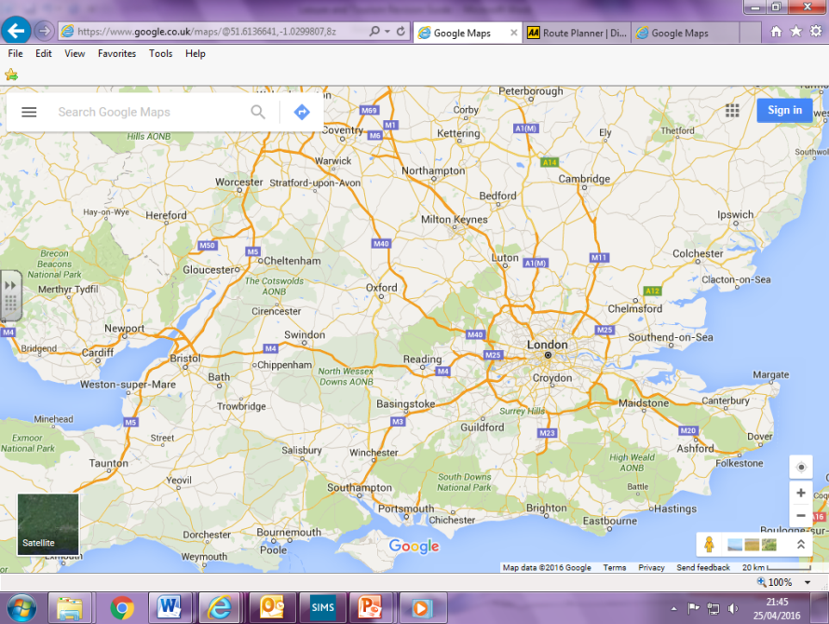
Farnborough

London is in south east England. It is approx. 36 miles in a north easterly direction from Farnborough. Take the A331, then the M3 (northbound) and join the A4 into London. This should take approx 1 hour 15 minutes without traffic. You could also take a train from Farnborough Main to London Waterloo station, or a bus from Farnborough Kingsmead South Bus Station to London Victoria Bus Station. Other major train stations in London are Paddington, Euston, St. Pancras, Kings Cross and Victoria. London has 5 major airports: Heathrow, Gatwick, Luton, Stanstead and City Airport.

London meets the needs of different groups of people due to:

Couples:
- Enjoy a candlelit dinner at ‘Clos Maggiore’, which is often said to be London’s most romantic restaurant,
- ‘The Corinthia Hotel’ – a 5* romantic hotel on Embankment,
- ‘Voltaire’ is a unique champagne bar located in a series of vaults
- The View from ‘the Shard’ offers sweeping views of the city,
- take a romantic stroll in South Bank along the River Thames at night,
- London helicopter tour,
- hire a row boat on the Serpentine Lake in Hyde Park,
- see a show at a West End theatre.
- Book an exclusive Champagne Experience aboard the London Eye where you get a private capsule, your own waiter, champagne and chocolates.

Families with children:
- the ‘Rainforest Café’, located just two minutes from Piccadilly Circus, brings together the sights and sounds of the jungle in a vibrant and exciting atmosphere of fun for all the family,
- ‘The Nadler Kensington’ hotel has large rooms can sleep up to four people and there is no extra charge for baby cots. There's also a mini kitchen so you can prepare your own light meals and snacks. It is reasonably priced,
- See ‘Charlie and the Chocolate Factory’ at the Theatre Royal,
- Natural History Museum,
- London Zoo,
- See Buckingham Palace.

Groups:
- ‘Travelodge’ on London City Road is affordable for groups of people,
- ‘Giraffe’ in Royal Festival Hall is a great atmosphere for groups and has a selection of food for everyone,
- the Ice Bar in Soho, where everything in the bar is made from ice including the walls, tables, chairs and even the glasses that cocktails are served in,
- see a stand-up comedy show at ‘The Comedy Store’,
- ‘Fabric’ nightclub,
- see a West End show like ‘The Book of Mormon’,
- hire bikes with the London Bicycle Tour Company,
- go on the London Eye.

Elderly:
- ‘Le Meridien’ hotel has access for elderly and disabled people,
- ‘OXBO Bankside’ restaurant for affordable food with wheelchair and accessibility access,
- Buckingham Palace,
- British Museum,
- Westminster Abby,
- St Paul’s Cathedral,
- Listen to a classical concert at ‘The Royal Albert Hall’,
- Visit the ‘Tate Modern’ art gallery.

Overseas City Destination – New York, USA
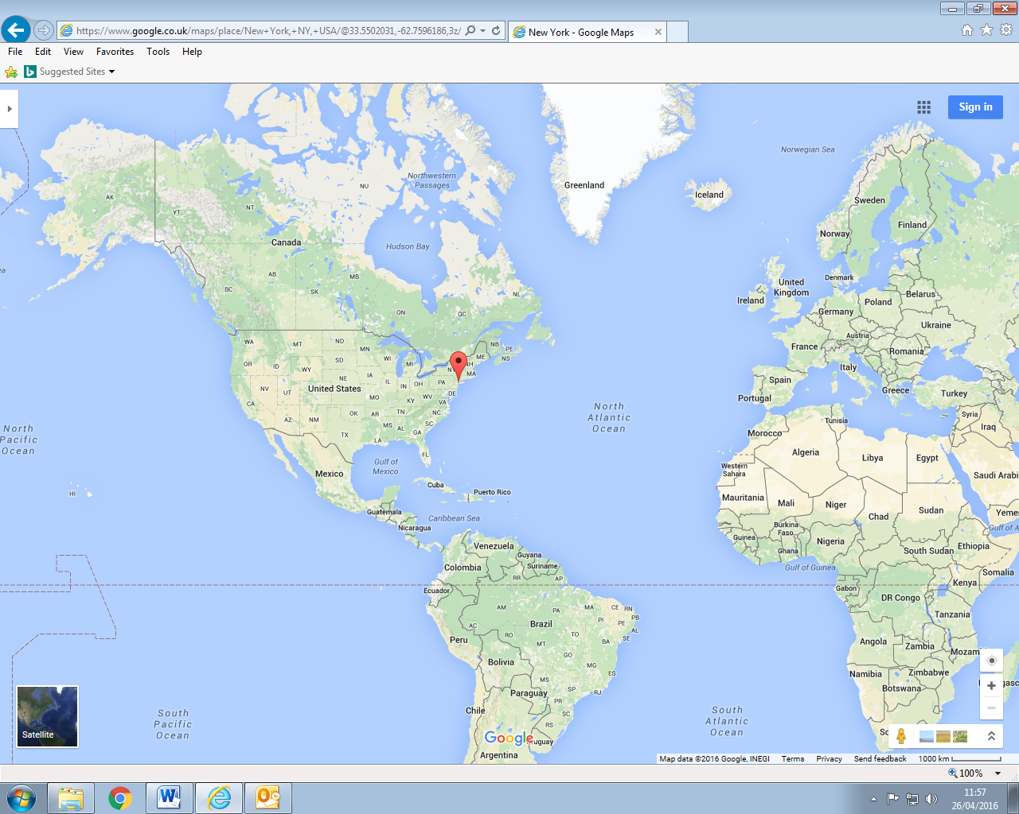
New York. Land at JFK or Newark Airports.
UK – Farnborough. Fly from London Heathrow Airport, or Gatwick Airport.
New York is in north east USA. It has three major airports: John F. Kennedy (JFK) International Airport which deals with international flights, LaGuardia Airport which mostly deals with domestic (internal) flights within the USA, and Newark International Airport which deals with both international and domestic flights. It has two main train stations: Grand Central Station and Penn Station. There are three main bus stations, the most well-known one is the Port Authority Bus Terminal.
To get to New York from Farnborough, drive on the A331, join the M3 and then the M25 and follow signs to Heathrow Airport. Or get a train from Farnborough North, change at Reading, and then change at Hayes and Harlington Station for a train to Heathrow. The plane will take you from Heathrow Airport to either JFK or Newark International Airports.

New York meets the needs of different groups of people due to:

Couples:
- the ‘Plaza Hotel’ is the most iconic New York City hotel. It has been the backdrop for countless movies that take place in New York City and provides a very romantic place to stay.
- ‘Barbetta’ Restaurant is one of the most romantic places to eat in New York and is New York City’s oldest Italian restaurant,
- Take a horse-drawn carriage ride through Central Park,
- Go ice skating at The Rockefeller Center at Christmas,
- The Empire State Building is the tallest building in New York City and is so romantic that many couples get married at the top of the ‘Cathedral of the Skies,’ every year,
- Watch a ‘New York Yankees’ baseball game at Yankee Stadium in the Bronx area of New York. This is also the stadium for New York City FC. This is an overseas major sports venue.
- Metropolitan Museum of Art.

Families with children:
- American Museum of Natural History,
- The Bronx Zoo,
- The Brooklyn Children’s Museum,
- Central Park in Manhattan is full of child-friendly activities like amusements, a small animal zoo, an ice-rink in the winter and an Egyptian themed playground,
- Children’s Museum of Manhattan for ages 6 and under,
- Coney Island amusement park,
- Empire State Building,
- Watch a show on Broadway,
- Watch a ‘New York Yankees’ baseball game at Yankee Stadium in the Bronx area of New York. This is also the stadium for New York City FC. This is an overseas major sports venue.
- Eat in the Planet Hollywood restaurant which is full of real movie memorabilia,
- Stay at ‘The Milburn’ in Manhattan for an affordable family hotel which offers children’s books and family movies, as well as PlayStations to use during their stay for free.

Groups:
- Take a Circle Line Landmark Cruise and cruise around the southern tip of Manhattan Island that will include views of the One World Trade Center, the Statue of Liberty and Brooklyn Bridge.
- take a NYC TV and Movie Tour – this is a 2 ½ hour tour that show you parts of the sets from Friends, Ghostbusters, American Hustle and Spider-man,
- take an ‘Open Loop’ open-top bus tour,
- go to the top of the Empire State Building,
- See a Broadway show such as ‘Jersey Boys’,
- go to a stand-up comedy club like ‘Carolines’ on Broadway,
- Watch a ‘New York Yankees’ baseball game at Yankee Stadium in the Bronx area of New York. This is also the stadium for New York City FC. This is an overseas major sports venue.
- eat in ‘B.B. King Blues Club’ where you can eat whilst watching blues bands play,
- stay in ‘The Wolcott Hotel’ which is designed for groups and is very affordable.

Elderly:
- take a ‘Harbour Line Cruise’ and enjoy afternoon tea on a 1920’s style yacht which seeing the sights on New York from the water,
- visit Brooklyn Botanic Gardens to see beautiful flowers and wildlife,
- got to the 6th Avenue Antiques Market,
- listen to an orchestral, classical music show at ‘Carnegie Hall’,
- go to the ‘Top of the Rock’ observation deck in the Rockefeller Center and see the sights of New York including the Empire State Building,
- stroll through Central Park,
- Watch a ‘New York Yankees’ baseball game at Yankee Stadium in the Bronx area of New York. This is also the stadium for New York City FC. This is an overseas major sports venue.
- eat in ‘Miss Mamie's Spoon Bread Too’ restaurant which has full wheelchair access and is affordable for people on a pension,
- stay in the ‘Hotel Edison’ which has full wheelchair access and is affordable.

Overseas Ski Resort – Cervinia, Italy

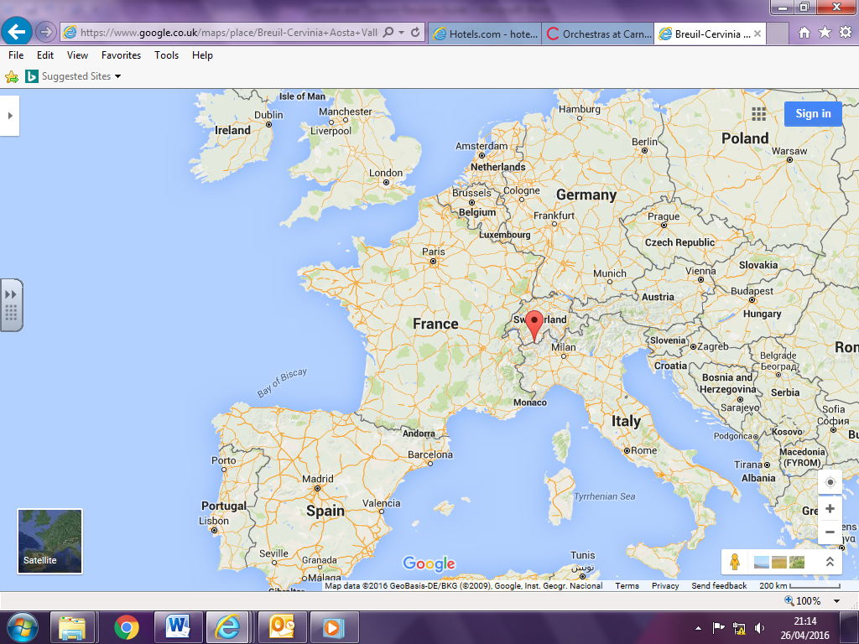
Cervinia
Farnborough

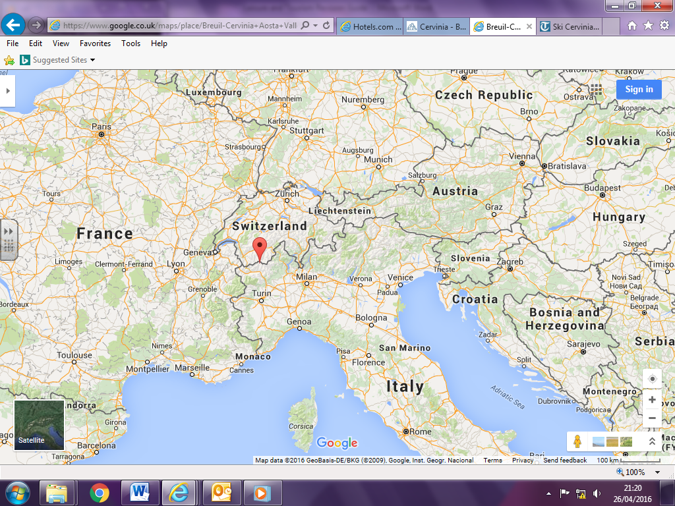
Cervinia
Turin Airport

Cervinia is in north west Italy, high in the Alps mountain range in the Matterhorn region, and is on the border with Switzerland. Snow is almost guaranteed there from November until the beginning of May. The nearest airport is Turin Airport, which is 75 miles south of Cervinia and will take about an hour and a half to drive there. To get there from Farnborough, drive on the A331 and join the M3 towards London. Join the M25 until the turning for the M1 and follow the M1 until you reach Luton Airport. Or you could get a train from Farnborough Main train station to Waterloo, then an underground train to London St Pancras International train station, then a train to Luton Airport Parkway train station, and finally a bus to Luton Airport. Fly from Luton Airport to Turin Airport, hire a car and drive north along the A5 road to Cervinia. You can get a train from Turin to Chatillon-Saint Vincent, which is south of Cervinia. You then need to get a bus or taxi to get the remaining 18 miles north to Cervinia. This should take 40 minutes without traffic. You could also get a bus from Turin Airport to Cervinia.

Cervinia meets the needs of different groups of people due to:

Couples:
- Go Heliskiing – where you fly by helicopter to the mountain top to reach the highest peaks and enjoy the romantic breath-taking views. Then ski down the mountain helped by guides to keep you safe.
- have a romantic candlelit dinner in a wooden hut up on the mountain, and then ski down the mountain in the moonlight. Book through ‘Moonlight Descents’,
- go for a quiet drink by an open fireplace in the cosy bar of ‘Hotel Bucaneve’,
- eat at ‘Le Vieux Grenier’ in the beautiful candlelit dining room. Restaurant serves wood-fired pizzas, home-made pasta dishes and delicious desserts,
- stay at ‘Hotel Hermitage’ which has a mountain cabin-feel but with the sophistication and service expected of a five-star hotel.

Families with children:
- Learn to ski with Ski School Cervino,
- there are two ‘snow playgrounds’ which are safe places for children to play,
- indoor climbing wall with courses for beginners and children,
- snowshoe walks,
- ice karting – like go karting, but on ice!
- visit the ‘The Dragon Hotel’ for a family friendly experience. It has a small Welsh pub upstairs and a fun and friendly English pub downstairs.
- eat at ‘The Dragon Hotel’ too! Burgers and chips in the English pub,
- stay at ‘Petit Palais’ which has reasonable prices and friendly, Crystal Club staff.

Groups:
- go on an ‘ice caves excursion’ and see one of the wonders of the Alps: The ice caves are the highest in Europe, at almost 4,000m high. To reach the caves there is a tunnel of 50 m dug out of the ice, 15 metres under the surface,
- snowshoe walks,
- ice karting – like go karting, but on ice!
- mountaineering,
- paragliding,
- go clubbing in ‘Bianconiglio’ which is the only club in town,
- eat at ‘Copa Pan’ which is a very popular and lively restaurant with a bar upstairs. Expect steak and chips, fondue, fresh pasta and pizzas,
- stay at ‘Sertoelli Sport Hotel’ is a modern Alpine building with spa facilities right next to the town for the night life, and the ski lifts for the skiing.

Elderly:
- visit the Museum "A Mountain of Work" which is the highest museum in Europe where you learn about how people have built the lift systems to work at that height,
- enjoy ‘slow skiing’ which is where you take your time and get away from it all to enjoy the views,
- go for a quiet drink by an open fireplace in the cosy bar of ‘Hotel Bucaneve’,
- eat at ‘La Chandelle’ and relax with a good bottle of Italian red and a selection of antipasti while taking in the mountain view,
- stay at ‘Les Neiges D'antan’ is ideal for those in need of relaxation.

UK National Park – New Forest, Hampshire.

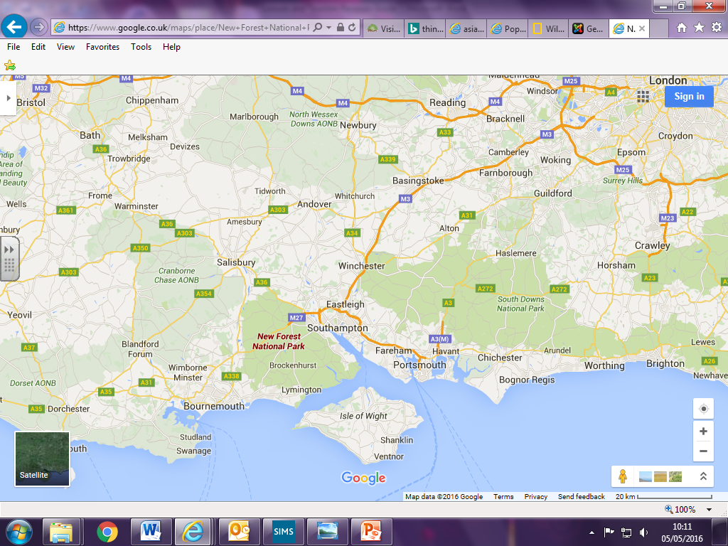
New Forest National Park.
Farnborough.

National Parks are protected areas because of their beautiful countryside, wildlife and cultural heritage. National Parks are covered by the Environment Act 1995. Their aim is to:
- Conserve and enhance the natural beauty, wildlife and cultural heritage
- Promote opportunities for the understanding and enjoyment of the special qualities of national parks by the public
When national parks carry out these purposes they also have the duty to:
- Seek to foster the economic and social well-being of local communities within the national parks

New Forest National Park is in southern England. It is about 80 miles south west of London, and would take you about 1 hour 50 minutes to drive there. From Farnborough, it is about 55 miles in a south west direction. It would take about an hour to drive there. Go on the A331 in a northern direction, and join the M3 to travel in a south westerly direction towards Southampton. At junction 13 in Southampton, join the M27. At Cadnam, take the A337 to Lyndurst, which is in the New Forest. You can catch a train from Farnborough Main train station and it will take about an hour and a half to reach Brockenhurst train station, which is in the centre of the New Forest. There are many bus routes there too. You could also get a ferry from the Isle of Wight to Lymington!
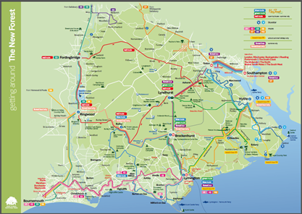

New Forest National Park meets the needs of different groups of people due to:

Couples:
- Hire bikes at one of the many cycling centres
- Explore the forest on horse-back
- Go camping at one of the many campsites
- Treat yourself to a cream tea and browse round the independent shops in Lyndhurst, the 'capital' of the forest
- Visit ‘Careys Manor Hotel and Senspa’ in Brockenhurst and escape, relax and explore the beautiful New Forest national park in complete comfort at luxury country house hotel and spa.
- Go on a yacht ride from Lymington and in The Solent,
- Stay at ‘Careys Manor Hotel and Senspa’ in Brockenhurst for a 5* romantic experience,
- Eat at ‘Le Blaireau’ restaurant which is within the ‘Careys Manor Hotel and Senspa’ too. It is a romantic French restaurant.

Families with children:
- Discover the secrets of the forest during a visit to the New Forest Centre, Lyndhurst
- Join in a ‘Watch wildlife’ at Hatchet Pond near Beaulieu - the largest body of water in the forest
- , including children's activities, guided walks, and our annual bioblitz wildlife bonanza
- Go camping at one of the many campsites
- Visit Lepe Country Park - there's a good tearoom and play area here as well as the beach
- Stop at Bolderwood car park and see the deer from the viewing platform
- Follow Rhinefield Tall Trees Trail at Blackwater near Brockenhurst.
- Go kite flying on a windy day at Whitefield Moor near Brockenhurst
- Treat yourself to a cream tea and browse round the independent shops in Lyndhurst, the 'capital' of the forest
- Take a picnic to Bolton's bench at Lyndhurst
- Check out the Reptile Centre off the A35 near Lyndhurst
- Hire bikes at one of the many cycling centres
- Explore the forest on horse-back
- Spend an action-packed day at Beaulieu at the National Motor Museum
- Hop on the steam train at Exbury Gardens
Join in the fun at Paulton's Family Theme Park near Ower
- Get adventurous at Calshot Activity Centre
- Take to the water at New Forest Activities, Beaulieu, with kayaks and canoes
- Book a barbecue site for your lunch.
- Go to ‘Go Ape’
- Stay at ‘Ocknell Camping’ which is a campsite suitable for families and people of all abilities, and costs between £12 - £22 per tent per night.
- Eat at ‘La Pergola’ Ristorante/Pizzeria in Lyndhurst. There is a children’s play area

Groups:
- Book a barbecue site for your lunch.
- Hire bikes at one of the many cycling centres
- Explore the forest on horse-back
- Go to ‘Go Ape’
- Go water skiing at the New Forest Water Park,
- Stay at ‘The White Rabbit Hotel’ which has rooms with multiple beds for large groups of people and is affordable,
- Eat at ‘The New Forest Inn’ near Lyndhurst which enjoys large groups of people and makes food to suit everyone.

Elderly:
- Visit the countryside museum and Elizabethan manor at Breamore House near Fordingbridge
- Spend an action-packed day at Beaulieu featuring the National Motor Museum, Palace House - home of the Montagu family - and Abbey Ruins
- Take a trip on the New Forest Tour for a birds-eye view of the villages and landscape
- Stop at Bolderwood car park and see the deer from the viewing platform
- Discover what it was like to live and work in an 18th century shipbuilding village at Buckler's Hard
- Treat yourself to a cream tea and browse round the independent shops in Lyndhurst, the 'capital' of the forest
- Watch wildlife at Hatchet Pond near Beaulieu - the largest body of water in the forest
- Stay at ‘The Crown Manor House Hotel’ in Lyndhurst. This 4* hotel is next to a golf club for relaxation.
- Eat at ‘The White Buck Inn’ near Ringwood. It is fully accessible for disabled and elderly people.

Short-haul destinations – are flights or trips within Europe or the Mediterranean Basin, which have a flight time of 4 hours or under from the UK e.g. Spain, Egypt, Morocco, Greece, Tunisia etc.

Long-haul destinations – are flights or trips that are beyond Europe and the Mediterranean Basin, and which have a flight time of 6-7 hours or over from the UK e.g. Dubai, Australia, New York, Vancouver, Peru etc.
Short-haul destinations

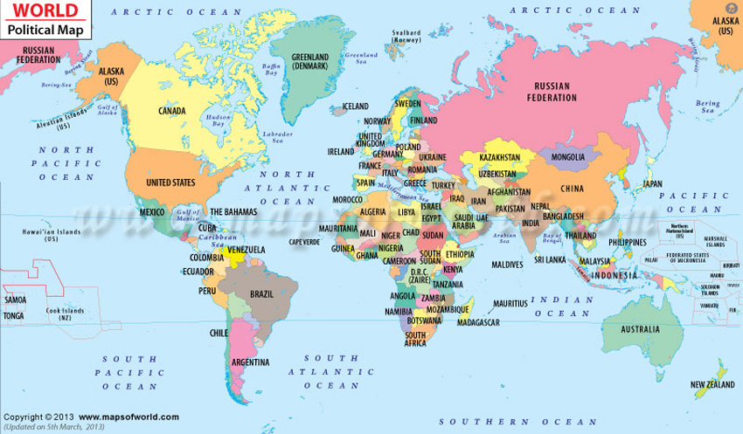

People choose their holiday destinations depending on certain factors. These include:

- How much it costs,
- The weather and climate,
- Their personal interests and tastes,
- The range of products and services on offer,
- Accessibility (how easy it is to reach a destination, as well as how easy it is to move around and use its facilities)
- The promotion of destinations,
- Events.

Think about how each of these factors would influence a person’s decision to go to each of our case studies.

Cost

Single people have fewer responsibilities, so might be able to afford a more expensive holiday,
Couples may have more responsibility such as a mortgage, and may need to watch their money,
Families with children might not be able to afford an expensive holiday as they have children. It costs more to take an entire family on holiday as you need to have more seats on the aeroplane, more rooms in the hotel and buy more food,
Groups there might be people with different levels of wealth within the group, so the cost of the holiday needs to suit everybody. They might be able to get a group discount. They will need several rooms.
Students do not have a lot of money as they have student loans. They might want a cheap holiday with cheap flights e.g. budget airlines such as easyjet and Ryanair.

Weather and climate

Outdoor activities are particularly affected by the weather and climate, so if you want something like a beach holiday or a ski holiday, you need to choose somewhere to travel to that has the most chance of having the right weather and climate.

Personal interests and tastes

People will choose to go to places where they are most likely to see things they are interested in e.g. if someone was particularly interested in volcanoes, they might go to see the remains of Mount Vesuvius in Pompeii, Italy. If they are interested in the Inca’s, they might go to Peru to see Machu Picchu. If someone really likes art and museums, they might go to Paris etc.,

The range of products and services on offer

These include:
- transport,
- accommodation,
- attractions,
- activities.

Transport
- What range of transportation methods are there to be able to reach their destination?
- How can they get from the airport to the hotel?
- How easy or cheap is it to travel?

Accommodation
- Are there all-inclusive holidays? These are most frequently found in long-haul beach resort destinations. The customer pays a single bill, normally in advance. This bill covers accommodation, meals, drinks and leisure activities at the hotel. Sometimes however, more expensive optional activities like diving, gourmet restaurant meals and branded drinks need to be paid for in addition. Many all-inclusive hotel guests have bought a package holiday, including the hotel, flights and airport transfer. This means that people can relax without having to worry about additional bills and costs. There are huge disadvantages for the country you are visiting though. The hotels import food from other countries instead of using local produce. This doesn’t help the local economy at all. They are also bad for the environment.
- Is there self-catering options so that you can cook your own meals? This is often cheaper and more suitable for families.
- Half-board means that breakfast and evening meal is provided, but you need to buy your own lunch.

Attractions

Different attractions appeal to different people. Some people might prefer a beach resort holiday where they can sunbathe on a beach all week, whereas others might like a city destination and go sightseeing. What attracts you often depends on who you are travelling with.
- Amusement arcades and funfairs would appeal to families with children and teenagers.
- Boating lakes would appeal to couples and families with children.
- Harbour pleasure cruises would appeal to retired people, single people and families with children.
- Beach activities would appeal to families with children, groups travelling together and children.
- Leisure pools/water parks would appeal to teenagers and children.
- Afternoon band concerts in the park would appeal to retired people, single people, couples and mature adults.

Accessibility

Accessibility is the ease of reaching a destination. Factors affecting disability include:
- location e.g. is it easy to get to?
- transport types e.g. are there rail links? Are there main roads to it? Is there an airport nearby? Can you get there by ferry? Are there many bus routes?
- measures to be taken to meet the special needs of visitors e.g. ramps, lifts, leaflets in braille, audio guides for hearing impaired, a dial-a-ride scheme to collect disabled people, hotel rooms on the ground floor etc.

Promotion of destinations

This is a way of bringing leisure and tourism products and services to the attention of potential customers. Leisure and tourism organisations, including regional tourist boards, transport and accommodation providers, tour operators and travel agents will run different promotions and use promotional materials and techniques such as brochures, TV adverts and websites.

