Questions
Q1.
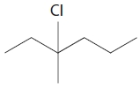
The molecule shown above is 3-chloro-3-methylhexane. It reacts with hot, alcoholic potassium hydroxide to produce a number of different alkenes. This reaction can be classified as
A elimination.
B oxidation.
C reduction.
D substitution.

(Total for question = 1 mark)

Q2.
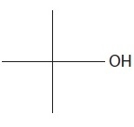
The systematic name of the compound with skeletal formula shown above is

A 1,1-dimethylethanol.
B 2,2-dimethylethanol.
C 2-methylpropan-1-ol.
D 2-methylpropan-2-ol.
(Total for Question = 1 mark)

Q3.
Which of the following could be used to oxidize ethanol to ethanoic acid?

A Concentrated H₂SO₄
B
C H⁺/Cr³⁺
D Concentrated NaOH solution
(Total for Question = 1 mark)

Q4.
Which of these is a tertiary alcohol?
A 3-methylpentan-2-ol
B Pentan-2-ol
C Pentan-3-ol
D 2-methylpentan-2-ol
(Total for question = 1 mark)

Q5.
Which of the following is a secondary alcohol?
A butan-1-ol
B butan-2-ol
C 2-methylpropan-1-ol
D 2-methylpropan-2-ol
(Total for question = 1 mark)

Q6.
The alcohol shown below can be classified as
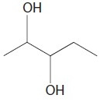

A just primary.
B primary and secondary.
C just secondary.
D secondary and tertiary.
(Total for Question = 1 mark)

Q7.
Which of these compounds is a secondary halogenoalkane?
A CH₃CH(OH)CH₃
B CH₃CCl(CH₃)CH₃
C CH₃CHClCH₃
D CH₃CH₂CH₂Cl
(Total for question = 1 mark)

Q8.
Hydrogen, H₂, is not a completely 'carbon neutral' fuel. Which of the following is an incorrect reason for this?
A Some CO₂ is released in the transportation of H₂ fuel.
B CO₂ is made when the electricity is generated for the manufacture of H₂.
C A small amount of CO₂ is produced on the combustion of H₂ fuel.
D CO₂ is released during the construction of the H₂ manufacturing plant.

(Total for question = 1 mark)

Q9.
When a chloroalkane is heated with aqueous sodium hydroxide
A no reaction occurs with primary, secondary or tertiary chloroalkanes.
B a reaction occurs with primary and secondary chloroalkanes but not with tertiary chloroalkanes.
C a reaction occurs with tertiary chloroalkanes but not with primary and secondary chloroalkanes.
D a reaction occurs with primary, secondary and tertiary chloroalkanes.
(Total for question = 1 mark)

Q10.
Chloroethane reacts with aqueous potassium hydroxide solution, producing ethanol as
the organic product.
(a) The hydroxide ion is acting as
(1)
A an electrophile.
B a nucleophile.
C an oxidizing agent.
D a reducing agent.
(b) Which of the following shows the correct electron-pair movements in this reaction?
(1)
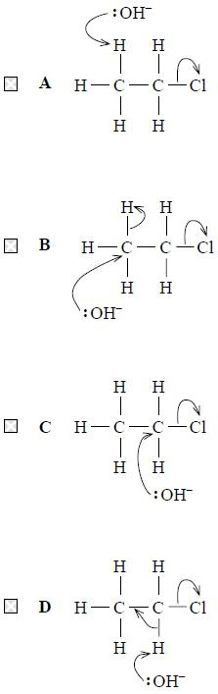
(Total for question = 2 marks)

Q11.
Samples of 1-chloropropane and 1-bromopropane are warmed with water containing dissolved silver nitrate in the presence of ethanol. The 1-chloropropane reacts more slowly because

A the C—Cl bond is more polar than the C—Br bond.
B the C—Cl bond is stronger than the C—Br bond.
C 1-chloropropane is less soluble than 1-bromopropane.
D 1-chloropropane is a weaker oxidizing agent than 1-bromopropane.
(Total for Question = 1 mark)

Q12.
The best method of converting ethanol, C₂H₅OH, into iodoethane, C₂H₅I, is to
A heat iodine and ethanol under reflux.
B react ethanol and potassium iodide in the presence of dilute acid.
C heat potassium iodide and ethanol with concentrated sulfuric acid.
D heat red phosphorus, ethanol and iodine under reflux.
(Total for question = 1 mark)

Q13.
These questions concern the use of infrared (IR) spectra to identify organic compounds. The IR absorption ranges associated with some organic functional groups are given below.
A O—H stretching in alcohols at 3750 − 3200 cm⁻¹
B CO stretching in aldehydes at 1740 − 1720 cm⁻¹
C CO stretching in ketones at 1700 − 1680 cm⁻¹
D CO stretching in carboxylic acids at 1725 − 1700 cm⁻¹
(a) When propan−2−ol is refluxed with potassium dichromate(VI) and sulfuric acid, the product will show a peak due to
(1)
A
B
C
D
(b) When propan−1−ol is heated with potassium dichromate(VI) and sulfuric acid, the product, that is distilled off as it is formed, will show a peak due to
(1)
A
B
C
D
(Total for question = 2 marks)

Q14.
How many molecular ion peaks (parent ion peaks) occur in the mass spectrum of 1,2-dibromoethane, CH₂BrCH₂Br?
Assume the only isotopes present are ¹H, ¹²C, ⁷⁹Br and ⁸¹Br.
A 1
B 2
C 3
D 4
(Total for Question = 1 mark)

Q15.
Propan-1-ol and propan-2-ol are separately oxidized under mild conditions by acidified sodium dichromate(VI) and the product immediately distilled off. What is the oxidation product in each case?
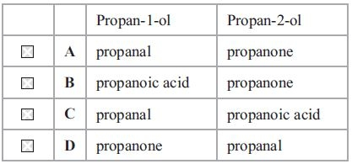
(Total for Question = 1 mark)

Q16.
Which of the following isomeric alcohols, with molecular formula C₅H₁₂O, can be oxidized to a carboxylic acid with five carbon atoms?
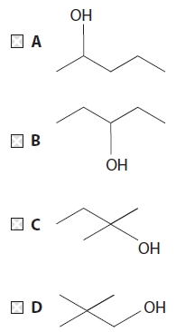

(Total for question = 1 mark)

Q17.
Which of the following reagents gives a positive result with a tertiary alcohol?
A Acidified potassium dichromate(VI) solution
B Phosphorus(V) chloride
C Dilute sulfuric acid
D Bromine water

(Total for question = 1 mark)

Q18.
Consider the following organic liquids:
A ethanal
B ethanol
C tetrachloromethane
D trichloromethane
(a) Each liquid is run from a burette. Which liquid would not be deflected significantly by a charged rod?
(1)
A
B
C
D
(b) Which liquid would react with phosphorus(V) chloride to give a gas which fumes in moist air?
(1)
A
B
C
D
(c) Which liquid would you expect to have the peak at the greatest mass/charge ratio in its mass spectrum?
(1)
A
B
C
D
(d) Which liquid has an infrared spectrum with a broad absorption due to hydrogen bonding?
(1)
A
B
C
D
(Total for question = 4 marks)

Q19.
The compound with formula CH₃CH(NH₂)CH₃ can be made by reacting alcoholic ammonia with

A propane.
B propene.
C 2-chloropropane.
D propan-2-ol.
(Total for Question = 1 mark)

Q20.
Which of the following formulae does not represent 2,2−dimethylpropan−1−ol?
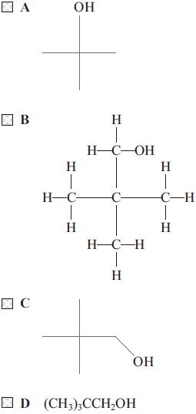
(Total for question = 1 mark)

Q21.
The skeletal formulae of some 6-carbon bromoalkanes are shown below.
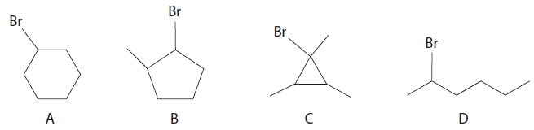?
(a) Which of the above bromoalkanes is not a structural isomer of the others?
(1)
A
B
C
D
(b) Which of the above is not a secondary bromoalkane?
(1)
A
B
C
D

(Total for question = 2 marks)

Q22.
What is the correct systematic name for the alcohol shown below?
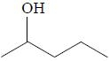
A hexan-4-ol
B hexan-2-ol
C pentan-4-ol
D pentan-2-ol
(Total for question = 1 mark)

Q23.
The compound
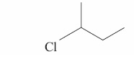
has the systematic name
A 2-chlorobutane
B 3-chlorobutane
C 1-chloro-1-methylpropanel
D 1-chloro-2-methylbutane
(Total for question = 1 mark)

Q24.
When chloroethane is heated with a concentrated solution of potassium hydroxide in
ethanol, the reaction which occurs is
A substitution.
B elimination.
C hydrolysis.
D redox.
(Total for question = 1 mark)

Q25.
The term "reflux" is best described as

A continuous evaporation and condensation.
B heating to evaporation and separation.
C heating under reduced pressure and separation.
D constant boiling.
(Total for Question = 1 mark)

Mark Scheme
Q1.

Q2.

Q3.

Q4.

Q5.

Q6.

Q7.

Q8.

Q9.

Q10.

Q11.

Q12.

Q13.

Q14.

Q15.

Q16.

Q17.

Q18.

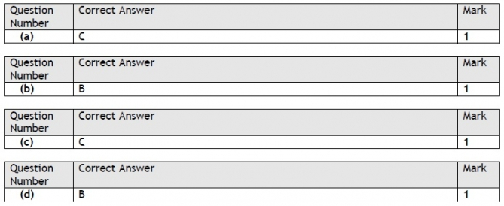

Q19.

Q20.

Q21.

Q22.

Q23.

Q24.

Q25.

